**T41 V12 Display Driver – Combo 3.3V and 5V - Assembly Manual**

**Version 2.10 – July 2, 2025**

**WJ Schmidt - K9HZ**

**INTRODUCTION**

The SPI drivers on the Teensy 4.1 are subpar and cause trouble when driving the display on the T41 radio in the V12 radio. The weak drivers have been discussed on the PJRC forums and the only solution know was to add 220 ohm resistors in series with the SPI control lines used as buffers. Others have found remedy by braiding or twisting the control lines between the teensy and the display and adding ferrite cores to reduce control line cross-talk. The V11 T1 Main board used a 74HC125, a quad bus buffer on the SPI control lines. This did work to eliminate any display glitches, but caused a very high level of RF noise in the radio due to the nature of the switches in the chip design.

After some research, it was discovered that there is a SPI buffer – driver chip specially designed for this situation, the ISO7242. The ISP7274 has four buffer-drivers and an isolating barrier that are capable at operating at the SPI clock frequency but do not generate RF noise like the 74HC125 does.

A small board was developed as a clever solution to incorporate the ISO7242 into the SPI lines between the Teensy 4.1 on the T41 Main board and the T41 display. The board plugs into the “DISPLAY” connector on the Main board, J7. The display cable that usually fits into display connector then plugs into the driver board. A completed display driver board is shown below.

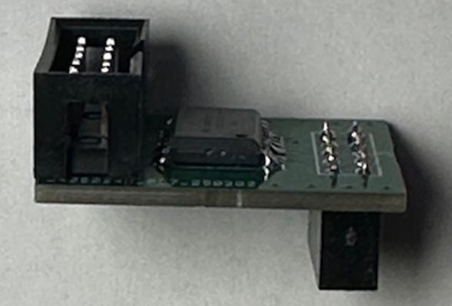

**INVENTORY AND PREWORK**

Before you begin, inventory the parts in the kit against the V012 Display Driver BOM to make sure you have everything you need to complete the adapter board. The schematic can be found as the last page of this document. The BOM is here:

**WHAT YOU NEED TO CONSIDER BEFORE BUILDING THIS KIT**

The displays for the T41 can be ordered as 3.3V displays or as 5V displays. This indicates the voltage that supplies the power to the voltage regulators on the display main board. The rest of the circuitry on the displays, including the control voltages are 3.3V. The supply voltage, either 3.3V or 5V is selected on the MAIN board to match the display requirements, and is passed through the “DISPLAY” connector (J7) to the display. The ISO7242 chip requires 3.3V to operate (all of the signals it buffers are always 0-3.3V), and therefore, if a 5V display was purchased for your T41, U1, the small UA78L033 regulator must be used to generate the 3.3V on the Display Driver board, and J3 on the Driver Board left OPEN. If the display purchased for your T41 project is 3.3V, then 3.3V is already supplied through the “DISPLAY” connector J3 and is used to power the ISO7242. In this case, U1, the UA78L033 regulator is not mounted and the J3 connector on the Display Adapter board is closed with a blob of solder. These choices are reiterated in the build instructions at the appropriate step.

**BUILDING THE BOARD**

1. Find a place where you can spread out your work, including printouts of the schematic and BOM. Your workstation should be such that you can leave it overnight without having to "clean up". The workspace should also be kid- and cat-proof. If you get tired, stop. Come back to it tomorrow. Rushing the assembly rarely works out saving time.
2. Start by cleaning the bord with IPA (Iso-propyl or “rubbing” alcohol) to make sure it’s clean:

3. Next, place the hardest part on the board… U1, the ISO7242 part. It's difficult to see the pin 1 mark on the IC. Note that while the designator for the IC, U1, is at the top of the part foot print, the pin 1 mark on the board is in the lower right-hand corner.

1. Place R1, R2, C2 (no red marker on the packaging) on the bottom of the Driver board.
2. **DECISION:** **IF** your display is 3.3V, and 3.3V is selected for your display voltage on the MAIN board at J8, **THEN:**
   1. Solder J3 on the bottom of the board closed.
   2. Continue at **STEP 5.**

**HOWEVER, IF** your display is 5V, and 5V is selected for your display voltage on the MAIN board at J8, **THEN**:

* 1. Solder U2, the small UA78L033 voltage regulator to the bottom of the board.
  2. Solder C1, the 0.33uf capacitor with red marked package to the bottom of the board.
  3. Continue at **STEP 5**.

1. **DECISION: IF** you mounted the MALE IDC connector for the display on the **TOP** of the MAIN board while building it, **THEN**:
   1. Mount the MALE IDC connector included with this kit on the **TOP** of the Display Driver board at J2 in the same orientation (i.e., the same connector locator tab position orientation). Note: the adaptor will be plugged into the main board such that J2 is to the inside (see “Using the Board” below), so if the male display IDC connector is on the outside edge of the main board, it will be on the inside (toward the ISO7241/2) of the adaptor. Be sure to double check orientation before solderingSolder the FEMALE IDC connector to the **BOTTOM** of the board at J1. The orientation of this connector does not matter as it does not have a locator tab.
   2. Continue at **STEP 6**.

**HOWEVER**, **IF** you mounted the MALE IDC connector for the display on the **BOTTOM** of the MAIN board while building it, **THEN**:

* 1. Mount the MALE IDC connector included with this kit on the **BOTTOM** of the Display Driver board at J2 in the same orientation (eg the same connector locator tab position orientation).
  2. Solder the FEMALE IDC connector to the **TOP** of the board at J1. The orientation of this connector does not matter as it does not have a locator tab.
  3. Continue at **STEP 6**.

6. The board is now complete. Use IPA again to clean the flux off the board. It should look like this (depending upon the connector choice made in step 5 above):

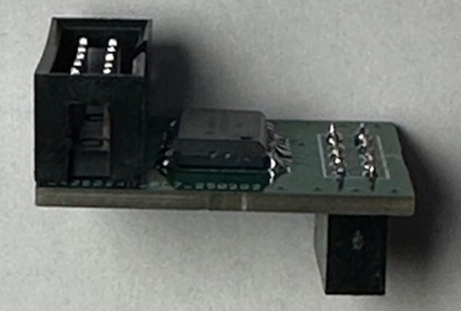

**USING THE BOARD**

If the DISPLAY connector is on the top side of your MAIN board, plug the Display Driver board into the main board as shown in this picture:

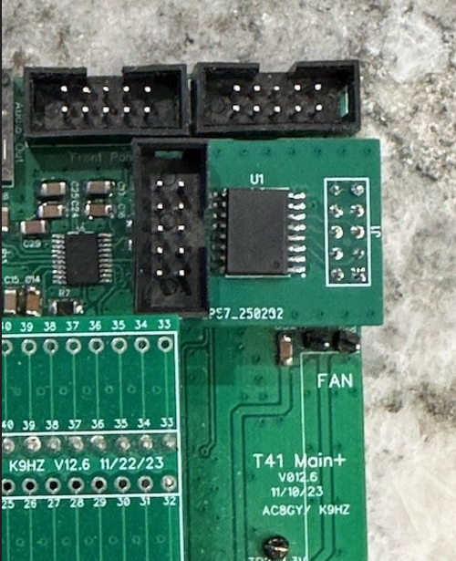

Then plug your display cable into the Display Driver board in the same orientation that it was plugged into the connector on the MAIN board.

IF, however, your DISPLAY connector is on the BACK side of the MAIN board, then plug the Display Driver board into the DISPLAY connector on the back side of the MAIN board. Then plug your display cable into the Display Driver board in the same orientation that it was plugged into the connector on the MAIN board.

Your display should now function without hanging and incomplete graphics. The 220 ohm resistors on the main board in the SPI control lines… R4 and R5 can be replaced with 0 Ohm resistors if your display still displays incomplete graphics.

