T41 Calibration Features

The T41 Calibration comprises 5 major steps:

1. Frequency Calibration.
2. Transmit IQ optimization.
3. Receive IQ optimization.
4. CW Power Level.
5. SSB Power Level.

For the best results, these steps should be performed in that order, starting with frequency calibration using WWV or other signals.

T41 Frequency Calibration

The frequency calibration routine sets the T41 internal reference clock to within a few Hz of the US NIST broadcast at 2.5 MHz, 5 MHz, 10 MHz, 15MHz and 20 MHz under the call sign of WWV. To simplify the calibration process, two new features are used; SAM AM detection and Direct Frequency input to set the T41 receive frequency. More about that after we describe the overall frequency calibration process.

T41 Frequency Calibration Process

The T41 clock generator depends on a 25MHz crystal to create accurate and stable frequency readout and transmission. One must calibrate the T41 clock using a standard frequency source as a comparison in order to achieve accurate tuning. It is normally desirable to have a receiver frequency readout accurate to a few Hz. Even a 50 Hz inaccuracy is objectionable in SSB transmissions. To put this in perspective, a 0.1% difference in a 14MHZ signal is 14 KHz. 10 Hz accuracy is within 0.00007%! There are two parts to achieving good frequency accuracy:

1. Access to an accurate frequency reference source
2. The ability to actually measure the difference between the reference and the T41 displayed frequency

Accurate frequency sources are readily available in the form of modern digital signal generators, standard sources such as Rubidium Frequency Standards, or on-the-air sources such as WWV in the USA and similar radio time/frequency services around the globe.

WWV broadcasts a variety of frequency and time signals on 5MHz, 10MHz and 15MHz, as well as others. WWV’s carrier is accurate to one part in 1014, which is many orders of magnitude more accurate than amateur radio requirements, or for that matter, it is much better than reasonably priced signal generators or affordable frequency standards. Needless to say, WWV or similar broadcasts are our preferred signal references.

That brings us to the second part of the frequency calibration process; how to measure the difference. There are many ways to accomplish this, such as zero beating the T41 output with the standard, using the SSB detector to create an off-tuned sidetone and measuring its frequency, or using the SAM PLL error signal as a guide.

Synchronous Amplitude Modulation Detection (SAM)

SAM is one of the best methods of achieving AM detection. The approach uses a Phase Locked Loop (PLL) to detect and replace the AM carrier with a steady carrier of constant amplitude. This eliminates one of the main causes of fading and garbled detection of AM signals. While most T41 users won’t be interested in shortwave DX, SAM has a major feature that makes it a very useful tool for accurate frequency calibration: a readout of the deviation in Hz of the tuning frequency of the T41 from the received WWV carrier signal. Basically, one adjusts the T41 clock until the deviation is as small as possible.

As part of the SAM detection process, the difference between the received signal from a source, such as WWV, and the internally generated frequency derived from the T41 clock is measured. The difference between the signal source (e.g., WWV) and the generated frequency from the T41’s clock is called the *error signal. The error signal* is calibrated in Hz and displayed on the screen. As the T41 clock is adjusted, the error signal is updated. For normal AM detection using SAM, the tuning can be a couple of kHz away from the received signal and SAM achieves good signal detection.

For calibration purposes, you tune in WWV or other known reference at its correct displayed frequency, and then use SAM to observe the computed PLL error. The T41 frequency calibration factor is then adjusted in real time to achieve minimum frequency error. It is possible to achieve an accuracy of several Hz in this manner. The long-term stability of the Si5351 crystal is reasonably good but is somewhat temperature dependent. We have found that, if the T41 is allowed to warm up for 10 to 15 minutes prior to calibration, the frequency tuning accuracy stays to within a couple of Hz or better over many hours, as long as the ambient temperature is reasonably constant.

Frequency Calibration Steps

To perform the T41 Frequency Calibration using WWV, follow these steps:

1. Select the Direct Frequency Input routine using the “user1” button ( #17).

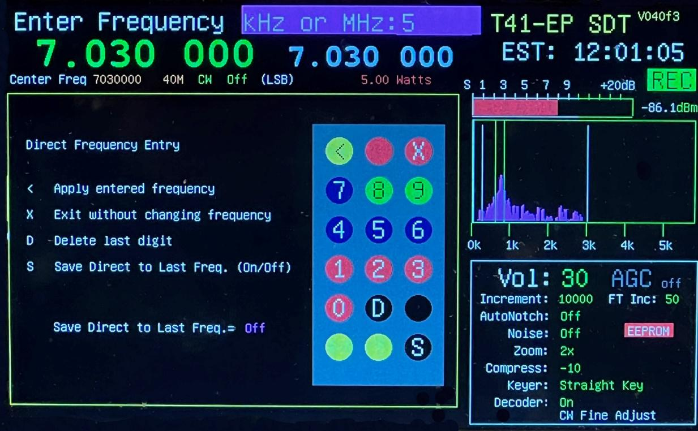Figure 1: Direct Frequency Input

1. Listen to the detected station signal to verify that WWV is actually tuned.
2. Now set the demod mode to SAM using the Demod pushbutton (#8).
3. Go to menu item ***Calibrate*** and select ***Freq Cal.*** Figure 2 shows theFrequency Calibrate screen.
4. Input the frequency of one of the WWV stations and press the “<” key as shown on the screen. For instance, set the Band to 40M and enter 5 for the 5MHZ WWV station. (Band selection must be high enough to allow the signal to pass through the low pass filter.) Figure 1 shows the Direct Frequency input screen. Press the Select pushbutton.
5. Above the spectrum display note the indicator (SAM) and the deviation readout. (See Figure 2.)
6. Using the Filter/Menu encoder, adjust the frequency calibration factor (displayed in the header) to achieve a minimum value of the SAM frequency error. A value of 1 or lower should be achievable.
7. Note the Freq Calibration value for future reference.
8. Press Select to store this value in EEPROM.

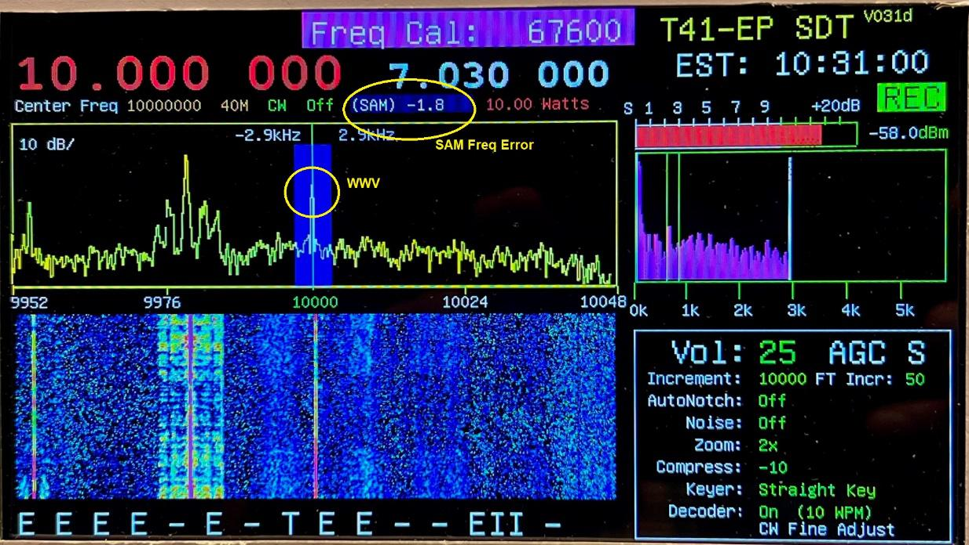Figure 2: Frequency Calibration Screen

The T41 is now calibrated to within a few Hz and the unit is ready for the next step.

In the event that WWV is not available, any known accurate station can be used, or an accurate signal reference source, such as a Rubidium Frequency standard can be substituted for WWV. Just use a sufficiently low-level signal of no more than 1mV as input.

I/Q Receive and Transmit Calibration

The T41 uses quadrature detection and modulation to achieve demodulation of SSB and AM signals and to create SSB and CW transmission signals. It is necessary to have accurate phase shifts and equal I and Q signal levels over the frequency range of 3 MHz to 30 MHz to achieve minimum alias or “ghost” signals. These ghosts appear either as mirror images of the signal around the central DC display in the case of Receive, or as adjacent sideband signals for SSB and CW transmission. A one-time IQ calibration procedure is necessary to account for gain differences and phase shifts in the I and Q analog circuits as a function of frequency. The calibration is performed in software for each band and receive/transmit mode. This results in a matrix of 28 parameters (four for each of 7 bands).

For Receive calibration, a steady signal within the band of interest is required. One way of doing this is to use a signal generator at the T41 antenna input. Another is to use the T41 Exciter to generate that signal. We have provided a means for T41 internal signals to be used, eliminating the need for an external signal generator.

For Transmit calibration, the required signals can be generated in software and output to allow observation of the signal spectrum. This, of course, requires access to either a spectrum analyzer or a receiver with a band scope frequency display. Alternatively, the T41 spectrum display can be used to observe the sideband created in the quadrature modulation process. This requires a special connection arrangement and a software routine that processes Receive and Excite functions simultaneously.

**Modification of the QSD Board**

The version V010/V011 QSD boards require a simple modification in order for the calibration process to work. This modification changes the enable signal to the Tayloe demodulator chip to be ON at all times. Version SDTVer050 software (and higher) control receiver enable via the Si5351 PLL IC (receiver LO is disabled during transmit).

A trace on the QSD PCB is cut, and a 0Ω jumper is added to the circuit. See Figure 3.

The modification allows the Receive circuits to operate at the same time as the Transmit circuits. This requires breaking a trace on the receive board and adding a shunt 0Ω resistor as shown in Figure 3.

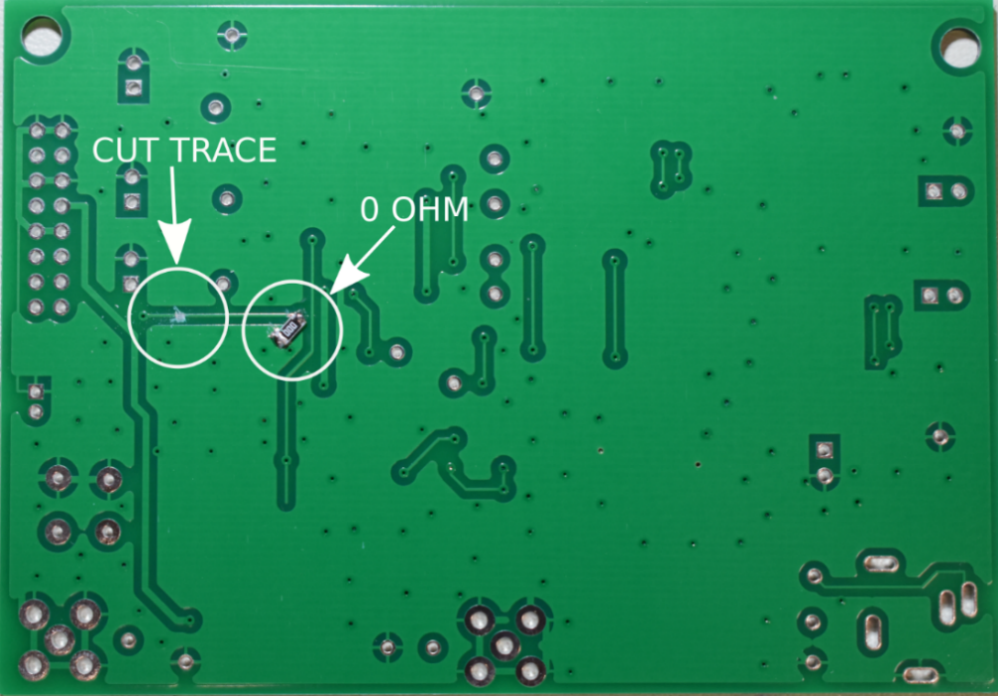

*Figure 3. QSD board modifications (V10 and V11 boards).*

Coaxial Configuration for Calibration

A temporary routing of the coaxial cables is required during calibration. Also, a 20 dB SMA attenuator is required.

The re-routing of the coaxial cables is performed as follows. Remove the cable from the input of the Power Amplifier; this is the RF output of the QSE. Remove the cable from the receiver connector on the Filter board; this is the RF input of the QSD.

Insert a 20 dB attenuator between the QSE output cable and the QSD input cable. Refer to the image below which shows the temporary cable routing. (See Figure 4.)

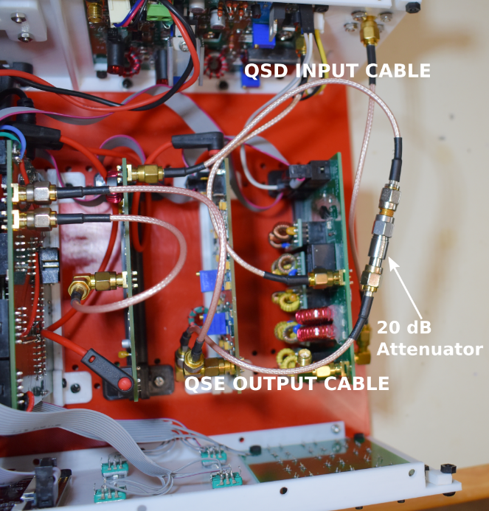

*Figure 4. Insertion of attenuator.*

Transmit Calibration

To perform T41 Transmit Calibration follow these steps:

1. Route the output QSE and input QSD cables together with a 20 dB attenuator inline.
2. Select the band to calibrate.
3. Set the T41 mode to CW. (The CW Mode indicator can be seen in the Band Info, just below the last three zeros in the VFO A frequency.)
4. Select ***Calibrate*** from the menu and select ***Xmit Cal.***
5. The display uses the 4X zoom, as shown in the Information Window in Figure 5. The main signal component is now 3 kHz away from the center, in the demod window. The adjacent sideband component is on the other side of center, also 3 kHz away from center. Figure 6 shows the display in USB mode.

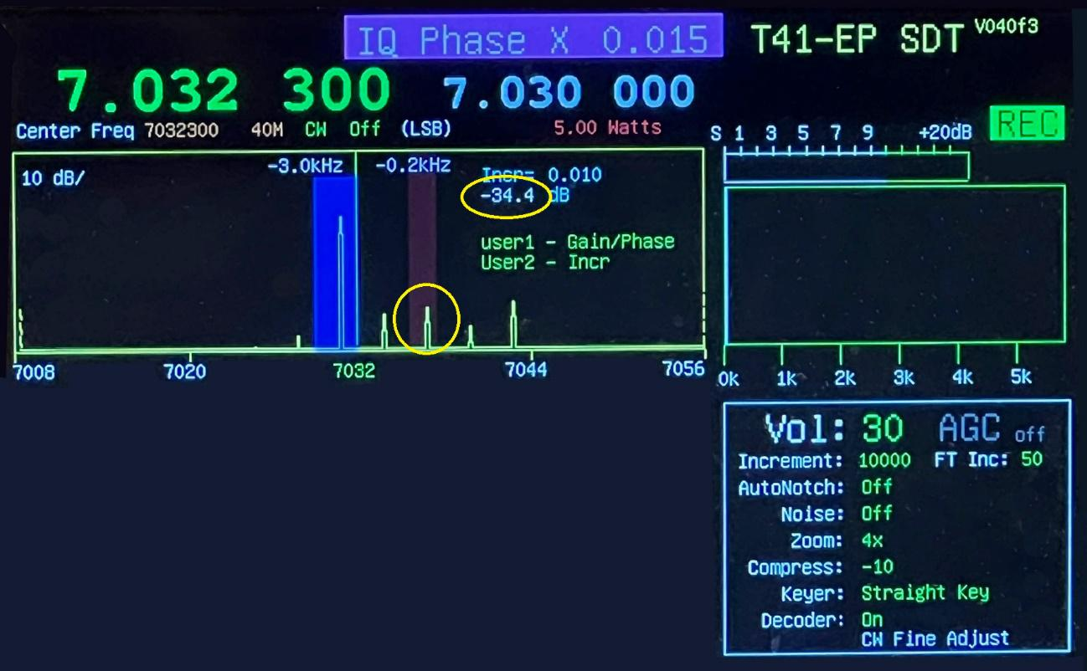

*Figure 5 Transmit IQ Calibration Screen (LSB)*

1. Use the Filter/Menu encoder to minimize the alias amplitude (i.e., the number seen in the Amplitude circle in Figure 5.)
2. Once the alias is as low as possible using the Gain adjustment, switch to the Phase adjustment by pressing the “User1” button (#17). Again, adjust for the lowest alias amplitude. The increment value (i.e., the number just above the Amplitude value in Figure 5) can be toggled between 0.001 and 0.010 using the “User2” button (#18) to give you more control over the rate of change in the Amplitude number.
3. It is necessary to go back and forth between Gain and Phase to achieve the best minimum. Once the best minimum is achieved, press the Select button to save the values to EEPROM
4. Repeat for all bands.

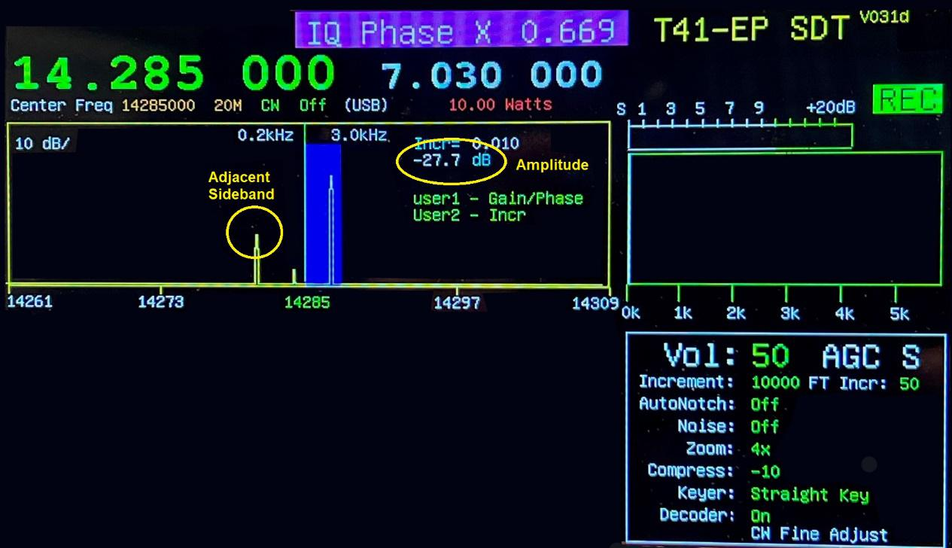Figure 6: Transmit IQ Calibration Screen (USB)

Receive Calibration

The cable connections are the same as before, but the display is different.

1. Using the same settings as for transmit, select ***Rec Cal*** from the ***Calibrate*** menu.
2. The display uses the 1X Zoom and has several readouts and a main frequency component 24KHz above the center for LSB. There is another component at 24KHz above the carrier in a red window. The circled Alias in the red window in Figure 6 is the alias we are attempting to minimize.

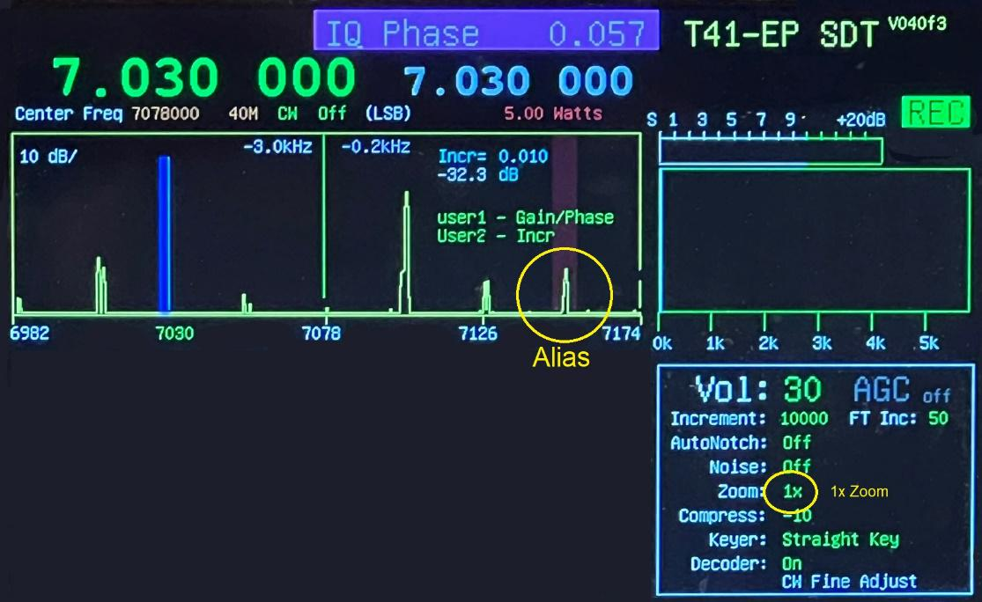*Figure 7. LSB IQ Receive Cal screen*

1. The display uses the 1X Zoom and has several readouts and a main frequency component 24KHz above the center for LSB. There is another component at 24KHz above the carrier in a red window. The circled Alias in the red window in Figure 6 is the alias we are attempting to minimize.
2. For USB, the positions are different, as shown in Figures 6 and 7..
3. To perform the Receive IQ calibration, follow similar steps as in the Transmit case.
4. Once the best minimum is achieved, press Select to store this value in EEPROM.

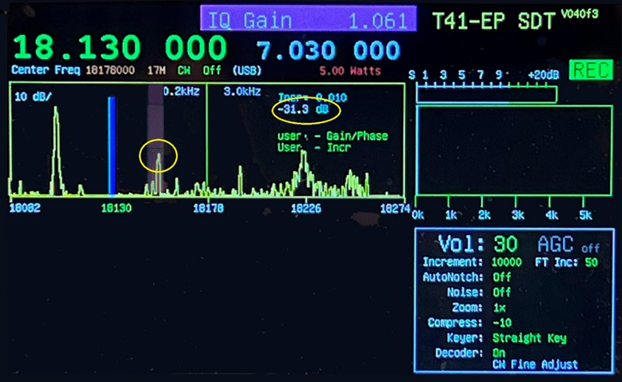

*Figure 8. USB IQ Receive Calibration screen*

1. Repeat for the other bands*.*

**When all bands have been successfully calibrated, move the QSD and QSE cables back to their normal positions.**

Power Output Calibration

Because the T41 RF power output varies by band and to account for differences between individual unit performance, a provision to calibrate the power output by band in CW and SSB modes is provided. The T41 should be connected to a dummy load and an accurate RF power meter should be used to measure the output power level. If you do not own a power meter, ask at your club meeting if someone has one you can borrow. If that fails, high school, junior college, and college/university Physics labs or EE departments may have one. You should make it clear you are a licensed amateur radio operator. You may have to take your T41 to their lab, but that’s better than buying a power meter.

Power calibration is done in two parts – CW and SSB for each band.

To use the Power Output Calibration feature, first go to *RF Set* menu option and select *Power Level*. Set the *Power:* to *5* or *10*. This is the power output setting in watts.

CW Power Calibration

1. Set the Mode to CW using the Mode pushbutton (#9) and select the band of interest. In *CW Options*, set the *Key Type* to *Straight Key.*
2. In the Calibrate menu option, select *CW PA Cal*. Plug in your Straight Key. Key the transmitter and write down the average power out.
3. Release the Key and change the setting to increase or decrease the power level setting to give a 5 or 10W output depending on the Power setting (referenced above). Note that you should read the power output from the power meter connected to the T41, *not* the CW PA Cal number shown in Figure 8. Repeat until the output is 5 or 10W. Figure 8 shows the CW PA output Cal screen.

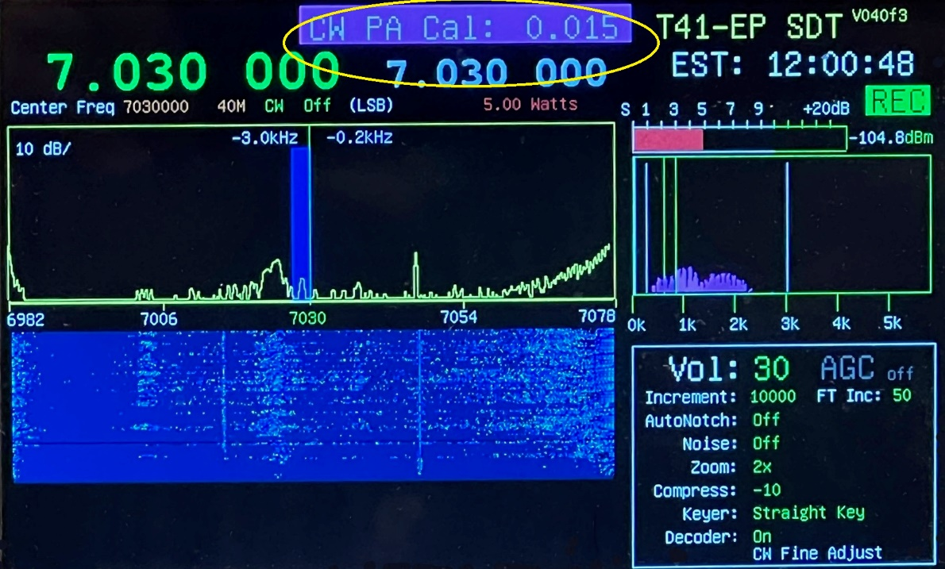Figure 9: CW Power Amplifier Power Calibration

1. Repeat for the other bands.

**SSB Power Calibration**

The SSB power calibration can be done here or at the end of the calibration process. Again, note that the steps must be done for each band.

1. Next set the Mode (#9) to SSB and select the band of interest.
2. In the *Calibrate* menu option, select *SSB PA Cal*. Plug in your mic and PTT switch. Key the mic and write down the average power out with a normal speaking voice and mic position.
3. Release the PTT
4. Note that there is a separate *Mic Level* menu setting. If your output is considerably different from the CW output, you may wish to change the Mic gain before setting the SSB Power Cal.
5. Change the calibration setting to increase or decrease the power level.
6. Continue this process until a satisfactory power level for a normal speaking voice is achieved.
7. If possible, monitor the power output waveform to ensure that clipping is not occurring. If that happens, reduce the mic gain, and recalibrate the SSB power out. Note that a rig with a panadapter/waterfall display can be used as a rough indicator of signal quality.
8. Repeat for the other bands.

*This completes the T41 power output calibration process.*

T41 Frequency Stability

A 12-hour frequency stability test was performed using the SAM output as a gauge of stability. The T41 was first warmed up for a couple of hours and then the Si5351 clock was calibrated to better than 1 Hz compared to the 5MHz WWV signal. Figure 10 shows the results; plotting the SAM frequency error signal versus time at 5-minute intervals. Obvious outliers caused by signal 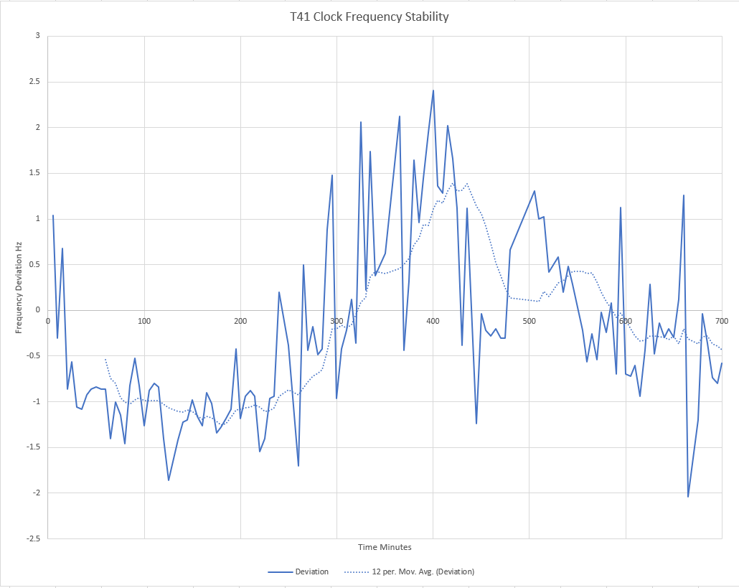

*Figure 10. Frequency Stability*

loss were excluded. Over the 12-hour test period, the frequency was maintained to within about +/- 2Hz at 5MHz. Good enough for government work.

After Calibration is Finished

Let’s be honest: Calibration is something you only want to do once. Alas, things can and do go wrong so we want to preserve your calibration work as best we can. There are two things we would suggest you do once you complete the calibration of your T41.

Backup EEPROM Data to SD Card

One of the Main Menu options is EEPROM. A secondary EEPROM menu option is Copy EEPROM 🡪 SD. This option simply copies the EEPROM data, which now includes your unique calibration data, to your SD card. While we haven’t “required” T41 owners to install a micro SD card in the Teensy SD cardholder, it could be the best $5 insurance policy you can buy. We encourage you to install an SD card and immediately use the EEPROM copy option to move that EEPROM data to the SD card.

However, things can still go wrong. Mr Murphy could decide to arrange a power failure right in the middle of that EEPROM save and corrupt the SD data. If you’re really unlucky, it might blow the Teensy at the same time! Therefore, we also encourage you to do a small modification to the EEPROM backup code.

Modify EEPROM Defaults Code

The is a function named *EEPROMSaveDefaults2()* in the EEPROM.cpp source code file. The purpose of the function it to store default data values in the EEPROMData object. These default values were selected because they contain values that are “close enough” to allow the T41 to function. They are not ideal values for your system because all of the components in your T41 is quite likely different than the ideal values for my system.

Because your system is now calibrated, it’s pretty much set up using values that enables it to perform at its best. What you should do is substitute your post-calibration EEPROM data for the current default values. This means it performs at its best using *your* data, not ours.

Altering the default data is easy. However, before doing anything, copy the exiting T41 source code project files to a backup place, just in case Murphy’s hiding somewhere close by. Once that’s done, just follow these steps:

1. Using the Arduino IDE, load the SDT project source code into the IDE.
2. Click on the MyConfigurationFile.h tab to load the header file into the IDE’s Source Code Window. If you don’t see the file listed in a tab at the top of the Source Code window, click the ellipsis (…) at the end of the tabs at the top-right and click the file from the dropdown list.
3. Line #3 should be uncommented so it looks like this:

#define DEBUG

This turns on some debug information after the next compile.

1. Click the Serial Monitor Icon at the top right of the IDE, just above the ellipsis.
2. Compile and upload the code. The T41 software is now running in debug mode.
3. The program now automatically display the contents of the *EEPROMData* object just below the Source Code window. You may have to click on the Serial Monitor link to see the output.
4. Scroll to the start of the EEPROM data dump using the scroll bar at the right edge of the Serial window.
5. Click on the EEPROM.cpp source code tab. This moves the EERPOM source code into the Source Code window.
6. Look for the *EEPROMStoreDefaults2()* function. It should be somewhere around line 1056. (You can also type Ctrl-F and type in the function name to find it.)
7. Note how the EEPROM code in the Source Code window shows the default values *we* choose, but the EEPROM data in the Serial Output window is *your* data. Change the values in the Source Code window to your values from the Serial Output window. Take your time.
8. When you’ve finished, scroll through the list to check your work. When you’re satisfied that the Source Code window now contains your values, compile/upload the code to your T41.
9. That’s it. Now if you ever have to restore your T41 to its default values, you’re using values that define *your* system, not ours.

Conclusion

This completes the calibration and backup process. Now enjoy the fruits of your labor!