**T41 BPF Assembly Manual**

**Version 1.00 – March 17, 2024**

**WJ Schmidt - K9HZ**

**INTRODUCTION**

The new T41 V12 BPF is really a general-purpose band-pass filter that can be used by all SDRs and SDTs as a preselector on receive, and as a true band pass filter on transmit. There are filter sections on the board for 160M, 80M, 60M, 40M, 30M, 20M, 17M-15M, 12M-10M, 6M, and BYPASS. There is no requirement to build out all filter sections if you intend on a subset of the available bands. The filters are selected using I2C communication and provide over 50dB of isolation on harmonic multiples, and better than 40dB on adjacent bands. Integrated logic is used to switch the BPF from the receive “antenna to receiver” path to the transmit “low power exciter to PA” by pin 1 of J4, the “BANDS” connector. BPF boards are sold individually, as part of the T41 V011 upgrade to V12 kit, and as part of a new T41 V12 radio board set. Figure 1 shows the BPF PCB.

*Figure 1. V112 Band Pass Filter Board.*

The callouts in Figure 1 show how the board accommodates either SMD toroid (i.e., wire-wound) inductors. In the figure, inductor L204 (3.9µH) can be either a 1206 SMD inductor or a toroid core with the appropriate number of windings.

**THEORY OF OPERATION**

1. **Power.**

Board power is 12VDC provided by a connector placed on the back side of the board. A 3.3V regulator provides voltage for the remainder of the parts on the board. Total power draw is on the order of 12ma.

1. **I2C addressing and switching.**

The BPF board is completely controlled via I2C communications. A MCP23017 16 bit I/O expander is used to communicate with a central processor (not provided) via SCL and SDA serial lines brought in through pins 7 and 5 of the J4 the “BANDS” connector. The I/O expander has hex address 0x24, and the user can select any of eight chip addresses from “000” to “111” shorting the solder switches provided (nb. the address of the expander for the T41 V12 primary receiver BPF address is “100”… so the solder switch on the board for A2 at JP4 should be filled and the rest left blank). See the following for more information: <https://github.com/DRWJSCHMIDT/T41/blob/main/T41_V012_Files_01-15-24/T41_V012_Design_Documents/T41_V12.6_I2C_Assignments.xlsx>

Two eight-bit words written by the external processor to the I/O expander to activate the expanders output lines to select the filters. Only one filter (or BYPASS) should be selected at a time even though multiple filters could be theoretically selected. The I/O expander has two output ports, designated GPA0-GPA7 and GPB0-GPB7. Writing a “1” to these locations selects the filters and the TX or RX switched paths. The truth table for this is:

*Table 1. Truth table for band selection.*

The BPF is switched into the TX path when pin 1 of J4 the “BANDS” connector is HIGH (=3.3V), and in the RX path when pin 1 is LOW (=0.0V).

All RF switching is accomplished using MASWSS0179 SPDT switches. Opposite switch polarity is accomplished using SN74LVC1G04DCK signal inverters.

1. **Filter Design.**

Each of the individual filter sections were designed using ELSIE as five section, ten pseudo pole, shunt-input Chebyshev filters as seen below (example for 160M):

*Figure 2. Chebyshev filter for 160M.*

The filters are designed for 50 ohms input and output, and have very tight bandwidths as can be seen in the transmission plot (160M) below:

*Figure 3. Filter response.*

The design files and plots for all filters can be found here: [T41/T41_V012_Files_01-15-24/T41_V012_BPF_Design_Files at main · DRWJSCHMIDT/T41 (github.com)](https://github.com/DRWJSCHMIDT/T41/tree/main/T41_V012_Files_01-15-24/T41_V012_BPF_Design_Files)

**CONSTRUCTION**

Begin by deciding how many of the filter sections you will build. For those sections, the inductors can be EITHER hand-wound T-37 sized toroids, or 1206 SMD sized fixed inductors, as shown in Figure 1. Either approach gives good results. Two capacitors are stacked together in some cases to get the required value for the filter section (i.e., a single inductor of the required value is unavailable or hard to find). Soldering stacked capacitors is not difficult… place one on the board first, solder it on both ends, and then solder the stacked capacitor on top of the soldered capacitor… soldering it in place as if it were being placed directly onto the board. That is, the two inductors are “piggy-backed” on one another.

Inventory all parts for your BPF. Print out the BOM and check them off so you know if something is missing. The BPF can be found here: <https://github.com/DRWJSCHMIDT/T41/blob/main/T41_V012_Files_01-15-24/T41_V012_BOMs/T41_BPF_Board_BOM_V12.6_03-09-24.xlsx>

1. **Switches and Inverters first (top).**

Place all of the MASWSS0179 switches ( U1, U3, U4, U6, U7, U9, U10, U12, U13, U15, U16, U18, U19, U21, U24, U25, U27, U28, U30, U31, U36) on the top of the board first. Place the SN74LVC1G04DCK parts (U2, U5, U8, U11, U14, U17, U20, U23, U26, U29, U37) at the same time.

**NOTE:** Jack made the mistake of putting the bypass caps on first, which meant that many of the MASWSS0179 switches were sitting between bypass caps. As a result, even with careful heating with the hot air gun, some caps slid out of place while heating the pads for the switches. Don’t make the same mistake.

**NOTE 2:** It is difficult (for old people?) to read the reference dot that indicates where pin 1 is on the MASWSS0179 switch chips. Jack said he was almost never sure he saw the reference dot, but could usually see the numbers printed on the top of the chip. Jack’s experience is that, if you can read the chip numbers, pin 1 is one the lower-left of the chip as you read it. It’s a good idea to check that you mounted the chip properly on the board. A simple test is to check for continuity on pin 2 of the chip and a ground post of an SMA connector near the middle of the PCB or one of the mounting holes. (See Figure 1.)

1. **Diodes and Resistors (top).**

Place diodes D1-D4 and the three resistors R1, R2, and R3 on the board top. Watch the polarity of the diodes… the bar can be hard to see. The white bar should be on the left side of the diode as the board sits with the two mounting holes at the bottom. Now is a good time to select the address for the I/O expander too. Place a solder blob to make the associated address line a “1” (for the T41 project, that would be JP4 or address line A2 only for the primary receiver).

1. **Capacitors (top) and the Processing Known as Stacking.**

Place top-side capacitors. There are 119 SMD capacitors to place if you elected to build the entire BPF.

**Note 1:** The values selected for the capacitors used on the filter board are fairly precise values. Using other (close) values will cause the filter’s performance to degrade somewhat. This often causes a problem because manufacturers don’t produce that exact value. For example, consider C93, which is found in the 160M leg of the filter. Its value is 580pF, which is a value most companies do not produce.

Now look at the BOM for the BPF board. You will not find an entry for C93. However, you will find entries for C93a (330pF) and C93b (250pF). Because capacitance for capacitors wired in parallel is additive, the value for the stacked pair is equal to the sum of their individual values. Connecting these two capacitors in parallel yields the desired value of 580pF. Creating this value is done by a process call “**stacking**”, where one capacitor is mounted on the board in the normal fashion and the second capacitor is “stacked” on top of the first and soldered to the capacitor on the bottom. In Figure 4, the two stacked caps are soldered into position C93:

*Figure 4. Stacked capacitors.*

It’s a little hard to see in Figure 4 that there are two caps, one on top of the other. The stacking was done by applying small amounts of solder paste to the C93 pads, placing the first cap in place and using the heat gun to solder in place. I applied two additional dabs of solder paste on the capacitor ends. The cap was still warm enough to melt the paste. I then placed the second cap on top of the first and used to heat gun to solder it firmly in place. Figure 4 is the result.

*Figure 5. Stacked SMDs.*

Figure 5 is a drawing of two stacked SMD caps like those shown in Figure 4. Note there are a number of things that can go South when stacking SMDs. First, the bottom cap in the stack might not have a good connection to the PCB. Second, the top cap might not have a good connection to the bottom cap. Third, there might be too much solder between the two end

caps, thus shorting out the endpoints A and B. You should check each stack for these possibilities. It takes a minute to check for these possible errors, but doing the check now is a lot easier than doing it with a completed board.

First, set your DVM for a continuity check between points A and B in Figure 5. There should be no continuity. If there is continuity, it’s likely because of too much solder was used when stacking them. Unsoder the top caps and remove the excess solder. (Solder wick makes this pretty easy.)

Next look at the schematic for the board and see where points A and B connect to the board. Perhaps point B connects to GND and point A connects to one lead of cap C12. Now touch one probe to point B and the other probe to a GND point (e.g., a ground lug for one of the SMA connectors). There should be continuity. This tells you two things: 1) point B is properly grounded, and 2) the two caps are soldered together. Now move one probe to point A and the other probe to the pad for C12. There should be continuity. (You may have to switch to the other pad if it’s not clear from the schematic.)

**The Bottom.**

Place parts on the bottom of the board. Turn J3 so that the wires enter the connector from the top. TP15 can be placed on either side of the board… your choice.

1. **SMA connectors (top).**

Mount two SMA RF connectors on the top (or bottom if you prefer) of the PCB and solder them into place. If you are using the BPF with a V12 radio, populate connectors J1 and J2 and solder shut the jumpers JP10 and JP11. If you are using the BPF with a V11 radio, instead populate the J5 and J6 SMA connectors. You don’t need to populate both sets of connectors.

1. **Stop and test!**

This is a good point to stop assembling and test whether board control is working. We will test whether we can connect to the board via I2C and whether the RF switches are working correctly. This test setup requires the T41 main board to be populated and working, or you can use a spare microcontroller if you feel up to the challenge. The sketch we will use can be found on GitHub at this address:

<https://github.com/DRWJSCHMIDT/T41/blob/main/T41_V012_Files_01-15-24/T41_V012_Software/T41_V12_Software_For_Board_Testing/V12_BPF_Board_Test/BPFTest/BPFTest.ino>

Connect the T41 main board’s BANDS connector to the BPF board, load this sketch onto the Teensy, monitor the serial port, and power up the BPF board. If the I2C connection to the BPF board is working you should see the following menu in the serial monitor terminal:

Current state:

BPF Band: BYPASS [0b1000]

Select option and hit enter:

N - Select BYPASS

6 - Select 6M band

10 - Select 10M band

12 - Select 12M band

15 - Select 15M band

17 - Select 17M band

20 - Select 20M band

30 - Select 30M band

40 - Select 40M band

60 - Select 60M band

80 - Select 80M band

160 - Select 160M band

This means that the Teensy is able to connect to the BPF board and is ready to receive commands to control the band. If the Teensy is unable to connect to the BPF board, you will see the following message instead on the serial monitor:

BPF MCP23017 not found at 0x24

Check whether you have soldered the A2 address selection jumper closed, whether the board is powered, and whether the cable between the Teensy’s BANDS connector and the BPF board is working. If you still can’t connect then there is most likely a solder bridge on U35 – check it carefully under a microscope.

Next we will use a NanoVNA to measure the passband between the input/output SMA connectors and the inputs/outputs of the filters. Set up the NanoVNA with coax cables on both ports. On the receive port, add an SMA connector to which you have soldered two short lengths of wire as shown in this picture.

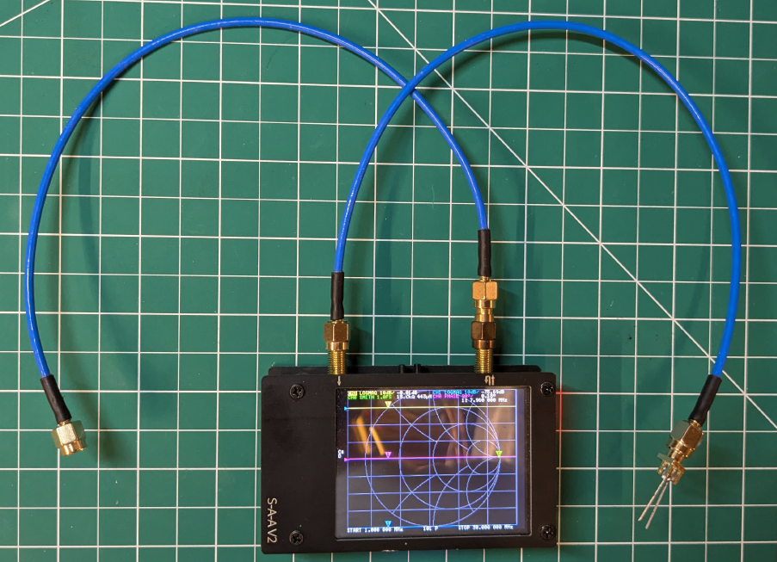

Start by testing the “input”. Connect the transmit/receive coax cable to J2 and put the probes of the receive coax cable into the thru holes for L91 (first inductor in the 160m filter) as shown in the photo below.

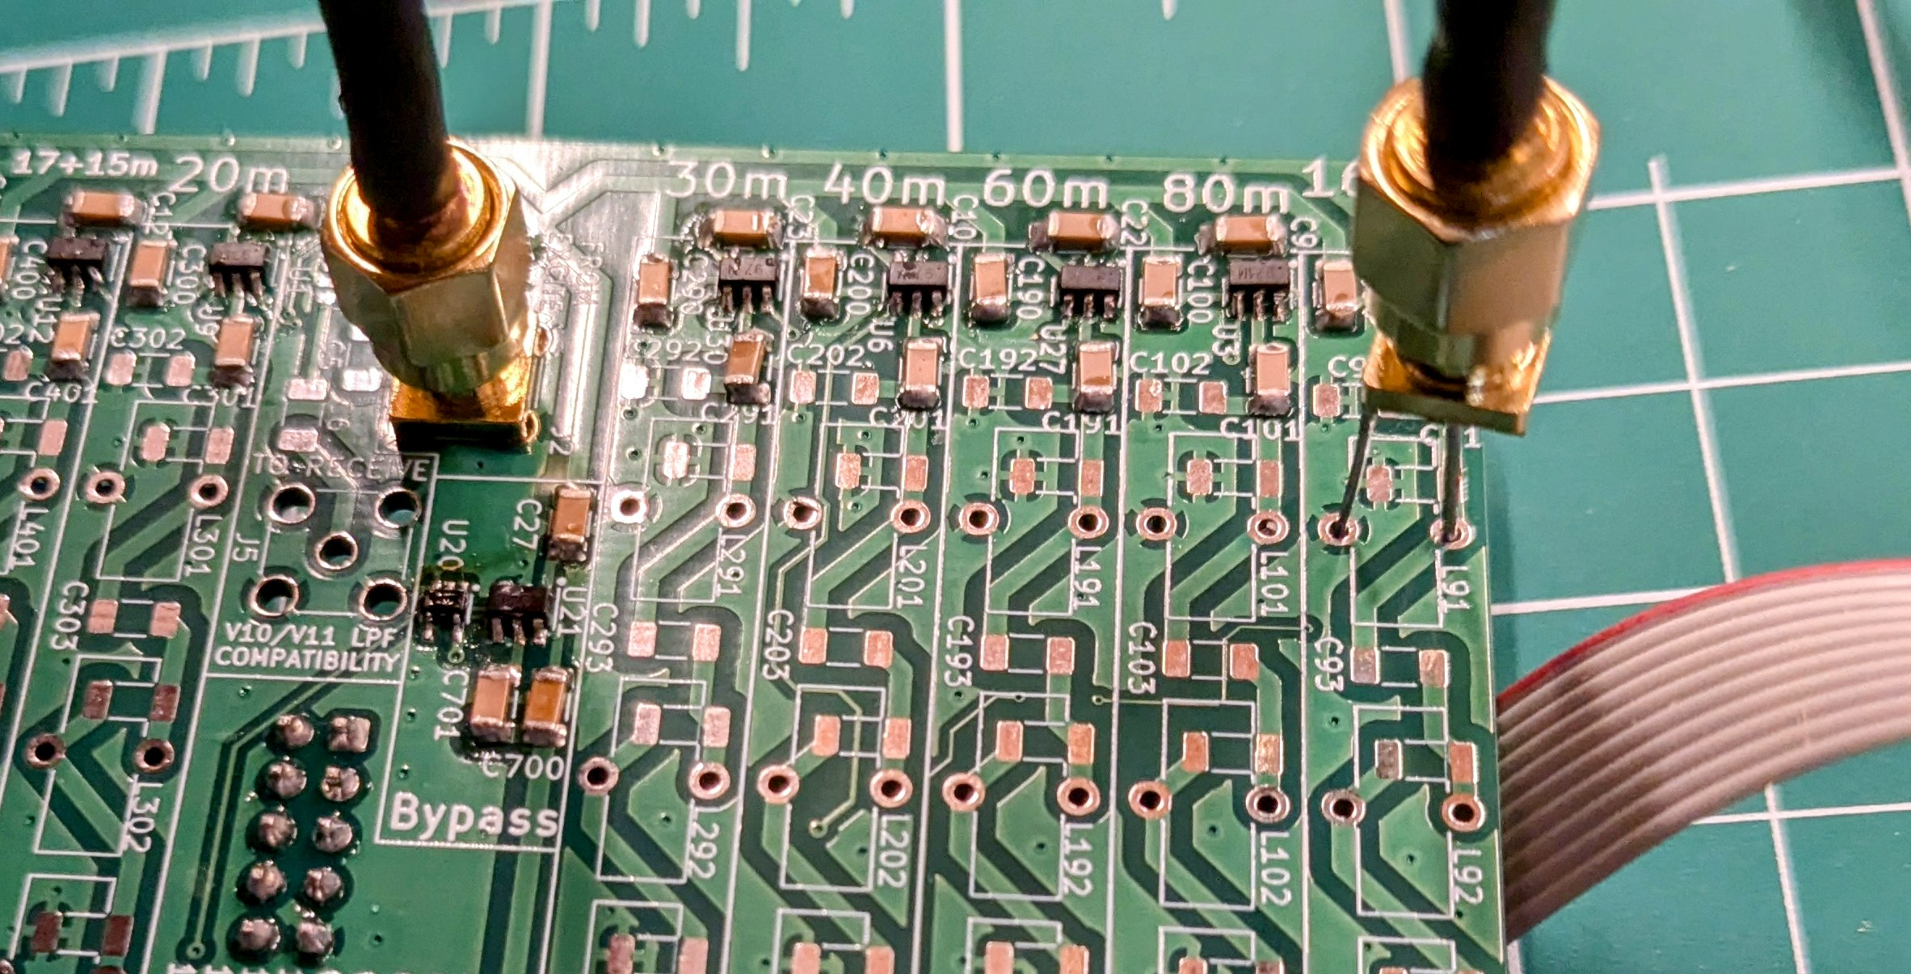

In the serial monitor window of the testing routine, send the command “160” to the BPF to select the 160m filter. You should see the measured response on the VNA change from the first picture below to the second picture.

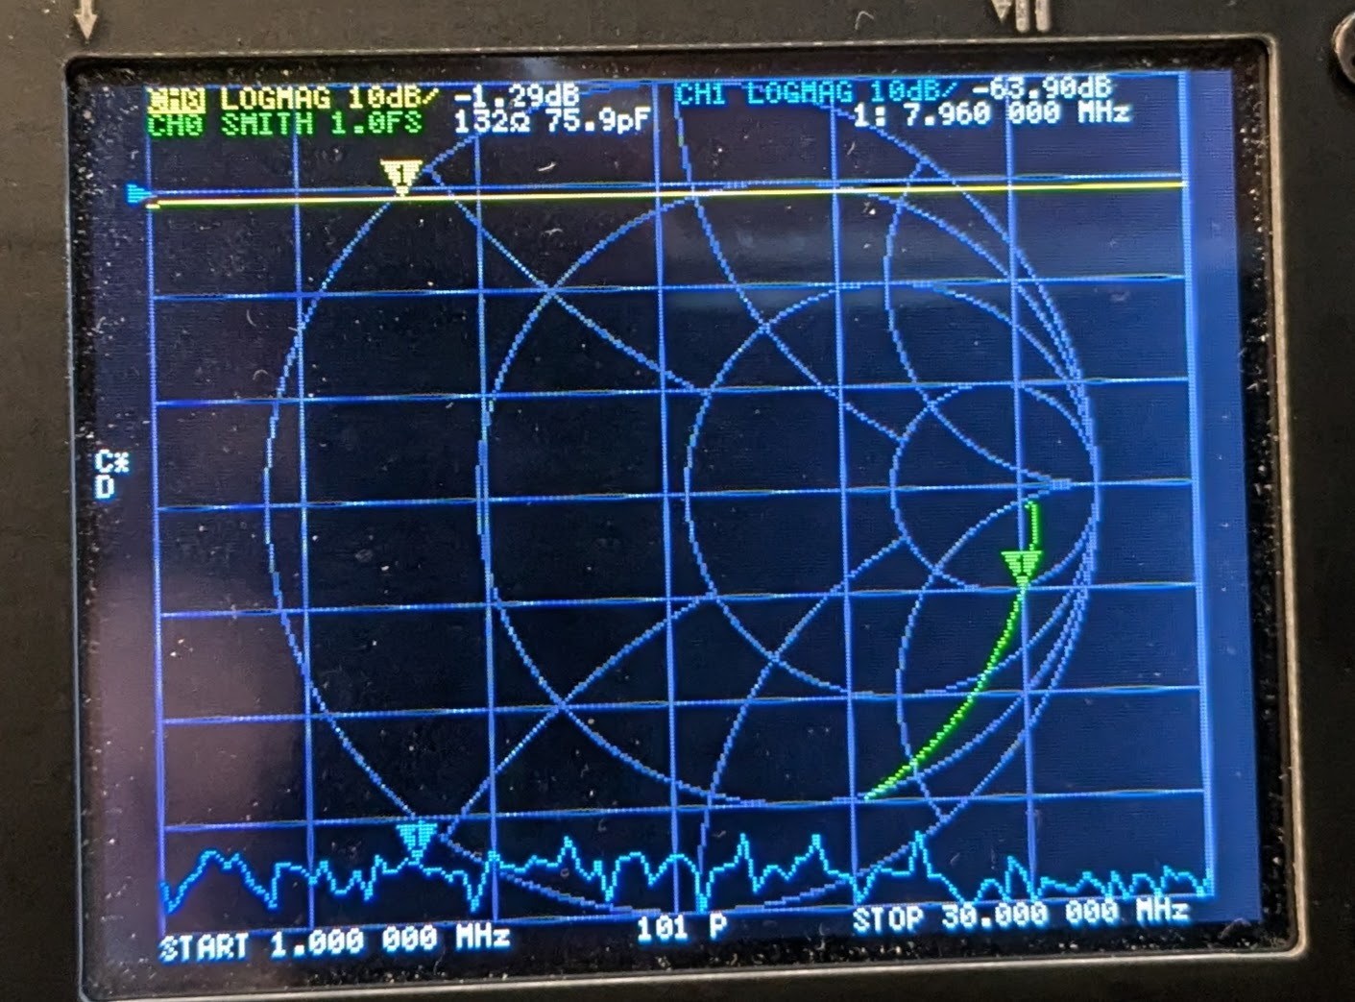*Measured response before the 160m filter is selected*

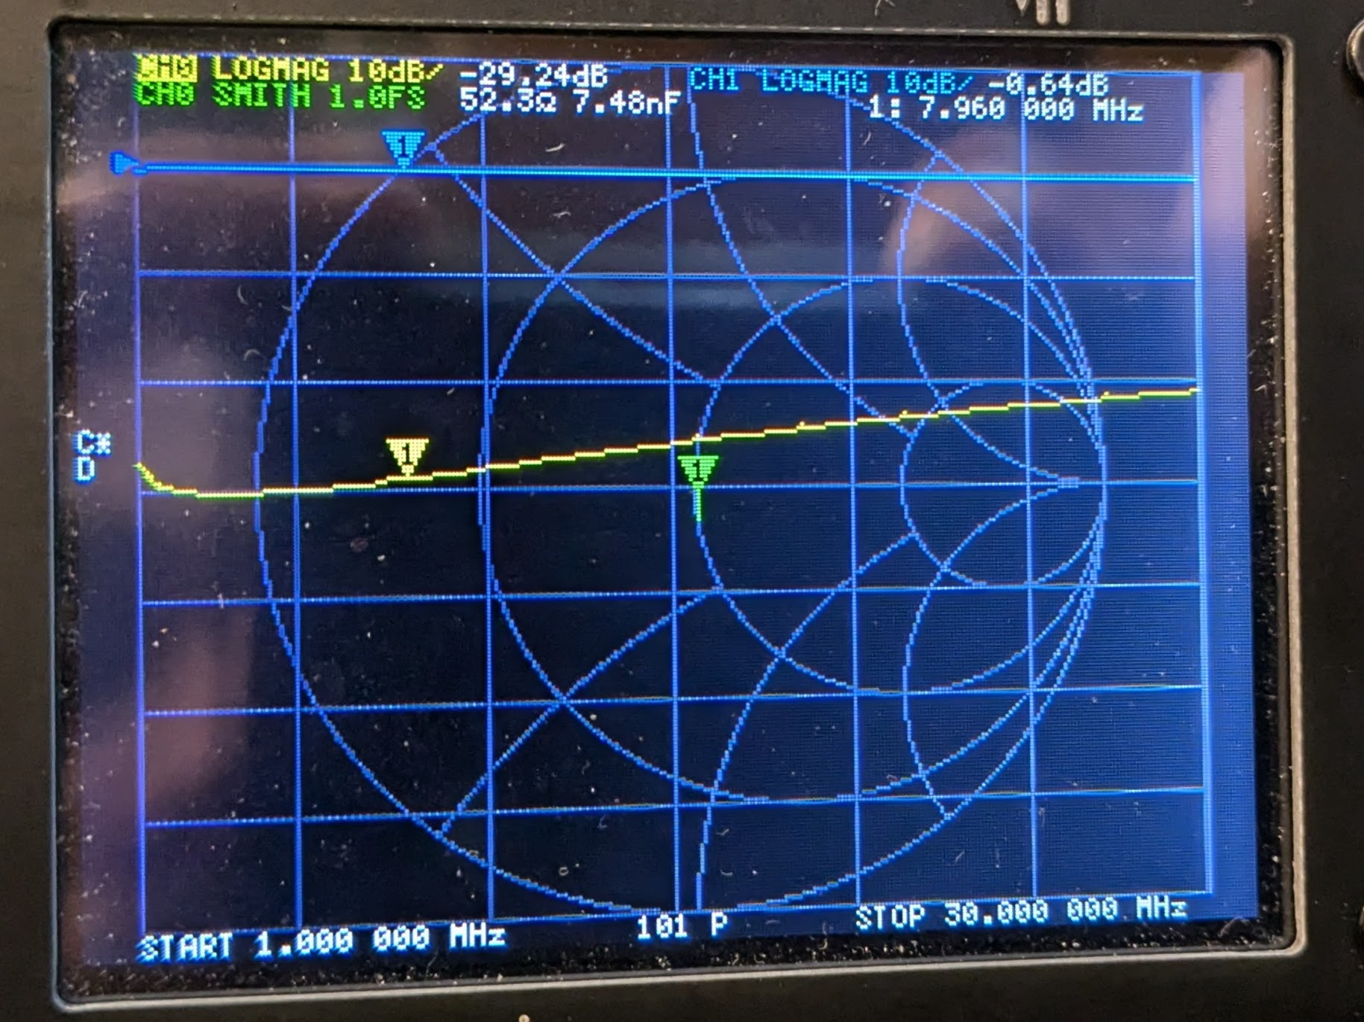*Measured response after the 160m filter is selected*

Repeat this measurement for all the other filter bands. If the amplitudes of S21 and S11 are not roughly -0.6 dB and -25 dB respectively, then you have a solder bridge or other soldering issue on that RF switch or inverter chip.

Then, switch the transmit/receive coax to the J1 connector and repeat this measurement method on the other side of the board.

Finally, connect one coax connector to J1 and the other to J2 and confirm that the BYPASS mode works correctly – you should get S21 between J1 and J2 of roughly -0.8 dB in BYPASS mode. Once this is complete, proceed with the inductor assembly.

1. **The Inductors (top).**

If you are using SMD 1206 form inductors, simply put the indictors in the spaces provided. For using toroids, the winding information is on the BOM. Cut the length you need, making sure there are no “kinks” in the wire. Now “stretch” the wire by holding both ends with pliers and gently pulling on the ends.

There is no right or wrong way to wind the toroids. Just wind them so that the wire is spread out over the entire space of the core. The finished toroid should look similar to Figure 6.

*Figure 6. Finished toroid*

You can make things easier by using special low melting enamel wire… so that you can simply tin the end of the wires on the toroid with a hot blob of solder… the enamel burns off and leaves bare copper that tins with the solder (wire that comes in the kit from KitsAndParts is this kind of wire). I usually wind all of the toroids before placing them. You can print out the PCB from the PDF file in the Github and place them on the paper in their spots for safe keeping.

**The Crochet Hook Method**

Using a crochet hook to wind the toroids makes it an easier task. This video:

<https://www.youtube.com/watch?v=F5wRoLYjrG4>

shows winding a trifilar toroid, but a single wire uses the same technique, but is even easier to do. If you lose count, take a picture with your phone and count the turns on the image. If that fails, save the image on disk, load an image editor (e.g., Paint), increase the size of the image, and count the turns.

If you haven’t done so already, you need to remove the insulating enamel coating on the wire if non-melting insulation is used. You can scrape it away with a sharp blade (e.g., box cutter). Just be careful not to nick the wire. We tend to use a small piece of fine-grit sandpaper held between the thumb and forefinger and pull the lead from the coil base to about 0.5” long and snip off the rest.

Placing toroids can be difficult without a little help. Some people use small strips of carpet tape (double sided tape) cut to fit inside the toroid outlines on the PCB. Put the tape strip down first, then place the toroid. Then flip the board over… push down a little… and solder both leads. Others simply fish the leads through the appropriate mounting holes, flip the board over, pull on the leads to snug the toroid to the PCB, and solder the leads. Now take your DMV and measure the resistance between the two leads you just soldered. It should show as a dead short. If not, inspect your work, perhaps looking for a break in the wire.

After winding and mounting all of the toroids, we put some hot glue on the toroids where they meet the board. This simply makes them less likely to move when the rig is transported. If you should ever need to remove a toroid, a quick pass with a heat gun or hair dryer will loosen the glue.

1. **Inspect and Clean.**

Inspect your BPF board to make sure there are no empty spots for parts unless you intended on leaving some parts off.

You can clean your BPF board using IPA followed by dishwashing detergent. A toothbrush helps get all the flux off. Dry the board with a hair dryer on LOW HEAT until completely dry. Your BPF is ready to use.