**T41 V12 2nd Receiver Adapter Board - Assembly Manual**

**Version 1.00 – May 26, 2024**

**WJ Schmidt - K9HZ**

**INTRODUCTION**

The T41 V12 radio allows you to add a second receiver. This amounts to building a second RF board only populating the receive section and using a si5351 with a different I2C address than the si5351 on the primary RF board. The 2nd receiver generates its own I&Q signals that must be resolved into baseband audio. To do this, a second 1808 ADC must be added to digitize the signal. The second receiver adapter board has the second 1808 on it along with an RF splitter so that RF from the antenna can be split into two 50 ohm paths and fed to the BPF in front each of the receivers.

**THEORY OF OPERATION - INCOMPLETE**

1. **Power.**

Board power is 12VDC provided by a connector placed on right-hand side of the board. This is fed a 5V and 3.3V regulators to provide voltage for the remainder of the parts on the board. Total power draw is on the order 100 ma.

1. **I2C addressing and switching.**

The RF board is controlled via I2C communications from the V12 Main board. An MCP23017 16 bit I/O expander is used to communicate with a central processor via SCL and SDA serial lines brought in through pins 7 and 5 of J3, the “RF CONTROL” connector. The I/O expander has hex address 0x24, and the user can select any of eight chip addresses from “000” to “111” shorting the solder switches provided (nb. the address of the expander for the T41 V12 primary receiver BPF address is “100”… so the solder switch on the board for A2 at JP4 should be filled and the rest left blank). See the following for more information: <https://github.com/DRWJSCHMIDT/T41/blob/main/T41_V012_Files_01-15-24/T41_V012_Design_Documents/T41_V12.6_I2C_Assignments.xlsx>

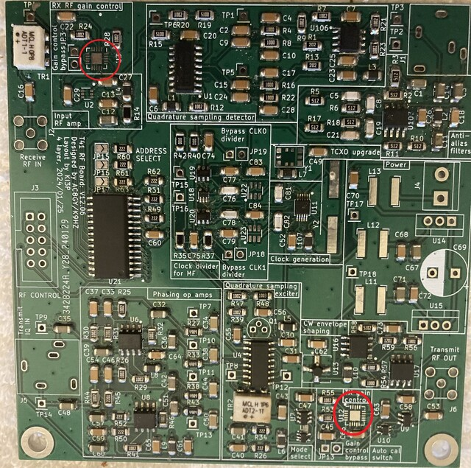

Turns out, they aren't that bad to put on the PCB. (I did a post on this.) I can pass along some pointers, that you probably already know but some others may not:

0. Find a place where you can spread out your work, including printouts of the schematic and BOM. Your work station should be such that you can leave it overnight without having to "clean up". The workspace should also be kid- and cat-proof. If you get tired, stop. Come back to it tomorrow. Rushing the assembly rarely works out saving time.

1. Watch some YouTube videos on using a hot air gun if you don't have any experience with a hot air gun. This one's pretty good: <https://www.youtube.com/watch?v=NxPWwHUJCqM>  Note how the solder is "wicked-up" to the pin automatically. I usually put a little flux on the pads first. Note how solder wick can be used to remove solder bridges between pins.

2. Put all of the IC's on first. As you can see above, U2, U22, U23 and others are not soldered in place. Going back and doing it later may loosen some nearby SMDs that are already on the board. The video above shows that other SMDs in the neighborhood are fine as long as you direct the air flow properly. If some other SMDs loosen, no big deal; just reposition them and redo the connection. Also, make sure you position it correctly. It's hard to see the pin 1 mark on some of the ICs.

3. Do the "low-lying" SMDs next (e.g., caps and resistors). It takes less paste than you think if you're using a hot air gun. (I think this is the only way to go.) For example, in the middle of the Quadrature Sampling Exciter above, look at C30 and C31. The left side of C31 has more paste on its pad than is needed while the right side looks less "bulbous". Both sides of C30 look better as far as the quantity of paste used. If you're unsure about your SMDs soldering ability, buy a practice kit (eBay 395157507695 for $2 or 156044393350--more expensive, but more variety of SMDs and faster delivery: $16. Pay attention to delivery dates!) Both have some ICs and a variety of SMD sizes from the 1206s used in the T41 down to 0402 which I can barely see without glasses.

4. I'm sufficiently OCD that I place the resistors so all numbers can be read from one direction given their orientation. It doesn't make any difference to the circuit, but it does make it easier to read them if debugging is needed.

5. Add the "skyscraper" components to the PCB last (e.g., electrolytics, IDC, SMA, and other connectors) to the board.