**T41 V12 RF Board Assembly Manual**

**Version 1.00 – April 23, 2024**

**WJ Schmidt - K9HZ**

**INTRODUCTION**

The new T41 V12 RF board is ~~really a general-purpose band-pass filter that can be used by all SDRs and SDTs as a preselector on receive, and as a true band pass filter on transmit. There are filter sections on the board for 160M, 80M, 60M, 40M, 30M, 20M, 17M-15M, 12M-10M, 6M, and BYPASS. There is no requirement to build out all filter sections if you intend on using a smaller set. The filters are selected using I2C communication and provide over 50dB of isolation on harmonic multiples, and better than 40dB on adjacent bands. Integrated logic is used to switch the BPF from the receive “antenna to receiver” path to the transmit “low power exciter to PA” by pin 1 of J4, the “BANDS” connector. BPF boards are sold individually, as part of the T41 V011 upgrade to V12 kit, and as part of a new T41 V12 radio board set.~~

**THEORY OF OPERATION**

1. **Power.**

Board power is 12VDC provided by a connector placed on the back side of the board. A 3.3V regulator provides voltage for the remainder of the parts on the board. Total power draw is on the order of 12ma.

1. **I2C addressing and switching.**

The BPF board is completely controlled via I2C communications. A MCP23017 16 bit I/O ~~expander is used to communicate with a central processor (not provided) via SCL and SDA serial lines brought in through pins 7 and 5 of the J4 the “BANDS” connector. The I/O expander has hex address 0x24, and the user can select any of eight chip addresses from “000” to “111” shorting the solder switches provided (nb. the address of the expander for the T41 V12 primary receiver BPF address is “100”… so the solder switch on the board for A2 at JP4 should be filled and the rest left blank). See the following for more information:~~ <https://github.com/DRWJSCHMIDT/T41/blob/main/T41_V012_Files_01-15-24/T41_V012_Design_Documents/T41_V12.6_I2C_Assignments.xlsx>

~~Two eight-bit words written by the external processor to the I/O expander to activate the expanders output lines to select the filters. Only one filter (or BYPASS) should be selected at a time even though multiple filters could be theoretically selected. The I/O expander has two output ports, designated GPA0-GPA7 and GPB0-GPB7. Writing a “1” to these locations selects the filters and the TX or RX switched paths. The truth table for this is:~~

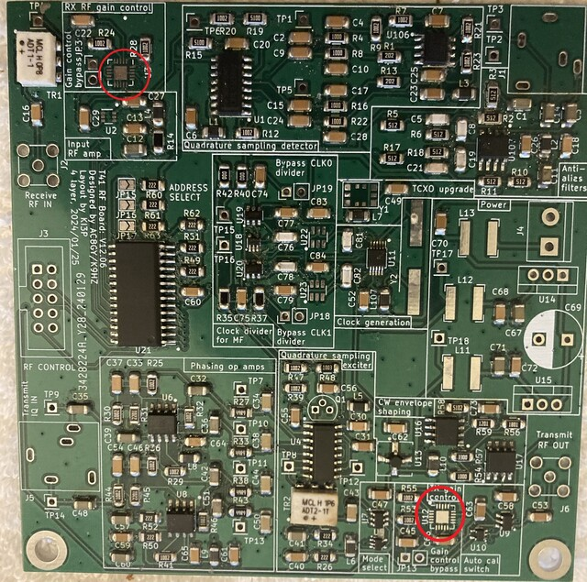

Turns out, they aren't that bad to put on the PCB. (I did a post on this.) I can pass along some pointers, that you probably already know but some others may not:

0. Find a place where you can spread out your work, including printouts of the schematic and BOM. Your work station should be such that you can leave it overnight without having to "clean up". The workspace should also be kid- and cat-proof. If you get tired, stop. Come back to it tomorrow. Rushing the assembly rarely works out saving time.

1. Watch some YouTube videos on using a hot air gun if you don't have any experience with a hot air gun. This one's pretty good: <https://www.youtube.com/watch?v=NxPWwHUJCqM>  Note how the solder is "wicked-up" to the pin automatically. I usually put a little flux on the pads first. Note how solder wick can be used to remove solder bridges between pins.

2. Put all of the IC's on first. As you can see above, U2, U22, U23 and others are not soldered in place. Going back and doing it later may loosen some nearby SMDs that are already on the board. The video above shows that other SMDs in the neighborhood are fine as long as you direct the air flow properly. If some other SMDs loosen, no big deal; just reposition them and redo the connection. Also, make sure you position it correctly. It's hard to see the pin 1 mark on some of the ICs.

3. Do the "low-lying" SMDs next (e.g., caps and resistors). It takes less paste than you think if you're using a hot air gun. (I think this is the only way to go.) For example, in the middle of the Quadrature Sampling Exciter above, look at C30 and C31. The left side of C31 has more paste on its pad than is needed while the right side looks less "bulbous". Both sides of C30 look better as far as the quantity of paste used. If you're unsure about your SMDs soldering ability, buy a practice kit (eBay 395157507695 for $2 or 156044393350--more expensive, but more variety of SMDs and faster delivery: $16. Pay attention to delivery dates!) Both have some ICs and a variety of SMD sizes from the 1206s used in the T41 down to 0402 which I can barely see without glasses.

4. I'm sufficiently OCD that I place the resistors so all numbers can be read from one direction given their orientation. It doesn't make any difference to the circuit, but it does make it easier to read them if debugging is needed.

5. Add the "skyscraper" components to the PCB last (e.g., electrolytics, IDC, SMA, and other connectors) to the board.