T41 V12.8 RF Board Assembly Manual
Version 1.00 – July 31, 2026
WJ Schmidt - K9HZ

INTRODUCTION
The new T41 V12.8 RF board combines the T41 QSE and QSD on a single board, placing the local oscillator onboard and keeping RF traces as short as possible for improved RF performance. The QFN devices—the Si5351 oscillator and two PE4312 attenuators—have been moved to premade plug-in modules that install like ICs. This simplifies soldering and assembly compared with earlier RF board versions, while also supporting experimentation without rebuilding the entire board. The new Oscillator Module uses the more capable eight-output Si5351, enabling automated calibration. The RF Attenuator Modules use one or two PE4312 devices to provide either 0–31.5 dB or 0–63 dB of attenuation.

THEORY OF OPERATION
- Power.
Board power is supplied as 12 VDC through a connector on the right side of the board. The input feeds 5 V and 3.3 V regulators, which supply the rest of the board circuitry. Total current draw is approximately 100 mA.

- I2C addressing and switching.
The V12 Main board controls the RF board over I2C. An MCP23017 16-bit I/O expander communicates with the central processor through the SCL and SDA lines on pins 7 and 5 of J3, the “RF CONTROL” connector. In software, the T41 V12 RF board assigns the I/O expander these hexadecimal addresses:

Primary RF board = 0x27
Secondary RF board = 0x23

The user can choose any of the eight chip addresses from 0x20 through 0x27 by configuring the solder switches. A shorted switch sets the corresponding bit to “0”; an open switch sets it to “1”. For the primary board, select 0x27.

The Si5351 oscillator is also controlled over I2C and supports two configurable addresses, 0x60 and 0x61, based on the A0 pin state on the QFN package: A0 = 0 selects 0x60, and A0 = 1 selects 0x61. The T41 V12.8 uses 0x61 so the radio can detect the new Oscillator Module and perform automatic calibration. If a second receiver is deployed using another V12.8 board, its oscillator address is 0x60.

For more information about I2C assignments, see: T41 V12.6 I2C Assignments

NEW MODULES FOR THE T41 V12.8 RF BOARD

The V12.8 RF board uses three plug-in modules that install like older PDIP 7400-series logic ICs: one Oscillator Module for each V12.8 RF board, plus Attenuator Modules as required. Use two Attenuator Modules for an RF board used for both receive and transmit, or one for a second receiver with no transmit function. Because the modules contain QFN parts that are difficult to hand-solder without hot-air tools, they are supplied with the QFN components already installed. To complete each module, solder on the attachment pins and insert the module into its matching board location in the correct orientation. This design should make the V12.8 RF board easier to assemble.

First, cut the required rows of male and female IDC pins for the modules. Machined pins and sockets are preferred because they mate precisely and reduce the risk of fit or contact issues. Stamped pins can also be used, but make sure the pins and sockets match, since they are available in different sizes and shapes, including square and rectangular styles.

For the Attenuator Modules, prepare four six-pin rows of pins and sockets—two rows per module U3 and U11. See below:

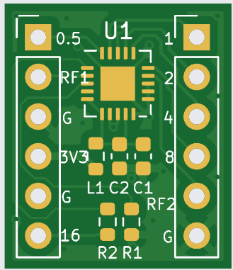
You will also need 2 rows of six pins and sockets, and 1 row of four pins and sockets for the Oscillator Module U12:

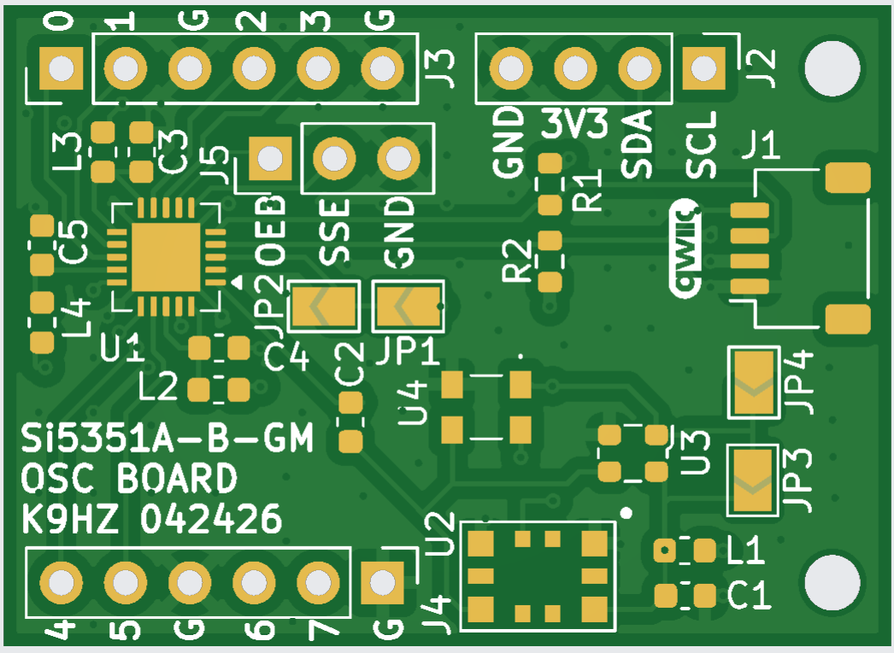

Set the Oscillator Module address at this stage. For a primary receiver, close JP1 with a small solder bridge to set the Si5351 I2C address to 0x61. For a secondary receiver, close only JP2 to set the address to 0x60. Do not close both JP1 and JP2, because that will short the 3.3 V supply rail to ground.

For best alignment, solder the module-board pins and sockets at the end of RF board assembly. First insert the pins into the sockets, then solder the pins and sockets to their boards at the same time.

ASSEMBLING THE T41 V12.8 RF BOARD

- Before continuing, verify all parts against the V12.8 RF board BOM on GitHub. Follow the recommended build sequence, because installing parts out of order can make soldering difficult in the limited workspace. Before soldering, wipe the board with isopropyl alcohol to remove oil and grease.

- Install the ICs and other semiconductors first, but save power regulators U14 and U15 for the final build stage. Install the semiconductor parts U1, U2, U4, U5, U6, U7, U8, U9, U10, U13, U16, U17, U21, U106, and U107.

- Select the RF control I2C address next to U21 by setting jumpers JP15, JP16, and JP17. Use address 0x27 for the primary RX board with no jumpers closed. Use address 0x23 for the secondary RX board by closing JP17.

- Next, install the capacitors, resistors, and bead inductors. If your V12.8 RF board has the Input RF Amp layout shown below, check the component placement carefully.

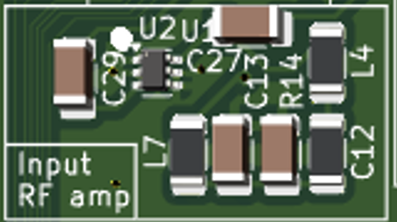

Be careful not to swap C12 and R14. The RF board labeling should appear as shown below; this labeling issue was corrected in later board batches.
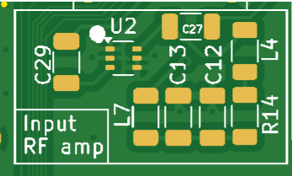
When installing resistors, capacitors, and bead inductors, begin near a previously installed semiconductor and work outward in a circular pattern to preserve soldering access as the PCB fills.

- Install transformers TR1 and TR2.
- Install the test point pins, including TP1, TP2, and any remaining test points.
- Install the remaining parts: voltage regulators U14 and U15, the 10-pin IDC box connector at J3 “RF Control,” the Oscillator Module, the Attenuator Modules, and the power connector at J4. To make power connections clear, mark the “+” and “−” screw terminals with red and black dots (with Sharpie pens). Install J1, J5, and J6.
- After assembly, remove flux with 90% or higher isopropyl alcohol. If needed, scrub the board with Dawn dish detergent and water using a toothbrush, then dry it with a hair dryer on the cool-air setting.

TESTING

To test the completed V12.8 RF board, connect the RF Control cable to the main board and apply 12 V to J4, observing the correct polarity. Then run either the I2C test routine or the Phoenix software on the main board to confirm that it detects the RF board at the correct I2C addresses. No additional testing is performed at this time.

