Introduction to the Version 12 Menu System
The V12 menuing system is a little different than the V11 and V10 menuing systems. Prior to V12, the user was required to use the Menu up (Menu ^) or Menu down (Menu v) pushbuttons to move through the menu list. While that works, it is not as convenient as it could be.
The first drawback was that, when you pushed a menu button, you were not sure where you would be in the list of menu options. The reason was because the list presented the next menu choice from the last time you used the menu system. For example, if you started at the first set of menu options (CW Options) and pressed the Menu up pushbutton, you advanced to RF Set. However, if you return to the menu system some time later and pressed the Menu up button, you would be at the VFO Select menu option. Unless you had a very good memory, it was always a challenge to remember how many button presses it would take to get the option you wanted.
A second drawback was that button presses were not particularly fast way to scroll through the menu list. Part of the reason is because the push buttons had to be “debounced” with time delays. As you may recall, a pushbutton has a momentary contact that tends to vibrate. Some of those vibrations are strong enough to be read by the Teensy as another switch closure. As fast as the Teensy is, a single (intentional) Menu up push could issue a half dozen (unintentional) Menu up switch closures This action may put the user much further down the list of menu options than they wanted.
A third drawback was that many of the main menu options (e.g., VFO Select) would have several sub-options from which to choose (e.g., VFO A, VFO B, Split). It could take the user quite a while to memorize all of the possible sub menu option meaning that the user may have to “search the menus” for the desired secondary menu option they want. Indeed, a major complaint of some commercial rigs is that the menu system is perceived as being too complex.
Finally, over the past several years, the three “free” pushbuttons the switch matrix started out with have been subsumed by the current menu system. The main reason this happened was because someone made the statement: “You know what would be neat to have…”. The new V12 menu system allows us to free up three previously-used buttons. We no longer use the Menu down (Menu v), Noise Floor, or Noise pushbuttons. The Menu down pushbutton is simply no longer needed because, with V12, you scroll through the menu list using the Menu/Filter encoder. The other two pushbutton functions have been moved to the Main menu list so the pushbuttons are no longer needed. The end result is that you can use the last three switches for whatever makes sense to you.
It's easier to understand the new menu system once you’ve seen how it looks while running. Figure 4-XX01 shows the V12 Menu System. As you can see, where the previous menu system only used the top display line, the new V12 menu uses more that half the screen real estate. In Figure 4-XX01, the left hand column presents the main menu choices while the right hand column depicts the sub-menus that are available as part of the Main menu option. That is, the CW Options Main menu is the currently-active menu choice. The currently-active menu choice is always shown in green. The secondary menu options associated with the currently-active Main menu choice it broken out in the right-hand column. They are displayed in a light gray color. In Figure 4-XX01, there are six sub-menu items (e.g., WPM – Xmit Delay). All options have a Cancel option.
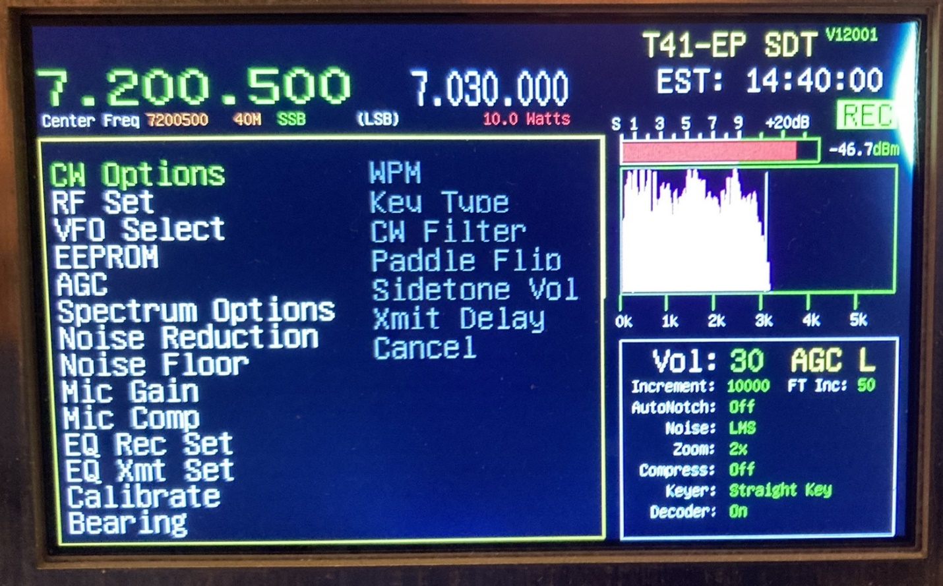
Figure 4-xx01. The V12 Menu System.
If you rotate the Filter/Menu encoder clockwise (i.e., CW), the currently-active menu choice would advance to RF Set which would be displayed with green letters and the color of CW Options would revert back to white. If you continue to turn the Filter/Menu encoder CW, the active menu entry advances down the list, updating its associated secondary menu options as you go. If you get down to the Bearing menu and rotate the encoder CW again, the Main menu option “wraps around” back to CW Options. If you were on CW Options and rotated the encoder counter clockwise (CCW), the menu “wraps” back to Bearing at the end of the list.
Suppose you want to change the current VFO from VFO A to VFO B. To do this, rotate the Filter/Menu encoder until the VFO Select option is active. Now press the Select pushbutton on the switch matrix. The display changes to look like Figure 4-XX02. Note that a submenu choice is highlighted in green. (The first choice in the list, like VFO A, is normally highlighted but I took the picture after rotating the Filter/Menu encoder to highlight VFO B. You can use the encoder to scroll backwards and forwards through the second menu options.) When you have the desired submenu option selected, press the Select pushbutton again and the highlighted option is selected. The display is then erased, updated, and redisplayed as it was before the Menu up button was pushed. However, VFO B would now be the active VFO. While it may have taken
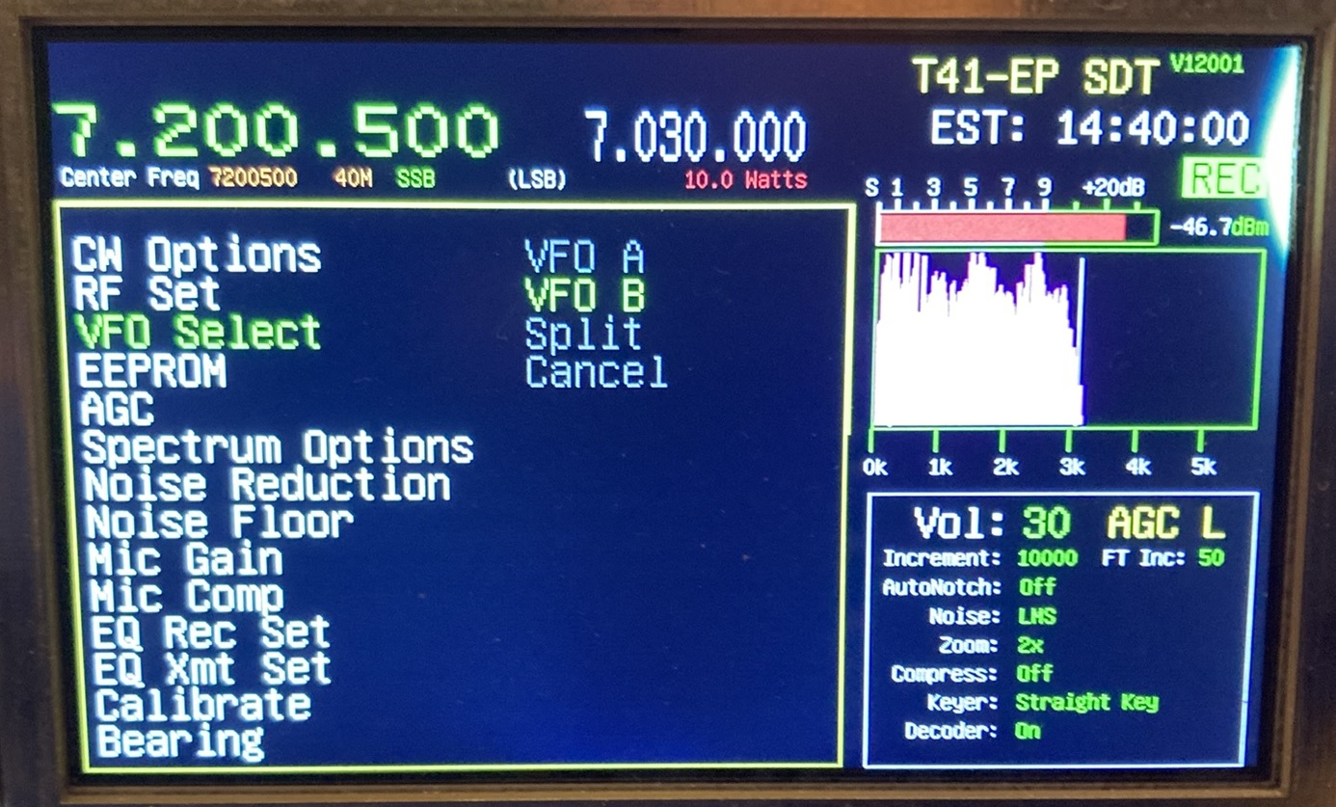
Figure 4-xx02. Making a VFO Select sub choice.
you a minute or two to read this discussion about the menu selection process and all of this may seem kinda fussy, you can do a complete menu selection is less than 2 seconds. The process is notably faster than the earlier menu system.

The Software for the V12 Menu System
The user starts the menu selection process by pressing the Menu up pushbutton on the switch matrix. That button press evokes the code fragment prese4nted in Listing 4-XX01. The
List 4-XX01. The Main_Menu_UP processing the Button.ccp
case MAIN_MENU_UP: // 11/16/23 JJP
DrawMenuDisplay(); // Draw selection box and main menu
SetPrimaryMenuIndex(); // Scroll through primary menus
SetSecondaryMenuIndex(); // Use the primary index selection
// redraw the secondary
secondaryMenuChoiceMade = functionPtr[mainMenuIndex]();
tft.fillRect(1, SPECTRUM_TOP_Y + 1, 513, 379, RA8875_BLACK);
DrawSpectrumDisplayContainer();
EraseMenus();
break;

DrawMenuDisplay() call draws the box outline for the list and populates the box with the Main and Sub menus. The Main menu entries are found in the *topMenus[] array in the INO file. This is organized as a simple array of string pointers to each Main menu option like shown on the left hand side of Figure 4-xx01. The submenu entries are found in the *secondaryChoices[][] array of string pointers. This array is a double-dimensioned array because each of the 14 Main menu choices has a varied number of submenus associated with each Main menu option. These are shown as the choices on the right hand side of Figure 4-xx01. Once the DrawMenuDisplay() is finished, the code is ready to bring the encoders into play.
The SetPrimaryMenuIndex() function call is responsible for managing the scrolling of the cursor through the Main menu list. When you select the desired option by pressing the Select pushbutton, it records the user’s selection and stores it in the mainMenuIndex variable.
The SetSecondaryMenuIndex() function call manages the scrolling through the secondaryChoices[][] array. Because the user has already selected the Main menu choice, the array list is controlled by using the Main menu choice, as in * secondaryChoices[mainMenuIndex][index]. When the user select the submenu option to execute by pressing the Select pushbutton, a function pointer is used to call the code for processing the selection.
The function pointer is defined as:
int (*functionPtr[])() = {&CWOptions, &RFOptions, &VFOSelect,
&EEPROMOptions, &AGCOptions, &SpectrumOptions, &ButtonNR,
&ButtonSetNoiseFloor, &MicGainSet, &MicOptions,
&EqualizerRecOptions, &EqualizerXmtOptions, &IQOptions,
&BearingMaps };

You can use Jack’s Right-Left Rule to find an explanation of how to parse this data definition. Simply stated, find the data’s identifier and “unwind” the definition by moving right and left through the tokens. Therefore, “functionPtr is an array of pointers to functions which return an int”. (If you use ChatGPT, just ask it to explain “Purdum's Right-Left Rule”.)
In the functionPtr[] array initializer list are the functions associated with each Menu choice. Notice how their positions correspond to the left hand column in Figure 4-XX01. Because the function name for each function is preceeded by the address-of operator (&), the functionPtr[] array is actually nothing more than the starting memory addresses (lvalue) for each function in the list. Therefore, the statement in Listing 4-xx01:
secondaryMenuChoiceMade = functionPtr[mainMenuIndex]();

is simply an efficient way of calling a function. For example, If we look at Figure 4-XX02, we can see that the selection was “VFO Select”. This selection means that the mainMenuIndex is equal to 2. Therefore, using the function pointer definition shown above:
secondaryMenuChoiceMade = functionPtr[mainMenuIndex]();
secondaryMenuChoiceMade = functionPtr[2]();
and we can see from the functionPtr initializer list that an index of 2 corresponds to VFOSelect, which reduces to:
secondaryMenuChoiceMade = VFOSelect();
which probably looks more familiar. The function pointer array allows us to use a single statement to call any of the 14 functions without having to write an explicit call using the function name. All we need to know is the mainMenuIndex to call the proper function.
The rest of the code in Listing 4-XX01 is just clean up code to erase the menu list and redraw the Spectrum and Waterfall displays. Spend as much time as you need to understand function pointers. They are an efficient way to processes all kinds of programming choices.

Processing a User Choice
So how does the code work once a menu selection is made? Suppose we selected the VFO Select option shown in Figure 4-XX02. We have already shown that this choice is tied to the mainMenuIndex value of 2 in the function pointer’s inializer list, VFOSelect(). The code for VFOSelect() is presented in Listing 4-XX02
Listing 4-XX02. Source code for the VFOSelect() function.(Partial listing.)
int VFOSelect()
{
MyDelay(10L);
NCOFreq = 0L;
splitOn = 0; // Default is no split active

switch (secondaryMenuIndex) {
case VFO_A: // VFO A
centerFreq = TxRxFreq = currentFreqA;
activeVFO = VFO_A;
currentBand = currentBandA;
tft.fillRect(FILTER_PARAMETERS_X + 180, FILTER_PARAMETERS_Y,
150, 20, RA8875_BLACK); // Erase
break;

case VFO_B: // VFO B
centerFreq = TxRxFreq = currentFreqB;
activeVFO = VFO_B;
currentBand = currentBandB;
tft.fillRect(FILTER_PARAMETERS_X + 180, FILTER_PARAMETERS_Y,
150, 20, RA8875_BLACK); // Erase
break;

case VFO_SPLIT: // Split
DoSplitVFO();
splitOn = 1; // Turn on
break;

default: // Cancel and anything else
Serial.print("Cancel or bogus value for VFO Select.
secondaryMenuIndex = ");
Serial.println(secondaryMenuIndex);
return activeVFO;
break;
} // End switch (more code below)
.
As you can see, the code is straightforward. The other Menu choices work in much the same manner. The exception is when more information is needed by the submenu choice. For example, in Figure 4-XX01 you can see that the first submenu choice is WPM. In this case, the code displays a prompt on the top line of the display for the Words Per Minute value and the Menu/Filter encoder is used to change the value of WPM.

Persistence
This is one of those rock/hardplace decisions. For example, we usually prefer to use the Least Mean Square noise filter and it almost never gets changed. In that case, we’d probably like to have that algorithm used all the time for noise reduction. Same for the Noise Floor option. In such cases, we’d like to persist those values in EEPROM so that they are in effect the next time we turn the rig on.
On the other hand, Jack’s CW speed isn’t so hot, so he prefers to have the WPM value set to 18WPM. However, he also likes to work the slow speed contests where the max WPM is limited to 13WPM (http://qrpcontest.com/pigwalk40/). When operating in that contest, Jack reduces the WPM to between 10-13WPM or slower if the other ham wants a slower speed. However, when the contest ends, Jack wants the WPM to be his default of 18WPM. In this case, Jack does not want to persist the 13WPM value, but use it in the current session.
What to do?
What we want to do with respect to menu changes may not be what you want to do in terms of persisting menu parameters in EEPROM. We suggest you look through the menu code for either am EEPROM.put() or an EEPROMWrite() function calls. If the menu code uses either of these menu calls, that menu item is probably persisted in EEPROM. You can decide whether EEPROM persistence is what you want or not. Commenting out either of the two function calls will result in that data item not being persisted in EEPROM.
What should you do if we prefer not to persist a value to EEPROM, but you do? In that situation, you have two choices. The messy choice is to dig into the code for that menu option and add one of the EEPROM calls that persists the data. A second option is to use the EEPROM →Save Current menu option. As explained earlier in this chapter, this menu sequence persists all of the current EEPROM values, including ones you may have just changed.
Take a little time to dig around in the menu code, especially if you are going to add a new menu item. If you do add or subtract a menu option, be sure to change the TOP_MENU_COUNT symbolic constant (currently set to 14) in the SDT.h header file.

