Heart-failure v2 statistical handoff
Real-data demo · analysis, interpretation, and figure-reading guide
Dataset: UCI Heart Failure Clinical Records (n=299)
Design: Observational follow-up cohort; secondary analysis
Primary outcome: Time to death with censoring
Review state: needs-author-decision
Asset index
# | File | Claim
Figure 1 | Fig1.png | Observed survival differs across prespecified ejection-fraction groups.
Figure 2 | Fig2.png | EF and serum creatinine retain prognostic associations after prespecified adjustment.
Figure 3 | Fig3.png | The two-feature model retains similar internal discrimination to the full baseline model.
Table 1 | Table1.csv | The table describes, rather than balances, outcome groups.
Table 2 | Table2.csv | The table reports effect size, uncertainty, and diagnostics together.
.
Figure 1 — Kaplan–Meier survival
Claim: Observed survival differs across prespecified ejection-fraction groups.
Method rationale: Time-to-event outcome with censoring requires Kaplan–Meier estimation; the overall log-rank test compares the three curves.
Scientific result: Overall log-rank p <0.001.
Interpretation: Lower baseline EF is associated with poorer observed survival.
Caption: Kaplan–Meier survival by prespecified baseline ejection-fraction group, with 95% confidence bands, censoring marks, and numbers at risk.
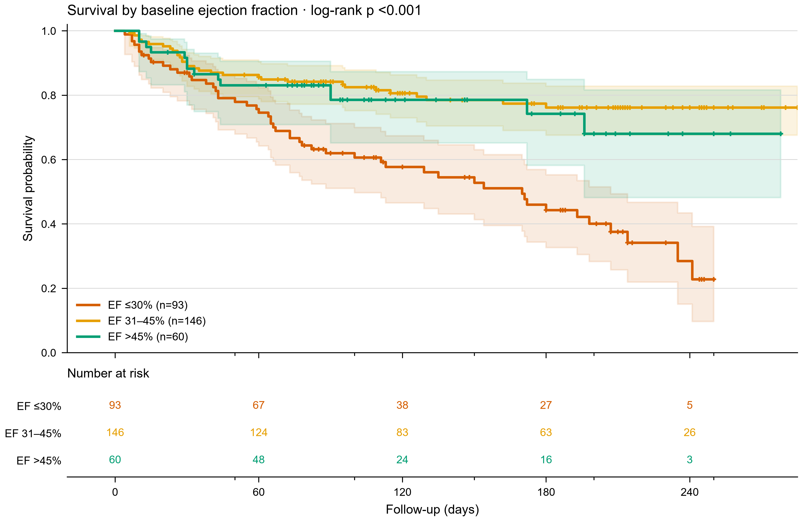
How to read
- Axes — follow-up days are on the horizontal axis; the vertical axis is the estimated probability of remaining alive.
- Colors — orange-red is EF ≤30%, gold is EF 31–45%, and green is EF >45%.
- Steps and lines — each downward step is an observed death; a horizontal segment means no death was observed between event times.
- Plus signs — these are censored patients, not deaths; follow-up ended without a recorded death at that time.
- Shaded bands — these are 95% confidence intervals around each survival estimate.
- Numbers at risk — the color-matched rows show how many patients remain under observation and event-free just before each time point.
- Reading order — compare when curves fall, how far they separate, how wide the bands are, and how many patients remain at risk.
- Late follow-up — treat tail separation cautiously when the risk rows contain only a few patients.
Common misreading: Curve separation is not causal evidence.
Cannot conclude: A treatment effect or a clinically optimal EF threshold.
Review status: final
Citation location: Results — survival analysis
Reproducibility: v2_demo/04_code/run_demo.py
.
Figure 2 — Adjusted Cox model
Claim: EF and serum creatinine retain prognostic associations after prespecified adjustment.
Method rationale: Cox regression estimates covariate-adjusted hazard ratios while retaining censoring information.
Scientific result: C-index 0.73; EF HR 0.79; creatinine HR 1.36.
Interpretation: Higher EF is associated with lower hazard; higher creatinine with higher hazard.
Caption: Prespecified multivariable Cox model. Continuous effects use clinically interpretable increments; horizontal lines are 95% confidence intervals.
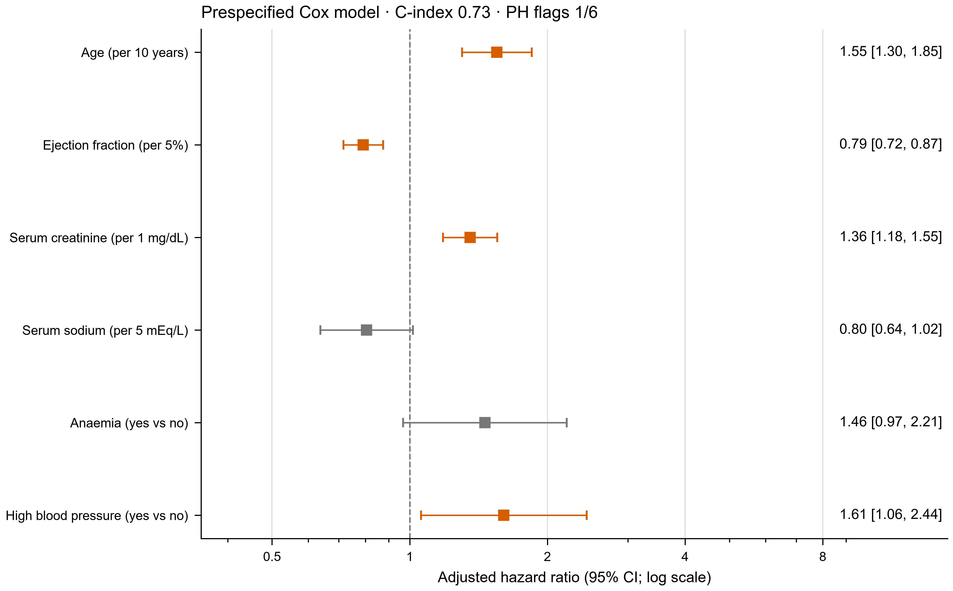
How to read
- Rows — each row is one covariate in the same adjusted Cox model.
- Squares — the square marks the adjusted hazard ratio (HR); the horizontal whisker is its 95% confidence interval.
- Dashed line — HR=1 is the no-association reference. Intervals crossing 1 are compatible with no association at the 0.05 level.
- Direction — estimates left of 1 indicate lower hazard and estimates right of 1 higher hazard, conditional on the adjustment set.
- Scale — the horizontal axis is logarithmic, so equal distances represent equal multiplicative changes rather than equal absolute changes.
- Colors — orange denotes p<0.05 in this figure and gray denotes p≥0.05; color does not establish causality or clinical importance.
- Units — EF is reported per +5 percentage points and creatinine per +1 mg/dL; other rows use the unit printed in the label.
- Diagnostics — read the C-index as model discrimination and inspect the PH flag before assuming an HR is constant over follow-up.
Common misreading: A hazard ratio is not an absolute risk ratio.
Cannot conclude: Causality, treatment benefit, or external validity.
Review status: needs-author-decision
Citation location: Results — adjusted associations
Reproducibility: v2_demo/04_code/run_demo.py
.
Figure 3 — Exploratory internal prediction
Claim: The two-feature model retains similar internal discrimination to the full baseline model.
Method rationale: Out-of-fold probabilities avoid evaluating each patient with a model trained on that patient; follow-up time is excluded.
Scientific result: Repeated-CV AUC: full 0.766 (0.061); two-feature 0.757 (0.063).
Interpretation: The compact model may be useful for hypothesis generation, not deployment.
Caption: Five-fold out-of-fold ROC and quantile-binned calibration for baseline logistic models. This secondary endpoint ignores unequal follow-up and is exploratory.
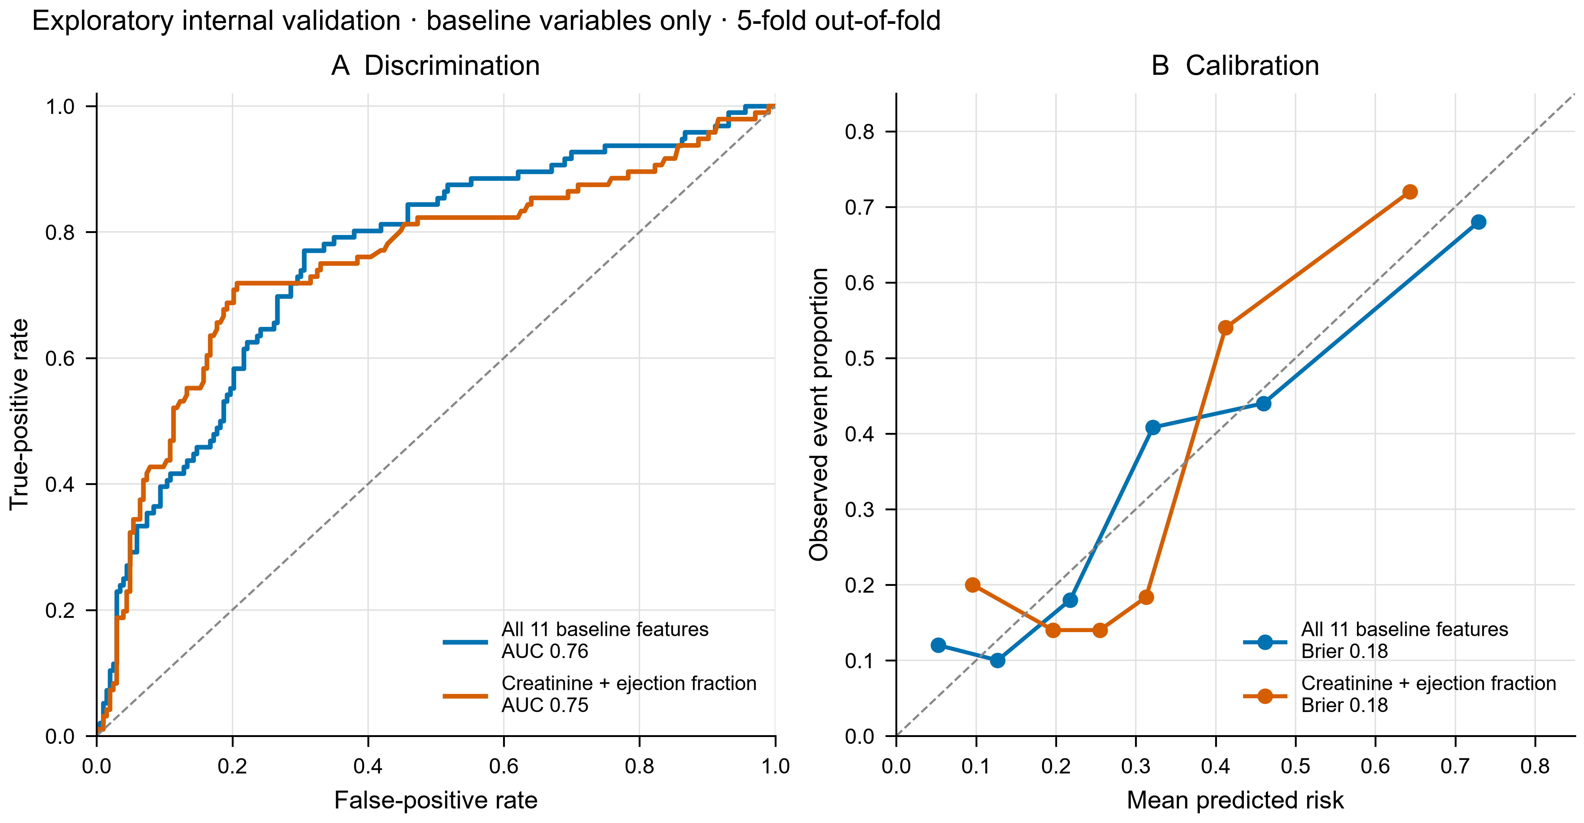
How to read
- Colors — blue is the full 11-feature model and orange is the two-feature creatinine + EF model in both panels.
- ROC panel — false-positive rate is on the horizontal axis and true-positive rate on the vertical axis; each curve position corresponds to a different threshold.
- ROC reference — the gray dashed diagonal is chance-level ranking; curves nearer the upper-left discriminate outcomes better.
- AUC — read the value in the legend as an overall ranking summary, not as accuracy at a selected threshold.
- Calibration points — each point is a quantile group of patients, not one patient; connecting lines are visual guides only.
- Calibration reference — the gray dashed identity line is perfect agreement. Points above it indicate underprediction and points below it overprediction for that group.
- Brier score — read the value in the legend as overall probability error; lower is better.
- Reading order — assess ROC discrimination and calibration separately, then compare both models without declaring equivalence from similar curves.
Common misreading: Similar AUC is not proof of model equivalence.
Cannot conclude: Transportability, net clinical benefit, or a safe decision threshold.
Review status: final
Citation location: Results — exploratory prediction
Reproducibility: v2_demo/04_code/run_demo.py
.
Table 1 — Cohort characteristics
Table 1. Baseline characteristics by observed outcome
Characteristic | Overall (n=299) | Censored (n=203) | Died (n=96) | SMD (Died − Censored)
Age, years | 60.0 [51.0, 70.0] | 60.0 [50.0, 65.0] | 65.0 [55.0, 75.0] | 0.54
Ejection fraction, % | 38.0 [30.0, 45.0] | 38.0 [35.0, 45.0] | 30.0 [25.0, 38.0] | -0.58
Serum creatinine, mg/dL | 1.1 [0.9, 1.4] | 1.0 [0.9, 1.2] | 1.3 [1.1, 1.9] | 0.57
Serum sodium, mEq/L | 137.0 [134.0, 140.0] | 137.0 [135.5, 140.0] | 135.5 [133.0, 138.2] | -0.41
Platelets, ×10³/µL | 262.0 [212.5, 303.5] | 263.0 [219.5, 302.0] | 258.5 [197.5, 311.0] | -0.1
Creatine phosphokinase, mcg/L | 250.0 [116.5, 582.0] | 245.0 [109.0, 582.0] | 259.0 [128.8, 582.0] | 0.12
Male sex | 194 (64.9%) | 132 (65.0%) | 62 (64.6%) | -0.01
Anaemia | 129 (43.1%) | 83 (40.9%) | 46 (47.9%) | 0.14
Diabetes | 125 (41.8%) | 85 (41.9%) | 40 (41.7%) | -0.0
High blood pressure | 105 (35.1%) | 66 (32.5%) | 39 (40.6%) | 0.17
Current smoking | 96 (32.1%) | 66 (32.5%) | 30 (31.2%) | -0.03
Continuous: median [Q1, Q3]; binary: n (%). SMD direction is Died minus Censored.
Claim: The table describes, rather than balances, outcome groups.
Method rationale: Distribution summaries and standardized differences describe observed groups without p-value-driven screening.
Caption: Baseline characteristics of the public heart-failure cohort.
How to read
- Compare medians and IQRs for continuous rows.
- For binary rows, read numerator and percentage together.
- Use SMD magnitude and direction as a descriptive imbalance measure, not as a causal effect.
Common misreading: Outcome-group imbalance is not an independent prognostic effect.
Cannot conclude: Independent effects or causal risk factors.
Review status: final
Citation location: Methods and Results — cohort
Reproducibility: v2_demo/04_code/run_demo.py
.
Table 2 — Prespecified Cox model
Table 2. Multivariable Cox proportional-hazards model
Covariate | Hazard ratio | 95% CI | p-value | PH-test p
Age, per 10 years | 1.55 | 1.30–1.85 | <0.001 | 0.83
Ejection fraction, per 5% | 0.79 | 0.72–0.87 | <0.001 | 0.025
Serum creatinine, per 1 mg/dL | 1.36 | 1.18–1.55 | <0.001 | 0.077
Serum sodium, per 5 mEq/L | 0.8 | 0.64–1.02 | 0.068 | 0.142
Anaemia, yes vs no | 1.46 | 0.97–2.21 | 0.071 | 0.921
High blood pressure, yes vs no | 1.61 | 1.06–2.44 | 0.026 | 0.826
Covariate-level PH-test p uses rank-transformed time. A global diagnostic and graphical residual review remain pending; inspect any p<0.05 flag.
Claim: The table reports effect size, uncertainty, and diagnostics together.
Method rationale: Prespecified adjustment prevents p-value-driven variable selection.
Caption: Adjusted hazard ratios and proportional-hazards diagnostics.
How to read
- Read HR with its 95% CI, not p-value alone.
- Check the PH-test column before treating the HR as constant over follow-up.
Common misreading: Statistical adjustment does not remove unmeasured confounding.
Cannot conclude: A mechanistic or causal relationship.
Review status: needs-author-decision
Citation location: Results — adjusted associations
Reproducibility: v2_demo/04_code/run_demo.py

