Figure & Table Report
Heart-failure survival — paper-figures worked example
Source paper: Chicco & Jurman (2020), BMC Med Inform Decis Mak 20:16 (CC BY 4.0)
Data: UCI dataset 519 (CC BY 4.0); 299 patients, 96 deaths (32%), median follow-up 115 d
Preset: generic high-quality
Generated by: paper-figures skill — lifelines / scikit-learn, seed = 0
Asset index
# | File | Claim
Figure 1 | Fig1.png | Deaths accrue over variable follow-up → survival analysis is required.
Figure 2 | Fig2.png | Patients with reduced ejection fraction have markedly worse survival.
Figure 3 | Fig3.png | The deceased had lower ejection fraction and higher serum creatinine.
Figure 4 | Fig4.png | Age, low EF and high creatinine independently raise mortality hazard.
Figure 5 | Fig5.png | Predictors are weakly correlated — little collinearity.
Figure 6 | Fig6.png | Serum creatinine + ejection fraction predict death almost as well as all features.
Table 1 | Table1.csv | Cohort description and univariable differences.
Table 2 | Table2.csv | Exact adjusted hazard ratios behind Fig. 4.
Figure 1 — Cohort overview
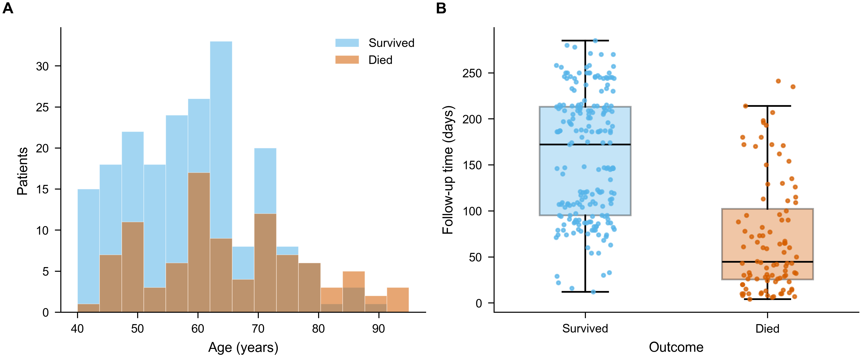
Claim: Deaths accrue over variable follow-up → survival analysis is required.
Caption: Figure 1. Study cohort (n=299; 96 deaths). (A) Age distribution by outcome. (B) Follow-up time by outcome (box = median + IQR; points = patients). Variable follow-up motivates time-to-event analysis.
Annotations
- A: overlaid histograms
- B: box + points
- Color: blue = survived, orange = died
Citation location: Methods/Results, cohort: "Of 299 patients, 96 (32%) died over a median 115-day follow-up (Fig. 1)."
Reproducibility: scripts/make_fig1_cohort_overview.py
Figure 2 — Survival by ejection fraction (Kaplan–Meier)
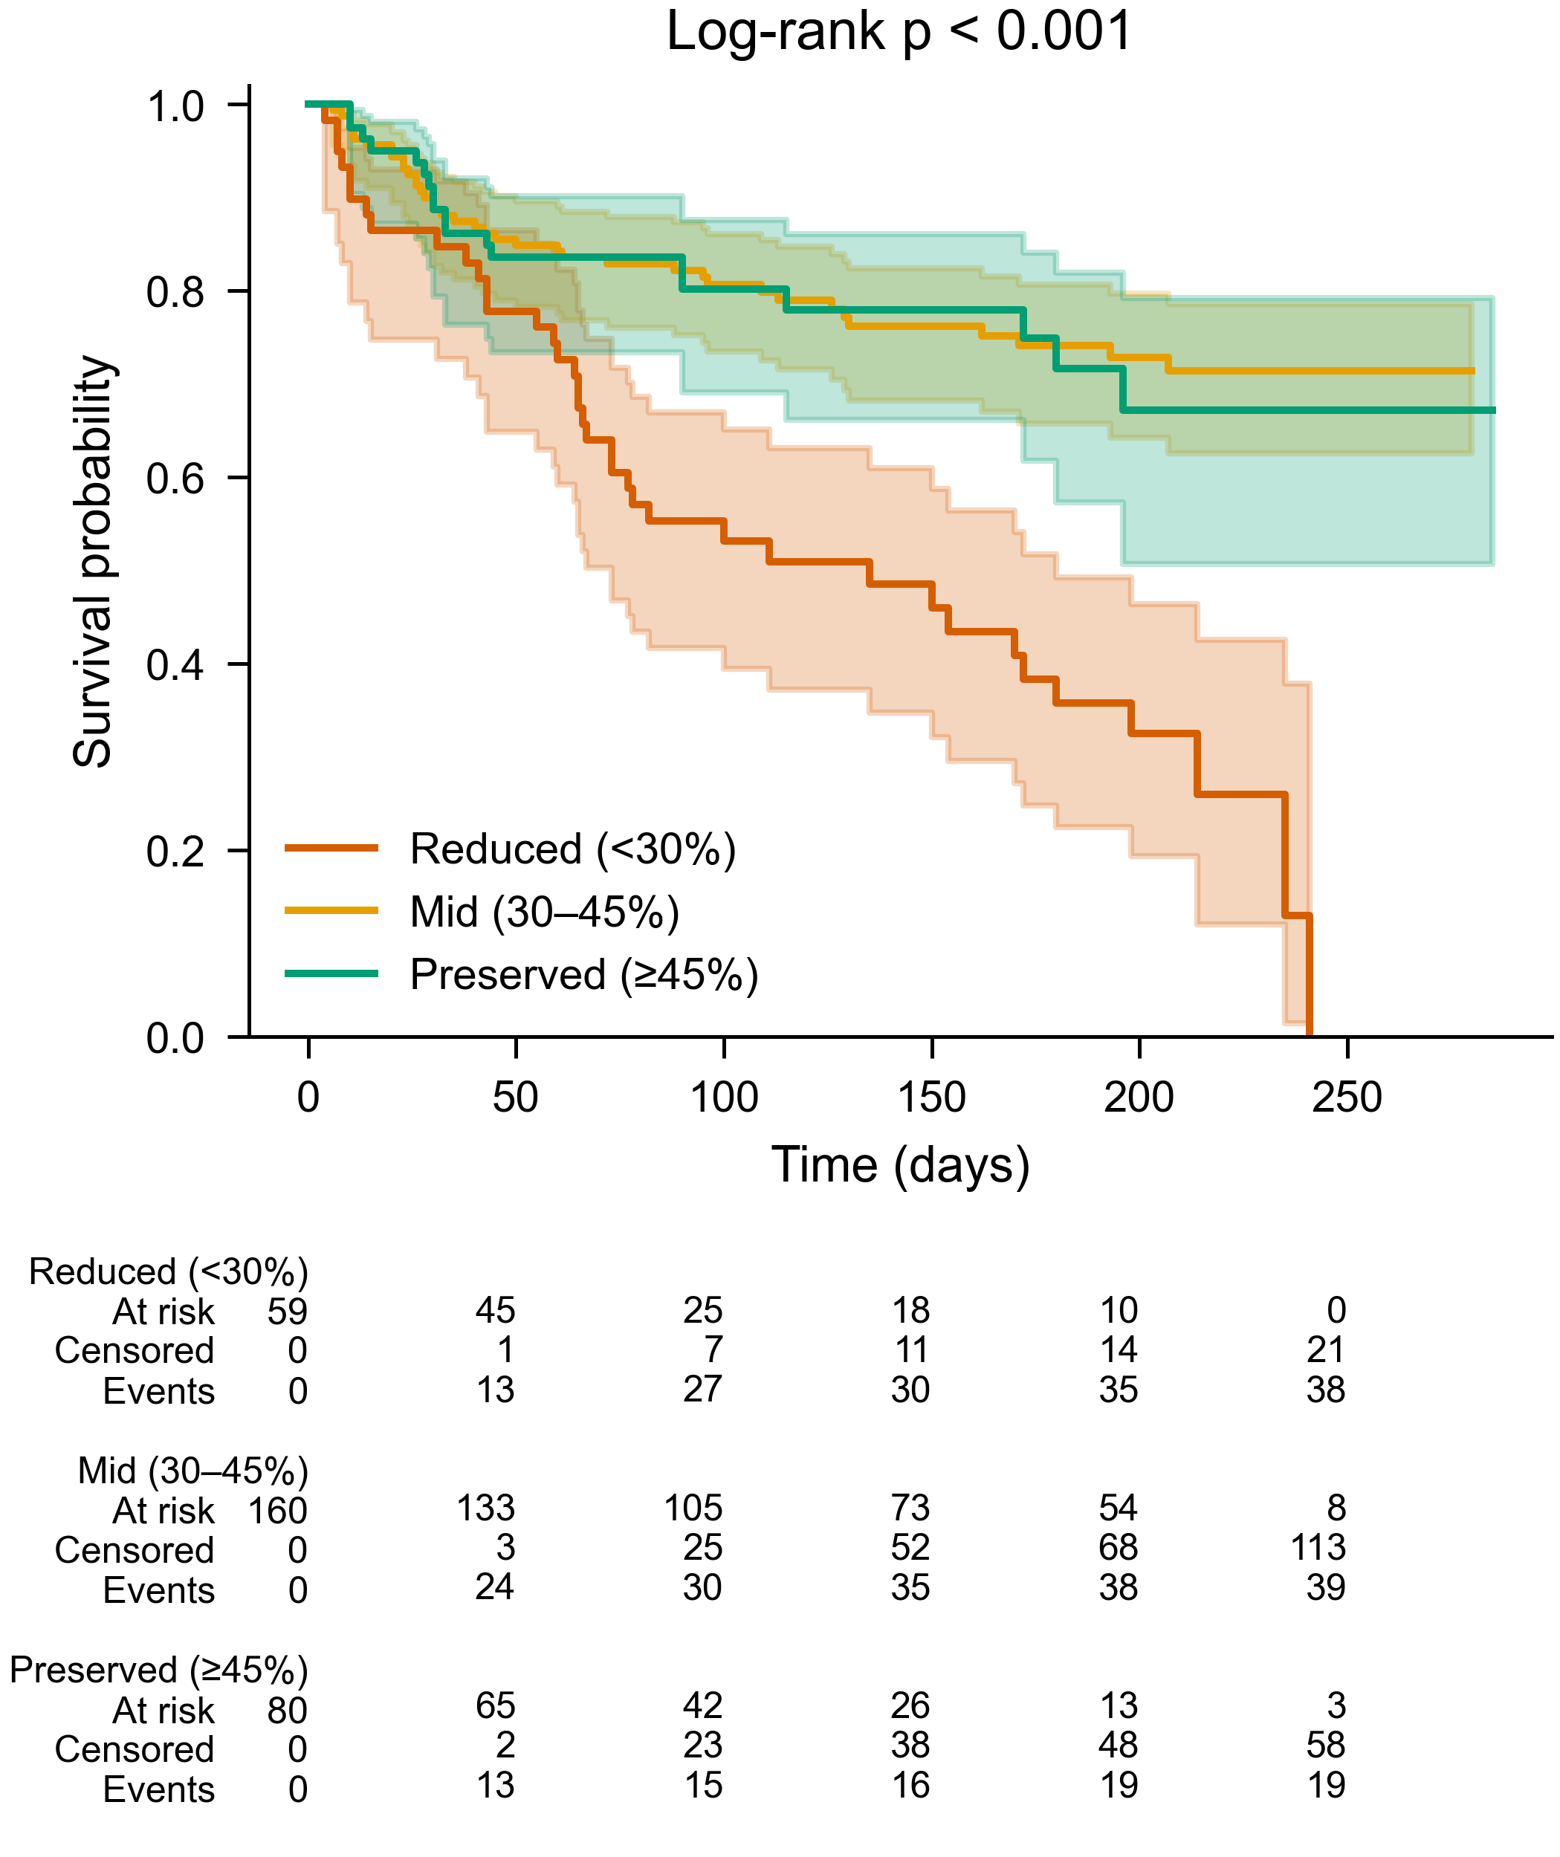
Claim: Patients with reduced ejection fraction have markedly worse survival.
Caption: Figure 2. Kaplan–Meier survival by ejection-fraction category — reduced (<30%, n=59), mid (30–45%, n=160), preserved (≥45%, n=80) — with 95% bands and numbers at risk/censored/events. Log-rank p<0.001.
Annotations
- Groups: clinically defined EF strata
- Below plot: at-risk / censored / events table
- Test: 3-group log-rank
Citation location: Results, survival: "Reduced ejection fraction was associated with lower survival (Fig. 2)."
Reproducibility: scripts/make_fig2_kaplan_meier.py
Figure 3 — Key predictors by outcome
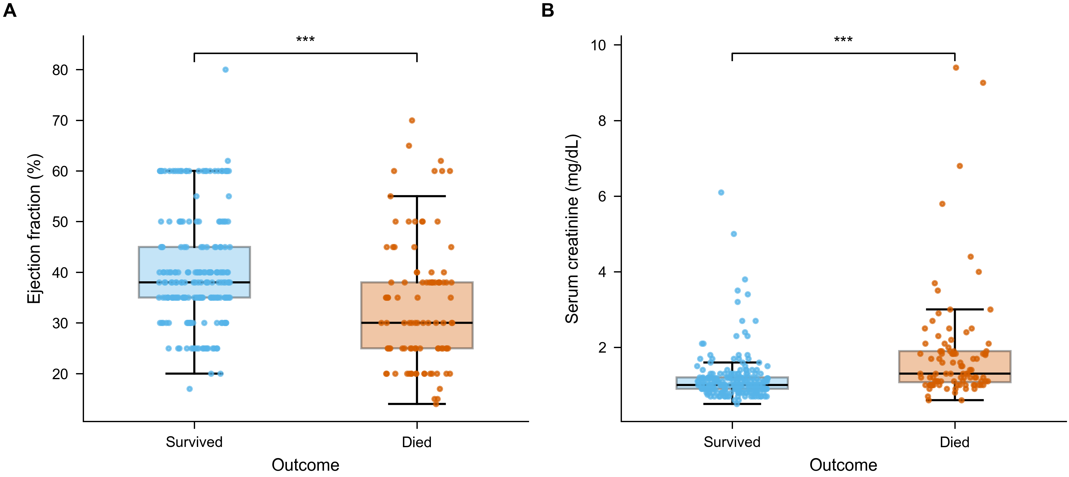
Claim: The deceased had lower ejection fraction and higher serum creatinine.
Caption: Figure 3. The two headline predictors by outcome. (A) Ejection fraction and (B) serum creatinine in patients who survived vs died. Box = median + IQR; points = patients. Mann–Whitney U; ***p<0.001.
Annotations
- Test: Mann–Whitney U (creatinine right-skewed)
- Markers: ***p<0.001
Citation location: Results, univariable: "EF was lower and creatinine higher among those who died (Fig. 3; Table 1)."
Reproducibility: scripts/make_fig3_predictors_boxplot.py
Figure 4 — Multivariable Cox model (forest)
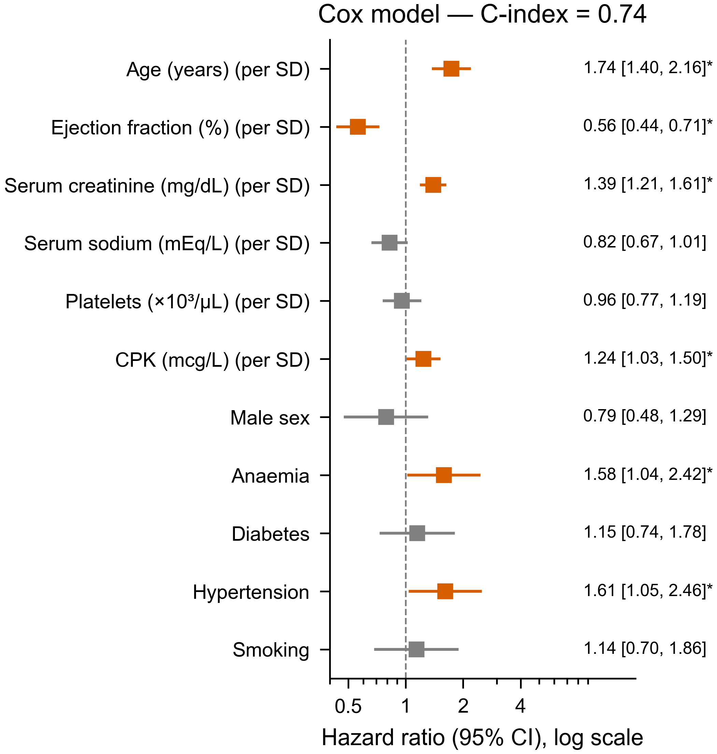
Claim: Age, low EF and high creatinine independently raise mortality hazard.
Caption: Figure 4. Hazard ratios (95% CI) from a multivariable Cox model (log scale; reference HR=1). Continuous predictors standardized (HR per 1 SD); coloured = p<0.05. Age (1.74), creatinine (1.39), CPK (1.24), anaemia (1.58), hypertension (1.61) raised hazard; ejection fraction (0.56) lowered it. Concordance index = 0.74.
Annotations
- Scale: log-scale HR, reference at 1
- Continuous: standardized → per 1 SD
- Highlight: significant predictors coloured
Citation location: Results, adjusted analysis: "EF, creatinine and age were independent predictors (Fig. 4; Table 2)."
Reproducibility: scripts/make_fig4_cox_forest.py
Figure 5 — Correlations among predictors
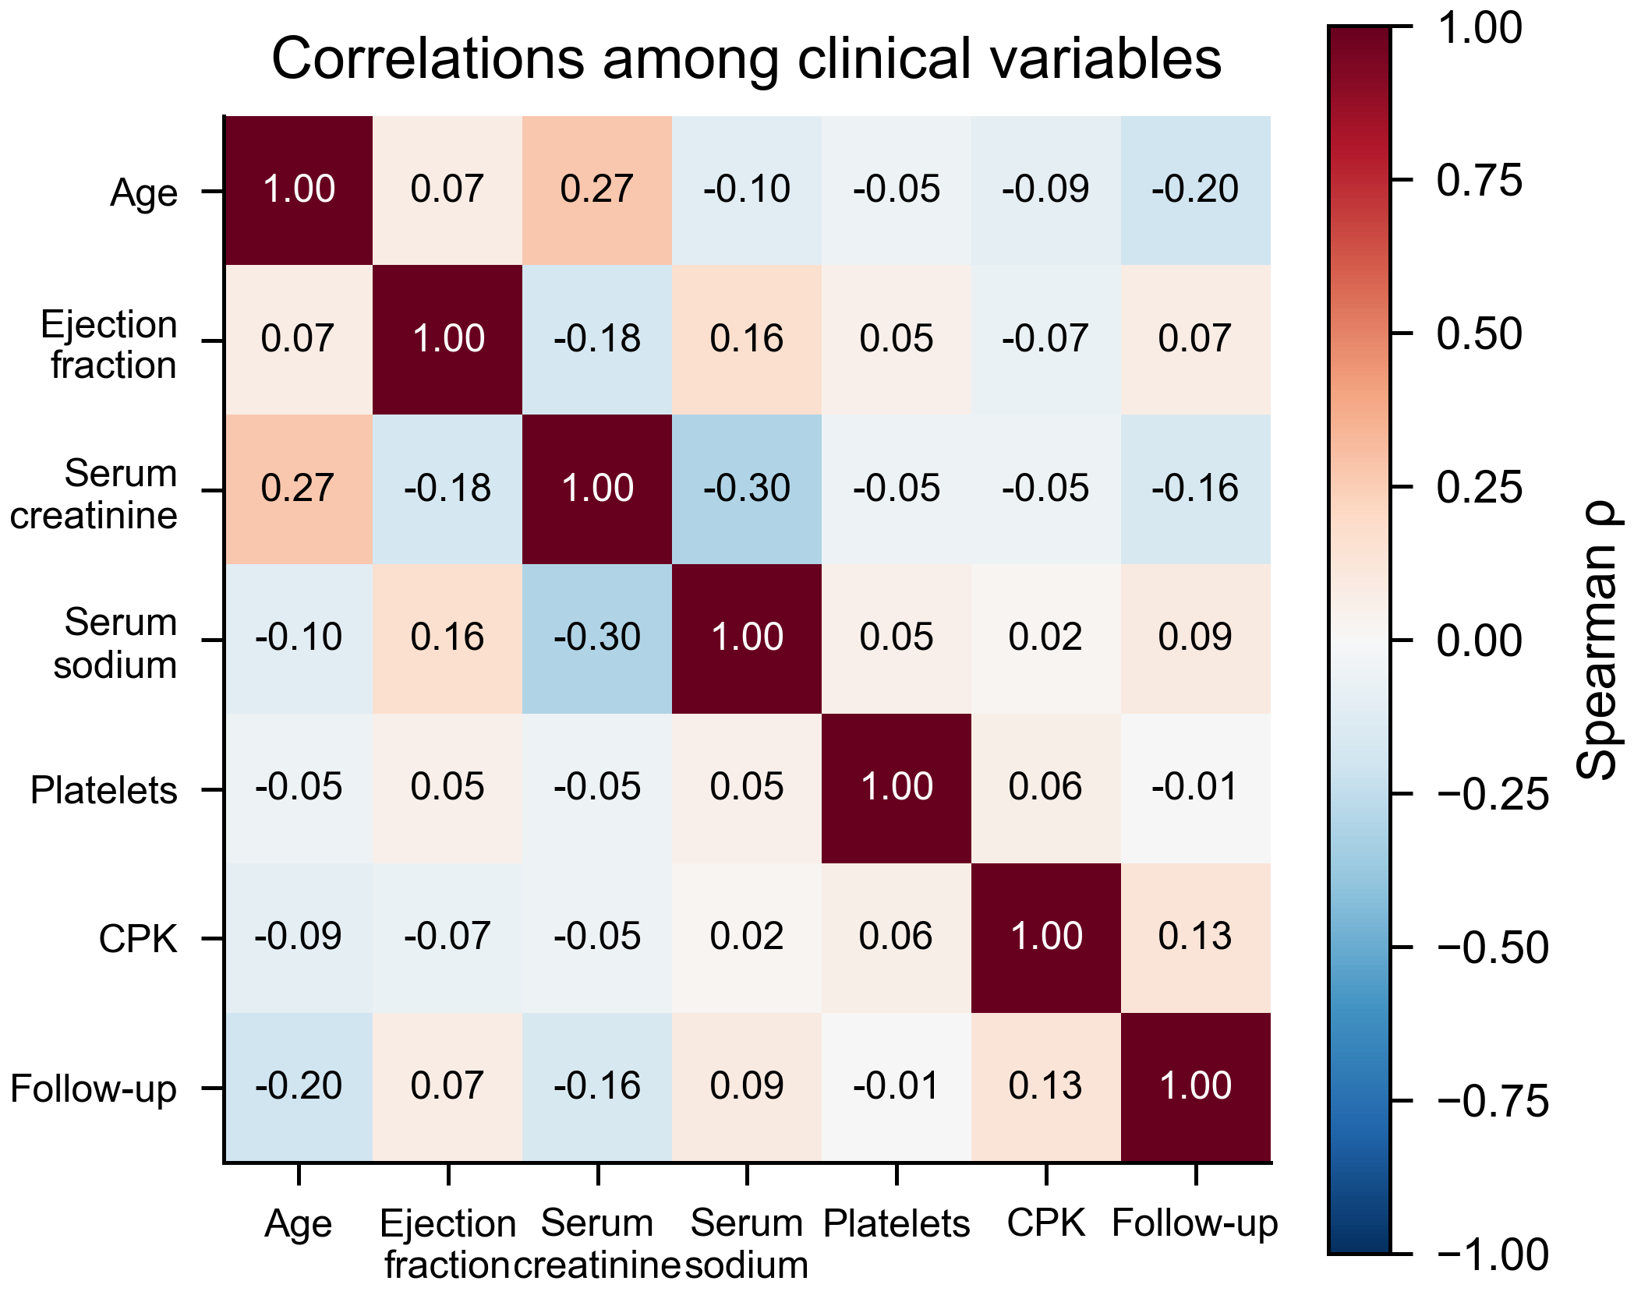
Claim: Predictors are weakly correlated — little collinearity.
Caption: Figure 5. Spearman correlations among continuous variables (diverging colormap centred at ρ=0; ρ annotated). Correlations are weak (|ρ|≤0.30), arguing against collinearity in the Cox model.
Annotations
- Method: Spearman (robust to skew)
- Colormap: diverging, centred at 0
Citation location: Results, diagnostics: "Predictors were weakly correlated, arguing against collinearity (Fig. 5)."
Reproducibility: scripts/make_fig5_correlation.py
Figure 6 — Two features vs full set (ROC)
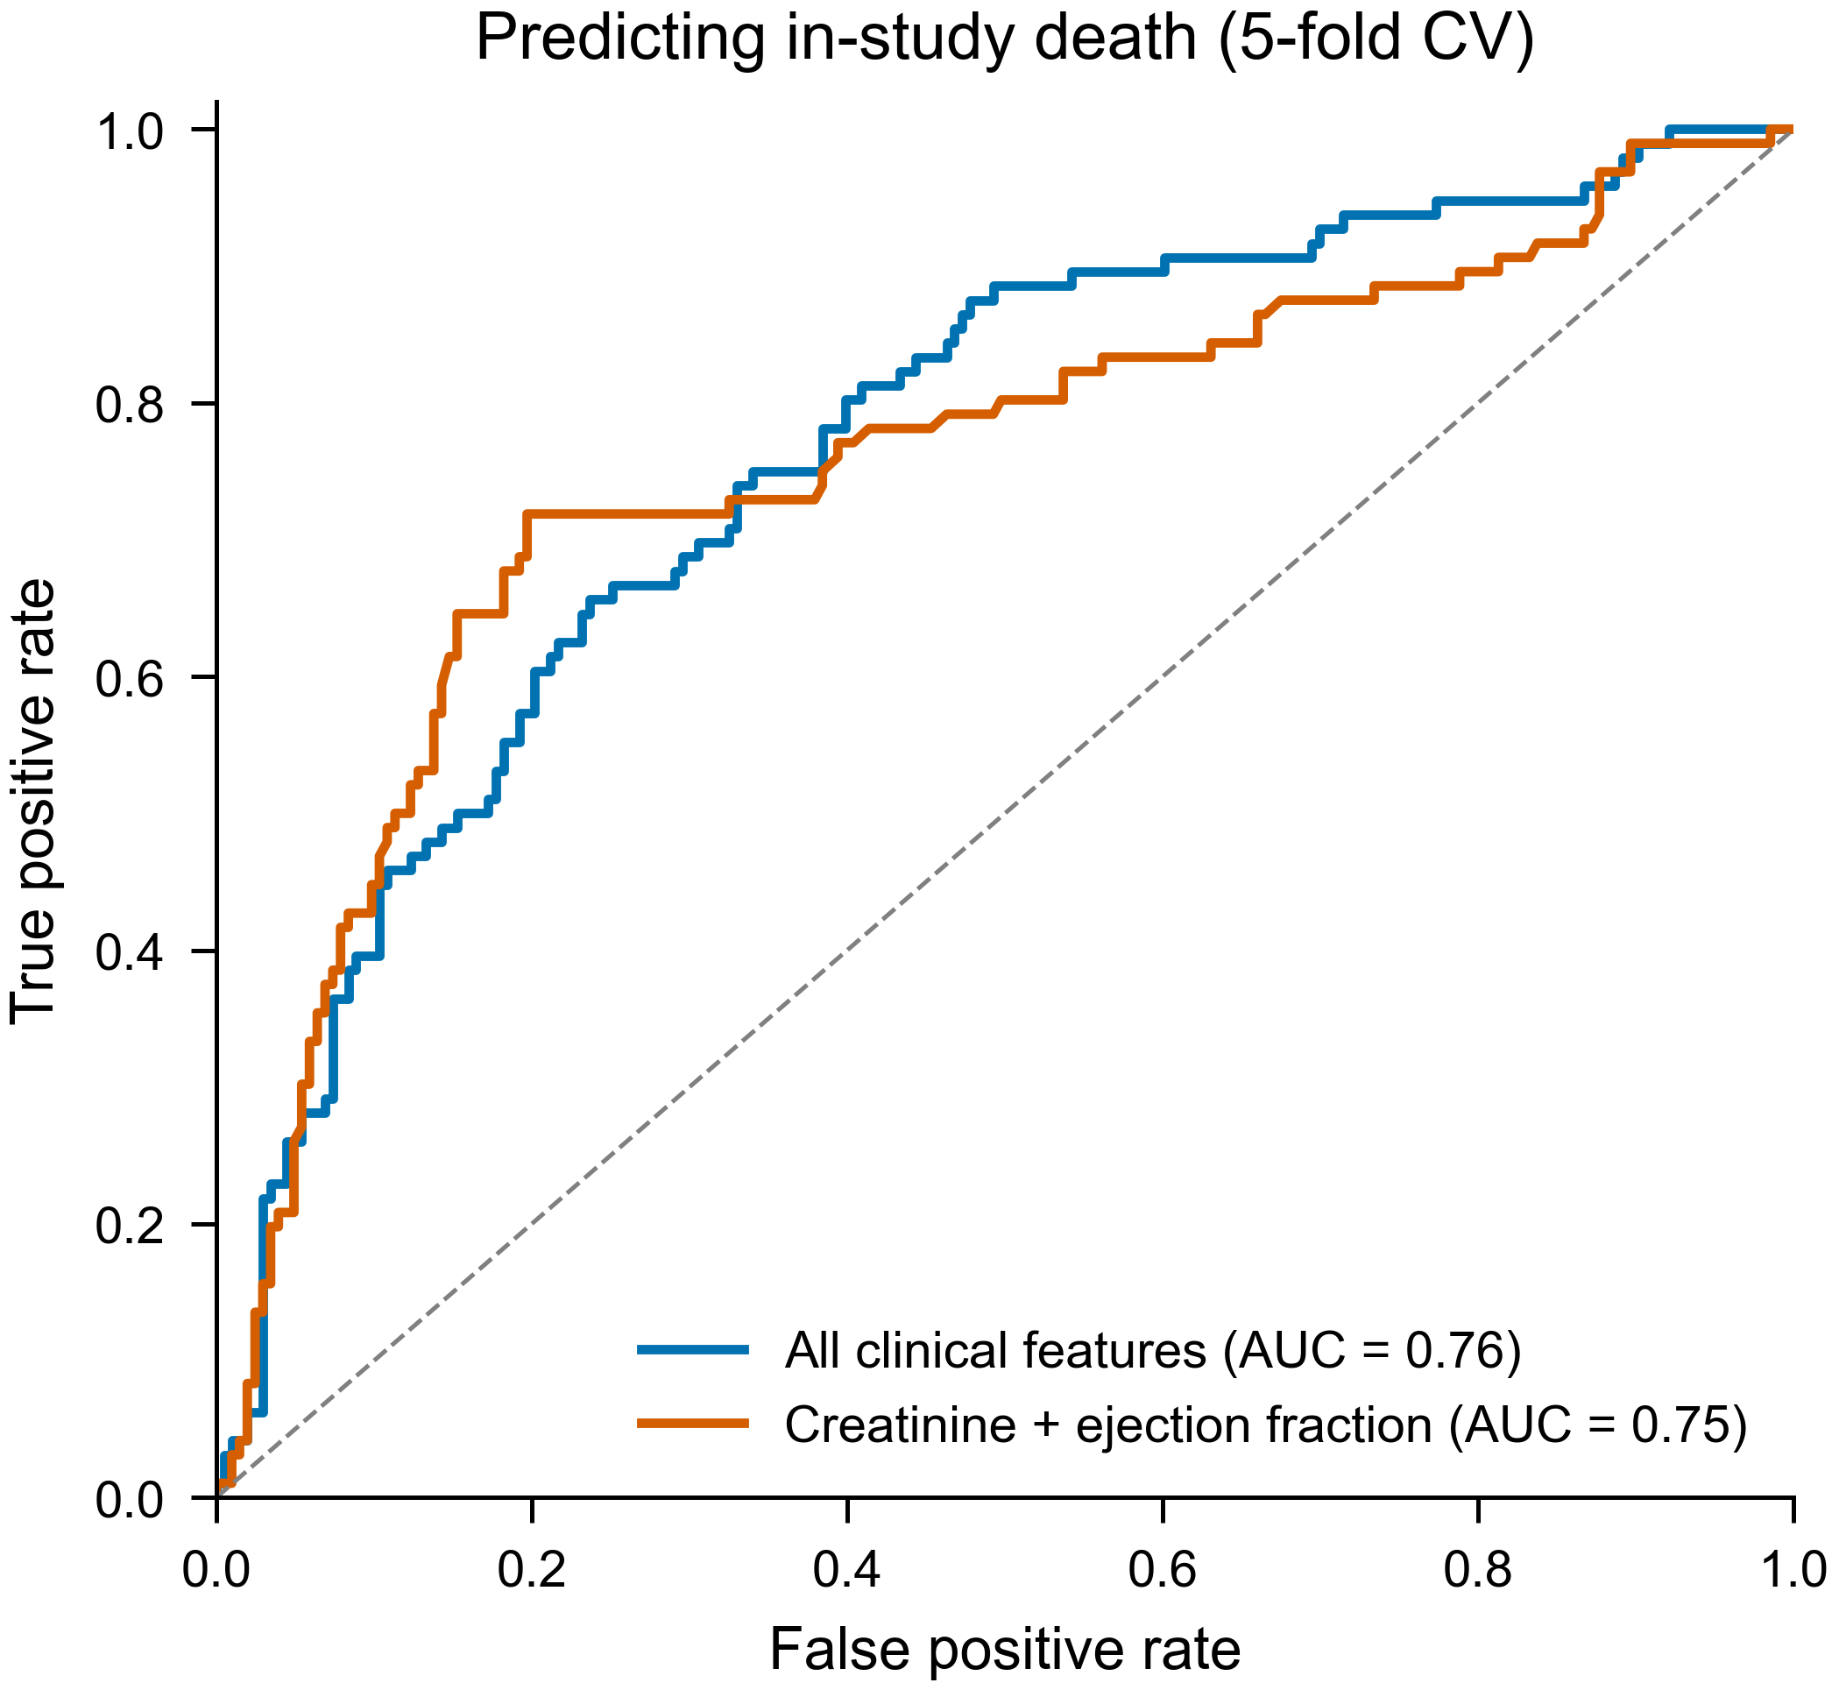
Claim: Serum creatinine + ejection fraction predict death almost as well as all features.
Caption: Figure 6. ROC for predicting in-study death (logistic regression, 5-fold cross-validated). A two-feature model — creatinine + ejection fraction (AUC=0.75) — nearly matched the full model (AUC=0.76). Follow-up time excluded to avoid leakage.
Annotations
- Validation: cross-validated AUC, not in-sample
- Leakage: `time` excluded as predictor
- Diagonal: chance line shown
Citation location: Discussion, parsimony: "Two features reproduced most of the full model's discrimination (Fig. 6)."
Reproducibility: scripts/make_fig6_roc.py
Table 1 — Baseline characteristics
Table 1. Baseline characteristics by survival status.
Characteristic | Survived (n=203) | Died (n=96) | p
Patients, n | 203 | 96 | nan
Age (years), median [IQR] | 60 [50–65] | 65 [55–75] | < 0.001
Ejection fraction (%), median [IQR] | 38 [35–45] | 30 [25–38] | < 0.001
Serum creatinine (mg/dL), median [IQR] | 1.00 [0.90–1.20] | 1.30 [1.08–1.90] | < 0.001
Serum sodium (mEq/L), median [IQR] | 137 [136–140] | 136 [133–138] | < 0.001
Platelets (×10³/µL), median [IQR] | 263 [220–302] | 258 [198–311] | 0.426
CPK (mcg/L), median [IQR] | 245 [109–582] | 259 [129–582] | 0.684
Male sex, n (%) | 132 (65%) | 62 (65%) | 1.000
Anaemia, n (%) | 83 (41%) | 46 (48%) | 0.307
Diabetes, n (%) | 85 (42%) | 40 (42%) | 1.000
Hypertension, n (%) | 66 (33%) | 39 (41%) | 0.214
Smoking, n (%) | 66 (33%) | 30 (31%) | 0.932
Continuous: median [IQR], Mann–Whitney U; binary: n (%), chi-square. Data: Chicco & Jurman (2020).
Claim: Cohort description and univariable differences.
Caption:
Annotations
- Continuous: median [IQR]
- Binary: n (%)
- p: univariable, unadjusted for follow-up
Citation location: Results, opening: "Baseline characteristics are summarized in Table 1."
Reproducibility: scripts/make_table1_baseline.py
Table 2 — Multivariable Cox model
Table 2. Multivariable Cox proportional-hazards model for mortality.
Predictor | HR [95% CI] | p
Age (per SD) | 1.74 [1.40, 2.16] | < 0.001
Ejection fraction (per SD) | 0.56 [0.44, 0.71] | < 0.001
Serum creatinine (per SD) | 1.39 [1.21, 1.61] | < 0.001
Serum sodium (per SD) | 0.82 [0.67, 1.01] | 0.058
Platelets (per SD) | 0.96 [0.77, 1.19] | 0.681
CPK (per SD) | 1.24 [1.03, 1.50] | 0.026
Male sex | 0.79 [0.48, 1.29] | 0.345
Anaemia | 1.58 [1.04, 2.42] | 0.034
Diabetes | 1.15 [0.74, 1.78] | 0.531
Hypertension | 1.61 [1.05, 2.46] | 0.028
Smoking | 1.14 [0.70, 1.86] | 0.608
HR with 95% CI; continuous predictors standardized (per 1 SD). C-index = 0.74; n=299, events=96. Data: Chicco & Jurman (2020).
Claim: Exact adjusted hazard ratios behind Fig. 4.
Caption:
Annotations
- Model: all covariates jointly
- Continuous: per 1 SD
- Fit: C-index reported
Citation location: Results, adjusted analysis: exact HRs cited alongside Fig. 4.
Reproducibility: scripts/make_table2_cox.py

