Figure & Table Report / 图表报告
Antarctic penguin morphometrics — paper-figures worked example / 南极企鹅形态学案例
Source paper / 来源论文: Gorman, Williams & Fraser (2014), PLOS ONE 9(3):e90081 (CC BY 4.0)
Data / 数据: palmerpenguins (CC0); data/penguins_raw.csv — one row = one penguin
Preset / 预设: generic high-quality (single/double column)
Generated by / 生成: paper-figures skill — matplotlib/seaborn, seed = 0
Asset index / 图表清单
# | File 文件 | Claim 结论
Fig 1 | Fig1.png | Flipper length and body mass differ among species; Gentoo largest.
Fig 2 | Fig2.png | Within every species, males are heavier than females.
Fig 3 | Fig3.png | Culmen length and depth are positively related within each species.
Fig 4 | Fig4.png | Flipper-length distributions are well separated across species.
Fig 5 | Fig5.png | Gentoo body mass is shifted to higher values.
Fig 6 | Fig6.png | Species occupy islands unevenly.
Fig 7 | Fig7.png | Body mass tracks flipper length; culmen depth runs opposite.
Fig 8 | Fig8.png | The four traits separate species in two dimensions.
Fig 9 | Fig9.png | The male–female body-mass effect is large in every species.
Table 1 | Table1.csv | Per-group morphometrics for reference.
Table 2 | Table2.csv | Exact test statistics behind Fig. 2.
Table 3 | Table3.csv | Documents the analysed sample.
Figure 1 — Body size among species
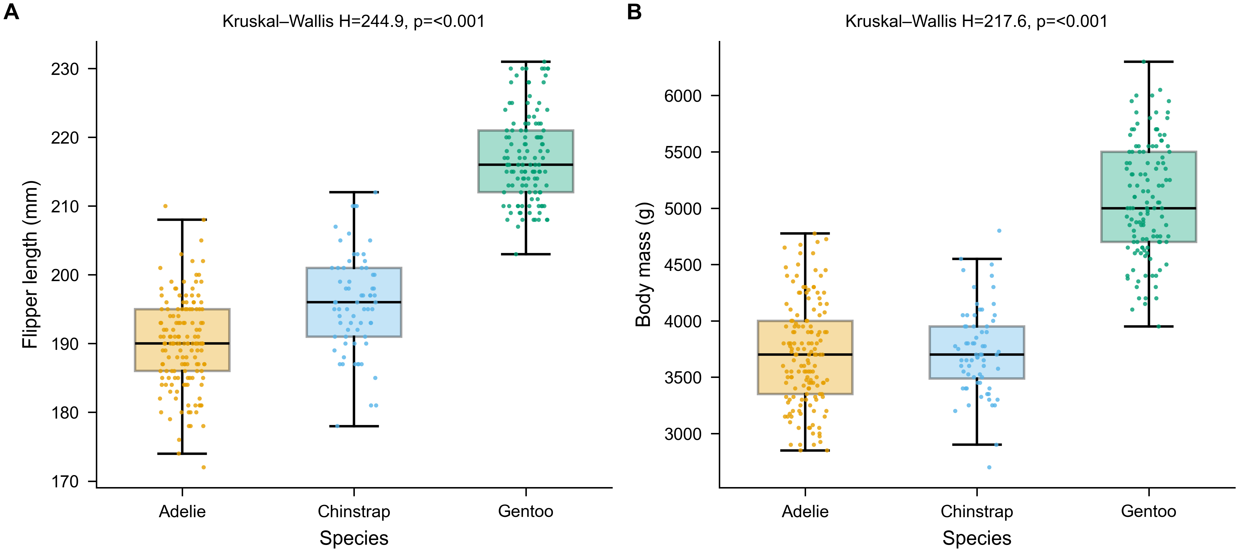
Claim / 论证: Flipper length and body mass differ among species; Gentoo largest.
Caption (EN): Figure 1. Body size differs among penguin species. (A) Flipper length and (B) body mass for Adélie (n=151), Chinstrap (n=68) and Gentoo (n=123); birds missing the measurement are excluded. Box = median + IQR; points = individual birds. Kruskal–Wallis (A: H=244.9; B: H=217.6; both p<0.001).
图注 (中文): 图 1。企鹅体型存在物种差异。(A)鳍长、(B)体重,阿德利(n=151)、帽带(n=68)、巴布亚(n=123);缺测个体已剔除。箱体=中位数+四分位距,散点=个体。Kruskal–Wallis(A:H=244.9;B:H=217.6;p 均<0.001)。
Annotations / 标注
- Test 检验: non-parametric Kruskal–Wallis
- Spread 离散: full distribution shown (no error bars)
- Color 配色: Okabe–Ito, colorblind-safe
Citation location / 引用位置: Results, body-size paragraph: "Gentoo were largest in flipper length and body mass (Fig. 1)."
Reproducibility / 可复现: scripts/make_fig1_morphometrics.py
Figure 2 — Sexual size dimorphism
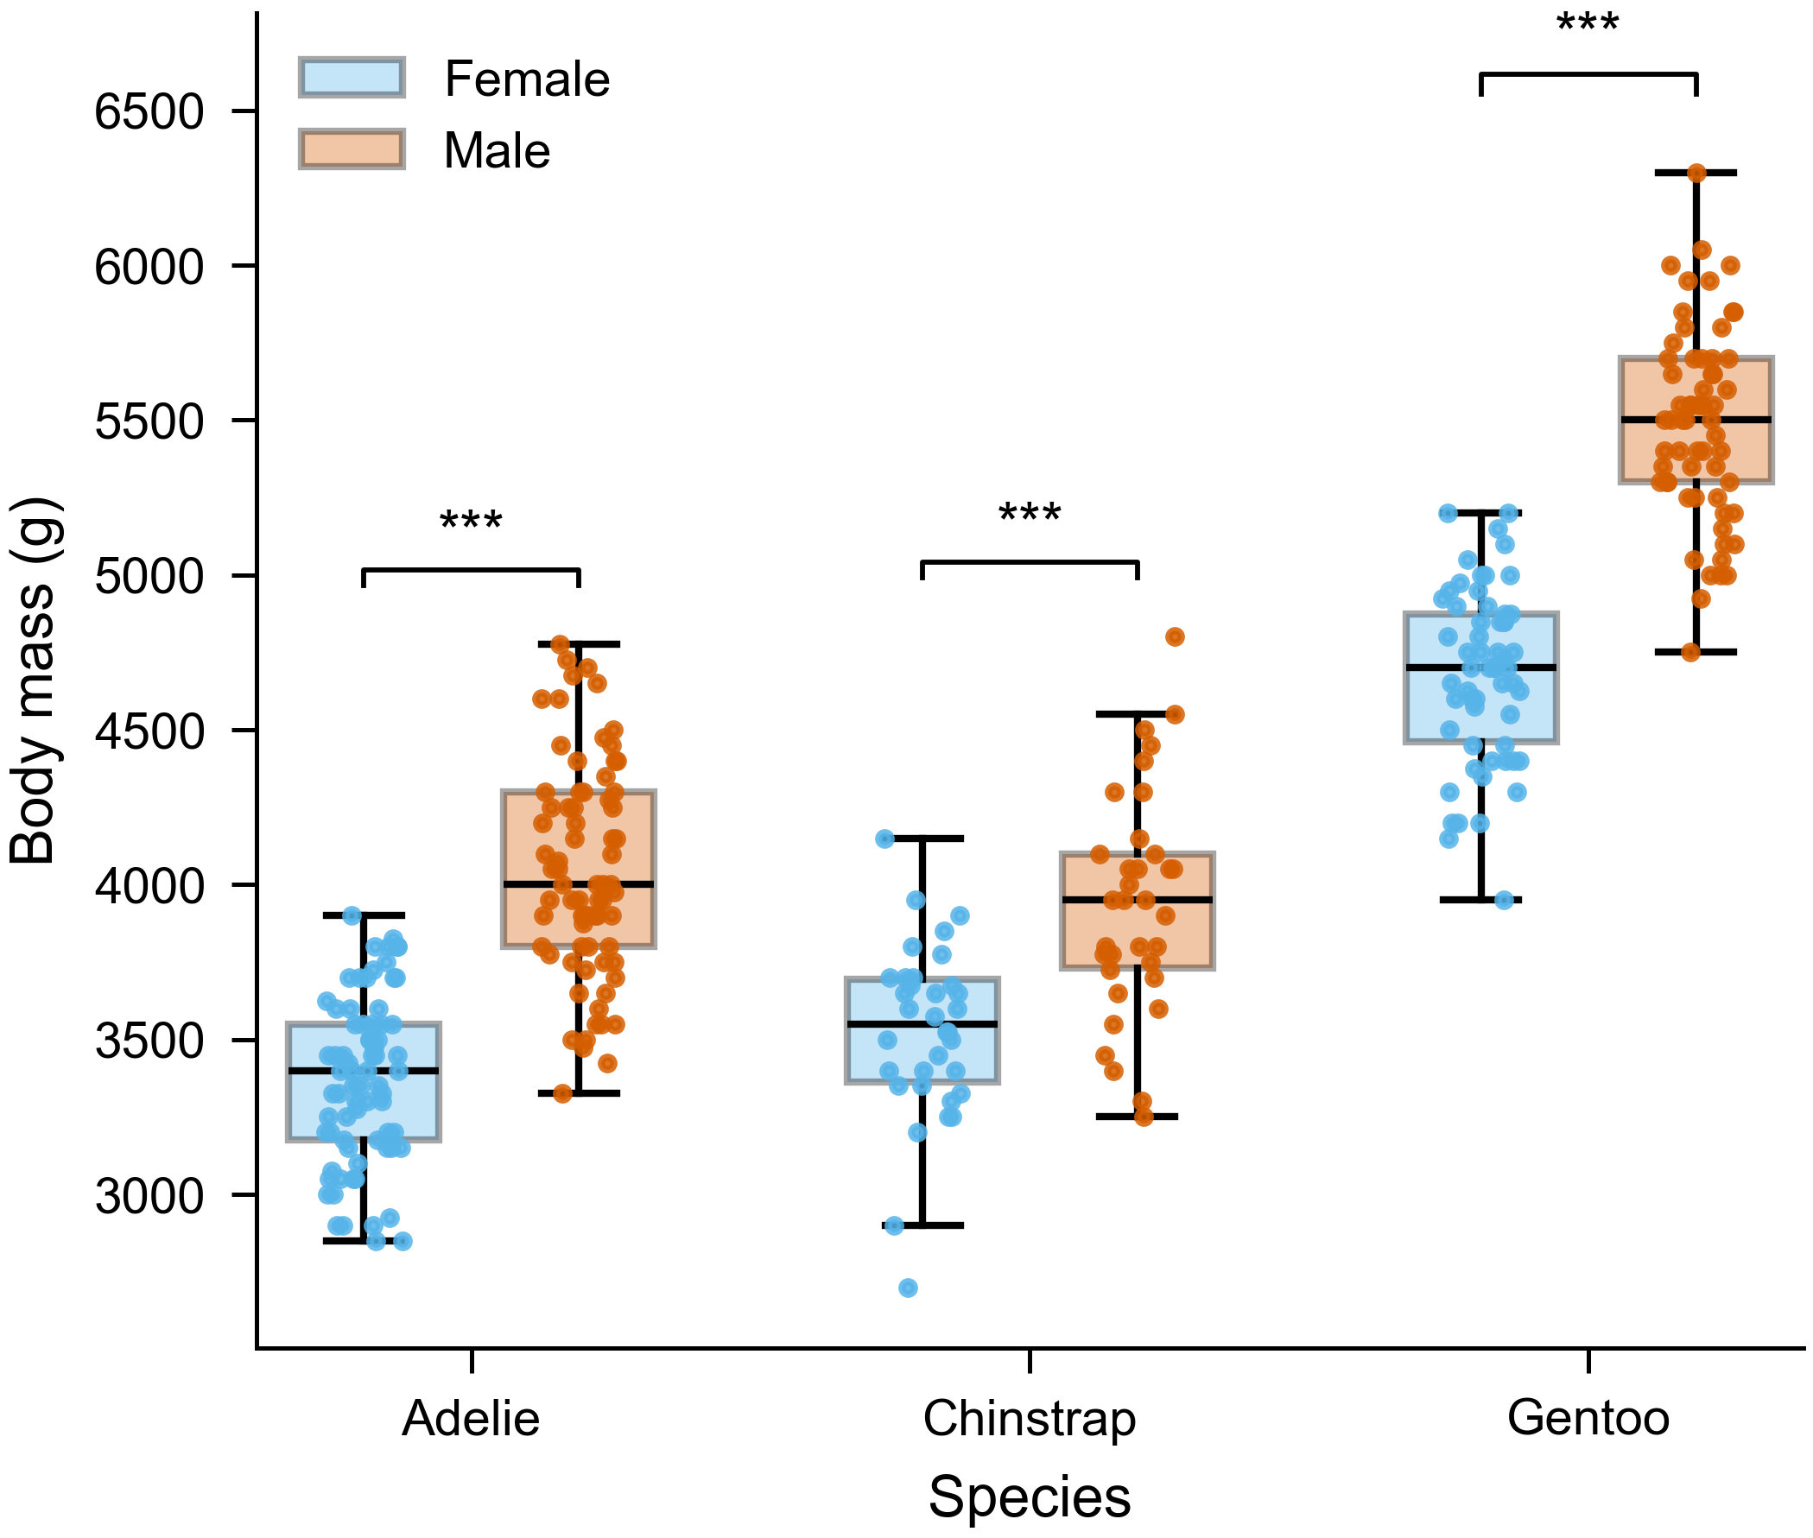
Claim / 论证: Within every species, males are heavier than females.
Caption (EN): Figure 2. Sexual size dimorphism in body mass. Males (orange) exceed females (blue) within each species. Per-species Welch's t-test; ***p<0.001 (Adélie t=13.1, g=2.16; Chinstrap t=5.2, g=1.25; Gentoo t=14.8, g=2.68).
图注 (中文): 图 2。体重的性体型二态。各物种内雄性(橙)大于雌性(蓝)。各物种 Welch t 检验;***p<0.001(阿德利 t=13.1,g=2.16;帽带 t=5.2,g=1.25;巴布亚 t=14.8,g=2.68)。
Annotations / 标注
- Test: Welch's t-test (unequal variance)
- Effect size 效应量: Hedges' g, large in all
- Markers: ***p<0.001
Citation location / 引用位置: Results, "Sexual dimorphism": "Males were heavier across all species (Fig. 2; Table 2)."
Reproducibility / 可复现: scripts/make_fig2_dimorphism.py
Figure 3 — Culmen shape relationship
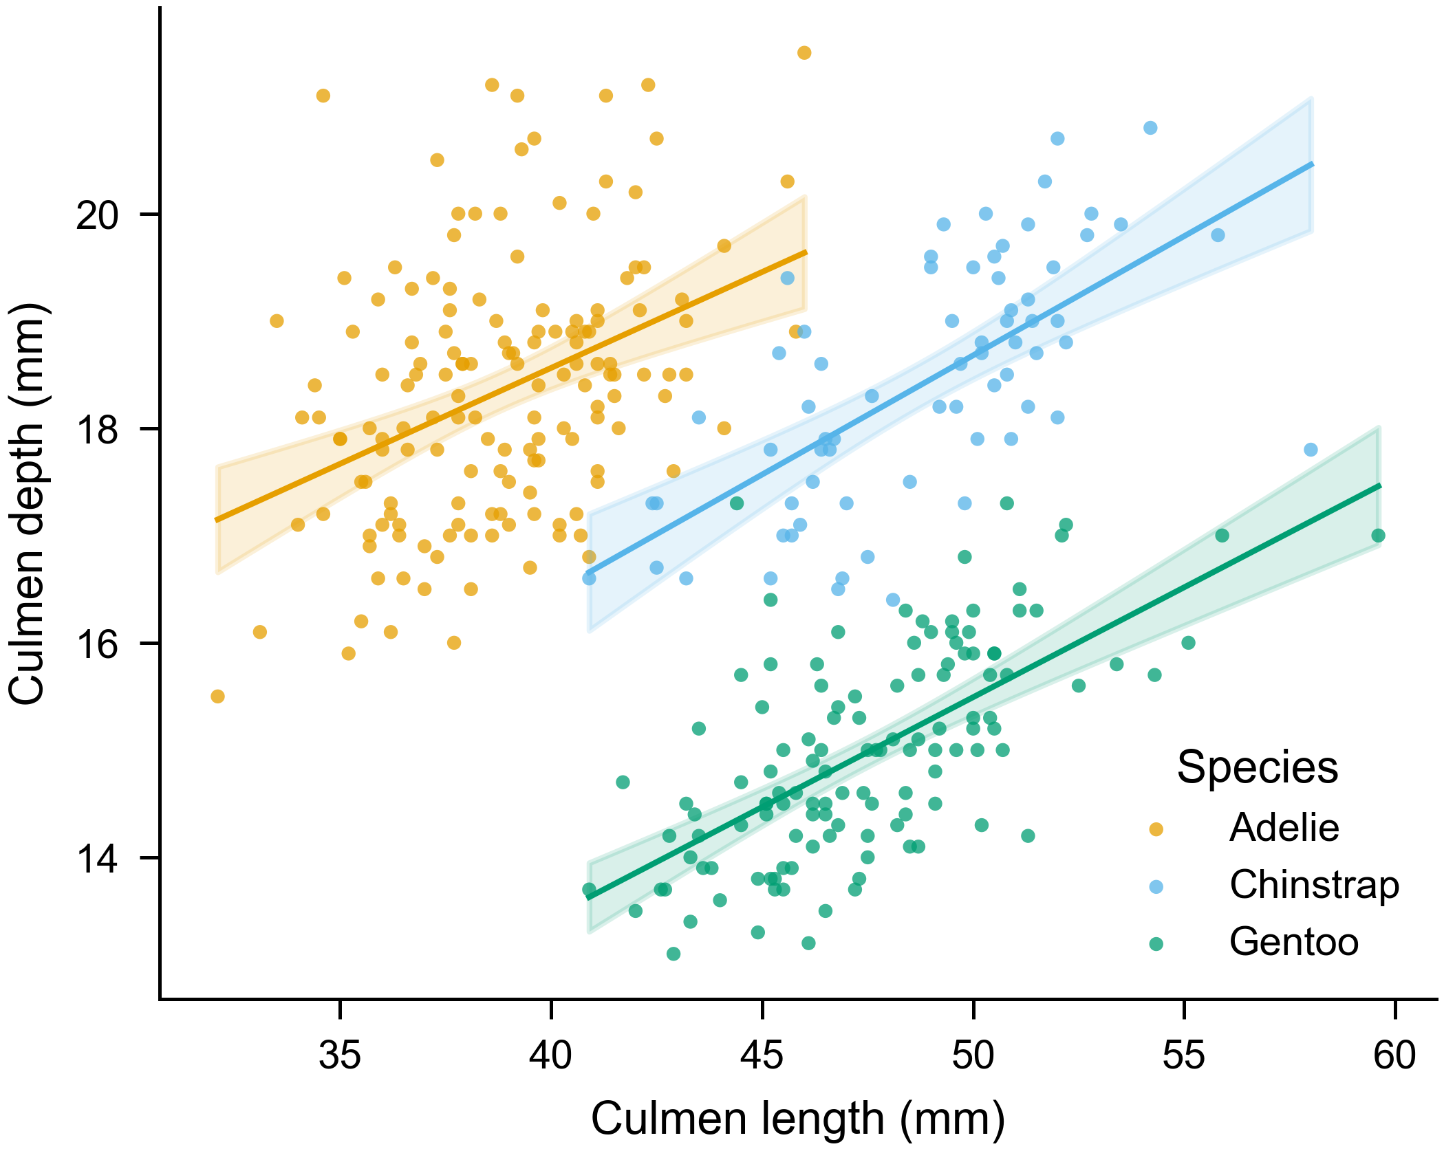
Claim / 论证: Culmen length and depth are positively related within each species.
Caption (EN): Figure 3. Culmen length vs depth with per-species OLS fits and 95% confidence bands. Positive within each species, though pooling reverses the slope (Simpson's paradox) — hence species-specific fits.
图注 (中文): 图 3。喙长 vs 喙深,按物种分别拟合最小二乘回归及 95% 置信带。各物种内正相关;合并则斜率反转(辛普森悖论),故采用分物种拟合。
Annotations / 标注
- Axes: x = culmen length (mm), y = culmen depth (mm)
- Band: 95% CI of the fitted mean
Citation location / 引用位置: Results, trait covariation: "Deeper culmens accompanied longer culmens within species (Fig. 3)."
Reproducibility / 可复现: scripts/make_fig3_scatter_regression.py
Figure 4 — Flipper-length distribution (raincloud)
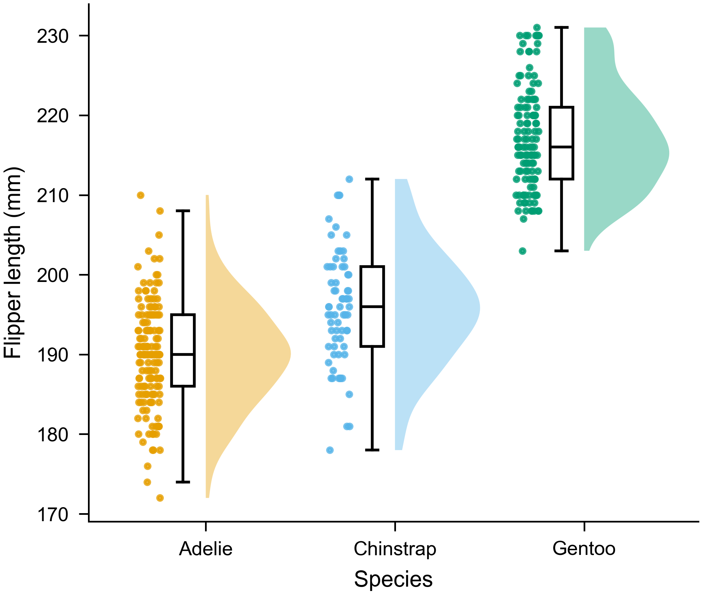
Claim / 论证: Flipper-length distributions are well separated across species.
Caption (EN): Figure 4. Flipper length by species as a raincloud: half-violin (density), box (median + IQR) and jittered points (individuals). Gentoo show clearly longer flippers.
图注 (中文): 图 4。各物种鳍长云雨图:半小提琴(密度)、箱体(中位数+四分位距)与抖动散点(个体)。巴布亚鳍长明显更大。
Annotations / 标注
- Shows: density + summary + raw data at once
- n: 152 / 68 / 124
Citation location / 引用位置: Results, flipper length: "Distributions barely overlapped between Gentoo and the others (Fig. 4)."
Reproducibility / 可复现: scripts/make_fig4_raincloud.py
Figure 5 — Body-mass distribution
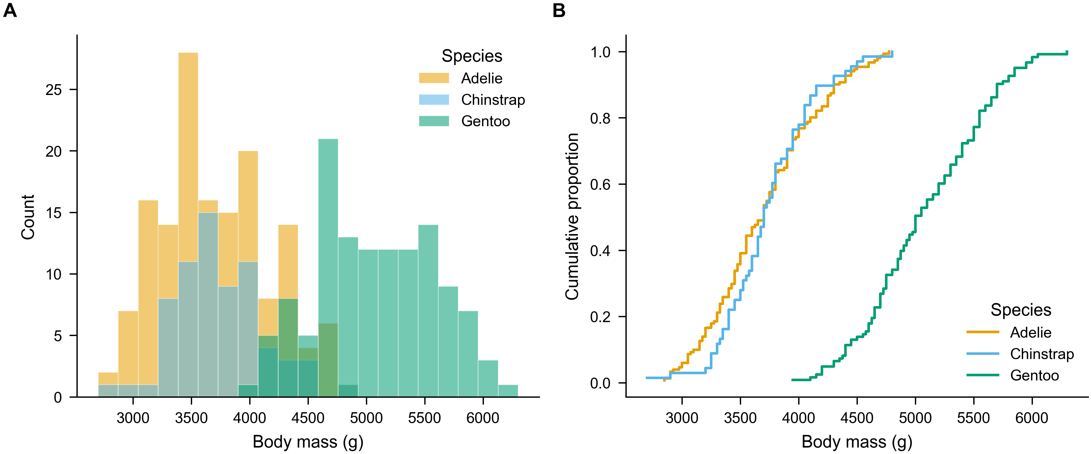
Claim / 论证: Gentoo body mass is shifted to higher values.
Caption (EN): Figure 5. Body-mass distribution by species. (A) Overlaid histograms (22 bins); (B) empirical CDFs. The ECDF shows Gentoo shifted entirely rightward of Adélie and Chinstrap.
图注 (中文): 图 5。各物种体重分布。(A)叠加直方图(22 区间);(B)经验累积分布。ECDF 显示巴布亚整体右移于阿德利与帽带。
Annotations / 标注
- A: histogram, bin width stated
- B: ECDF — binning-free, ideal for comparison
Citation location / 引用位置: Results, mass distribution: "Gentoo body mass scarcely overlapped the other species (Fig. 5)."
Reproducibility / 可复现: scripts/make_fig5_distribution.py
Figure 6 — Species across islands
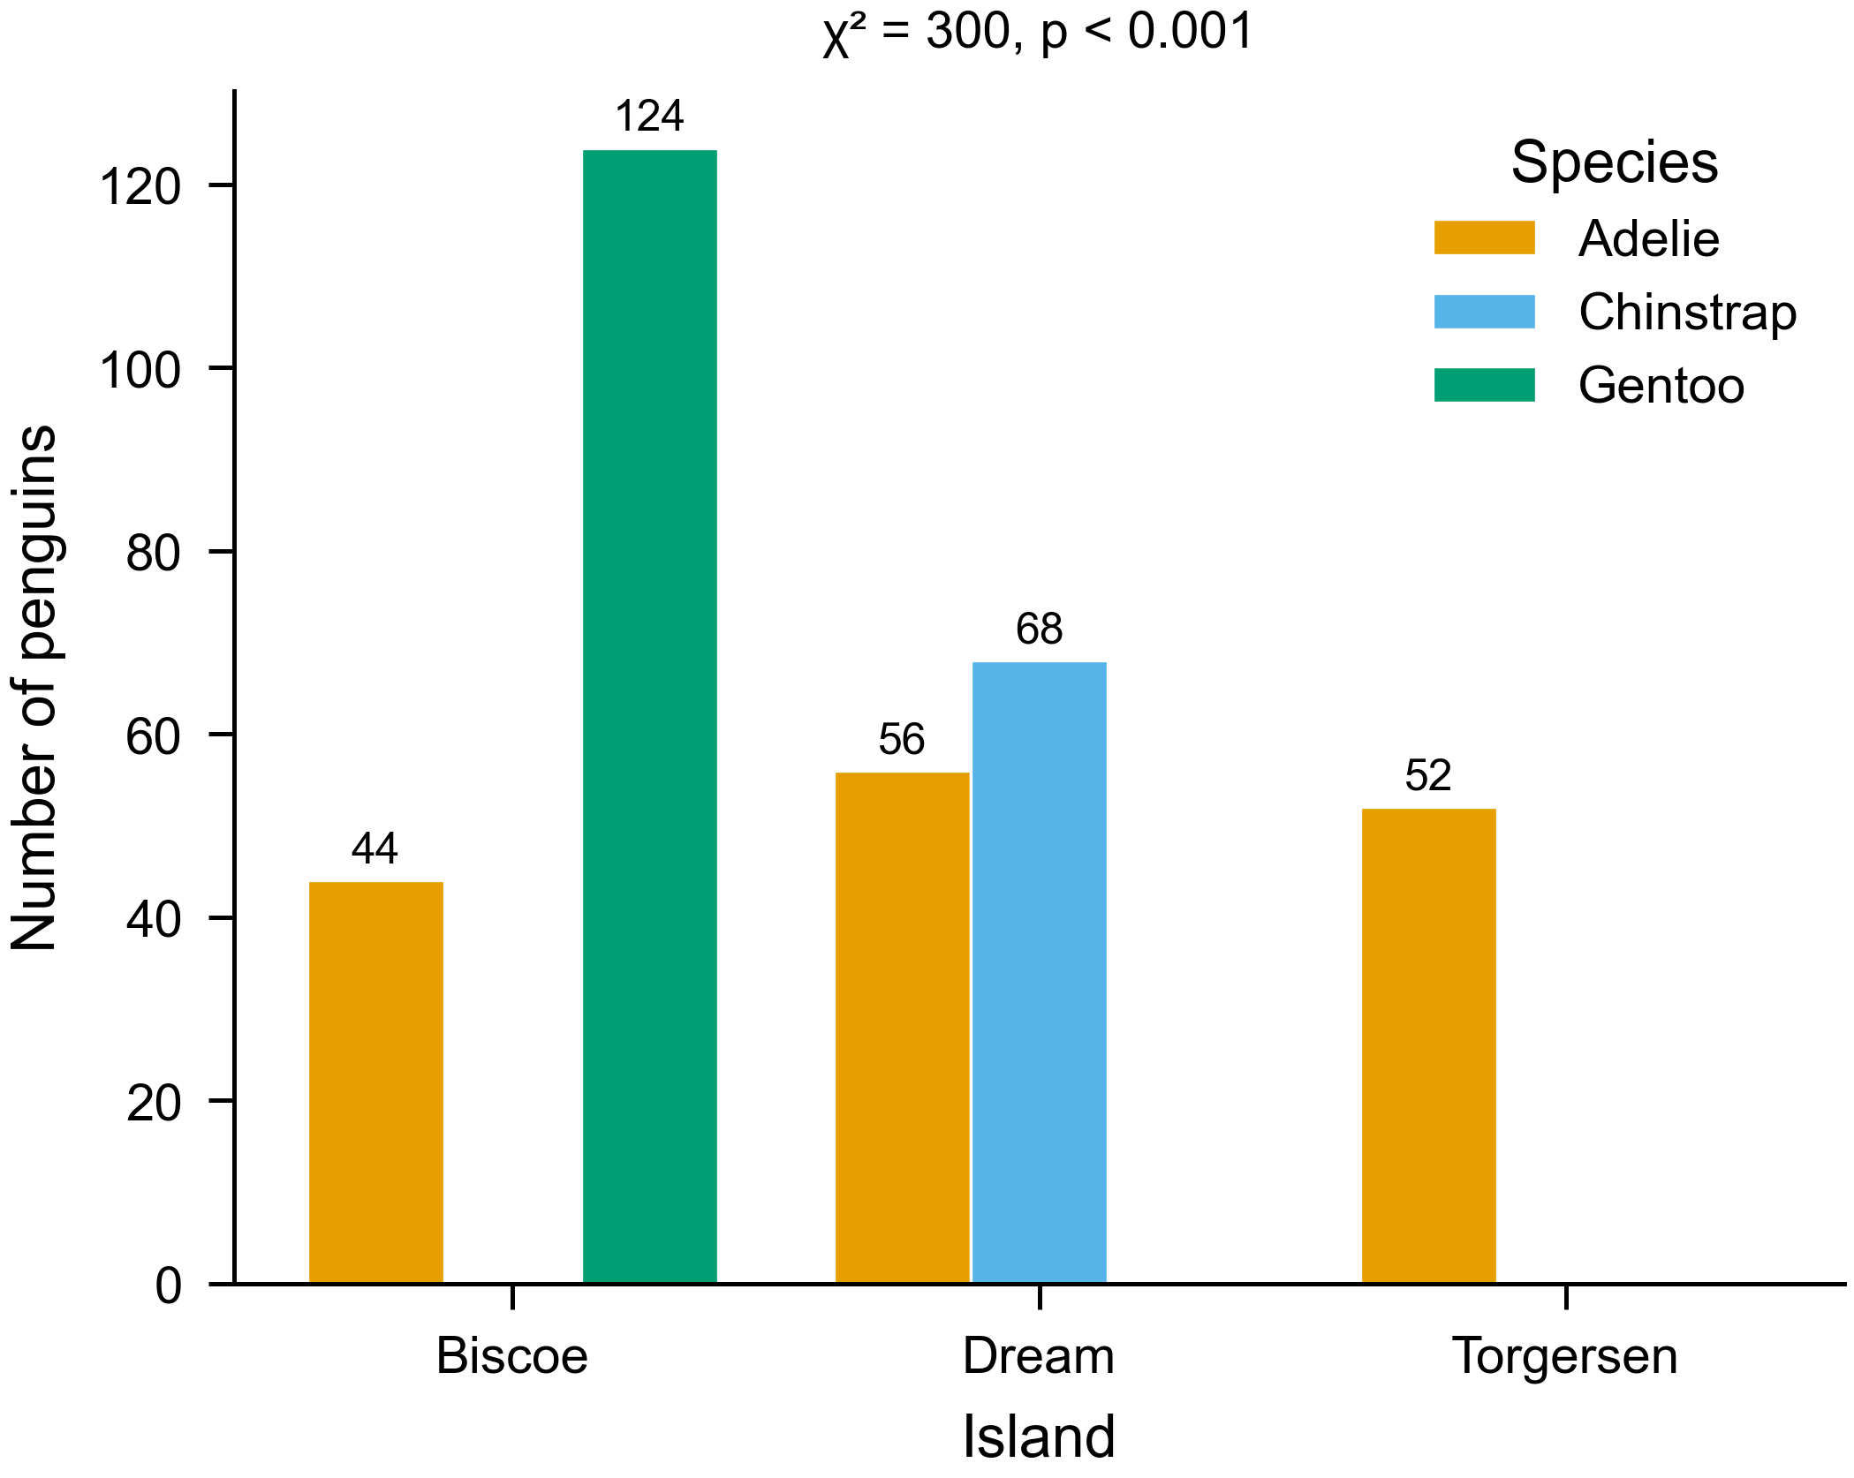
Claim / 论证: Species occupy islands unevenly.
Caption (EN): Figure 6. Penguins sampled per island and species (counts on bars; bars from zero). Species and island are strongly associated (χ²≈300, p<0.001).
图注 (中文): 图 6。各岛各物种采样数量(柱顶标注计数,柱从零起)。物种与岛屿强关联(χ²≈300,p<0.001)。
Annotations / 标注
- Bars: counts, baseline at zero
- Test: chi-square of association
Citation location / 引用位置: Methods/Results, sampling: "Sampling by island and species is shown in Fig. 6 (see Table 3)."
Reproducibility / 可复现: scripts/make_fig6_bar_counts.py
Figure 7 — Trait correlations
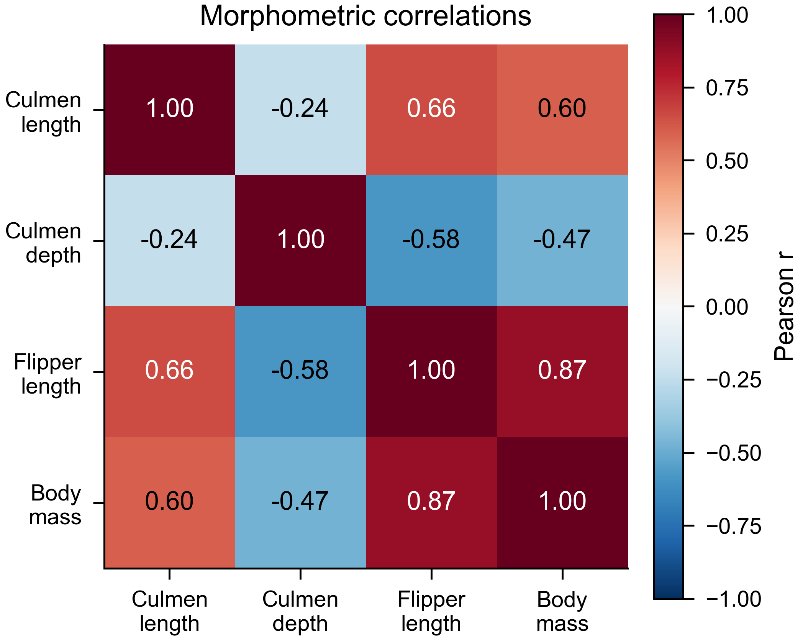
Claim / 论证: Body mass tracks flipper length; culmen depth runs opposite.
Caption (EN): Figure 7. Pearson correlations among four morphometric traits. Diverging colormap centred at r=0; r annotated. Flipper length and body mass correlate most (r=0.87).
图注 (中文): 图 7。四项形态性状的 Pearson 相关。发散色标以 r=0 为中心,标注 r。鳍长与体重相关最强(r=0.87)。
Annotations / 标注
- Colormap: diverging, centred at 0
- Cells: r annotated
Citation location / 引用位置: Results, trait structure: "Flipper length and body mass were tightly coupled (Fig. 7)."
Reproducibility / 可复现: scripts/make_fig7_corr_heatmap.py
Figure 8 — Morphometric space (PCA)
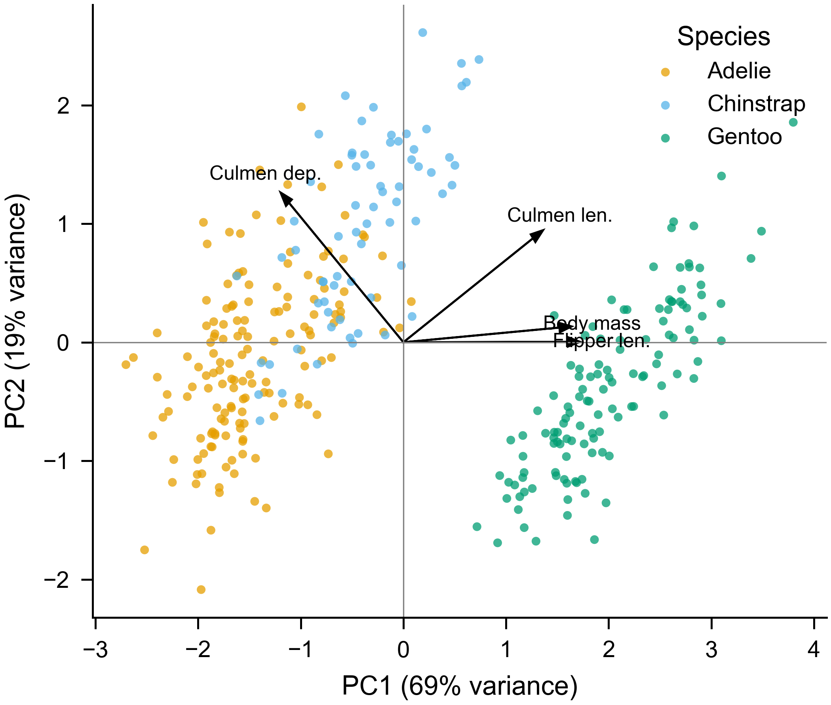
Claim / 论证: The four traits separate species in two dimensions.
Caption (EN): Figure 8. PCA of four z-scored traits. Points coloured by species; arrows are trait loadings. PC1 (69%) separates Gentoo; PC2 (19%) reflects culmen depth.
图注 (中文): 图 8。四项标准化性状的主成分分析。散点按物种着色,箭头为载荷。PC1(69%)区分巴布亚;PC2(19%)反映喙深。
Annotations / 标注
- Preprocessing: traits z-scored before PCA
- Axes: % variance explained
Citation location / 引用位置: Results, multivariate: "A PCA of morphometrics cleanly separated the species (Fig. 8)."
Reproducibility / 可复现: scripts/make_fig8_pca.py
Figure 9 — Dimorphism effect sizes (forest)
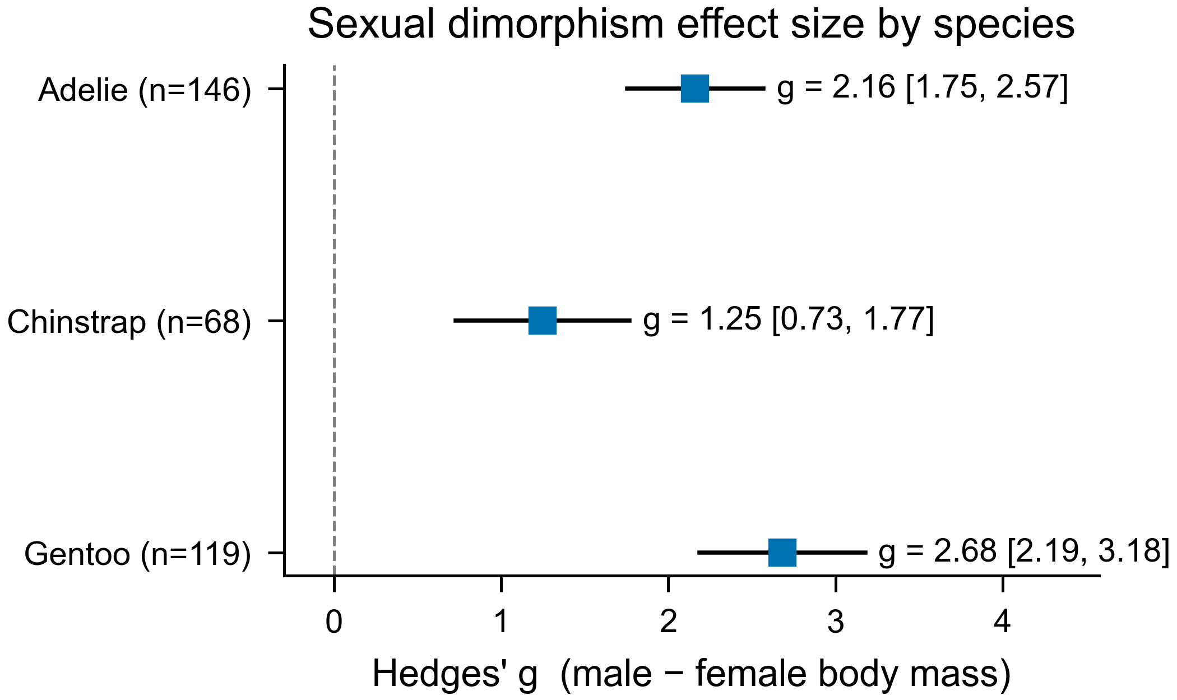
Claim / 论证: The male–female body-mass effect is large in every species.
Caption (EN): Figure 9. Standardized male–female body-mass difference (Hedges' g) per species with 95% CIs; dashed line at g=0. All intervals lie well above zero (Adélie 2.16; Chinstrap 1.25; Gentoo 2.68).
图注 (中文): 图 9。各物种雄减雌体重的标准化差异(Hedges' g)及 95% CI;虚线为 g=0。所有区间均明显大于零(阿德利 2.16;帽带 1.25;巴布亚 2.68)。
Annotations / 标注
- Point: g
- Line: 95% CI
- Reference: dashed at 0
Citation location / 引用位置: Discussion, effect magnitude: "Dimorphism was not merely significant but large (Fig. 9)."
Reproducibility / 可复现: scripts/make_fig9_forest.py
Table 1 — Morphometric summary
Table 1. Morphometric measurements (mean ± SD) by species and sex.
Species | Sex | n | Culmen length (mm) | Culmen depth (mm) | Flipper length (mm) | Body mass (g)
Adelie | Female | 73 | 37.3 ± 2.0 | 17.6 ± 0.9 | 188 ± 6 | 3369 ± 269
Adelie | Male | 73 | 40.4 ± 2.3 | 19.1 ± 1.0 | 192 ± 7 | 4043 ± 347
Chinstrap | Female | 34 | 46.6 ± 3.1 | 17.6 ± 0.8 | 192 ± 6 | 3527 ± 285
Chinstrap | Male | 34 | 51.1 ± 1.6 | 19.3 ± 0.8 | 200 ± 6 | 3939 ± 362
Gentoo | Female | 58 | 45.6 ± 2.1 | 14.2 ± 0.5 | 213 ± 4 | 4680 ± 282
Gentoo | Male | 61 | 49.5 ± 2.7 | 15.7 ± 0.7 | 222 ± 6 | 5485 ± 313
n = number of penguins. Data: Gorman et al. (2014).
Claim / 论证: Per-group morphometrics for reference.
Annotations / 标注
- Statistic: mean ± SD
- n: stated per group
Citation location / 引用位置: Results, opening: "Morphometrics by species and sex are summarized in Table 1."
Reproducibility / 可复现: scripts/make_table1_summary.py
Table 2 — Sexual dimorphism tests
Table 2. Sexual dimorphism by species and trait (Welch's t-test).
Species | Trait | Female (mean ± SD) | Male (mean ± SD) | t | df | p | Hedges' g [95% CI]
Adelie | Culmen length (mm) | 37.3 ± 2.0 | 40.4 ± 2.3 | 8.78 | 142.1 | < 0.001 | 1.45 [1.08, 1.81]
Adelie | Culmen depth (mm) | 17.6 ± 0.9 | 19.1 ± 1.0 | 8.93 | 143.1 | < 0.001 | 1.47 [1.10, 1.84]
Adelie | Flipper length (mm) | 188 ± 6 | 192 ± 7 | 4.56 | 140.2 | < 0.001 | 0.75 [0.41, 1.09]
Adelie | Body mass (g) | 3369 ± 269 | 4043 ± 347 | 13.13 | 135.7 | < 0.001 | 2.16 [1.75, 2.57]
Chinstrap | Culmen length (mm) | 46.6 ± 3.1 | 51.1 ± 1.6 | 7.57 | 48.7 | < 0.001 | 1.82 [1.25, 2.38]
Chinstrap | Culmen depth (mm) | 17.6 ± 0.8 | 19.3 ± 0.8 | 8.9 | 66.0 | < 0.001 | 2.13 [1.54, 2.73]
Chinstrap | Flipper length (mm) | 192 ± 6 | 200 ± 6 | 5.75 | 65.9 | < 0.001 | 1.38 [0.85, 1.91]
Chinstrap | Body mass (g) | 3527 ± 285 | 3939 ± 362 | 5.21 | 62.6 | < 0.001 | 1.25 [0.73, 1.77]
Gentoo | Culmen length (mm) | 45.6 ± 2.1 | 49.5 ± 2.7 | 8.88 | 111.3 | < 0.001 | 1.61 [1.19, 2.02]
Gentoo | Culmen depth (mm) | 14.2 ± 0.5 | 15.7 ± 0.7 | 12.49 | 109.7 | < 0.001 | 2.26 [1.80, 2.72]
Gentoo | Flipper length (mm) | 213 ± 4 | 222 ± 6 | 9.94 | 106.7 | < 0.001 | 1.80 [1.37, 2.22]
Gentoo | Body mass (g) | 4680 ± 282 | 5485 ± 313 | 14.76 | 116.6 | < 0.001 | 2.68 [2.19, 3.18]
Male vs female; g = Hedges' g (positive = males larger). Data: Gorman et al. (2014).
Claim / 论证: Exact test statistics behind Fig. 2.
Annotations / 标注
- Test: Welch's t; Welch–Satterthwaite df
- Effect: Hedges' g with 95% CI
Citation location / 引用位置: Results, "Sexual dimorphism": cited alongside Fig. 2 for exact statistics.
Reproducibility / 可复现: scripts/make_table2_dimorphism_stats.py
Table 3 — Sample composition
Table 3. Sample composition by species, island and sex (number of penguins).
Species | Island | Female | Male | Unknown | Total
Adelie | Biscoe | 22 | 22 | 0 | 44
Adelie | Dream | 27 | 28 | 1 | 56
Adelie | Torgersen | 24 | 23 | 5 | 52
Chinstrap | Dream | 34 | 34 | 0 | 68
Gentoo | Biscoe | 58 | 61 | 5 | 124
All | — | 165 | 168 | 11 | 344
Unknown = sex not determined. Data: Gorman et al. (2014).
Claim / 论证: Documents the analysed sample.
Annotations / 标注
- Counts: with row and grand totals
Citation location / 引用位置: Methods, study sample: "The analysed sample is detailed in Table 3."
Reproducibility / 可复现: scripts/make_table3_composition.py

