# **Capstone Project Report**

By Dharmendrasinh Raj

## Introduction / Business Problem

When one has to move to a different area or city/town that they are not familiar with, it is diffiuct to make a decision on where to settledown which fulfills the need of the person. For example while moving to a totally new city while changing a job.

The person might have different needs such as if someone is having school going kids, they may want to stay to a place where the schools, playgrounds are nearby. Someone who frequently travels by air may want to stay in an area which is in proximity to Airport and has an ease of public transport.

One may also rent a place temporary and then look out for preferred areas. But this is a time-consurming process and moving from one place to another can result in excessive cost.

For a small places/towns, it is easy to identify such areas. However, in big cities, this becomes a challenge.

The project aims to address this problem by suggesting the areas that matches the desired facilities criteria of a person.

## Data

Following datasets/APIs will be used the solve the problem –

1. FourSquare (<https://foursquare.com/>)

* Venue search API – this API returns a list of venues near the given location (coordinates) that matches a search criteria.
* API Request URL – <https://api.foursquare.com/v2/venues/search>
* Full API Document Reference – <https://developer.foursquare.com/docs/api-reference/venues/search/>

1. OpenCage Geocoder (<https://opencagedata.com/api>)

* Reverse geocoding API – this API provides reverse geocoding (lat/long to text) i.e. returns the location name from coordinates.
* API Request URL – <https://api.opencagedata.com/geocode/v1/json>
* Full API Document Reference – <https://opencagedata.com/api#request>

1. Facilities dataset – this is a local dataset of facilities that contains the list of facilities that the user can decide to choose from e.g. School, Bank, Hospital, Sports center etc. The dataset is created manually.

The dataset will look something like below:

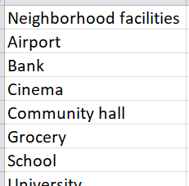

1. Coordinates dataset – this is a local dataset that contains the list of cities in India and their respective coordinates. The data has been extracted from Simple Maps website (<https://simplemaps.com/data/in-cities>)

The dataset will look something like below:

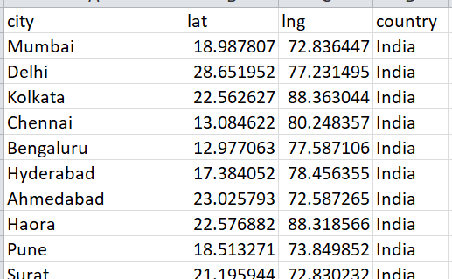

## Methodology

## Results

## Conclusion