

**Science Exhibition**Student Benefits Card



By :

Dharmendra Nama (KID : K14249)

Juli Kumari (KID : K15409

Course : MCA (3th Sem)

**Questions.Com**

**Introduction**

**Questions.com** is a online asking question Web App. In this Site Lot of student get help to asking and given answer to related question. Teachers and students and Guardian will be get and post there question and get answer by another teachers and student that are master of that question. It will help to improve your performance. And it is Free of Cost to post and get Questions and Answers

Website : <http://www.Questions.com>

**Purpose**

This is a Public purpose website. In which the site Help to Students by providing online Questions and answers that solve or resolve by self and other person. This is Free service

**Requirement**

Information about the service and its Categories. All Type of Questions and Answers are provided by Teachers and Students and Guardians.

Requirement of student’s and Teachers basic information that are used for Registration

**Software Requirement**

Operating System: Mac, Linux, android, Windows (All)

Browser Application: Chrome, Firefox, Safari, Internet Explorer etc.

Database: MySQL

**Technology Used**

* Mark-up Languages: Html, CSS3, Bootstrap 3.
* Client Side Script Languages: JavaScript, JQuery, Ajax, JSON, angular js
* Server Side Script Languages: PHP 5,
* Server Side Script Framwork: Codeigniter,
* Javascript Framwork: SPA(single Page Application) with angular js
* Databases: MySQL (DBMS)
* Server: Apache Server
* RAM: 512 MB
* Database: MySQL Server
* SEO: Search Engine Project.

**Database Tables**

Questions_db

1. **tbl_adv**
2. id
3. user_id
4. title
5. image
6. type
7. created
8. stoped
9. status
10. **tbl_answers**
    1. id
    2. questions_id
    3. user_id
    4. answer
    5. accepted
    6. created
    7. modified
11. **tbl_bms_user**
    1. id
    2. username
    3. email
    4. password
    5. created
12. **tbl_bs_page**
    1. id
    2. user_id
    3. plan
    4. cost
    5. limits
    6. plan_duration
    7. time_status
    8. Created
    9. modified
13. **tbl_category**
    1. id
    2. title
    3. description
    4. total_link_question
    5. Satus
14. **tbl_cate_ques**
    1. id
    2. category_id
    3. question_id
15. **tbl_complain**
    1. id
    2. user_id
    3. message
    4. status
    5. created
16. **tbl_contact**
    1. id
    2. email
    3. name
    4. message
    5. created
    6. action
17. **tbl_fav_tag**
    1. id
    2. user_id
    3. tag_id
18. **tbl_follow** 
    1. id
    2. follower_id
    3. following_id
    4. created
19. **tbl_questions**
    1. id
    2. creator_id
    3. question
    4. description
    5. total_no_answer
    6. viewers
    7. level
    8. status
    9. created
    10. modified
    11. object_link_id
    12. taags
    13. cats
20. **tbl_seo**
    1. id
    2. meta_key
    3. meta_value
21. **tbl_site_state**
    1. id
    2. ip_address
    3. browser
    4. os(operating system)
    5. country
    6. created
22. **tbl_subscribe**
    1. id
    2. email
    3. status
    4. created
23. **tbl_tags**
    1. id
    2. title
    3. description
    4. total_linked_question
    5. total_intrest_user
24. **tbl_tags_question**
    1. id
    2. question_id
    3. tags_id
25. **tbl_user**
    1. id
    2. name
    3. email
    4. password
    5. confirm_password
    6. forget_hint
    7. gender
    8. image
    9. profession
    10. status
    11. location
    12. mobile
    13. institute_name
    14. about
    15. dob
    16. modified
    17. created
26. **tbl_user_visitor**
    1. id
    2. user_id
    3. visitor_ip
    4. created
27. **tbl_votes**
    1. id
    2. medium_type
    3. medium_id
    4. user_id

**Data Flow Diagram**

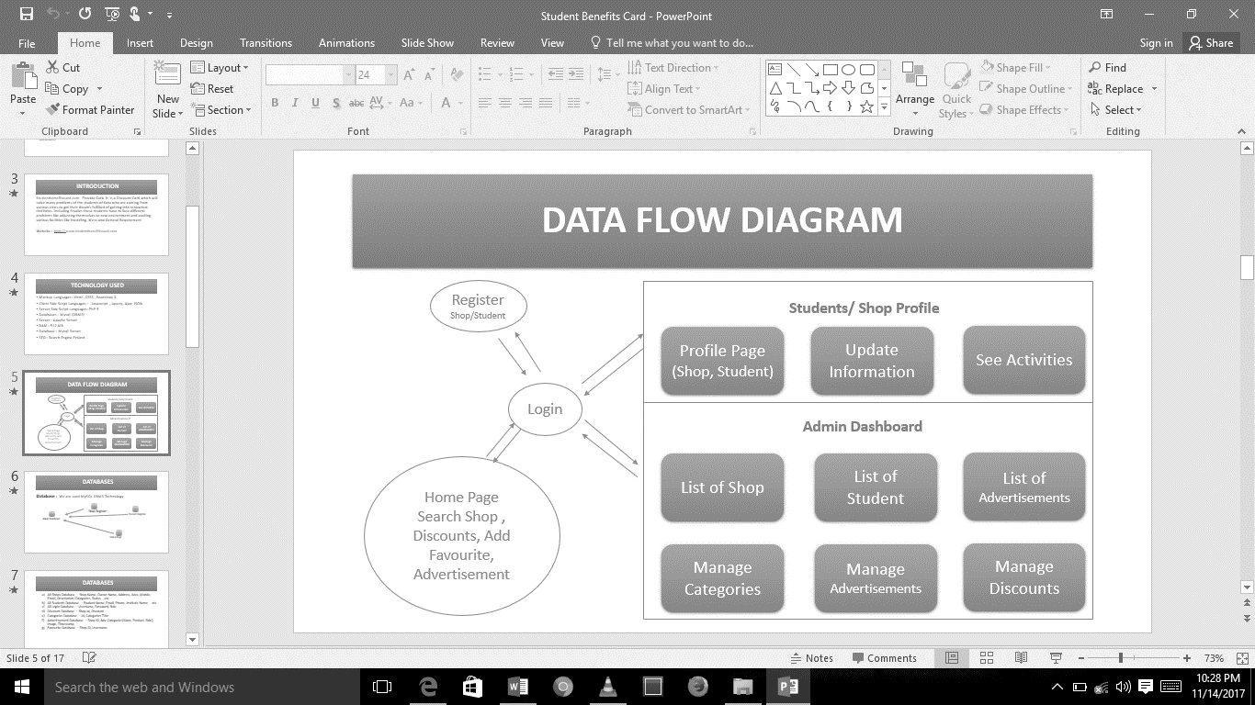

**Offline Document Process**

**Terms & Conditions of Firms**

**TERMS & CONDITIONS**

1. The firm owner has to follow the terms and conditions of the company.
2. Firm owner will give discount only the students show “Student Benefits Card”.
3. Firm owner will give discount only to the student registered in the company.
4. Company will provide the discount rate to the student holding “Student Benefits Card”.
5. The duration of agreement between firm owner and company will be valid for three year.
6. Company is not responsible for the quality or any problem regarding the product solved by the firm owner.
7. The duration of agreement between firm owner and company can be increased according to rule of a company.
8. Company can change the rule of the “Student Benefits Card” according to needs.
9. All legal prosecutions related to “Student Benefits Card” are subject to kota jurisdiction only.
10. In case of “**HOSTEL”** the agreement between firm and company is valid for one year.

I have carefully read the terms and condition to follow for registration of “Student Benefits Card” and I accept all terms and condition with fully.

Seal & Signature

**Terms & Conditions of Students**

**“TERMS AND CONDITION FOR “STUDENT BENEFITS CARD”**

1. “**Student Benefits Card**” is a “**discount card**” card issued by Krishnas softdeal Pvt. Ltd Kota.
2. Client must be a student of the school / coaching institute / college.
3. Student after payment of registration fee will be valid for maximum one year from date of issuing with unique identification number.
4. Services of “**Student Benefits Card**” will commence 10 days after date of registration.
5. Student must show benefit the “**Student Benefits Card**” and “Photo ID-Proof” of coaching institute for availing any service. Student will not card at any service.
6. In case of student unable to sign his/her document parent / guardian can sign the documents.
7. The facilities of “Student Benefits Card” are available only in Kota city at selected shop, mess, stationary etc. Any benefits are not available card and will not be reimbursed outside the Kota city. The Centers can be added or deleted as when required the company.
8. All benefits of “Student Benefits Card” can be availed only in Kota city where institute is situated. All benefits are not available and will not be reimbursed outside the Kota city.
9. The “Student Benefits Card” is only for authorized registered student, other student cannot use this card in any circumstance.
10. One student cannot hold more than one card of current session. If any misuse / disuse of card will be cancelled and registration fee will not be returned.
11. Registration once done will not be refunded after 3 day of registration of availing any facility whichever in early.
12. If “Student Benefits Card” is lost then he/she should inform customer care center immediately, new card will be issues after paying 300/- by student after 5 days.
13. If you require any assistance call customer care center 0744-2407544 or 07877407544 24hrs.
14. I have carefully read the terms & conditions to follow for registration of “Student Benefits Card” and I accept all terms and conditions willfully.
15. .All legal prosecutions related to “Student Benefits Card” are subject to kota jurisdiction only.

Date: Signature of parent / Guardian

…………………………………………………………………………………………………..

1. Strictly bring the receipt the “Student Benefits Card“.
2. Card will receive within 10 days from the date of receive the receipt.
3. The receipt will not valid without stamp of company.
4. If you require any assistance call customer care center 0744-2407544 or 07877407544 24hrs.