AI_PHASE3

NAME: D. RAJ KUMAR

REGISTRATION NUMBER: au952321106018

Market Basket Insights

Important note:

T hs n o t e b o o k has b e c o m e ve ry l a r g e , a n d I could no t add more nformat on t o t , s o I w l l d v de t nt o a number of not ebo oks. So y ou can und erstand the content And b e an excellent r e f e r e n c e f o r y o u

Table of Content:

Machine Learning and Types

Application of Machine Learning

Steps of Machine Learning

Factors help to choose algorithm

Algorithm

Evaluate Algorithms

Linear Regression

Logistic Regression

Support Vector Machine

Naive Bayes Algorithm

KNN

Perceptron
Random Forest

Decision Tree

Extra Tree

Gradient Boosting

Light GBM

XGBoost

Catboost

Stochastic Gradient Descent

Lasso

Kernel Ridge Regression

Bayesian Ridge

Elastic Net Regression

LDA

K-Means Algorithm

CNN

LSTM

PCA

Apriori

Prophet

ARIMA

Machine Learning:

Linear Regression:

It is a basic and commonly used type of predictive analysis. These regression estimates are used to explain the relationship between one dependent variable and one or more independent variables. Y = a + bX where

Y – Dependent Variable

a – intercept - Bise

X – Independent variable

b – Slope -Weights
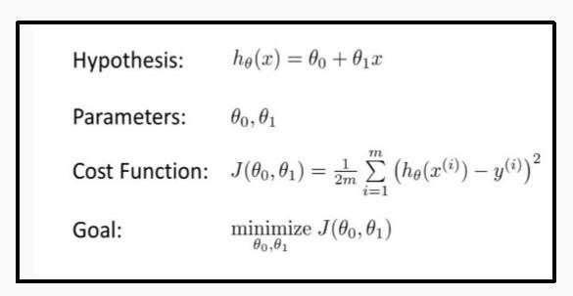

Example: University GPA' = (0.675)(High School GPA) + 1.097

import numpy as np

import pandas as pd

from matplotlib import pyplot as plt
from sklearn.linear_model import LinearRegression

from sklearn.metrics import mean_squared_error, r2_score

train = pd.read_csv("../input/random-linear-regression/train.csv")

test = pd.read_csv("../input/random-linear-regression/test.csv")

train = train.dropna()

test = test.dropna()

train.head()

OUTPUT :

x y

- 24.0 21.549452

- 50.0 47.464463

- 15.0 17.218656

- 38.0 36.586398

- 87.0 87.288984

Model with plots and accuracy:

X_train = np.array(train.iloc[:, :-1].values)

y_train = np.array(train.iloc[:, 1].values)

X_test = np.array(test.iloc[:, :-1].values)

y_test = np.array(test.iloc[:, 1].values)

model = LinearRegression(fit_intercept=True, normalize=True,copy_X=True,n_jobs=-1)

model.fit(X_train, y_train)

y_pred = model.predict(X_test)

accuracy = model.score(X_test, y_test)

plt.plot(X_train, model.predict(X_train), color='green')

plt.show()

print(accuracy)
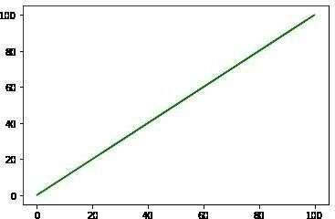

0.9888014444327563

Logistic Regression:

It’s a classification algorithm, that is used where the response variable is categorical. The idea of Logistic Regression is to find a relationship between features and probability of particular outcome.

odds= p(x)/(1-p(x)) = probability of event occurrence / probability of not event occurrence
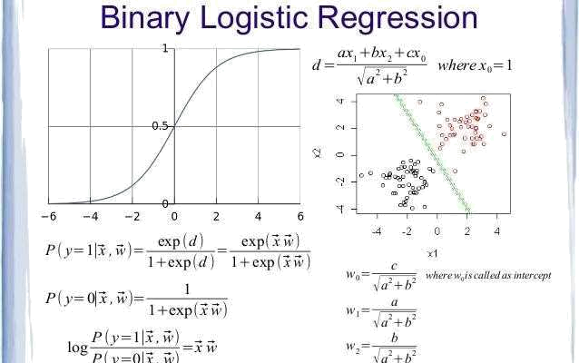

Libraries and data:

import sklearn

from sklearn.model_selection import train_test_split from

sklearn.linear_model import LogisticRegressionfrom

sklearn.metrics import r2_score

from statistics import mode

train = pd.read_csv("../input/titanic/train.csv")

test = pd.read_csv('../input/titanic/test.csv')

train.head()

OUTPUT:
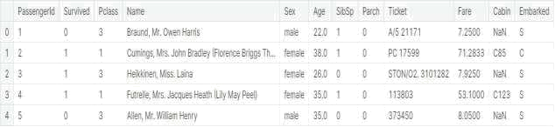

Model and Accuracy:

from sklearn.model_selection import train_test_split

X_train, X_test, y_train, y_test = train_test_split(X, y, test_size=0.25, random_state=5)

from sklearn.linear_model import LogisticRegression

#linear_model.LogisticRegression(penalty='l2’,dual=False,tol=0.0001,C=1.0,fit _intercept=True,intercept_scaling=1,

- class_weight=None,random_state=None,solver='warn’,max_iter=100,

- multi_class='warn’, verbose=0,warm_start=False, n_jobs=None)

model = LogisticRegression(max_iter = 500000)

model.fit(X_train, y_train)

y_pred = model.predict(X_test)

accuracy = model.score(X_test, y_test)

print(accuracy)

OUTPUT:

0.8251121076233184

Support Vector Machine:

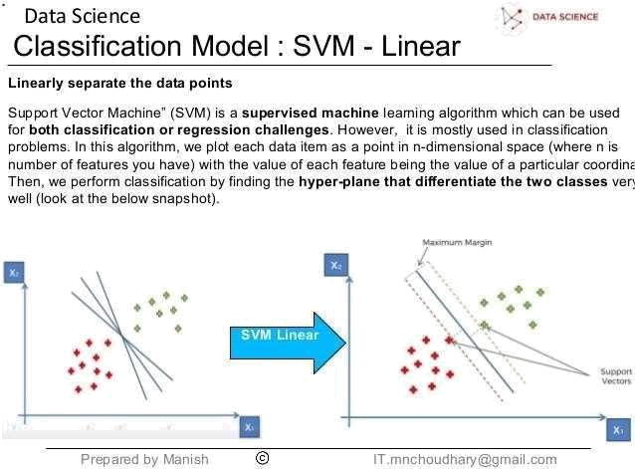

Support Vector Machines are perhaps one of the most popular and talked aboutmachine learning algorithms.It is primarily a classier method that performs classification tasks by constructing hyperplanes in a multidimensional space that separates cases of different class labels. SVM supports both regression and classification tasks and can handle multiple continuous and categorical variables

Example: One class is linearly separable from the others like if we only had two features like Height and Hair length of an individual, we’d first plot these two variables in two dimensional space where each point has two co-ordinates

Libraries and Data:

from sklearn.model_selection import train_test_split from sklearn.model_selection import cross_val_score from sklearn.svm import SVC

data_svm = pd.read_csv("../input/svm-classification/UniversalBank.csv")

data_svm.head()
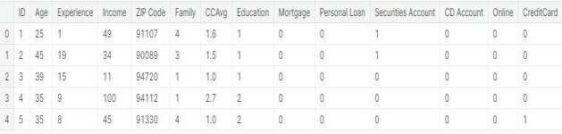

Model and Accuracy:

- =data_svm.iloc[:,1:13].values y = data_svm.iloc[:, -1].values

X_train,X_test, y_train, y_test = train_test_split(X,y, test_size= 0.25, random_state= 0)

'''

sklearn.svm.SVC(C=1.0, kernel=’rbf’, degree=3, gamma=’auto_deprecated’, coef0=0.0, shrinking=True,

probability=False,tol=0.001,cache_size=200, class_weight=None,verbose=False,

max_iter=-1, decision_function_shape='ovr’, random_state=None)

'''

classifier= SVC(kernel = 'rbf', random_state= 0)

classifier.fit(X_train, y_train)

y_pred =classifier.predict(X_test)

accuracies= cross_val_score(estimator = classifier,X = X_train, y = y_train, cv = 10)

accuracies.mean()

OUTPUT:

0.7077333333333333

Naive Bayes Algorithm:
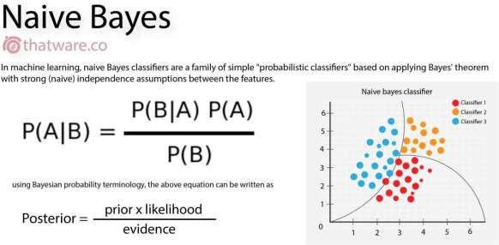

A naive Bayes classifier is not a single algorithm, but a family of machine learning algorithms which use probability theory to classify data with an assumption of independence between predictors It is easy to build and particularly useful for very large data sets. Along with simplicity, Naive Bayes is known to outperform even highly sophisticated classification methods

Example: Emails are given and we have to find the spam emails from that.A spam filter looks at email messages for certain key words and puts them in a spam folder if they match.

Libraries and Data:

from sklearn.naive_bayes import GaussianNB

from sklearn.preprocessing import StandardScaler

from sklearn.metrics import accuracy_score
data =

pd.read_csv('../input/classification-suv-dataset/Social_Network_Ads. csv')

data_nb =

data

data_nb.head(

)
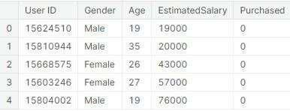

Model and Accuracy:

X = data_nb.iloc[:,

[2,3]].valuesy =

data_nb.iloc[:, 4].values

X_train, X_test, y_train, y_test = train_test_split(X, y, test_size = 0.20, random_state =

- sc_X = StandardScaler() X_train = sc_X.fit_transform(X_train) X_test = sc_X.transform(X_test)

'''

sklearn.naive_bayes.GaussianNB(priors=None, var_smoothing=1e-09)

'''

classifier=GaussianNB()

classifier.fit(X_train,y_train)

y_pred=classifier.predict(X_test)

acc=accuracy_score(y_test,

y_pred)

print(acc)

KNN :

KNN does not learn any model. and stores the entire training data set which it uses as its representation.The output can be calculated as the class with the highest frequency from the K-most similar instances. Each instance in essence votes for their class and the class with the most votes is taken as the prediction
