The following steps refer to Google's official tutorial: <https://cloud.google.com/vision/automl/docs/tflite-android-tutorial>.

However, this tutorial is not complete, in other words, it cannot work, so we decided to provide a more comprehensive one.

1. Train a model through AutoML on GCP and you will get an ‘xxx.tflite’ model and an ‘xxx.txt’ labels files.

Training tutorials at <https://cloud.google.com/vision/automl/docs/tutorial>.

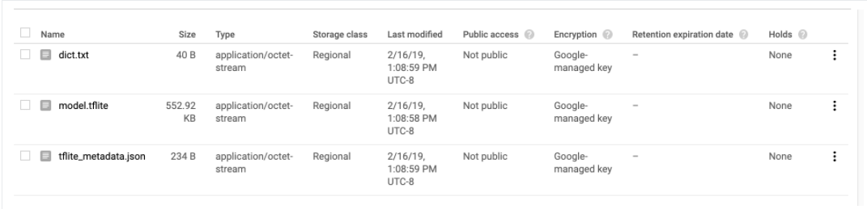

1. Download the android application demo:

git clone <https://github.com/googlecodelabs/tensorflow-for-poets-2>

Enter the folder ‘./tensorflow-for-poets-2/android/tflite/app/src/main/assets’ and you will find two files: graph.lite and labels.txt

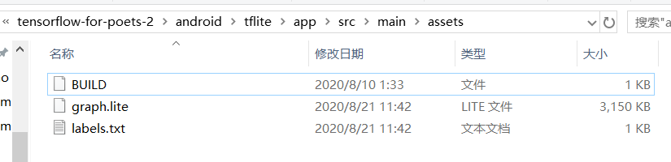

Replace the two files with those created by AutoML. Note to change ‘xxx.tflite’ to ‘graph.lite’ and ‘xxx.txt’ to ‘labels.txt’.

1. Install Android Studio: <https://developer.android.com/studio>

Select “Open an existing Android Studio project” and go to the following directory path.

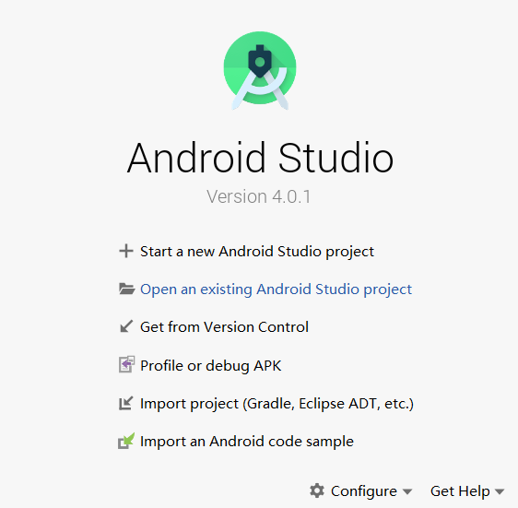 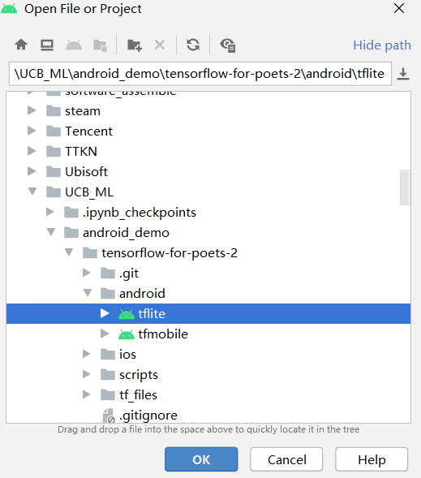

1. Synchronize project with Gradle files.



1. Set up an Android device:

<https://developer.android.com/studio/debug/dev-options.html#enable>

1. Connect your phone and computer with USB lines and now android studio will manage to find your device.
2. Modify the code to run the quantized AutoML model:

Open the file ImageClassifier.java:

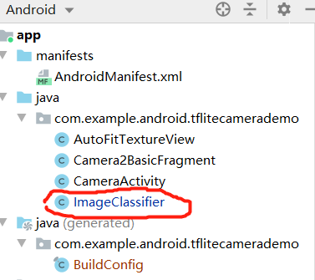

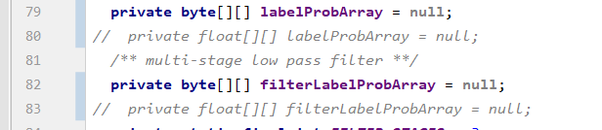

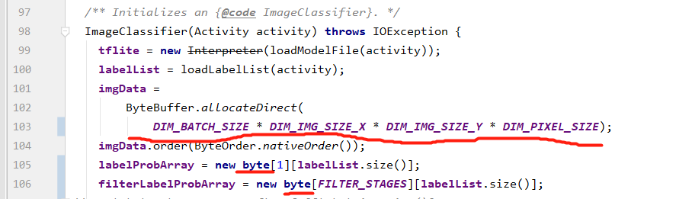

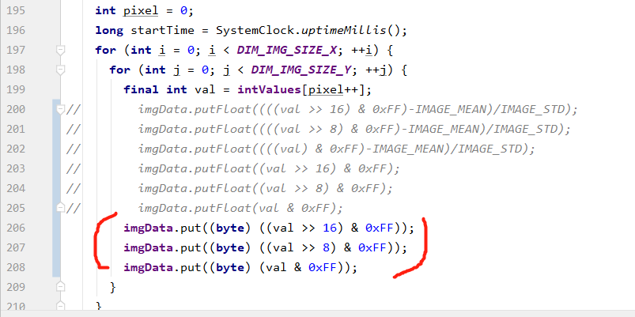

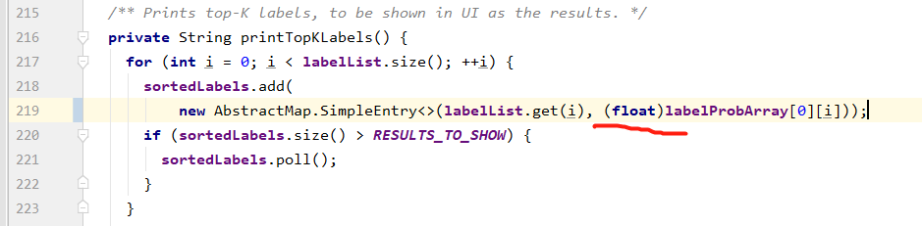

1. Hit the triangle shape button to start downloading App.

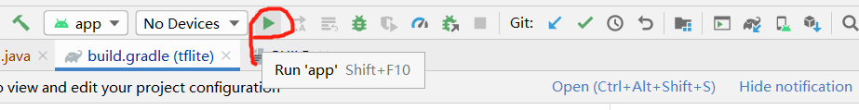

1. Launch the App on your phone and test it!!!