成句/要對班上同學保密喲☆[[編輯](https://web.archive.org/web/20200927121357mp_/http:/wiki.komica.org/index.php?title=%E6%88%90%E5%8F%A5/%E8%A6%81%E5%B0%8D%E7%8F%AD%E4%B8%8A%E5%90%8C%E5%AD%B8%E4%BF%9D%E5%AF%86%E5%96%B2%E2%98%86&action=edit&section=0&summary=/*%20%E9%A6%96%E6%AE%B5%20*/%20)]

[跳至導覽](https://web.archive.org/web/20200927121357/http:/wiki.komica.org/%E6%88%90%E5%8F%A5/%E8%A6%81%E5%B0%8D%E7%8F%AD%E4%B8%8A%E5%90%8C%E5%AD%B8%E4%BF%9D%E5%AF%86%E5%96%B2%E2%98%86#mw-head)[跳至搜尋](https://web.archive.org/web/20200927121357/http:/wiki.komica.org/%E6%88%90%E5%8F%A5/%E8%A6%81%E5%B0%8D%E7%8F%AD%E4%B8%8A%E5%90%8C%E5%AD%B8%E4%BF%9D%E5%AF%86%E5%96%B2%E2%98%86#p-search)

**要對班上的同學保密喲☆（クラスの皆には内緒だよ☆）**

|  |
| --- |
| 本條目的內容要對班上的同學保密喲☆ |



**目錄**

* [1出處](https://web.archive.org/web/20200927121357/http:/wiki.komica.org/%E6%88%90%E5%8F%A5/%E8%A6%81%E5%B0%8D%E7%8F%AD%E4%B8%8A%E5%90%8C%E5%AD%B8%E4%BF%9D%E5%AF%86%E5%96%B2%E2%98%86#.E5.87.BA.E8.99.95)
* [2迷因](https://web.archive.org/web/20200927121357/http:/wiki.komica.org/%E6%88%90%E5%8F%A5/%E8%A6%81%E5%B0%8D%E7%8F%AD%E4%B8%8A%E5%90%8C%E5%AD%B8%E4%BF%9D%E5%AF%86%E5%96%B2%E2%98%86#.E8.BF.B7.E5.9B.A0)
* [3用法](https://web.archive.org/web/20200927121357/http:/wiki.komica.org/%E6%88%90%E5%8F%A5/%E8%A6%81%E5%B0%8D%E7%8F%AD%E4%B8%8A%E5%90%8C%E5%AD%B8%E4%BF%9D%E5%AF%86%E5%96%B2%E2%98%86#.E7.94.A8.E6.B3.95)
* [4關聯條目](https://web.archive.org/web/20200927121357/http:/wiki.komica.org/%E6%88%90%E5%8F%A5/%E8%A6%81%E5%B0%8D%E7%8F%AD%E4%B8%8A%E5%90%8C%E5%AD%B8%E4%BF%9D%E5%AF%86%E5%96%B2%E2%98%86#.E9.97.9C.E8.81.AF.E6.A2.9D.E7.9B.AE)
* [5回應](https://web.archive.org/web/20200927121357/http:/wiki.komica.org/%E6%88%90%E5%8F%A5/%E8%A6%81%E5%B0%8D%E7%8F%AD%E4%B8%8A%E5%90%8C%E5%AD%B8%E4%BF%9D%E5%AF%86%E5%96%B2%E2%98%86#.E5.9B.9E.E6.87.89)

出處[[編輯](https://web.archive.org/web/20200927121357/http:/wiki.komica.org/index.php?title=%E6%88%90%E5%8F%A5/%E8%A6%81%E5%B0%8D%E7%8F%AD%E4%B8%8A%E5%90%8C%E5%AD%B8%E4%BF%9D%E5%AF%86%E5%96%B2%E2%98%86&action=edit&section=1)]

* 《[魔法少女小圓](https://web.archive.org/web/20200927121357/http:/wiki.komica.org/%E9%AD%94%E6%B3%95%E5%B0%91%E5%A5%B3%E3%81%BE%E3%81%A9%E3%81%8B%E2%98%86%E3%83%9E%E3%82%AE%E3%82%AB)》第十話。
  + 曉美焰在最初的時間線，成為魔法少女前誤入魔女結界，被鹿目圓與巴麻美救出時，小圓的發言。

迷因[[編輯](https://web.archive.org/web/20200927121357/http:/wiki.komica.org/index.php?title=%E6%88%90%E5%8F%A5/%E8%A6%81%E5%B0%8D%E7%8F%AD%E4%B8%8A%E5%90%8C%E5%AD%B8%E4%BF%9D%E5%AF%86%E5%96%B2%E2%98%86&action=edit&section=2)]

[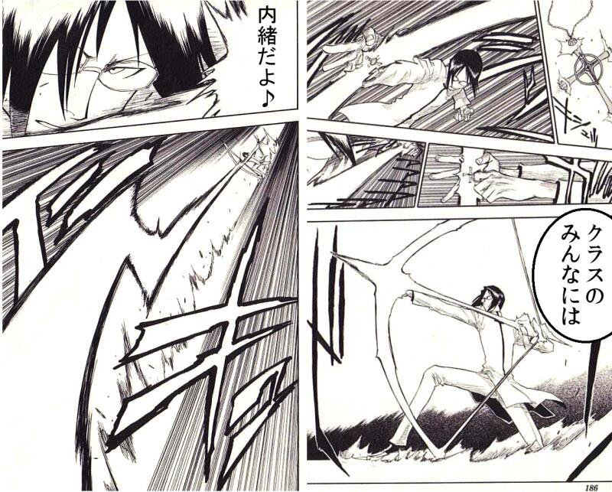](https://web.archive.org/web/20200927121357/http:/wiki.komica.org/%E6%AA%94%E6%A1%88:CcbgPpdVAAItUVo.jpg)

* 因為同為拉弓的姿勢，有網友將《死神》漫畫中石田雨龍的台詞改成這句話。
  + ~~滅卻師少年雨龍~~
* 雖然只是二創常見的台詞惡搞，不過在《[龍族拼圖](https://web.archive.org/web/20200927121357/http:/wiki.komica.org/%E9%BE%8D%E6%97%8F%E6%8B%BC%E5%9C%96)》於2016年推出死神合作活動後，問題才真正顯現出來。
* 這句**原作中完全沒出現的台詞**居然在活動中成為雨龍的隊長技能名稱。
* 雖然官方在發現後馬上採取滅火行動（將技能名稱變更成「僕の弓になら籠っているよ」），不過依然成為眾多玩家茶餘飯後的話題。

用法[[編輯](https://web.archive.org/web/20200927121357/http:/wiki.komica.org/index.php?title=%E6%88%90%E5%8F%A5/%E8%A6%81%E5%B0%8D%E7%8F%AD%E4%B8%8A%E5%90%8C%E5%AD%B8%E4%BF%9D%E5%AF%86%E5%96%B2%E2%98%86&action=edit&section=3)]

* 當自己超級英雄或魔法少女等的秘密身分被同班同學發現時。
* ~~拉弓時~~

關聯條目[[編輯](https://web.archive.org/web/20200927121357/http:/wiki.komica.org/index.php?title=%E6%88%90%E5%8F%A5/%E8%A6%81%E5%B0%8D%E7%8F%AD%E4%B8%8A%E5%90%8C%E5%AD%B8%E4%BF%9D%E5%AF%86%E5%96%B2%E2%98%86&action=edit&section=4)]

* [魔法少女小圓](https://web.archive.org/web/20200927121357/http:/wiki.komica.org/%E9%AD%94%E6%B3%95%E5%B0%91%E5%A5%B3%E3%81%BE%E3%81%A9%E3%81%8B%E2%98%86%E3%83%9E%E3%82%AE%E3%82%AB)
  + [鹿目圓](https://web.archive.org/web/20200927121357/http:/wiki.komica.org/%E9%B9%BF%E7%9B%AE%E5%9C%93)
* [龍族拼圖](https://web.archive.org/web/20200927121357/http:/wiki.komica.org/%E9%BE%8D%E6%97%8F%E6%8B%BC%E5%9C%96)
* [風評被害](https://web.archive.org/web/20200927121357/http:/wiki.komica.org/%E9%A2%A8%E8%A9%95%E8%A2%AB%E5%AE%B3)

回應[[編輯](https://web.archive.org/web/20200927121357/http:/wiki.komica.org/index.php?title=%E6%88%90%E5%8F%A5/%E8%A6%81%E5%B0%8D%E7%8F%AD%E4%B8%8A%E5%90%8C%E5%AD%B8%E4%BF%9D%E5%AF%86%E5%96%B2%E2%98%86&action=edit&section=5)]

表單的頂端

顯示 的最新 則留言；各留言左側皆設有回應用單選鈕重新整理

連線至 討論:成句/要對班上同學保密喲☆ 失敗：找不到頁面 [404]

留言：具名留言送出

表單的底部

[3 個分類](https://web.archive.org/web/20200927121357/http:/wiki.komica.org/%E7%89%B9%E6%AE%8A:%E5%88%86%E9%A1%9E)：

* [成句](https://web.archive.org/web/20200927121357/http:/wiki.komica.org/%E5%88%86%E9%A1%9E:%E6%88%90%E5%8F%A5)
* [魔法少女まどか★マギカ](https://web.archive.org/web/20200927121357/http:/wiki.komica.org/%E5%88%86%E9%A1%9E:%E9%AD%94%E6%B3%95%E5%B0%91%E5%A5%B3%E3%81%BE%E3%81%A9%E3%81%8B%E2%98%85%E3%83%9E%E3%82%AE%E3%82%AB)
* [龍族拼圖](https://web.archive.org/web/20200927121357/http:/wiki.komica.org/%E5%88%86%E9%A1%9E:%E9%BE%8D%E6%97%8F%E6%8B%BC%E5%9C%96)