Q1. **Randomised QuickSort**

**Code Used for Analysis:**

**void solve(int n){**

**// cout << n << endl;**

**swap_ct=0;**

**vector<int> arr;**

**int maxi = 1e5;**

**for (int i = 0;i < n;i++){**

**arr.push_back(rand()%(maxi));**

**}**

**int ans=0;**

**auto start = high_resolution_clock::now();**

**quicksort(arr,0,n-1);**

**auto stop = high_resolution_clock::now();**

**// cout<<endl;**

**// printArray(arr,n);**

**// auto start1 = high_resolution_clock::now();**

**// ans=countInversions(arr,n);**

**// auto stop1 = high_resolution_clock::now();**

**// cout<<ct<<endl;**

**auto duration = duration_cast<microseconds>(stop - start);**

**// auto duration1= duration_cast<microseconds>(stop1 - start1);**

**cout << swap_ct << endl;**

**}**

**Code:**

**void swap(vint &arr, int i, int j) {**

**swap_ct++;**

**int temp = arr[i];**

**arr[i] = arr[j];**

**arr[j] = temp;**

**}**

**int partitionLeft(vint &arr, int low, int high) {**

**int pivot = arr[high];**

**int i = low;**

**for (int j = low; j < high; j++) {**

**if (arr[j] <= pivot) {**

**swap(arr, i, j);**

**i++;**

**}**

**}**

**swap(arr, i, high);**

**return i;**

**}**

**int partitionRight(vint &arr, int low, int high) {**

**srand(time(NULL));**

**//CHOOSING PIVOT ELEMENT HERE**

**int r = low + rand() % (high - low);**

**swap(arr, r, high);**

**return partitionLeft(arr, low, high);**

**}**

**void quicksort(vint &arr, int low, int high) {**

**if (low < high) {**

**int p = partitionRight(arr, low, high);**

**quicksort(arr, low, p - 1);**

**quicksort(arr, p + 1, high);**

**}**

**}**

**Apriori Analysis:**

**Analysis of the time complexity of the randomized quicksort algorithm in terms of its best, average, and worst-case scenarios.**

**1. *Best-case scenario:\***

**- The best-case scenario occurs when the pivot selected in each partitioning step happens to be the median of the array.**

**- In this ideal situation, the array is perfectly divided into two equal halves at each recursive call.**

**- The recurrence relation becomes T(n) = 2T(n/2) + Θ(n), where T(n) is the time complexity for an array of size n.**

**- The solution to this recurrence relation is T(n) = O(n log n).**

**2. *Average-case scenario:\***

**- In the average case, the pivot is selected randomly, and on average, it has a good chance of partitioning the array in a balanced way.**

**- The expected time complexity for the average case is O(n log n).**

**- This result is derived by considering the expected size of subproblems at each level of recursion.**

**3. *Worst-case scenario:\***

**- The worst-case scenario occurs when the pivot selection is always biased, leading to unbalanced partitioning.**

**- The recurrence relation becomes T(n) = T(n-1) + Θ(n), where T(n) is the time complexity for an array of size n.**

**- The solution to this recurrence relation is T(n) = O(n^2).**

**- However, the probability of encountering the worst-case scenario is very low due to the random selection of the pivot.**

**In summary, the randomized quicksort algorithm has an average-case time complexity of O(n log n), which is its most significant and commonly analyzed performance measure. The worst-case time complexity is theoretically O(n^2), but the probability of this occurring is low due to the random pivot selection. The best-case time complexity is O(n log n) when the pivot selection is always optimal.**

**Hence Randomized Quicksort performs better in the worst case than any other fixed pivot selection algorithm**

**A Posteriori Analysis:**

**Graph of Average case of First Pivot, Last Pivot and Randomised Quicksort:**

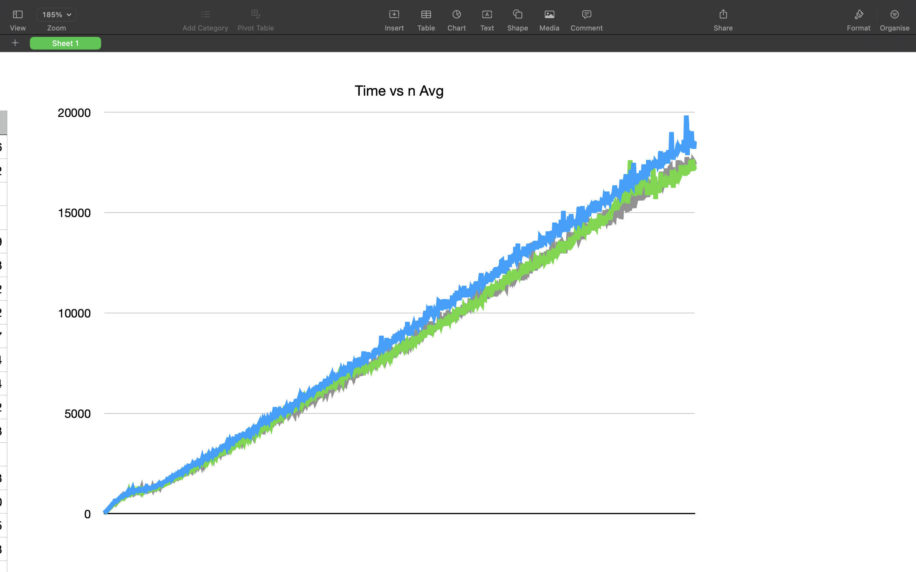

**Graph of Swaps in Randomised QuickSort:**

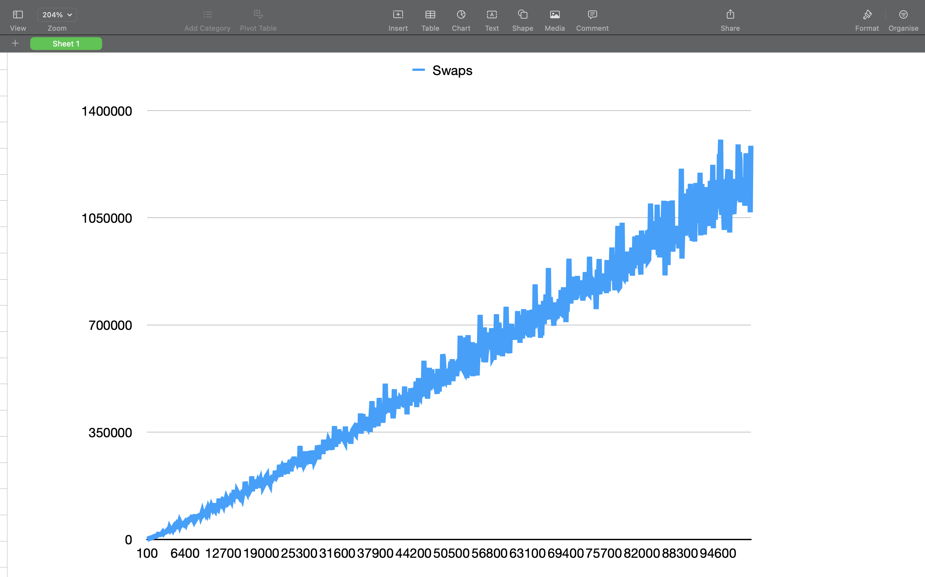

**Graph of Worst Case of Last, First Pivot and Randomised Quicksort:**

**Worst case calculated considering input as Sorted Array**

**Excel File for the Data is Attached.**

**Accuracy and Correctness: The 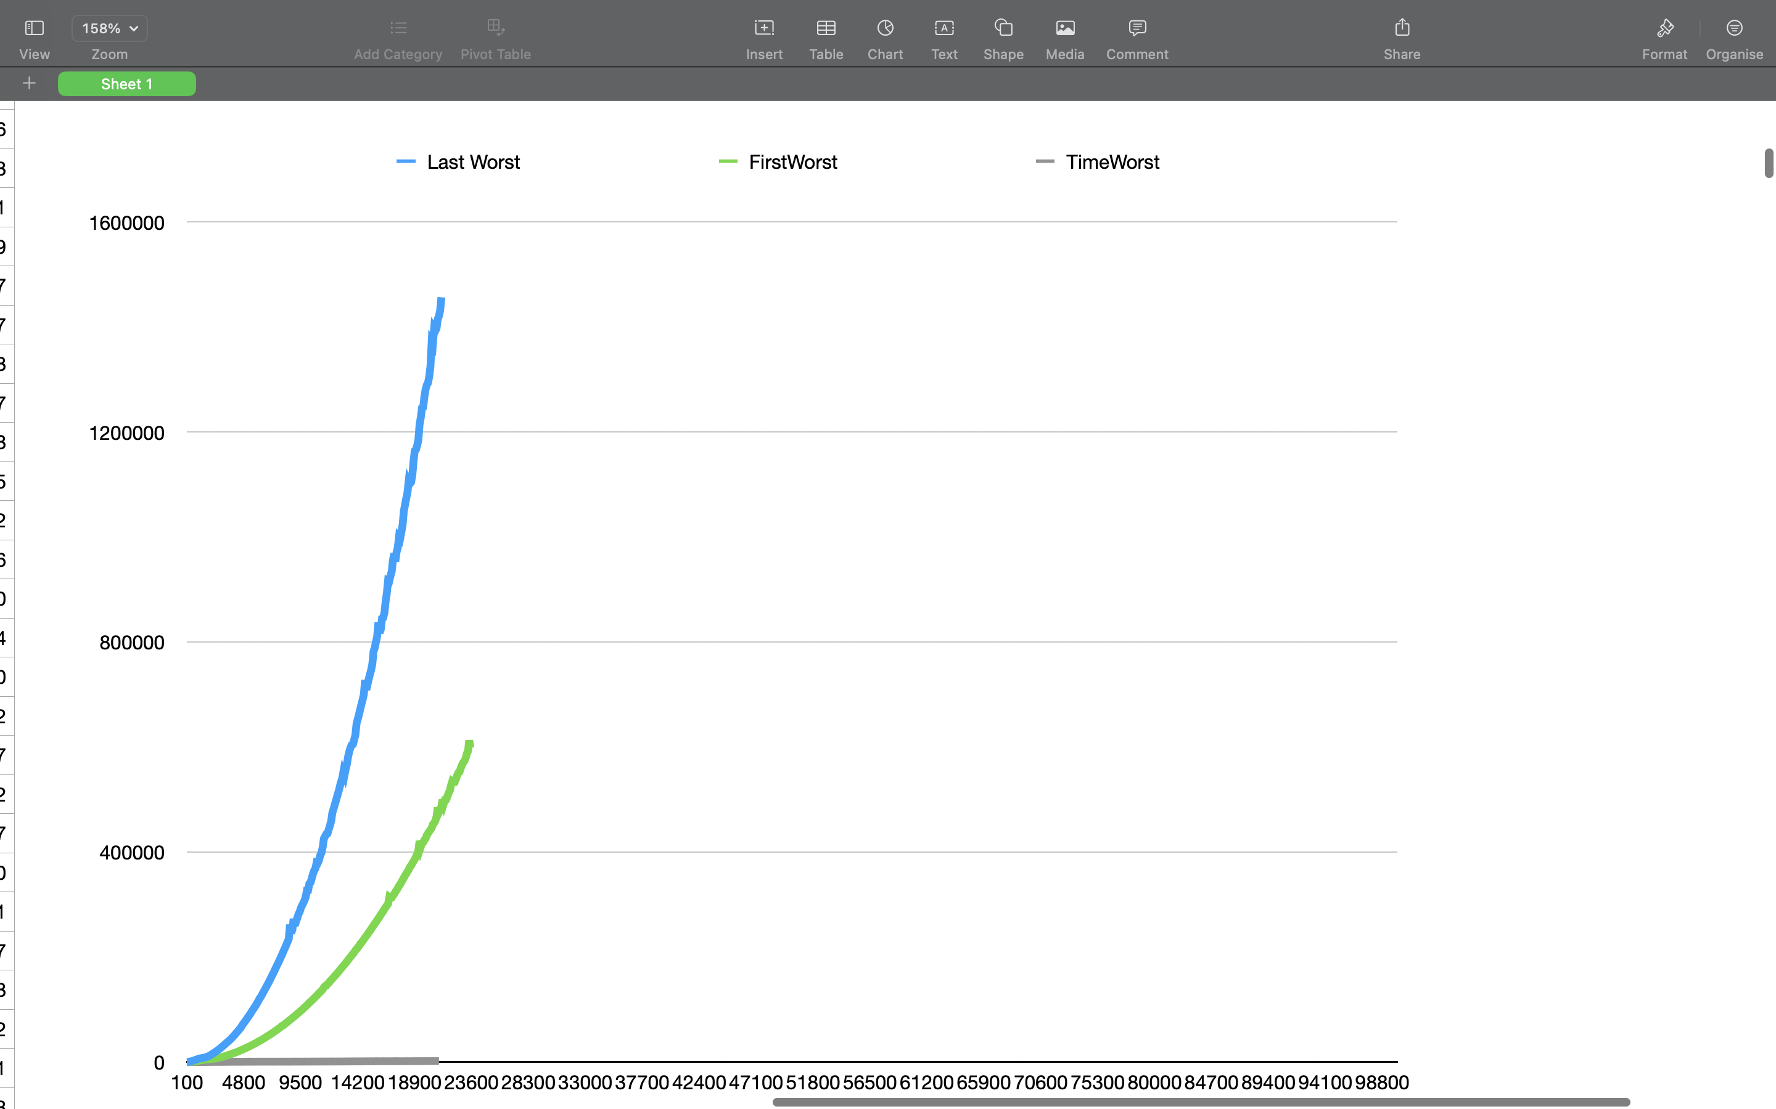algorithm gives the correct sorted output for each input array and size.**

**Profiling:**

**Excel File attached and Graphs given above.**