*Objectives*

Our goal is to stream in E. Coli, or some other bacterial, microscopy and tag those cells as well as determine important biological features in real time to help biologists more effectively collect data and experiment. This could also provide real time feedback about the window quality of the microscope on the sample, allowing the biologist to move the window to get a better view (such as making sure a minimum of multiple phenotypes are within the region depending on the experiment.)

*Motivation*

Currently, there aren't many tools to analyze microscopy to detect bacteria or cells in real time. The Image Stream [2] stands as a real time solution of cell analysis of flow cytometry, but requires the image stream device in order to use it and loses spatial information unique to stationary cell growth, so a lineage of cells can’t be determined. Our solution would aim to work with more standard microscopy equipment that allows image streaming without disturbing the cells, and most importantly, work in real time.

E. Coli is a nice candidate as it is unicellular, well researched and biologically interesting, and not very mobile as they don’t have a flagellum. It also has a distinctive ovular shape making detection and classification easier.

Finally, for microscopy experiments, the evidence to support a claim must be visual usually through physiological distinctions of the cell, how it grows, or by fluorescent coloring detection. Real time analysis would allow experiments to become more modular as a researcher could add a solution to the culture and based on the results from that determine another media to add.

*Significance/Uniqueness*

Allowing feedback about window quality may allow an experimenter to find a better window, that is better evidence to support their hypothesis, to save time from re-performing the experiment. Bacterial samples can only be viewed for a few hours during their “log” phase where they exhibit exponential growth due to cell doubling, so it is imperative to find a good window as early as possible to view as much growth. Our project is mostly based around “Velocity” as we would need to analyze and report back to the researcher as quickly as possible once enough information for a quality assessment can be made, separating this from standard image analysis of data.

Data could be collected in real time with partnership with the school of biological sciences as they possess microscopy equipment [1], supporting interdisciplinary collaboration. We also have access to published microscopy video from various papers [3] which, if the time period between images is small, could provide a sufficient training set.

*System Features*

W*e* would implement as system to identify and tag bacteria within an image. We would then find different descriptors that important for biological experimentation (usually color fluorescents are used to mark traits which impact growth). A metric to judge window quality would have to be communicated by the researcher. Developing other features such as creating a family lineage so that a researcher could click on a cell and see all varying degrees of family could be useful as well as being able to isolate the birth and death of a single bacteria. Depending on the difficulty, simulative and expectation maximization techniques could be used to predict what will happen in a window or determine how a state could have been generated (so if you move your microscope to a new location, try and find what is the most likely growth pattern up to that point).

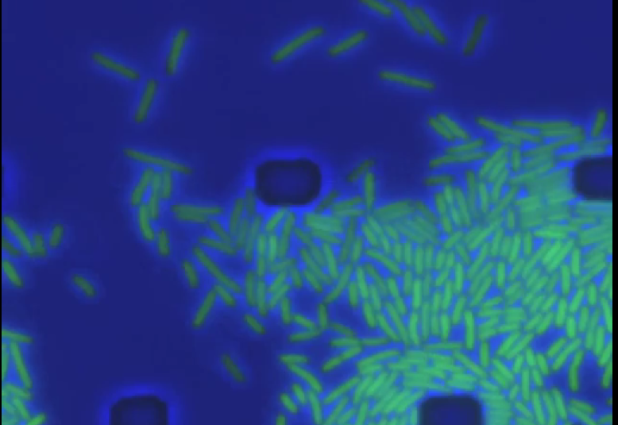

(example of image from time lapse microscopy that could be analyzed)

*Related Work*

* Time-lapse microscopy is used in one study to develop a computational model analyze cell cycle changes of individual cells. The authors’ motivation was in part due to the subjective and time-consuming nature of manual analysis. [4]
* One study processes images gathered over time of cell nuclei by analyzing the intensity, convexity and texture of various visual markers, which were used to identify key components of nuclei segmentation. [5]
* These researchers used a machine learning approach to develop an automated method to identify a certain type of leukemia in microscopic blood images. [6]
* This study primarily focuses on comparing two different computational methods to classify cell nuclei in different phases of mitosis given time-lapse fluorescence microscopy data. [7]
* MicrobeJ is a static image analysis tool that is used to analyze illuminated bacterial cells, including but not limited to their shape and curvature. [8] This tool is primarily used for already collected data; the functionality is what we aim to mimic in our project, but in real time.

*Backup project*

Children with autism frequently have other associated conditions—like pica. Pica involves the eating and chewing of non-food items. These items can range from unsanitary (used gum, hair, used straws) to acutely dangerous (nails, glass, rocks). [9] This can be extremely dangerous and difficult for parents to control. Constant surveillance of the child is required; however, it is rarely practical to monitor a child 24 hours a day.

Our project would use a camera in the child's area to look for visual clues that this behavior is about to happen. These clues could include holding a hand near the mouth for several seconds, chewing that is not preceded by eating, and the clutching of small objects followed by the hand moving to the mouth. By using the camera on a mobile device, we could also have the device give audio alerts to the child and send messages to the parents. The app could also store (internal storage or cloud-based) video for a time period before and after the suspected behavior. This would allow parents and medical professionals the opportunity to observe what items the child is eating. Knowing what the child is eating allows parents to remove those items from the child's environment. [10] In the case of emergency medical care, knowing what was ingested could allow doctors to determine the correct course of action much faster.

There is a clear benefit of this software for autistic children and their caregivers. According to the Agency for Healthcare Research and Quality, there were 1,862 hospitalizations due to pica. [11] A potential problem with the project is that the visual clues may not be sufficiently distinct enough to accurately detect pica-related behavior. Another difficulty is that bedrooms and bathrooms are common locations for pica-related behaviors; however, those are both locations where cameras are unwelcome.

*Bibliography*

1. <http://sbs.umkc.edu/dobens/microscopy.cfm>
2. <http://www.microscopyu.com/pdfs/Zuba-Surma_etal_Folia_Histochem_Cytobiol_45-279-2007.pdf>
3. <http://journals.plos.org/ploscompbiol/article?id=10.1371%2Fjournal.pcbi.1004825#sec018> (contains videos)
4. Chen, Zhou & Wong. “Automated segmentation, classification, and tracking of cancer cell nuclei in time-lapse microscopy.” *IEEE Transactions on Biomedical Engineering,* vol. 53, no. 4, April 2006. <http://ieeexplore.ieee.org/document/1608529/>
5. Dewan, Ahmad & Swamy. “A Method for Automatic Segmentation of Nuclei in Phase-Contrast Images Based on Intensity, Convexity and Texture.” *IEEE Transactions on Biomedical Circuits and Systems,* vol. 8, no. 5, October 2014. <http://ieeexplore.ieee.org/document/6762958/>
6. Goutam & Sailaja. “Classification of acute myelogenous leukemia in blood microscopic images using supervised classifier.” *2015 IEEE International Conference on Engineering and Technology (ICETECH),* March 2015. <http://ieeexplore.ieee.org/document/7275021/>
7. Tran, Pham & Zhou. “Cell phase identification using fuzzy Gaussian mixture models.” *Proceedings of 2005 International Symposium on Intelligent Signal Processing and Communication Systems,* 2005. <http://ieeexplore.ieee.org/document/1595447/>
8. MicrobeJ Plugin Tool <http://www.indiana.edu/~microbej/index.html>
9. <http://www.autismkey.com/pica-and-autism/>
10. <https://www.autismspeaks.org/blog/2013/06/21/pica-autism-connection-help-perspective-got-questions>
11. <http://www.livescience.com/16072-pica-hospitalizations-increase-eating-disorders.html>