*Project Name*: Real-Time Analysis of Microscopic Video Data

*Report 2*

*Project Objectives*

Our goal is to stream in yeast, E.Coli,and other bacterial microscopy and tag those cells as well as determine important biological features in real time to help biologists more effectively collect data and experiment. The main object would be to develop a lineage model of bacteria between frames as well as determine and tag significant events, such as cells splitting or interacting or dying. This could also provide real time feedback about the window quality of the microscope on the sample, allowing the biologist to move the window to get a better view(such as making sure a minimum of multiple phenotypes are within the region depending on the experiment.)

*Significance*

Cell microscopy and observation is largely done by specialized human workers as humans are the gold standard of image detection and recognition as well as knowing what important biological features to assess. This is costly as the person’s time could be used on other facets of research and human labor itself is costly.

Cell experiments are also performed in stages. That is, one single gene or biological factor is looked for and analyzed through microscopy (generally analyzing the images after the experiment and after applying different filters to the data to make things stand out), after which another experiment is performed. If biological features that are sought after could be analyzed and detected in real time, the experiments could become more modular, allowing a researcher to apply a chain of experiments together, saving time and money.

This is very complex feature analysis that would have extremely accurate though. So the bare bones fundamental structure, such as performing lineage tracking and extracting features, would have to be able to function well.

*Features: Use Case/Scenario*

Our primary use case is to be able to detect and tag the cells in each frame in a video. That is, given a frame determine what type of cell and its location in the image. Counting the total number of cells is also biologically useful and an extension of this case.

Our current implementation is to use SIFT features to determine important key points for a yeast cell and identify those points within the video for each frame. Unfortunately, this is not working well for our data, even to the point where it cannot find the image which we trained on for determining the SIFT points of a yeast cell within the video. This could be due to how few SIFT points we found within the image, but changing the amount of points we generate on the image and video still hasn’t improved our methods of detection.

Training on more images of yeast and aggregating those features through image analysis aggregation schemes like Fischer Vector, VLAD, or Super Vector may yield much better results than just training and trying to detect one image. Using these schemes in MATLAB is an easy task but fairly uncertain one for Java.

Tagging what state the cell is in is also important and a second use case. We wish to be able to tag a yeast cell that is budding, that is there is a smaller yeast cell growing conjoined to it, or E.Coli splitting, where E.Coli grows long and then tapers in the middle before it splits entirely into two different sister E.Coli.

Here we are having a better job of identifying yeast cells that are budding, at least for the image we trained on, however even though SIFT is rotation invariant, it wasn’t able to pick up budding cells that are in a different orientation. Again, training on more than one image and aggregating our features through an image analysis aggregation schema could improve our detection powers for classifying whether an image contains budding or splitting cells and annotate them correctly.

These two use cases would allow us to map states of one image to another to determine lineage and map a lineage tree the cells. This is highly adventurous though and likely will not be finished within the project’s semester scope.

*Approach*

* Data Sources
  + Published cellular research with microscopy movies (frames taken every 2-5 minutes). Youtube also offers video data of microscopy as well, generally with frames taken within a shorter window, but for lesser duration. The research data also tries to analyze more complicated mechanisms while the youtube data displays features such as budding and reproduction.
  + Research papers that we have looked at may be found in our literature review, and an example of youtube data would be the following:

<https://www.youtube.com/watch?v=iOvrq6ssy2Y>

<https://www.youtube.com/watch?v=BTHYaf-EuYs>

* + We may also have access to a usb microscope allowing for real time streamed microscopy. The microscope is 500x which would allow viewing of yeast cells on a basic level.

* Analytic Tools
  + Spark- Apache Spark allows us to perform data parallelism through the mapreduce paradigm, allowing us to train and learn from our data in order to build a model to classify what parts of our images are cells and what state they exist in.
  + OpenImageJ- OpenImageJ is a library that allows the user to extract key points and frames through SIFT point detection and tagging.
  + Spark MLLib- the Spark MLLib is a rich resource of machine learning, allowing us easy access to decision trees, random forests, feature analysis, and neural network schemes.
  + Storm- Storm allows us to perform task parallelism so that when we stream in videos as frames, we are able to perform many tasks on those frames in order to determine where cells are and what state they are in.
  + Kafka- Kafka is a publisher subscriber system that allows a robust high volume queuing of data from which Spark and Storm can act as both consumers and producers of different topics in order to communicate between themselves and the client.
* Analytical Tasks
  + Track and detect cells from one frame to another
    - Requires ability to detect individual cells
    - Requires ability to differentiate or map cells from one frame to another
  + Classify and annotate whether a cell is dividing or budding
  + Train on multiple images and aggregate SIFT features from them
  + Extract many features from cells.
    - Note: This could be physiological such as size and shape or behavior such as splitting and interactions among cells, or triggered, such as turning on a fluorescent light to see a gene expression tag glow.
  + Determining if slide needs to be adjusted relative to microscope
  + Counting number of cells in view
* Expected Inputs/Outputs
  + The expected input would be a video of cell microscopy where we output a lineage tree or video as well as biological tagging (such as knowing when it’s splitting) or what gene or protein it contains via fluorescent tagging.
  + Another input could be a video stream from a microscope where each frame is processed.
  + These inputs would be processed and serve as inputs for other functions within the program as well. Such as processing the video to make SIFT points easier and more meaningful to extract.
  + Outputs would be a lineage tree of cells, ability to find locations within the video of biological features such as splitting and budding, and counts of the number of cells seen in total or with a certain feature.
  + Other outputs: Metadata on video such as attribute measurements at a specific time or average values over length of video
* Algorithms
  + SIFT aggregation schemes: Training on one image and using it as representative of an entire class doesn’t work and really doesn’t work with our data. As such, we need to aggregate many sift points from different cells of the same type and group them to classify what is a yeast cell, what is a budding cell, what is an E.Coli, etc. These methods include Bag of Words at its most primitive, evolving into VLAD, Fischer Vector, and Super Vector as more complicated schemes.
  + Random Forest/Decision Tree algorithms
  + Object detection, aggregation, and segregation using image analysis.
    - Note: The current key point extraction technique using SIFT as shown in Lab2,3 does not accurately find single E.Coli in our videos. E.Coli are all fairly regular and contain a lot of the same curvature (that SIFT tries to find and map as a key point). E.Coli also grow and wiggle changing their shape, making curvature based methods difficult for tracking it. We also have yeast cell data tend to have more distinctive features within them and around them, which could be easier to detect and track.

*Related Work*

* Open Source Projects
  + MicrobeJ for ImageJ (I don’t think MicrobeJ is opens source though, but ImageJ is)
* Literature Reviews (some are from proposal)
  + <http://www.ncbi.nlm.nih.gov/pmc/articles/PMC4820279/> (ecoli videos)
  + <http://journals.plos.org/plosone/article?id=10.1371/journal.pone.0032621> (yeast)
  + <http://journals.plos.org/ploscompbiol/article?id=10.1371/journal.pcbi.1003396#s5> (yeast)
  + <http://www.ncbi.nlm.nih.gov/pubmed/27572972>
  + Chen, Zhou &amp; Wong. “Automated segmentation, classification, and tracking of cancer cell nuclei in time-lapse microscopy.” IEEE Transactions on Biomedical Engineering, vol. 53, no. 4, April 2006. <http://ieeexplore.ieee.org/document/1608529/>
  + Dewan, Ahmad &amp; Swamy. “A Method for Automatic Segmentation of Nuclei in Phase-Contrast Images Based on Intensity, Convexity and Texture.” IEEE Transactions on Biomedical Circuits and Systems, vol. 8, no. 5, October 2014. <http://ieeexplore.ieee.org/document/6762958/>
  + Goutam &amp; Sailaja. “Classification of acute myelogenous leukemia in blood microscopic images using supervised classifier.” 2015 IEEE International Conference on Engineering and Technology (ICETECH), March 2015. <http://ieeexplore.ieee.org/document/7275021/>
  + Tran, Pham &amp; Zhou. “Cell phase identification using fuzzy Gaussian mixture models.” Proceedings of 2005 International Symposium on Intelligent Signal Processing and Communication Systems, 2005. <http://ieeexplore.ieee.org/document/1595447/>
* Application Specification
  + OpenImaj/SIFT
* System Specification/Software Architecture
  + Spark - ML to assign probabilities of specific features in a frame
  + Storm - efficiently handle feature extraction from cell video data
  + Kafka - transferring video data between systems
  + Potentially utilizing MongoDB to store data that can be used to train and build our model for cell detection
  + AWS cloud - cloud computing platform we will utilize to implement the above technologies in real time
* Design of Big Data Analytics Server
  + Parallelism/Distribution: Task/Data
    - Data parallelism of splitting image into frame then applying ML algorithms to train for object classification.
    - Task parallelism within a frame to determine edges/sift points/biological tagging through color analysis or shape analysis.
  + Features, workflow, technologies:
  + General Workflow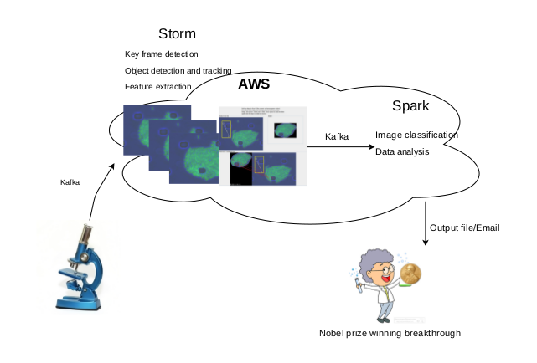
  + Storm Topology

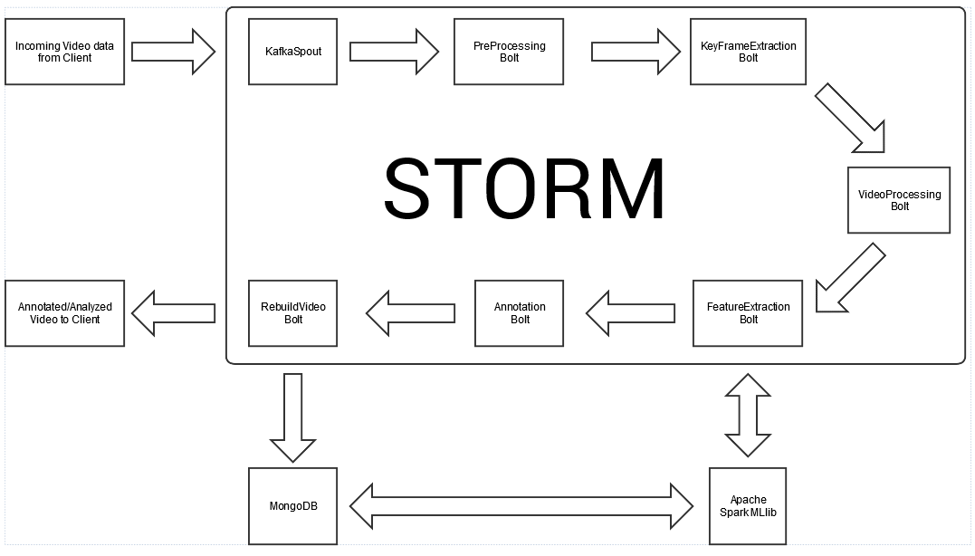

* + *KafkaSpout*: takes in encoded video data from client and decodes it
  + *PreProcessing Bolt:* Prepares video to be analyzed to key frame extraction bolt by dividing video into separate frames (groups of at least 2).
  + *KeyFrameExtraction Bolt:* Runs Main Frame Detection program and extracts the key frames to analyze that will be processed for feature detection.
  + *VideoProcessing Bolt:* Processes video to make detection more accurate (e.g., changes contrast of given video).
  + *FeatureExtraction Bolt:* Detects and extracts SIFT feature vectors that are sent to Spark. It also receives input from Spark to improve detection. Vectors are also sent to Annotation bolt so the frame can be annotated properly.
  + *Annotation Bolt:* Annotates frame by labelling specific cells based on given SIFT feature vectors
  + *RebuildVideo Bolt:* Rebuilds new video with annotated frames that can be sent back to the user for immediate viewing or stored in a MongoDB.
* Design of Mobile Client (smartphone/web): N/A
* Existing Applications/Services Used: Time-lapse microscopy videos (<http://www.ncbi.nlm.nih.gov/pmc/articles/PMC4820279/>)

Implementation

o Implementation of server using AWS to hold data and process via Spark and Storm

o Client application & UI for ease of use in uploading and receiving data from the cloud

*Documentation*

Proposal

Source: <https://github.com/DRinKC/RT-BigData-Project_Team1/tree/master/Proposal>

Lab3

Source: <https://github.com/DRinKC/RT-BigData-Project_Team1/wiki/Lab-3>

Metadata output from Main Frame Detection:

consoleOutput.jpg

Lab4

Source: <https://github.com/DRinKC/RT-BigData-Project_Team1/wiki/Lab-4> \

Object Detection & Tracking with annotation: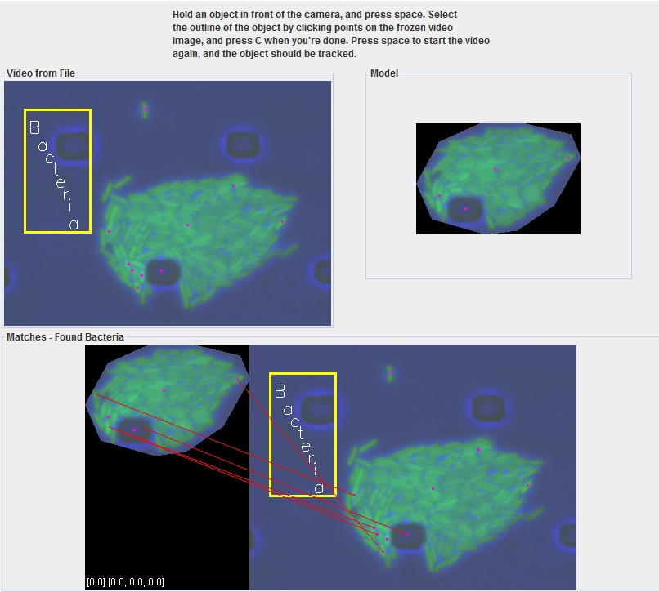

Lab5

Source: <https://github.com/DRinKC/RT-BigData-Project_Team1/wiki/Lab-5>

Object Detection and Annotation:

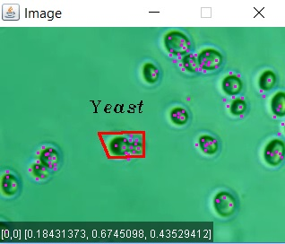

Decision Tree output:

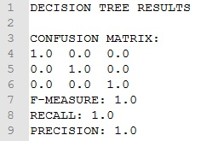

Random Forest output:

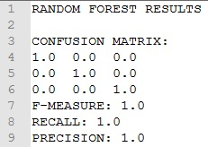

Lab6

Source: <https://github.com/DRinKC/RT-BigData-Project_Team1/wiki/Lab-6>

Extracting key frames, metadata and features, and sending data to Storm via Kafka Producer (no screenshot available)

*Project Management: Implementation status report*

* Work completed:
  + Description: Proposal, Lab 3, Lab 4, Lab 5, Lab 6
    - Responsibility:
      * Bill, Justin and David for Proposal: 5 hrs (Brendan joined late)
      * Bill & Brendan for Lab 3 part 1: Clarifai for acquiring and applying image tags for frame (4 hrs)
      * Justin Lab 3 part 2: mainframe detection (3-4 hrs)
      * David Lab 4: object detection/tracking (3-4 hrs)
      * Bill, Justin, David, Brendan: Feature and metadata extraction (3 hrs)
      * Bill, Justin, David, Brendan: Kafka producer and consumer (5-6 hours)
    - Contributions (members/percentage): roughly 25% each
  + Improvement of object detection
    - No real improvement, but we have plans to change contrast of videos to hopefully improve detection. Given nature of our video, we will have to incorporate both SIFT feature detection and edge detection, as cells’ features are not distinct based on features only.
  + Work to be completed
    - Description:
      * Implementing ML algorithms (and others) to more accurately detect cells and/or cell behavior.
      * Modifying our SIFT detection to see if it’s possible to detect E.Coli using the lab tutorial methods. Also test on yeast cells.
      * Knowing location of each cell during a frame of video (this would be classifying that something is a cell). This would be the first step in building a lineage tree.
      * Adding more annotations (i.e., not just labels, but also functions and/or cell lineage, etc.) --- to be fleshed out more in November
      * Implement a moderately simple way for non-technical scientists to submit data and receive results
      * Determining precision of results to increase validity for scientific research
      * Recreate local results on cloud
      * Created streamlined process that receives video data that processes and returns result to client
    - Responsibility (Task, Person):
      * Bill: Acquiring and configuring a microscope capable of digitally recording yeast and other single-celled organisms suitable for this project, assisting in implementation, and improving cell detection.
      * Brendan: Kafka, Storm, and general implementation on cloud and passing data
      * David: Assisting in implementation, creating bolts for Storm (see topology diagram above)
      * Justin: Implementation of ML algorithms through Spark and finding Java based SIFT feature aggregation.
    - Time to be taken (estimated #hours):
      * Bill's task: 7 - 10 hours
      * Brendan’s task: 6-8 hrs
      * David’s task: 7- 10 hrs
      * Justin’s task:7-10 hrs
* Issues/Concerns:
  + Gathering enough videos
    - Finding other similar microscope video on yeast
  + Improving the accuracy of object recognition
    - Accuracy/Precision of feature recognition on small objects in limited resolution videos
  + If the technology will work well enough with the existing data to implement desired features