# Mentoring-Week05

1. The focus this week will be all about BUGS! As a Software Engineer in Test our main role and responsibility is to test the application to ensure it is as bug free as possible. Please submit your answers to the questions on the form below.

**What do you do when you find a bug?**

**What do you do if you’re unsure if what you found is a bug?**

**How do you communicate with your team about the bug?**

**Where and how do you create the bug ticket?**

**What do you include on the bug ticket?**

**What do you do if developer says it’s not a bug?**

**Do you ever have any production bugs? If so, how do you deal with it?**

**How do you ensure you don’t miss this bug going into production again?**

Ask these questions to your mentors and see how they answer. Ask mentors to share some bugs they recently found and how they document their bugs?

RECALL:

**What is Bug/Defect Life Cycle?**

The bug life cycle in testing refers to a bug in which it goes through different states throughout its life. The life cycle begins with a new bug discovered by a tester while testing the application. It continues until the tester validates and closes the bug ticket.

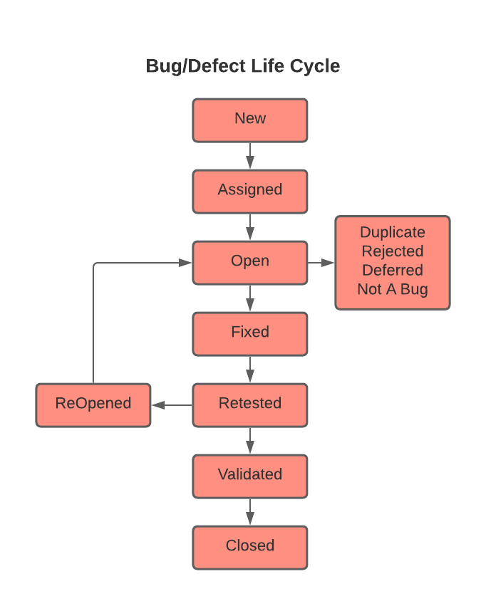

**What is a bug (defect)?**

A bug or defect is a feature or functionality that is not working or matching according to the expected outcome or requirement.

Reason a bug occurs:

1. Wrong implementation
2. Missing implementation
3. Extra implementation

**What is Severity?** Impact of bug on the customer business work flow.

EXAMPLE: user is not able to purchase products or cannot transfer money from one account to another.

**What is Priority?** How soon you want your developer to fix that bug.

EXAMPLE:

* Low Priority and Low Severity: This kind of bug is not affecting customer business flow but need to be fixed on upcoming released.
* High Priority and High Severity: A critical issue where a large piece of functionality or major system component is completely broken.
* High Priority and Low Severity: status indicate, that defect has to be fixed on immediate bases but does not affect the application work flow
* Low Priority and High Severity: An issue that won’t affects customers’ business, but it has a big impact in terms of functionality. (OFTEN THIS TYPE OF BUG DOES NOT OCCUR.)

|  |  |
| --- | --- |
| **Team Member** | **Answers to questions. (Please answer in BLACK color text)** |
| **1.**  Dylan Robertson | **What do you do when you find a bug?**  **Check to make sure a bug ticket is not already created for this specific bug, or if it is that you have more information for the bug ticket before creating a bug ticket of your own**  **What do you do if you’re unsure if what you found is a bug?**  **Ask co-workers for their opinion/help to see if you overlooked something. When in doubt, file a bug report to cover for yourself**  **How do you communicate with your team about the bug?**  **This depends on bug severity and priority; the higher the severity and priority, the more imperative it is that you touch base with your team about it to raise their awareness, as whomever is assigned to fix it might not see it for a few hours if they are in the middle of working on something or out to lunch. A quick message on slack or whatsapp should do the trick.**  **Where and how do you create the bug ticket?**  **On your company’s preferred bug tracking software/bug report filing system**  **What do you include on the bug ticket?**  **Title, description, steps to reproduce, actual and expected results, any attachments showing the bug from your perspective, priority**  **What do you do if developer says it’s not a bug?**  **Have a discussion with the developer as to why the do not believe your defect is in fact a bug, and if you still disagree a three amigos meeting can be held to give final clarification to the issue**  **Do you ever have any production bugs? If so, how do you deal with it?**  **How do you ensure you don’t miss this bug going into production again?**  **Production bugs are unfortunately a part of the business. While rare, they can be devastating for the company as they can cause a loss in customers, and therefore a loss in revenue. While production bugs are a thing, they are arguably a shared responsibility of the team; if you as a QA missed the bug in your tests, most likely other members of the development team missed it as well. While it is our job to prevent bugs from making it into the final project, it is also the job of the developers who are often the first line of defense against bugs and as a whole team, we are responsible for them. This is something important to remember to prevent yourself from getting too down about it.**  **Feature flags to shut off certain parts of code are good for making quick “repairs” to the code, to allow the program to keep running minus problem areas. Also, prioritization of test code, while often a slight detriment to development speed, usually produces higher quality products. Proper maintenance of that code should help with this even further.** |
| **2.** | **What do you do when you find a bug?**  **What do you do if you’re unsure if what you found is a bug?**  **How do you communicate with your team about the bug?**  **Where and how do you create the bug ticket?**  **What do you include on the bug ticket?**  **What do you do if developer says it’s not a bug?**  **Do you ever have any production bugs? If so, how do you deal with it?**  **How do you ensure you don’t miss this bug going into production again?** |
| **3.** | **What do you do when you find a bug?**  **What do you do if you’re unsure if what you found is a bug?**  **How do you communicate with your team about the bug?**  **Where and how do you create the bug ticket?**  **What do you include on the bug ticket?**  **What do you do if developer says it’s not a bug?**  **Do you ever have any production bugs? If so, how do you deal with it?**  **How do you ensure you don’t miss this bug going into production again?** |
| **4.** | **What do you do when you find a bug?**  **What do you do if you’re unsure if what you found is a bug?**  **How do you communicate with your team about the bug?**  **Where and how do you create the bug ticket?**  **What do you include on the bug ticket?**  **What do you do if developer says it’s not a bug?**  **Do you ever have any production bugs? If so, how do you deal with it?**  **How do you ensure you don’t miss this bug going into production again?** |
| **5.** | **What do you do when you find a bug?**  **What do you do if you’re unsure if what you found is a bug?**  **How do you communicate with your team about the bug?**  **Where and how do you create the bug ticket?**  **What do you include on the bug ticket?**  **What do you do if developer says it’s not a bug?**  **Do you ever have any production bugs? If so, how do you deal with it?**  **How do you ensure you don’t miss this bug going into production again?** |
| **6.** | **What do you do when you find a bug?**  **What do you do if you’re unsure if what you found is a bug?**  **How do you communicate with your team about the bug?**  **Where and how do you create the bug ticket?**  **What do you include on the bug ticket?**  **What do you do if developer says it’s not a bug?**  **Do you ever have any production bugs? If so, how do you deal with it?**  **How do you ensure you don’t miss this bug going into production again?** |

**NOTE: Students should prepare additional questions to ask your mentor every meeting. These meetings are great opportunities to learn from your mentors. Please take notes during your meetings as there will be a lot of information discussed and you may need to recall it later.**

Thanks ☺

Meeting Notes: