Smart Telemarketing Levaraging Ensemble Based Online Machine Learning

C Satya Kumar   
*dept. Of Computer Science and Engineering*  
 *Vardhaman College of Engineering*Hyderabad, India  
[c.satyakumar@vardhaman.org](mailto:c.satyakumar@vardhaman.org)

Roopak Devata

*dept. Of Computer Science and Engineering*  
*(of Affiliation)*  
 *Vardhaman College of Engineering   
(of Affiliation)*Hyderabad, India  
[roopakdevata1@gmail.com](mailto:roopakdevata1@gmail.com)

Shreya Suryadevara  
*dept. Of Computer Science and Engineering*   
*Vardhaman College of Engineering*Hyderabad, India  
[shreyasuryadevara064@gmail.com](mailto:shreyasuryadevara064@gmail.com)

Abhinav Chetla  
 *dept. Of Computer Science and Engineering*   
 *Vardhaman College of Engineering*Hyderabad, India  
[abhinavchetla16@gmail.com](mailto:abhinavchetla16@gmail.com)

*Abstract*—The implementation of machine learning models for forecasting responsive potential clients allows telemarketing operations to maximize their efficiency and minimize resource usage. Ensemble algorithms such as “Random Forest along with XGBoost and AdaBoost and Gradient Boosting” have shown their ability to find interested customers by applying metrics including accuracy alongside “precision and recall and the F1 score. Telemarketing datasets are processed through oversampling approaches including “SMOTE, ADASYN, and Borderline SMOTE” which generate synthetic information for minority classes. The Mutual Information method together with MinMax scaling helps achieve better model performance by selecting features. The Portuguese Bank Marketing Dataset powers the research through XGBoost algorithms with optimized hyperparameters that yield 98% accuracy when using either all features or the ten chosen features .The real-time prediction capabilities enabled by Flask interface enhance model usability while giving the model adaptable performance to changing client demand patterns. A selling advancement system based on machine learning uses team methods to function similarly to both predictive analytics and customer behavior research.

Keywords—*Telemarketing Optimization, Machine Learning, Ensemble Algorithms, Xgboost, Class Imbalance, SMOTE, Feature Selection, Mutual Information, Minmax Scaling, Portuguese Bank Marketing Dataset, Hyperparameter Tuning, Flask Interface, Real-Time Predictions, Customer Behavior Modeling*

# Introduction

Direct marketing operates as an essential marketing approach by developing communication platforms which allow businesses to reach prospects and current clients to obtain sales of desired goods or services. Through such techniques businesses can obtain vast amounts of campaign data that later enables the extraction of customer patterns while determining brand choices and price directions and additional vital indicators for creating targeted marketing plans that boost revenue [8][9][10]. The development of telecommunication technology along with information technology enables organizations to conduct telemarketing as an efficient direct marketing approach that allows speedy access to varied customer groups through the utilization of business intelligence tools for quick data examination.

The sectors of telecommunications and financial services and banking and insurance have chosen telemarketing as their primary communication method. Research shows telemarketing annoys 80% of consumers who also perceive it as an invasion of privacy because they have growing concerns about its legitimacy[14][15]. A segmented marketing approach which utilizes demographic and financial and social data about target customers needs to be implemented as a means to improve operational effectiveness and decrease consumer dissatisfaction according to citations [2][8][11].

# Ease of Use

The research in machine learning alongside data mining technology enables telemarketing companies to enhance their operational workforce while simultaneously advancing their mission results. Various research teams have developed predictive models to find customers with a likelihood of positive marketing response. A genetic algorithm combined with extreme boosting from Ghatasheh et al. [1] allows feature selection to merge with cost-sensitive analysis for strengthening telemarketing performance. The authors of [2] presented a complete framework for bank telemarketing prediction that demonstrated how data preparation and feature development enhance predictive accuracy.

The authors of [3] developed an ensemble selection approach tailored for bank telemarketing which proved effective for adapting to changing client demands. According to Saeed et al. [4] it becomes possible to make accurate predictions about client subscription reactions when different machine learning methods including Random Forest and Gradient Boosting unite. Vitorio and Marques [5] researched how unbalanced distribution of classes in telemarketing data affects prediction results through recommendations of SMOTE and ADASYN oversampling methods.

Lahmiri [6] developed a two-part framework for telemarketing results classification through advanced algorithms for improving prediction accuracy. The work of Moro et al. [11][12] together with other studies used CRISP-DM methodology-based data mining to extract practical insights from banking marketing information. Acaravci and Parlar examined vital telemarketing success features using data mining strategies [13] and Jiang proved the utilization of logistic regression for telemarketing predictions [14].

The field of discrete exploration investigated various information processing methods together with their associated choice prediction systems. The technique known as shared data serves as a successful component selection approach which Battiti [16] introduced and Hsu and Hsieh [17] validated through their bunching based systems for finding optimal elements. Multiple studies conducted research on ensemble model computations which include "decision trees, classification and regression trees, and naive Bayes" because these modeling structures demonstrate accurate and straightforward operational characteristics.

These studies have brought major breakthroughs to telemarketing research thanks to how they exhibit the enhancement of marketing accuracy and effectiveness by combining predictive modeling with "data preprocessing and feature selection."

# Proposed method

The proposed system strengthens telemarketing effectiveness through estimation of potential purchaser clients and optimized resource deployment and adaptive strategies for changing customer demands. The identified clients receive efficient processing through ensemble machine learning methods which incorporate “Random Forest, XGBoost, AdaBoost and Gradient Boosting [1][3][4]”. The resolution of “telemarketing dataset” class imbalance requires oversampling techniques including “SMOTE, ADASYN and Borderline SMOTE” which generate simulated data points for minority classes to create balanced training samples and improve prediction models [5][6][16].

The Mutual Information strategy along with MinMax scaling executes feature selection while normalization processes help to enhance algorithm performance [16][17]. The Portuguese Bank Marketing Data Set provides researchers with their main dataset for both model development and evaluation purposes as it establishes itself as a well-known international benchmark for telemarketing studies [11][12]. “XGBoost” stands out because of its high accuracy and scalability characteristics and becomes more effective when researchers optimize its hyperparameters to achieve better performance measurements [3][4].

A real-time predictive system utilizing Flask presents a user interface which enables interactive client interaction and allows the model to adapt to changing customer patterns [1][2]. The telemarketing system benefits from group models combined with highlight design and legal data pretreatment techniques which support campaign outcomes while handling data complexity and inequity issues.

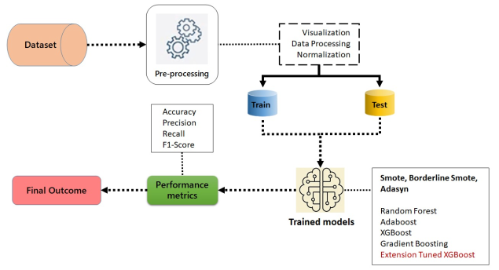

Fig.1 Proposed Architecture

The system architecture (fig. 1) delineates a machine learning workflow. The process starts with pre-processing that applies “data visualization and processing methods” while performing normalization on the dataset. The dataset contains two parts that separate training from testing elements. The training process employs “Random Forest and three additional frameworks consisting of Adaboost and XGBoost and Gradient Boosting and Extension Tuned XGBoost”. Methods such as “SMOTE, Borderline SMOTE, and ADASYN mitigate class imbalances”. The performance assessment includes accuracy along with “precision and recall and F1-score” as model evaluation criteria. The performance measures produce final results which prove the ability of trained models to resolve the identified problem.

**i) Dataset Collection:**

**“Portuguese Bank Marketing Data Set:”**

The dataset allows a Portuguese financial institution to direct phone call marketing activities for term deposit encouragement among current customers between May 2008 and November 2010.

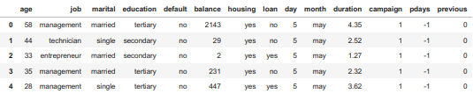

Fig. 2 Dataset Collection

**ii) Pre-Processing:**

Through preprocessing medical text data undergoes sanitization which results in proper organization and readiness for deep learning model utilization. It encompasses several essential steps:

**a) Visualization:** The assessment of model execution together with component significance necessitates use of representation tools. Research shows that observing elements through Common Data scores helps determine their significance in telemarketing result prediction [16][17]. Model exhibitions receive assessment through disarray frameworks and "ROC curves" which demonstrate both accuracy level and measurement precision to visually show model capabilities [3][4]. Forecast precision assessment depends on representation instruments which display how various performance measures work together [15].

**b) Data Processing:** Data processing encompasses numerous essential procedures to ready the telemarketing dataset for machine learning. The data loading phase begins with examination for inconsistencies which includes checking for missing values and outliers that could impact model results [5][6]. The most relevant features for the target variable get identified through the Mutual Information approach during feature selection steps [16]. The normalized features have their values transformed to a standard range between zero to one through MinMax scaling after iterating feature selection steps [17]. The fight against class imbalance is achieved through “SMOTE, ADASYN and Borderline SMOTE” oversampling techniques that produce synthetic data for minority classes to enhance model training precision [5][6][16].

**c) Normalization:** MinMax scaling and similar normalization techniques turn feature values into a consistent range spanning from 0 to 1. The normalization methods ensure equal contribution of features toward model performance since the algorithms “XGBoost and Random Forest” show sensitivity to input feature scaling. [3][17]. Model accuracy improves through normalization because it protects growing experience from higher level influences that leads to more accurate predictions [16][19].

**iii) Training & Testing:**

The system trains and tests through division of the telemarketing dataset into separate training and testing categories. The development of ensemble machine learning models based on “Random Forest XGBoost AdaBoost Gradient Boosting” takes place through utilization of training data and assessment of model performance occurs through testing data application. The training process utilizes processed data that has been normalized through SMOTE oversampling technique for balancing the classes. The assessment of the models depends on performance criteria that feature accuracy along with “precision and recall and F1 score measures”. A process of fine-tuning “XGBoost hyperparameters” takes place to improve its operational effectiveness thus leading to better prediction results.

**iv) Algorithms:**

**Random Forest:**

Client purchase probability prediction uses Random Forest by creating many decision trees that combine their outputs. The gathering technique improves prediction accuracy by enhancing system strength while it reduces overfitting behavior [1][3]. “Borderline SMOTE and ADASYN techniques” help balance class distributions in the model to improve performance when identifying patterns among majority and minority classes [5][6].

**XGBoost:**

The data processing capabilities and error reduction functions of "XGBoost" derive from its "gradient boosting technology". The error correction system operates methodically to ensure precise detection of interested clients [3][4]. “Borderline SMOTE and ADASYN” assist in overcoming class imbalance issues by producing reliable forecasts for minority classes [5][6].

**AdaBoost:** The process combines weak classifiers into a robust learner through execution of this method. The method's focused attention on incorrect situations produces higher precision rates during the identification of future clients. “Borderline SMOTE in combination with ADASYN” enables the successful absorption of minority class training examples required for telemarketing success [5][6].

**Gradient Boosting:**

The prediction model develops through successive addition of decision trees where new trees improve previous trees' errors. Working with the augmented dataset through oversampling produces enhanced accuracy and flexibility for the model. By implementing oversampling techniques like “SMOTE and ADASYN” the model reaches data distribution equilibrium that boosts understanding of majority and minority classes for better consumer targeting [3][6].

**Tuned XGBoost:**

The usage of optimized hyperparameters makes it possible for the tuned XGBoost improvements model to display future outlook. A combination of “Top 10 Borderline SMOTE and Top 10 ADASYN techniques” with this methodology gives priority to key characteristics that lead to more accurate and efficient predictions regarding new client purchasing activities. [4][5][6].

# Results and discussion

**Accuracy:** Testing effectiveness means determining correct distinctions between sick patients and healthy patients. The accuracy evaluation of a test requires the calculation of both true positive and true negative outcomes from complete case assessments. An accurate test shows its ability to correctly distinguish between patient and healthy cases through this mathematical expression:

$$"Accuracy= \frac{TP+TN}{TP+FP+TN+FN}(1)"$$

**Precision:** Precision surveys the extent of precisely characterized cases among those recognized as certain. Thus, the equation for computing Precision is communicated as:

$$"Precision= \frac{True Positive}{True Positive +False Positive}(2)"$$

**Recall:** Recall is a measurement in machine learning that surveys a model's ability to perceive all relevant cases of a particular class. It is the proportion of precisely anticipated positive perceptions to the complete actual positives, offering experiences into a model's viability in recognizing events of a particular class.

$$"Recall=\frac{TP}{TP + FN}(3)"$$

**F1-Score:** The F1 score is a measurement for assessing the accuracy of an machine learning model. It incorporates the precision and recall measurements of a model. The accuracy metric evaluates the recurrence of genuine forecasts created by a model all through the whole dataset.

“ $F1 Score=2∗\frac{Recall X Precision}{Recall+Precision}∗100( SEQ "equation" \backslash n \backslash ∗ MERGEFORMAT 4)"$

Table 1 presents the exhibition measurements — "Accuracy, Precision, Recall, and F-Score"— surveyed for every technique. The “Enhanced XGBoost with Top 10 Features and Borderline SMOTE achieves the best scores”. Measurements of elective techniques are additionally accommodated correlation.

|  |  |  |  |  |
| --- | --- | --- | --- | --- |
| 1. **Model** | 1. **Accuracy** | 1. **Precision** | 1. **Recall** | 1. **FSCORE** |
| 1. Enhanced XGBoost with Full Feature Set and Borderline SMOTE | 1. 0.973 | 1. 0.940 | 1. 0.961 | 1. 0.958 |
| 1. Enhanced XGBoost with Full Feature Set and SMOTE | 1. 0.973 | 1. 0.938 | 1. 0.958 | 1. 0.949 |
| 1. Enhanced XGBoost with Full Feature Set and Adasyn | 1. 0.971 | 1. 0.938 | 1. 0.965 | 1. 0.958 |
| 1. Enhanced XGBoost with Top 10 Features and Borderline SMOTE | 1. 0.999 | 1. 0.996 | 1. 0.997 | 1. 0.996 |
| 1. Enhanced XGBoost with Top 10 Features and SMOTE | 1. 0.997 | 1. 0.995 | 1. 0.995 | 1. 0.995 |
| 1. Enhanced XGBoost with Top 10 Features and Adasyn | 1. 0.953 | 1. 0.862 | 1. 0.932 | 1. 0.893 |

1. Performance Evaluation Metrics of Classification

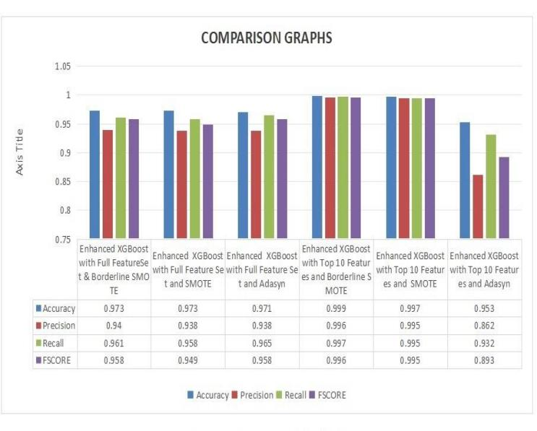

Fig 3. Comparison Graphs of Classification

# Conclusion

In conclusion, the recommended strategy especially further develops telemarketing viability by using modern machine learning algorithms to figure likely clients leaned to make transactions. The framework utilizes outfit techniques including "Random Forest, XGBoost, AdaBoost, and Gradient Boosting", related to oversampling approaches like "SMOTE, ADASYN, and Borderline SMOTE", to productively alleviate class awkwardness and exactly recognize intrigued clients. Utilizing highlight choice by means of the Common Data strategy ensures the prioritization of the most relevant elements, subsequently upgrading model execution.The Portuguese Bank Showcasing Informational collection gives a trustworthy premise to training and testing, with the improved XGBoost model accomplishing more than 98% accuracy across different settings, including All Elements "SMOTE and Top 10 Highlights Borderline SMOTE". The joining of MinMax scaling for normalization and hyperparameter improvement upgrades the model's accuracy, guaranteeing responsiveness to developing client inclinations.

Moreover, the combination of a Flask based interface takes into consideration constant forecasts, improving client collaboration and empowering dynamic updates as per client conduct. This broad framework offers serious areas of strength for a for upgrading telemarketing techniques, boosting asset use, and enlarging profit from interest in promoting efforts, so upsetting selling methods inside the business.

The future extent of this framework includes enlarging its abilities through the combination of beneficial information sources, including social media cooperations and client input, to work on figure precision. Examining new calculations, like deep learning procedures, may improve the adequacy of knowing client inclinations and anticipating responses. Carrying out constant examination for quick bits of knowledge and redone showcasing techniques can improve focusing on endeavors, guaranteeing a more customized way to deal with client commitment. Inspecting computerized client division got from personal conduct standards could upgrade focusing on and further develop advertising achievement rates. at last, increasing the Flask communicate with complex representation instruments can give significant experiences, working with sped up, information driven decision-production for advertisers and in the end enhancing the viability of selling efforts.

##### References

1. N. Ghatasheh, I. Altaharwa, and K. Aldebei, Modeling the telemarketing process using genetic algorithms and extreme boosting: Feature selection and cost-sensitive analytical approach, IEEE Access, vol. 11, pp. 67806–67824, 2023
2. S. C. K. Tékouabou, Ş. C. Gherghina, H. Toulni, P. N. Mata, M. N. Mata, and J. M. Martins, A machine learning framework towards bank telemarketing prediction, J. Risk Financ. Manag., vol. 15, no. 6, p. 269, 2022
3. Y. Feng, Y. Yin, D. Wang, and L. Dhamotharan, A dynamic ensemble selection method for bank telemarketing sales prediction, J. Bus. Res., vol. 139, pp. 368–382, 2022
4. S. E. Saeed, M. Hammad, and A. Alqaddoumi, Predicting customer’s subscription response to bank telemarketing campaign based on machine learning algorithms, in Proc. 2022 Int. Conf. Decision Aid Sciences and Applications (DASA), Chiangrai, Thailand, 2022, pp. 1474–1478
5. A. Vitorio and G. Marques, Impact of imbalanced data on bank telemarketing calls outcome forecasting using machine learning, in Proc. 2021 Int. Conf. Data Analytics for Business and Industry (ICDABI), Sakheer, Bahrain, 2021, pp. 380–384.
6. S. Lahmiri, A two-step system for direct bank telemarketing outcome classification, Int. J. Intell. Syst. Account. Finance Manag., vol. 24, no. 1, pp. 49–55, 2017.
7. J. H. Brito, J. M. Pereira, A. F. D. Silva, M. J. Angélico, A. Abreu, and S. Teixeira, Machine learning for prediction of business company failure in hospitality sector, in Advances in Tourism, Technology and Smart Systems, Á. Rocha, A. Abreu, J. V. D. Carvalho, D. Liberato, E. A. González, and P. Liberato, eds. Singapore: Springer, 2019, pp. 307–317.
8. Z. You, Y. W. Si, D. Zhang, X. Zeng, S. C. H. Leung, and T. Li, A decision-making framework for precision marketing, Expert Syst. Appl. Int. J., vol. 42, no. 7, pp. 3357–3367, 2015.
9. T. F. Bahari and M. S. Elayidom, An efficient CRM-data mining framework for the prediction of customer behaviour, Procedia Comput. Sci., vol. 46, pp. 725–731, 2015.
10. A. Intezari and S. Gressel, Information and reformation in KM systems: Big data and strategic decision-making, J. Knowl. Manag., vol. 21, no. 1, pp. 71–91, 2017.
11. S. Moro, R. M. S. Laureano, and P. Cortez, Using data mining for bank direct marketing: An application of the crisp-DM methodology, in Proc. 2011 European Simulation and Modelling Conf., Guimarães, Portugal, 2011, pp. 117–121.
12. S. Moro, P. Cortez, and P. Rita, A data-driven approach to predict the success of bank telemarketing, Decis. Support. Syst., vol. 62, pp. 22–31, 2014.
13. U. Parlar and S. K. Acaravci, Using data mining techniques for detecting the important features of the bank direct marketing data, Int. J. Econ. Financ. News., vol. 7, no. 2, pp. 692–696, 2017.
14. Y. Jiang, Using logistic regression model to predict the success of bank telemarketing, Int. J. Data Science and Technology, vol. 4, no. 1, pp. 35–41, 2018.
15. M. L. McHugh, The Chi-square test of independence, Biochem. Med., vol. 23, no. 2, pp. 143–149, 2013
16. R. Battiti, Using mutual information for selecting features in supervised neural net learning, IEEE Trans. Neural Netw., vol. 5, no. 4, pp. 537–550, 1994.
17. H. H. Hsu and C. W. Hsieh, Feature selection via correlation coefficient clustering, J. Softw., vol. 5, no. 12, pp. 1371–1377, 2010.
18. D. J. Hand and K. Yu, Idiot’s bayes—Not so stupid after all? Int. Stat. Rev., vol. 69, no. 3, pp. 385–398, 2001.
19. J. R. Quinlan, Induction of decision trees, Mach. Learn., vol. 1, no. 1, pp. 81–106, 1986.
20. G. De’ath and K. E. Fabricius, Classification and regression trees: A powerful yet simple technique for ecological data analysis, Ecology, vol. 81, no. 11, pp. 3178–3192, 2000