**BOOKING SYSTEM FOR TATTOO HERITAGE**

**BY**

**Palistha Shakya**

**725511112016**

National College of Computer Studies

Paknajol, Kathmandu

*A Summer Project Report Submitted to*

**Faculty of Management, Tribhuvan University**

in partial fulfillment of the requirements for the degree of

**Bachelor of Information Management**

Paknajol, Kathmandu

July 2019

# STUDENT DECLARATION

This is to certify that I have completed the Summer Project entitled "Booking System for Tattoo Heritage" under the guidance of "Brihat Singh Boswa" in partial fulfillment of the requirements for the degree of **Bachelor of Information Management** at Faculty of Management, Tribhuvan University. This is my original work and I have not submitted it earlier elsewhere.

Date: Signature:

Name: Palistha Shakya

# CERTIFICATE FROM THE SUPERVISOR

This is to certify that the summer project entitled " Booking System for Tattoo Heritage" is an academic work done by "Palistha Shakya" submitted in the partial fulfillment of the requirements for the degree of Bachelor of Information Management at Faculty of Management, Tribhuvan University under my guidance and supervision. To the best of my knowledge, the information presented by her in the summer project report has not been submitted earlier.

______________________

Signature of the Supervisor

Name:

Designation:

Date:

# ACKNOWLEDGEMENT

This Report entitled "Booking System for Tattoo Heritage" is prepared in the partial fulfillment of the requirements of Tribhuvan University for the Bachelor of Information Management at Faculty of Management.

I take this opportunity to acknowledge my heartfelt gratitude to my supervisor Mr. Brihat Singh Boswa for his valuable guidance, encouragement and inspiration at every step in my research work. It is no exaggeration to state without his guidance, suggestion and cooperation, this study wouldn't have got the shape it has.

Above of all, I would like to thankour college, National College of Computer Studies for providing me such a wonderful opportunity to prepare this report which helps to develop our knowledge and skill on programming language.

**Palistha Shakya**

# EXECUTIVE SUMMARY

Tattoo Heritage is a place where people come from various places to make tattoo and piercing their body. The design of the tattoo is selected by customers which can be cultural, religious, creatures, flowers and much more. All the designs are drawn first before the tattoo is made. They have participated in many tattoo programs. They have also visited India for Tattoo Conventions and have received many awards.

It is a small organization where people visit only through the help of personal contact or Facebook. There is no use of promotional activities to know the people about Tattoo Heritage. The people need to visit the organization before making a tattoo which is difficult for them. Sometimes, it also creates problem for the organization if the customers visit the organization in the middle of work. There is no proper booking system of organization.

The basic purpose of this study is to develop a system that automates the processes and activities of an organization. For this, we will use PHP for web based application whereas MySQL for database as backend and HTML, Bootstrap, JS and CSS as frontend. The tools which are used for data collection are primary data such as direct interview and secondary data such as internet. It also contains various UML diagrams like class diagram, ER diagram, and use case diagram.

# TABLE OF CONTENT

STUDENT DECLARATION i

CERTIFICATE FROM THE SUPERVISOR ii

ACKNOWLEDGEMENT iii

EXECUTIVE SUMMARY iv

TABLE OF CONTENT v

LIST OF FIGURES vii

ABBREVIATION viii

Chapter 1: Introduction 1

1.1 Background 1

1.2 Introduction of the organization 1

1.3 Current situation of the organization 1

1.4 Problem of the report 1

1.5 Objective of the report 2

1.6 Methodology adopted for writing the report 2

1.6.1 Project framework 2

1.6.2 Data and information 2

1.6.3 Techniques of project report analysis 3

Chapter 2: Requirement analysis and feasibility study 4

2.1 Requirement specification 4

2.1.1 Functional requirement 4

2.1.2 Non-functional requirement 4

2.2 Feasibility study 4

2.2.1 EF 4

2.2.2 TF 4

2.2.3 OF 4

2.2.4 SF 4

2.3 Process modeling 4

2.3.1 ER diagram 5

2.3.2 Use case diagram 5

2.3.3 Class diagram 6

Chapter 3: Discussions and conclusions 7

3.1 Discussion 7

3.2 Conclusion 7

REFERENCES 8

APPENDICES 9

# LIST OF FIGURES

Figure 1: ER diagram of Tattoo Heritage 5

Figure 2: Use case diagram of booking system for Tattoo Heritage 5

Figure 3: Class Diagram 6

# ABBREVIATION

HTML Hypertext Markup Language

JS JavaScript

CSS Cascading Style Sheets

i.e. That is

UML Unified Modeling Language

Etc. Etcetera

ER Entity relationship

SRS **Software requirements specification**

# Chapter 1: Introduction

## Background

Tattoos and body piercing are done as expressions of independence, for religious or cultural reasons, or to adorn one's body. Tattoo is a permanent picture, pattern, or word on the surface of skin, created by using needles to put colors under the skin. The art of making tattoos is tattooing. Nowadays tattoo is trending in Nepal. Many tattoo places have been established.

Piercing is performed quickly and without anesthesia by either a spring-loaded ear-piercing gun or piercing needles, with the needle diameter varying from six to 18 gauge. The skin is cleaned, and then the needle and jewelry are inserted through the tissue in one swift motion. Piercing is typically completed in tattoo or beauty parlors.

Tattoo Heritage is a small organization which is established for making tattoo and piercing their body. For this, various people come from different areas i.e. Nepalese and foreigners. In this organization there is a problem of lack of customer attraction and booking system so, to solve this problem a web page with booking should be used. For this, we will use PHP for web based application whereas MySQL for database as backend and HTML, Bootstrap, JS and CSS as frontend.

## Introduction of the organization

Tattoo Heritage is a small organization which is located at Nursing Chowk Thamel, Kathmandu. It was established in 2018 B.S. It is a place where people come from various places to make tattoo and piercing their body. There are three tattoo artist who does piercing and make tattoos. The design of the tattoo is selected by customers which can be cultural, religious, creatures, flowers and much more. All kinds of tattoos are done but mostly traditional tattoos are drawn. They have participated in many tattoo programs. They have also visited India for Tattoo Conventions and have received many awards.

All the people visit there only through the help of personal contact or by through Facebook. No promotion activities have been done by the organization for customer attraction. So, it is very difficult for the people to know about this place. It is the main problem of the organization. Again, the customers visit the organization in the middle of the work which creates disturbance for the other others. So, another problem for the organization is there is no proper booking system. The customers need to visit the organization with the design or without design and book the time personally which is difficult for them.

## Current situation of the organization

Currently, the organization is running with three artist. The people visit this place only through the help of personal contact or Facebook. There is no use of promotional activities to know the people about Tattoo Heritage. The people need to visit the organization before making a tattoo which is difficult for them. Sometimes, it also creates problem for the organization if the customers visit the organization in the middle of work. There is no proper booking system of organization. The problems which are faced by organization are:

* No use of promotional tool for customer attraction.
* There is lack of proper booking system of organization.

## Problem of the report

It is not possible to collect all the data due to limited time. It only covers the limited aspect of the organization. The problem of the report are:

* Could not gather more information i.e. information is limited due to the time bound.
* The system may not be feasible as it doesn't consider all the aspects of organization.
* It may not fulfill the user requirement as proper data could not be gathered due to the hectic schedule of the owner.

## Objective of the report

The basic purpose of this study is to develop a system that automates the processes and activities of an organization. This research is done to know about a problem in an organization which can be solved by web based application. The objective of this report are:

* To develop a web page for customer attraction.
* To make the booking system easier for both client and organization.
* To keep records in most effective way possible.

## Methodology adopted for writing the report

Different methodologies were used in order to get information required for the proposed system. Online research and direct interviews are the some of the methods to gather the information required.

### Project framework

The overall project is divided into three segments. They are:

1. Introduction
2. Analysis
3. Discussion and Conclusion
4. **Introduction**

The first chapter deals with introduction. There is a brief about the background and introduction of the organization. It also states the current situation of the organization which is lack of booking system and customer attraction. It highlights the problem of the organization which can be solved with the help of web page which contains the information of organization and booking system for the interested people. Along with these, it also shows the problem of the report, objective, and the tools used for data collection i.e. primary and secondary method.

1. **Requirement analysis and feasibility study**

In this chapter, requirement analysis and feasibility study of the software is done using various tools such as UML diagrams i.e. class diagram, ER diagram, and use case diagram.

1. **Discussion and Conclusion**

This chapter contains discussion and conclusion where we discuss about the tools used in the organization, findings and suggestions/solutions interpreting and significance of the findings and the conclusion of the report.

### Data and information

Data and information is needed to know about the current situation and problems of organization. For the collection of data and information we use various tools, all of which fall into two categories, i.e.

1. Primary data
2. Secondary data
3. **Primary data**

Primary data factual and original data. It is a **data that is collected from first-hand sources**, using methods like surveys, interviews, or experiments. It is collected with the research project in mind, directly from primary sources. Primary data sources include surveys, observations, questionnaire, personal interview, etc. In this report, most of the analysis is based on primary data which include various photographs and interviews.

1. **Secondary data**

Secondary data is data gathered from studies, surveys, or experiments that have been run by other people or for other research. It is just the analysis and interpretation of the primary data. Secondary data collection sources are government publications, websites, books, journal articles, etc. In this report, secondary data has also been used to some extent such as books and websites.

### Techniques of project report analysis

The techniques or tool used for gathering information are:

1. **Online research**

Online research is done by going through different websites that offers documentation, ideas and techniques about managing such kind of proposed system. Based on different kinds of information available on various websites, needed information were collected which is best for the proposed system.

1. **Interviews**

This research is based on interview taken in Tattoo Heritage. A direct personal interview with Mr. Aviseq Shakya, was conducted to gather information which is needed for the report.

# Chapter 2: Requirement analysis and feasibility study

## Requirement specification

A  SRS is a detailed description of a software system to be developed with its functional and non-functional requirements. The process of writing down the user requirement and system requirement in a formal document form using the specific language or some notations is called requirement specification. The requirement specification can be divided into two i.e. functional and non-functional requirement.

### Functional requirement

A functional requirement defines a system or its component. It describes the functions a software must perform. A function is nothing but inputs, its behavior, and outputs. It can be a calculation, data manipulation, business process, user interaction, or any other specific functionality which defines what function a system is likely to perform.

### Non-functional requirement

A non-functional requirement defines the quality attribute of a software system. It cover all the remaining requirements which are not covered by the functional requirements. They represent a set of standards used to judge the specific operation of a system.

## Feasibility study

### EF

### TF

### OF

### SF

## Process modeling

A software process model is a simplified representation of a software process. Each model represents a process from a specific perspective. System modeling is the process of developing abstract models of a system, with each model presenting a different view or perspective of that system. It helps the analyst to understand the functionality of the system and models are used to communicate with customers. Some of the models which is included in the report are shown below:

### ER diagram

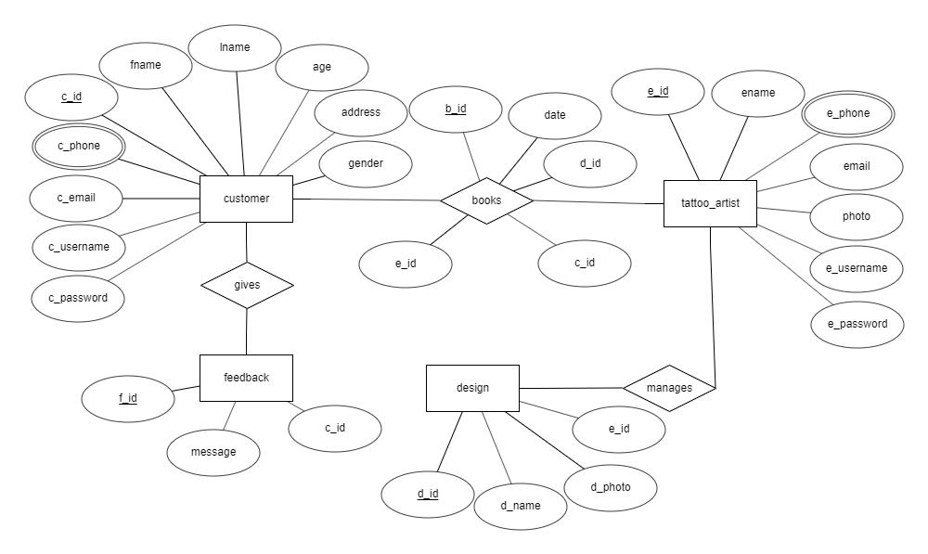

Figure 1: ER diagram of Tattoo Heritage

### Use case diagram



Figure 2: Use case diagram of booking system for Tattoo Heritage

### Class diagram



Figure 3: Class Diagram

# Chapter 3: Discussions and conclusions

## Discussion

The discussion of the report includes the introduction of the organization, current situation, problems of organization, and the tools which are used such as primary and secondary. It also includes how the system can be used to solve the problem, which programming language is used and advantages of the software for the organization.

## Conclusion

This system will make the booking system of Tattoo Heritage easier. It will also helps in customer attraction by providing the information about the organization which will improve the current situation. Here we used web based programming language i.e. PHP and MySQL for database. We used different data manipulation languages to manipulate the data.

# REFERENCES

Admin, S. (n.d.). *Software Requirement Specification (SRS)*. [online] Software Testing Class. Available at: http://www.softwaretestingclass.com/software-requirement-specification-srs/ [Accessed 10 Jul. 2019].

Guru99.com. (2017). [online] Available at: https://www.guru99.com/functional-vs-non-functional-requirements.html [Accessed 4 Jul. 2019].

Csis.pace.edu. (2018). [online] Available at: http://csis.pace.edu/~marchese/CS389/L5/Chap5_summary.pdf [Accessed 14 Jul. 2019].

Healthofchildren.com. (n.d.). *Piercing and Tattoos - symptoms, meaning, Definition, Purpose, Description, Risks, Normal results*. [online] Available at: http://www.healthofchildren.com/P/Piercing-and-Tattoos.html#ixzz5tc2E09xq [Accessed 1 Jul. 2019].

10.13140/RG.2.2.24292.68481. (2017). *Primary Sources of Data and Secondary Sources of Data*. [online] Available at: https://www.researchgate.net/publication/320010397_Primary_Sources_of_Data_and_Secondary_Sources_of_Data [Accessed 10 Jul. 2019].

Medium. (n.d.). *Software Engineering — Software Process and Software Process Models (Part 2)*. [online] Available at: https://medium.com/omarelgabrys-blog/software-engineering-software-process-and-software-process-models-part-2-4a9d06213fdc [Accessed 30 Jun. 2019].

# APPENDICES

