560 - Project 2

Steven Hahn

5/19/2021

####Business Understanding#### #The data for this project comes from clinical samples of breast cancer from the University of Wisconsin Hospitals between January 1989 and November 1991. Sample collection and analysis was performed in batches by Dr. WIlliam H. Wolberg. #The purpose of this project is to develop multiple classification methods to classify breast cancer tumors as benign or malignant. Overall classification will be done via an ensemble fashion; the various classifiers will each make a prediction and the overall classification will be determined by majority rule. #Source: <https://archive.ics.uci.edu/ml/datasets/breast+cancer+wisconsin+(original)>

#Install and library packages  
#install.packages("mlbench")  
library(mlbench)

## Warning: package 'mlbench' was built under R version 4.0.5

#Load data  
data(BreastCancer)  
BreastCancer.df <- BreastCancer  
  
#Remove rows with missing values   
BreastCancer.df <- na.omit(BreastCancer.df)

####Data Understanding Phase#### #In this phase, we will review the overal strucutre of the dataset. This review will be done using summarization methods as well as visualizations.

#Review and describe the basic structure of the data  
str(BreastCancer.df)

## 'data.frame': 683 obs. of 11 variables:  
## $ Id : chr "1000025" "1002945" "1015425" "1016277" ...  
## $ Cl.thickness : Ord.factor w/ 10 levels "1"<"2"<"3"<"4"<..: 5 5 3 6 4 8 1 2 2 4 ...  
## $ Cell.size : Ord.factor w/ 10 levels "1"<"2"<"3"<"4"<..: 1 4 1 8 1 10 1 1 1 2 ...  
## $ Cell.shape : Ord.factor w/ 10 levels "1"<"2"<"3"<"4"<..: 1 4 1 8 1 10 1 2 1 1 ...  
## $ Marg.adhesion : Ord.factor w/ 10 levels "1"<"2"<"3"<"4"<..: 1 5 1 1 3 8 1 1 1 1 ...  
## $ Epith.c.size : Ord.factor w/ 10 levels "1"<"2"<"3"<"4"<..: 2 7 2 3 2 7 2 2 2 2 ...  
## $ Bare.nuclei : Factor w/ 10 levels "1","2","3","4",..: 1 10 2 4 1 10 10 1 1 1 ...  
## $ Bl.cromatin : Factor w/ 10 levels "1","2","3","4",..: 3 3 3 3 3 9 3 3 1 2 ...  
## $ Normal.nucleoli: Factor w/ 10 levels "1","2","3","4",..: 1 2 1 7 1 7 1 1 1 1 ...  
## $ Mitoses : Factor w/ 9 levels "1","2","3","4",..: 1 1 1 1 1 1 1 1 5 1 ...  
## $ Class : Factor w/ 2 levels "benign","malignant": 1 1 1 1 1 2 1 1 1 1 ...  
## - attr(*, "na.action")= 'omit' Named int [1:16] 24 41 140 146 159 165 236 250 276 293 ...  
## ..- attr(*, "names")= chr [1:16] "24" "41" "140" "146" ...

summary(BreastCancer.df)

## Id Cl.thickness Cell.size Cell.shape Marg.adhesion  
## Length:683 1 :139 1 :373 1 :346 1 :393   
## Class :character 5 :128 10 : 67 2 : 58 2 : 58   
## Mode :character 3 :104 3 : 52 10 : 58 3 : 58   
## 4 : 79 2 : 45 3 : 53 10 : 55   
## 10 : 69 4 : 38 4 : 43 4 : 33   
## 2 : 50 5 : 30 5 : 32 8 : 25   
## (Other):114 (Other): 78 (Other): 93 (Other): 61   
## Epith.c.size Bare.nuclei Bl.cromatin Normal.nucleoli Mitoses   
## 2 :376 1 :402 3 :161 1 :432 1 :563   
## 3 : 71 10 :132 2 :160 10 : 60 2 : 35   
## 4 : 48 2 : 30 1 :150 3 : 42 3 : 33   
## 1 : 44 5 : 30 7 : 71 2 : 36 10 : 14   
## 6 : 40 3 : 28 4 : 39 8 : 23 4 : 12   
## 5 : 39 8 : 21 5 : 34 6 : 22 7 : 9   
## (Other): 65 (Other): 40 (Other): 68 (Other): 68 (Other): 17   
## Class   
## benign :444   
## malignant:239   
##   
##   
##   
##   
##

#graph variables   
  
library(ggplot2)

## Warning: package 'ggplot2' was built under R version 4.0.4

ggplot(BreastCancer.df) + geom_bar(aes(x = Cl.thickness))

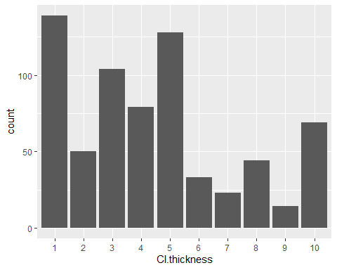

ggplot(BreastCancer.df) + geom_bar(aes(x = Cell.size))

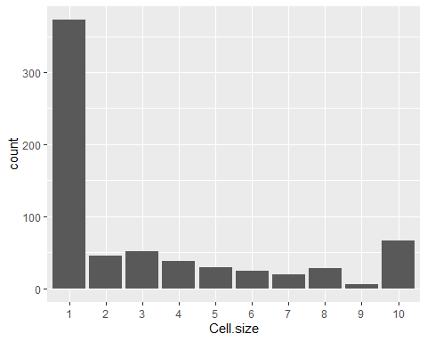

ggplot(BreastCancer.df) + geom_bar(aes(x = Cell.shape))

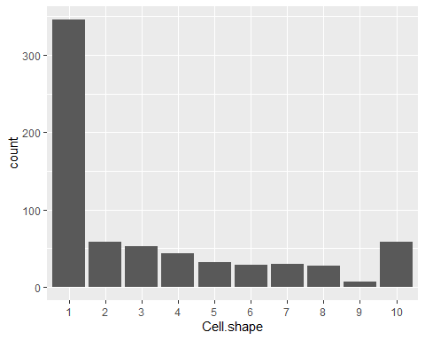

ggplot(BreastCancer.df) + geom_bar(aes(x = Marg.adhesion))

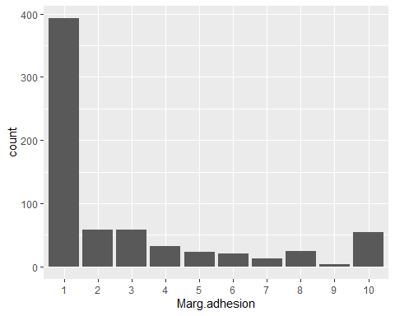

ggplot(BreastCancer.df) + geom_bar(aes(x = Epith.c.size))

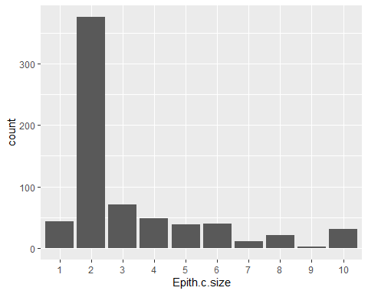

ggplot(BreastCancer.df) + geom_bar(aes(x = Bare.nuclei))

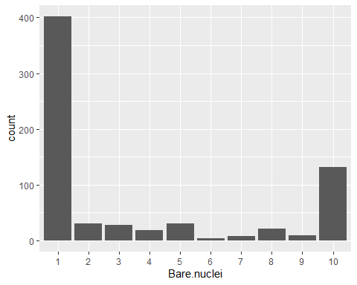

ggplot(BreastCancer.df) + geom_bar(aes(x = Bl.cromatin))

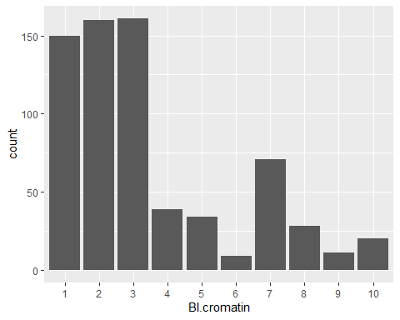

ggplot(BreastCancer.df) + geom_bar(aes(x = Normal.nucleoli))

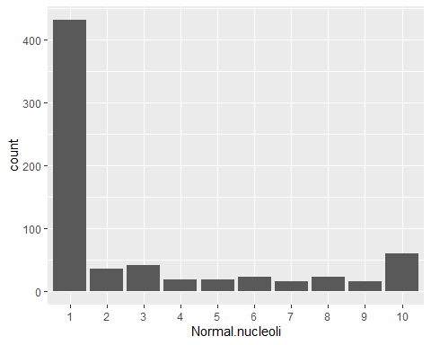

ggplot(BreastCancer.df) + geom_bar(aes(x = Mitoses))

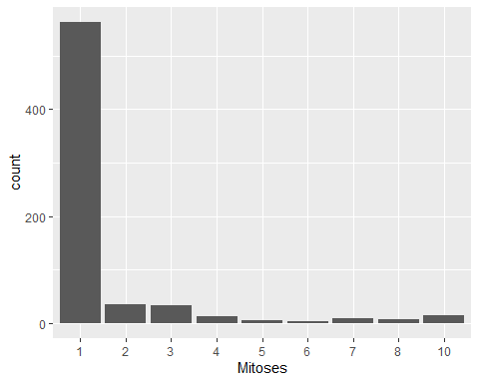

#Graph variables with our lable, Class, to get a clearer understanding of how each variable relates to our label. For each variable, there are two plots. The first is a simple count of the Class compared to the varaible; the second shows the Class as a percentage of each factor of the varialbe.   
  
#Plot Cell Thickness vs. Class  
ggplot() +  
 geom_bar(data = BreastCancer.df,  
 aes(x = factor(Cl.thickness),  
 fill = factor(Class)),  
 position = "stack") +  
 scale_x_discrete("Cell Thickness") +  
 scale_y_continuous("Percent") +  
 guides(fill=guide_legend(title="Class"))+  
 scale_fill_manual(values=c("blue",  
 "red"))

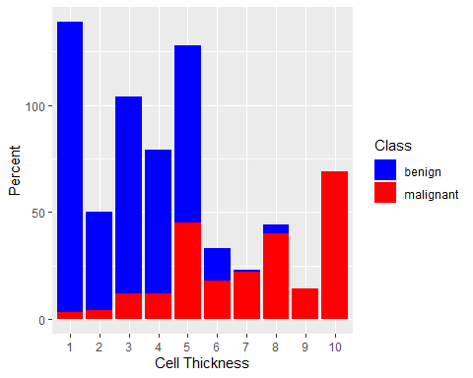

ggplot() +  
 geom_bar(data=BreastCancer.df,  
 aes(x = factor(Cl.thickness),  
 fill = factor(Class)),  
 position = "fill") +  
 scale_x_discrete("Cell Thickness")+  
 scale_y_continuous("Percent") +  
 guides(fill=guide_legend(title="Class")) +  
 scale_fill_manual(values=c("blue", "red"))

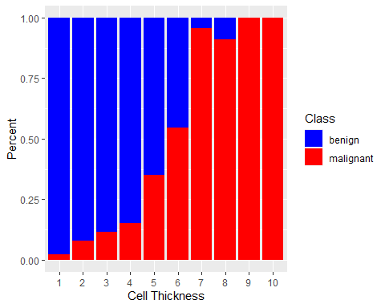

#Plot Cell.size vs. Class  
ggplot() +  
 geom_bar(data = BreastCancer.df,  
 aes(x = factor(Cell.size),  
 fill = factor(BreastCancer.df$Class)),  
 position = "stack") +  
 scale_x_discrete("Cell Size") +  
 scale_y_continuous("Percent") +  
 guides(fill=guide_legend(title="Class"))+  
 scale_fill_manual(values=c("blue",  
 "red"))

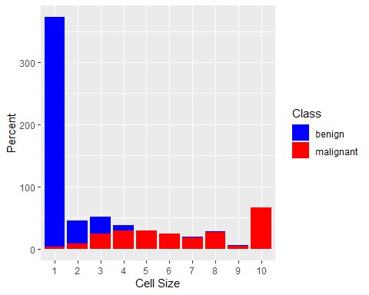

ggplot() +  
 geom_bar(data=BreastCancer.df,  
 aes(x = factor(Cell.size),  
 fill = factor(BreastCancer.df$Class)),  
 position = "fill") +  
 scale_x_discrete("Cell Size")+  
 scale_y_continuous("Percent") +  
 guides(fill=guide_legend(title="Class")) +  
 scale_fill_manual(values=c("blue", "red"))

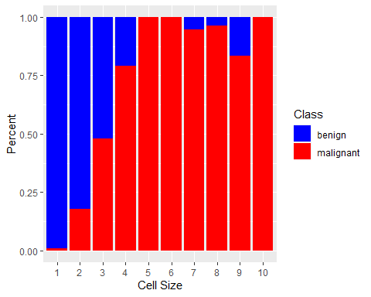

#Plot Cell.shape vs. Class  
ggplot() +  
 geom_bar(data = BreastCancer.df,  
 aes(x = factor(Cell.shape),  
 fill = factor(BreastCancer.df$Class)),  
 position = "stack") +  
 scale_x_discrete("Cell Shape") +  
 scale_y_continuous("Percent") +  
 guides(fill=guide_legend(title="Class"))+  
 scale_fill_manual(values=c("blue",  
 "red"))

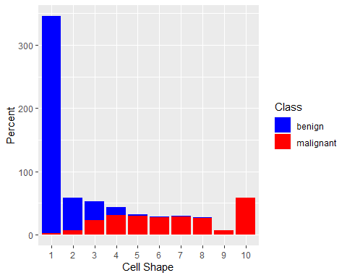

ggplot() +  
 geom_bar(data=BreastCancer.df,  
 aes(x = factor(Cell.shape),  
 fill = factor(BreastCancer.df$Class)),  
 position = "fill") +  
 scale_x_discrete("Cell Shape")+  
 scale_y_continuous("Percent") +  
 guides(fill=guide_legend(title="Class")) +  
 scale_fill_manual(values=c("blue", "red"))

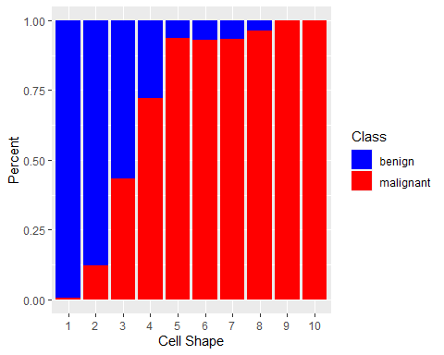

#Plot Marg.adhesion vs. Class  
ggplot() +  
 geom_bar(data = BreastCancer.df,  
 aes(x = factor(Marg.adhesion),  
 fill = factor(BreastCancer.df$Class)),  
 position = "stack") +  
 scale_x_discrete("Marg.adhesion") +  
 scale_y_continuous("Percent") +  
 guides(fill=guide_legend(title="Class"))+  
 scale_fill_manual(values=c("blue",  
 "red"))

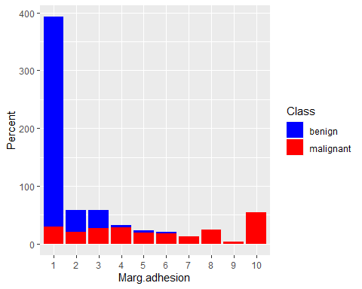

ggplot() +  
 geom_bar(data=BreastCancer.df,  
 aes(x = factor(Marg.adhesion),  
 fill = factor(BreastCancer.df$Class)),  
 position = "fill") +  
 scale_x_discrete("Marg.adhesion")+  
 scale_y_continuous("Percent") +  
 guides(fill=guide_legend(title="Class")) +  
 scale_fill_manual(values=c("blue", "red"))

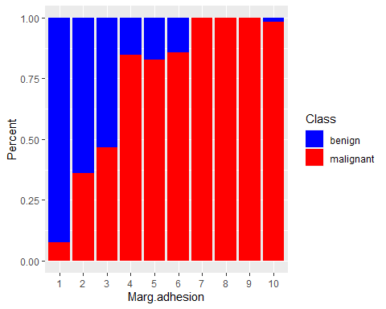

#Plot Bare nuclei vs. Class  
ggplot() +  
 geom_bar(data = BreastCancer.df,  
 aes(x = factor(Bare.nuclei),  
 fill = factor(BreastCancer.df$Class)),  
 position = "stack") +  
 scale_x_discrete("Bare.nuclei") +  
 scale_y_continuous("Percent") +  
 guides(fill=guide_legend(title="Class"))+  
 scale_fill_manual(values=c("blue",  
 "red"))

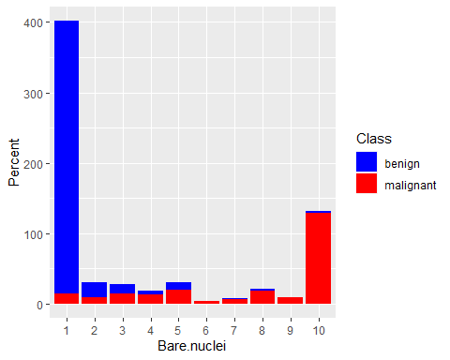

ggplot() +  
 geom_bar(data=BreastCancer.df,  
 aes(x = factor(Bare.nuclei),  
 fill = factor(BreastCancer.df$Class)),  
 position = "fill") +  
 scale_x_discrete("Bare.nuclei")+  
 scale_y_continuous("Percent") +  
 guides(fill=guide_legend(title="Class")) +  
 scale_fill_manual(values=c("blue", "red"))

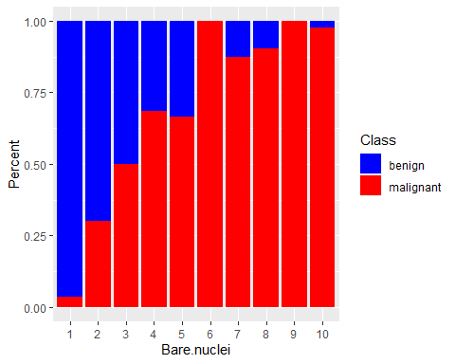

#Plot Bl.cromatin vs. Class  
ggplot() +  
 geom_bar(data = BreastCancer.df,  
 aes(x = factor(Bl.cromatin),  
 fill = factor(BreastCancer.df$Class)),  
 position = "stack") +  
 scale_x_discrete("Bl.cromatin") +  
 scale_y_continuous("Percent") +  
 guides(fill=guide_legend(title="Class"))+  
 scale_fill_manual(values=c("blue",  
 "red"))

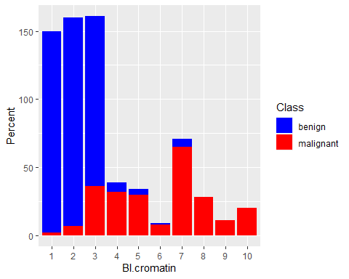

ggplot() +  
 geom_bar(data=BreastCancer.df,  
 aes(x = factor(Bl.cromatin),  
 fill = factor(BreastCancer.df$Class)),  
 position = "fill") +  
 scale_x_discrete("Bl.cromatin")+  
 scale_y_continuous("Percent") +  
 guides(fill=guide_legend(title="Class")) +  
 scale_fill_manual(values=c("blue", "red"))

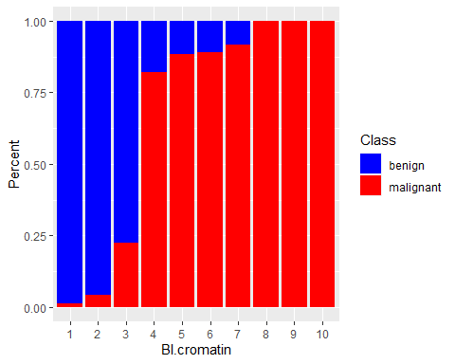

#Plot Normal.nucleoli vs. Class  
ggplot() +  
 geom_bar(data = BreastCancer.df,  
 aes(x = factor(Normal.nucleoli),  
 fill = factor(BreastCancer.df$Class)),  
 position = "stack") +  
 scale_x_discrete("Normal.nucleoli") +  
 scale_y_continuous("Percent") +  
 guides(fill=guide_legend(title="Class"))+  
 scale_fill_manual(values=c("blue",  
 "red"))

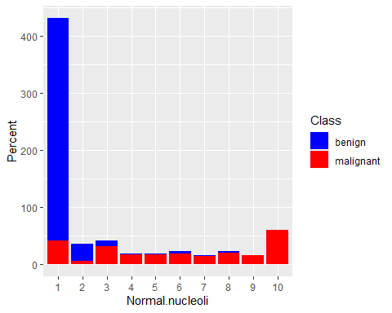

ggplot() +  
 geom_bar(data=BreastCancer.df,  
 aes(x = factor(Normal.nucleoli),  
 fill = factor(BreastCancer.df$Class)),  
 position = "fill") +  
 scale_x_discrete("Normal.nucleoli")+  
 scale_y_continuous("Percent") +  
 guides(fill=guide_legend(title="Class")) +  
 scale_fill_manual(values=c("blue", "red"))

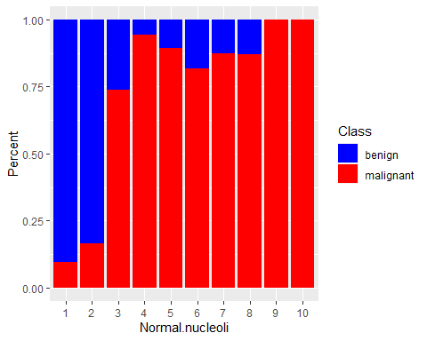

#Plot Mitoses vs. Class  
ggplot() +  
 geom_bar(data = BreastCancer.df,  
 aes(x = factor(Mitoses),  
 fill = factor(BreastCancer.df$Class)),  
 position = "stack") +  
 scale_x_discrete("Mitoses") +  
 scale_y_continuous("Percent") +  
 guides(fill=guide_legend(title="Class"))+  
 scale_fill_manual(values=c("blue",  
 "red"))

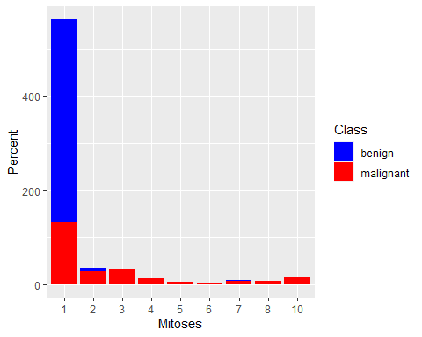

ggplot() +  
 geom_bar(data=BreastCancer.df,  
 aes(x = factor(Mitoses),  
 fill = factor(BreastCancer.df$Class)),  
 position = "fill") +  
 scale_x_discrete("Mitoses")+  
 scale_y_continuous("Percent") +  
 guides(fill=guide_legend(title="Class")) +  
 scale_fill_manual(values=c("blue", "red"))

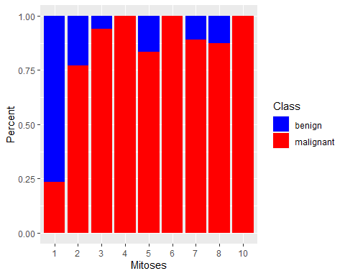

#Create correlation matrix   
corrdata <- cbind(BreastCancer.df$Cl.thickness, BreastCancer.df$Cell.size, BreastCancer.df$Cell.shape, BreastCancer.df$Marg.adhesion, BreastCancer.df$Epith.c.size, BreastCancer.df$Bare.nuclei, BreastCancer.df$Bl.cromatin, BreastCancer.df$Normal.nucleoli, BreastCancer.df$Mitoses)  
corrdata

## [,1] [,2] [,3] [,4] [,5] [,6] [,7] [,8] [,9]  
## [1,] 5 1 1 1 2 1 3 1 1  
## [2,] 5 4 4 5 7 10 3 2 1  
## [3,] 3 1 1 1 2 2 3 1 1  
## [4,] 6 8 8 1 3 4 3 7 1  
## [5,] 4 1 1 3 2 1 3 1 1  
## [6,] 8 10 10 8 7 10 9 7 1  
## [7,] 1 1 1 1 2 10 3 1 1  
## [8,] 2 1 2 1 2 1 3 1 1  
## [9,] 2 1 1 1 2 1 1 1 5  
## [10,] 4 2 1 1 2 1 2 1 1  
## [11,] 1 1 1 1 1 1 3 1 1  
## [12,] 2 1 1 1 2 1 2 1 1  
## [13,] 5 3 3 3 2 3 4 4 1  
## [14,] 1 1 1 1 2 3 3 1 1  
## [15,] 8 7 5 10 7 9 5 5 4  
## [16,] 7 4 6 4 6 1 4 3 1  
## [17,] 4 1 1 1 2 1 2 1 1  
## [18,] 4 1 1 1 2 1 3 1 1  
## [19,] 10 7 7 6 4 10 4 1 2  
## [20,] 6 1 1 1 2 1 3 1 1  
## [21,] 7 3 2 10 5 10 5 4 4  
## [22,] 10 5 5 3 6 7 7 10 1  
## [23,] 3 1 1 1 2 1 2 1 1  
## [24,] 1 1 1 1 2 1 3 1 1  
## [25,] 5 2 3 4 2 7 3 6 1  
## [26,] 3 2 1 1 1 1 2 1 1  
## [27,] 5 1 1 1 2 1 2 1 1  
## [28,] 2 1 1 1 2 1 2 1 1  
## [29,] 1 1 3 1 2 1 1 1 1  
## [30,] 3 1 1 1 1 1 2 1 1  
## [31,] 2 1 1 1 2 1 3 1 1  
## [32,] 10 7 7 3 8 5 7 4 3  
## [33,] 2 1 1 2 2 1 3 1 1  
## [34,] 3 1 2 1 2 1 2 1 1  
## [35,] 2 1 1 1 2 1 2 1 1  
## [36,] 10 10 10 8 6 1 8 9 1  
## [37,] 6 2 1 1 1 1 7 1 1  
## [38,] 5 4 4 9 2 10 5 6 1  
## [39,] 2 5 3 3 6 7 7 5 1  
## [40,] 10 4 3 1 3 3 6 5 2  
## [41,] 6 10 10 2 8 10 7 3 3  
## [42,] 5 6 5 6 10 1 3 1 1  
## [43,] 10 10 10 4 8 1 8 10 1  
## [44,] 1 1 1 1 2 1 2 1 2  
## [45,] 3 7 7 4 4 9 4 8 1  
## [46,] 1 1 1 1 2 1 2 1 1  
## [47,] 4 1 1 3 2 1 3 1 1  
## [48,] 7 8 7 2 4 8 3 8 2  
## [49,] 9 5 8 1 2 3 2 1 5  
## [50,] 5 3 3 4 2 4 3 4 1  
## [51,] 10 3 6 2 3 5 4 10 2  
## [52,] 5 5 5 8 10 8 7 3 7  
## [53,] 10 5 5 6 8 8 7 1 1  
## [54,] 10 6 6 3 4 5 3 6 1  
## [55,] 8 10 10 1 3 6 3 9 1  
## [56,] 8 2 4 1 5 1 5 4 4  
## [57,] 5 2 3 1 6 10 5 1 1  
## [58,] 9 5 5 2 2 2 5 1 1  
## [59,] 5 3 5 5 3 3 4 10 1  
## [60,] 1 1 1 1 2 2 2 1 1  
## [61,] 9 10 10 1 10 8 3 3 1  
## [62,] 6 3 4 1 5 2 3 9 1  
## [63,] 1 1 1 1 2 1 2 1 1  
## [64,] 10 4 2 1 3 2 4 3 9  
## [65,] 4 1 1 1 2 1 3 1 1  
## [66,] 5 3 4 1 8 10 4 9 1  
## [67,] 8 3 8 3 4 9 8 9 8  
## [68,] 1 1 1 1 2 1 3 2 1  
## [69,] 5 1 3 1 2 1 2 1 1  
## [70,] 6 10 2 8 10 2 7 8 9  
## [71,] 1 3 3 2 2 1 7 2 1  
## [72,] 9 4 5 10 6 10 4 8 1  
## [73,] 10 6 4 1 3 4 3 2 3  
## [74,] 1 1 2 1 2 2 4 2 1  
## [75,] 1 1 4 1 2 1 2 1 1  
## [76,] 5 3 1 2 2 1 2 1 1  
## [77,] 3 1 1 1 2 3 3 1 1  
## [78,] 2 1 1 1 3 1 2 1 1  
## [79,] 2 2 2 1 1 1 7 1 1  
## [80,] 4 1 1 2 2 1 2 1 1  
## [81,] 5 2 1 1 2 1 3 1 1  
## [82,] 3 1 1 1 2 2 7 1 1  
## [83,] 3 5 7 8 8 9 7 10 7  
## [84,] 5 10 6 1 10 4 4 10 9  
## [85,] 3 3 6 4 5 8 4 4 1  
## [86,] 3 6 6 6 5 10 6 8 3  
## [87,] 4 1 1 1 2 1 3 1 1  
## [88,] 2 1 1 2 3 1 2 1 1  
## [89,] 1 1 1 1 2 1 3 1 1  
## [90,] 3 1 1 2 2 1 1 1 1  
## [91,] 4 1 1 1 2 1 3 1 1  
## [92,] 1 1 1 1 2 1 2 1 1  
## [93,] 2 1 1 1 2 1 3 1 1  
## [94,] 1 1 1 1 2 1 3 1 1  
## [95,] 2 1 1 2 2 1 1 1 1  
## [96,] 5 1 1 1 2 1 3 1 1  
## [97,] 9 6 9 2 10 6 2 9 9  
## [98,] 7 5 6 10 5 10 7 9 4  
## [99,] 10 3 5 1 10 5 3 10 2  
## [100,] 2 3 4 4 2 5 2 5 1  
## [101,] 4 1 2 1 2 1 3 1 1  
## [102,] 8 2 3 1 6 3 7 1 1  
## [103,] 10 10 10 10 10 1 8 8 8  
## [104,] 7 3 4 4 3 3 3 2 7  
## [105,] 10 10 10 8 2 10 4 1 1  
## [106,] 1 6 8 10 8 10 5 7 1  
## [107,] 1 1 1 1 2 1 2 3 1  
## [108,] 6 5 4 4 3 9 7 8 3  
## [109,] 1 3 1 2 2 2 5 3 2  
## [110,] 8 6 4 3 5 9 3 1 1  
## [111,] 10 3 3 10 2 10 7 3 3  
## [112,] 10 10 10 3 10 8 8 1 1  
## [113,] 3 3 2 1 2 3 3 1 1  
## [114,] 1 1 1 1 2 5 1 1 1  
## [115,] 8 3 3 1 2 2 3 2 1  
## [116,] 4 5 5 10 4 10 7 5 8  
## [117,] 1 1 1 1 4 3 1 1 1  
## [118,] 3 2 1 1 2 2 3 1 1  
## [119,] 1 1 2 2 2 1 3 1 1  
## [120,] 4 2 1 1 2 2 3 1 1  
## [121,] 10 10 10 2 10 10 5 3 3  
## [122,] 5 3 5 1 8 10 5 3 1  
## [123,] 5 4 6 7 9 7 8 10 1  
## [124,] 1 1 1 1 2 1 2 1 1  
## [125,] 7 5 3 7 4 10 7 5 5  
## [126,] 3 1 1 1 2 1 3 1 1  
## [127,] 8 3 5 4 5 10 1 6 2  
## [128,] 1 1 1 1 10 1 1 1 1  
## [129,] 5 1 3 1 2 1 2 1 1  
## [130,] 2 1 1 1 2 1 3 1 1  
## [131,] 5 10 8 10 8 10 3 6 3  
## [132,] 3 1 1 1 2 1 2 2 1  
## [133,] 3 1 1 1 3 1 2 1 1  
## [134,] 5 1 1 1 2 2 3 3 1  
## [135,] 4 1 1 1 2 1 2 1 1  
## [136,] 3 1 1 1 2 1 1 1 1  
## [137,] 4 1 2 1 2 1 2 1 1  
## [138,] 3 1 1 1 2 1 1 1 1  
## [139,] 2 1 1 1 2 1 1 1 1  
## [140,] 9 5 5 4 4 5 4 3 3  
## [141,] 1 1 1 1 2 5 1 1 1  
## [142,] 2 1 1 1 2 1 2 1 1  
## [143,] 3 4 5 2 6 8 4 1 1  
## [144,] 1 1 1 1 3 2 2 1 1  
## [145,] 3 1 1 3 8 1 5 8 1  
## [146,] 8 8 7 4 10 10 7 8 7  
## [147,] 1 1 1 1 1 1 3 1 1  
## [148,] 7 2 4 1 6 10 5 4 3  
## [149,] 10 10 8 6 4 5 8 10 1  
## [150,] 4 1 1 1 2 3 1 1 1  
## [151,] 1 1 1 1 2 1 1 1 1  
## [152,] 5 5 5 6 3 10 3 1 1  
## [153,] 1 2 2 1 2 1 2 1 1  
## [154,] 2 1 1 1 2 1 3 1 1  
## [155,] 9 9 10 3 6 10 7 10 6  
## [156,] 10 7 7 4 5 10 5 7 2  
## [157,] 4 1 1 1 2 1 3 2 1  
## [158,] 3 1 1 1 2 1 3 1 1  
## [159,] 1 1 1 2 1 3 1 1 7  
## [160,] 4 1 1 1 2 2 3 2 1  
## [161,] 5 6 7 8 8 10 3 10 3  
## [162,] 10 8 10 10 6 1 3 1 9  
## [163,] 3 1 1 1 2 1 3 1 1  
## [164,] 1 1 1 2 1 1 1 1 1  
## [165,] 3 1 1 1 2 1 1 1 1  
## [166,] 1 1 1 1 2 1 3 1 1  
## [167,] 1 1 1 1 2 1 2 1 1  
## [168,] 6 10 10 10 8 10 10 10 7  
## [169,] 8 6 5 4 3 10 6 1 1  
## [170,] 5 8 7 7 10 10 5 7 1  
## [171,] 2 1 1 1 2 1 3 1 1  
## [172,] 5 10 10 3 8 1 5 10 3  
## [173,] 4 1 1 1 2 1 3 1 1  
## [174,] 5 3 3 3 6 10 3 1 1  
## [175,] 1 1 1 1 1 1 3 1 1  
## [176,] 1 1 1 1 2 1 1 1 1  
## [177,] 6 1 1 1 2 1 3 1 1  
## [178,] 5 8 8 8 5 10 7 8 1  
## [179,] 8 7 6 4 4 10 5 1 1  
## [180,] 2 1 1 1 1 1 3 1 1  
## [181,] 1 5 8 6 5 8 7 10 1  
## [182,] 10 5 6 10 6 10 7 7 9  
## [183,] 5 8 4 10 5 8 9 10 1  
## [184,] 1 2 3 1 2 1 3 1 1  
## [185,] 10 10 10 8 6 8 7 10 1  
## [186,] 7 5 10 10 10 10 4 10 3  
## [187,] 5 1 1 1 2 1 2 1 1  
## [188,] 1 1 1 1 2 1 3 1 1  
## [189,] 3 1 1 1 2 1 3 1 1  
## [190,] 4 1 1 1 2 1 3 1 1  
## [191,] 8 4 4 5 4 7 7 8 2  
## [192,] 5 1 1 4 2 1 3 1 1  
## [193,] 1 1 1 1 2 1 1 1 1  
## [194,] 3 1 1 1 2 1 2 1 1  
## [195,] 9 7 7 5 5 10 7 8 3  
## [196,] 10 8 8 4 10 10 8 1 1  
## [197,] 1 1 1 1 2 1 3 1 1  
## [198,] 5 1 1 1 2 1 3 1 1  
## [199,] 1 1 1 1 2 1 3 1 1  
## [200,] 5 10 10 9 6 10 7 10 5  
## [201,] 10 10 9 3 7 5 3 5 1  
## [202,] 1 1 1 1 1 1 3 1 1  
## [203,] 1 1 1 1 1 1 3 1 1  
## [204,] 5 1 1 1 1 1 3 1 1  
## [205,] 8 10 10 10 5 10 8 10 6  
## [206,] 8 10 8 8 4 8 7 7 1  
## [207,] 1 1 1 1 2 1 3 1 1  
## [208,] 10 10 10 10 7 10 7 10 4  
## [209,] 10 10 10 10 3 10 10 6 1  
## [210,] 8 7 8 7 5 5 5 10 2  
## [211,] 1 1 1 1 2 1 2 1 1  
## [212,] 1 1 1 1 2 1 3 1 1  
## [213,] 6 10 7 7 6 4 8 10 2  
## [214,] 6 1 3 1 2 1 3 1 1  
## [215,] 1 1 1 2 2 1 3 1 1  
## [216,] 10 6 4 3 10 10 9 10 1  
## [217,] 4 1 1 3 1 5 2 1 1  
## [218,] 7 5 6 3 3 8 7 4 1  
## [219,] 10 5 5 6 3 10 7 9 2  
## [220,] 1 1 1 1 2 1 2 1 1  
## [221,] 10 5 7 4 4 10 8 9 1  
## [222,] 8 9 9 5 3 5 7 7 1  
## [223,] 1 1 1 1 1 1 3 1 1  
## [224,] 10 10 10 3 10 10 9 10 1  
## [225,] 7 4 7 4 3 7 7 6 1  
## [226,] 6 8 7 5 6 8 8 9 2  
## [227,] 8 4 6 3 3 1 4 3 1  
## [228,] 10 4 5 5 5 10 4 1 1  
## [229,] 3 3 2 1 3 1 3 6 1  
## [230,] 10 8 8 2 8 10 4 8 9  
## [231,] 9 8 8 5 6 2 4 10 4  
## [232,] 8 10 10 8 6 9 3 10 9  
## [233,] 10 4 3 2 3 10 5 3 2  
## [234,] 5 1 3 3 2 2 2 3 1  
## [235,] 3 1 1 3 1 1 3 1 1  
## [236,] 2 1 1 1 2 1 3 1 1  
## [237,] 1 1 1 1 2 5 5 1 1  
## [238,] 1 1 1 1 2 1 3 1 1  
## [239,] 5 1 1 2 2 2 3 1 1  
## [240,] 8 10 10 8 5 10 7 8 1  
## [241,] 8 4 4 1 2 9 3 3 1  
## [242,] 4 1 1 1 2 1 3 6 1  
## [243,] 1 2 2 1 2 1 1 1 1  
## [244,] 10 4 4 10 2 10 5 3 3  
## [245,] 6 3 3 5 3 10 3 5 3  
## [246,] 6 10 10 2 8 10 7 3 3  
## [247,] 9 10 10 1 10 8 3 3 1  
## [248,] 5 6 6 2 4 10 3 6 1  
## [249,] 3 1 1 1 2 1 1 1 1  
## [250,] 3 1 1 1 2 1 2 1 1  
## [251,] 3 1 1 1 2 1 3 1 1  
## [252,] 5 7 7 1 5 8 3 4 1  
## [253,] 10 5 8 10 3 10 5 1 3  
## [254,] 5 10 10 6 10 10 10 6 5  
## [255,] 8 8 9 4 5 10 7 8 1  
## [256,] 10 4 4 10 6 10 5 5 1  
## [257,] 7 9 4 10 10 3 5 3 3  
## [258,] 5 1 4 1 2 1 3 2 1  
## [259,] 10 10 6 3 3 10 4 3 2  
## [260,] 3 3 5 2 3 10 7 1 1  
## [261,] 10 8 8 2 3 4 8 7 8  
## [262,] 1 1 1 1 2 1 3 1 1  
## [263,] 8 4 7 1 3 10 3 9 2  
## [264,] 5 1 1 1 2 1 3 1 1  
## [265,] 3 3 5 2 3 10 7 1 1  
## [266,] 7 2 4 1 3 4 3 3 1  
## [267,] 3 1 1 1 2 1 3 2 1  
## [268,] 3 1 1 1 2 1 2 1 1  
## [269,] 1 1 1 1 2 1 2 1 1  
## [270,] 1 1 1 1 2 1 3 1 1  
## [271,] 10 5 7 3 3 7 3 3 8  
## [272,] 3 1 1 1 2 1 3 1 1  
## [273,] 2 1 1 2 2 1 3 1 1  
## [274,] 1 4 3 10 4 10 5 6 1  
## [275,] 10 4 6 1 2 10 5 3 1  
## [276,] 7 4 5 10 2 10 3 8 2  
## [277,] 8 10 10 10 8 10 10 7 3  
## [278,] 10 10 10 10 10 10 4 10 9  
## [279,] 3 1 1 1 3 1 2 1 1  
## [280,] 6 1 3 1 4 5 5 10 1  
## [281,] 5 6 6 8 6 10 4 10 4  
## [282,] 1 1 1 1 2 1 1 1 1  
## [283,] 1 1 1 1 2 1 3 1 1  
## [284,] 10 4 4 6 2 10 2 3 1  
## [285,] 5 5 7 8 6 10 7 4 1  
## [286,] 5 3 4 3 4 5 4 7 1  
## [287,] 8 2 1 1 5 1 1 1 1  
## [288,] 9 1 2 6 4 10 7 7 2  
## [289,] 8 4 10 5 4 4 7 10 1  
## [290,] 1 1 1 1 2 1 3 1 1  
## [291,] 10 10 10 7 9 10 7 10 9  
## [292,] 1 1 1 1 2 1 3 1 1  
## [293,] 8 3 4 9 3 10 3 3 1  
## [294,] 10 8 4 4 4 10 3 10 4  
## [295,] 1 1 1 1 2 1 3 1 1  
## [296,] 1 1 1 1 2 1 3 1 1  
## [297,] 7 8 7 6 4 3 8 8 4  
## [298,] 3 1 1 1 2 5 5 1 1  
## [299,] 2 1 1 1 3 1 2 1 1  
## [300,] 1 1 1 1 2 1 1 1 1  
## [301,] 8 6 4 10 10 1 3 5 1  
## [302,] 1 1 1 1 2 1 1 1 1  
## [303,] 1 1 1 1 1 1 2 1 1  
## [304,] 5 5 5 2 5 10 4 3 1  
## [305,] 6 8 7 8 6 8 8 9 1  
## [306,] 1 1 1 1 5 1 3 1 1  
## [307,] 4 4 4 4 6 5 7 3 1  
## [308,] 7 6 3 2 5 10 7 4 6  
## [309,] 3 1 1 1 2 1 3 1 1  
## [310,] 5 4 6 10 2 10 4 1 1  
## [311,] 1 1 1 1 2 1 3 1 1  
## [312,] 3 2 2 1 2 1 2 3 1  
## [313,] 10 1 1 1 2 10 5 4 1  
## [314,] 1 1 1 1 2 1 2 1 1  
## [315,] 8 10 3 2 6 4 3 10 1  
## [316,] 10 4 6 4 5 10 7 1 1  
## [317,] 10 4 7 2 2 8 6 1 1  
## [318,] 5 1 1 1 2 1 3 1 2  
## [319,] 5 2 2 2 2 1 2 2 1  
## [320,] 5 4 6 6 4 10 4 3 1  
## [321,] 8 6 7 3 3 10 3 4 2  
## [322,] 1 1 1 1 2 1 1 1 1  
## [323,] 6 5 5 8 4 10 3 4 1  
## [324,] 1 1 1 1 2 1 3 1 1  
## [325,] 1 1 1 1 1 1 2 1 1  
## [326,] 8 5 5 5 2 10 4 3 1  
## [327,] 10 3 3 1 2 10 7 6 1  
## [328,] 1 1 1 1 2 1 3 1 1  
## [329,] 2 1 1 1 2 1 1 1 1  
## [330,] 1 1 1 1 2 1 1 1 1  
## [331,] 7 6 4 8 10 10 9 5 3  
## [332,] 1 1 1 1 2 1 1 1 1  
## [333,] 5 2 2 2 3 1 1 3 1  
## [334,] 1 1 1 1 1 1 1 3 1  
## [335,] 3 4 4 10 5 1 3 3 1  
## [336,] 4 2 3 5 3 8 7 6 1  
## [337,] 5 1 1 3 2 1 1 1 1  
## [338,] 2 1 1 1 2 1 3 1 1  
## [339,] 3 4 5 3 7 3 4 6 1  
## [340,] 2 7 10 10 7 10 4 9 4  
## [341,] 1 1 1 1 2 1 2 1 1  
## [342,] 4 1 1 1 3 1 2 2 1  
## [343,] 5 3 3 1 3 3 3 3 3  
## [344,] 8 10 10 7 10 10 7 3 8  
## [345,] 8 10 5 3 8 4 4 10 3  
## [346,] 10 3 5 4 3 7 3 5 3  
## [347,] 6 10 10 10 10 10 8 10 9  
## [348,] 3 10 3 10 6 10 5 1 4  
## [349,] 3 2 2 1 4 3 2 1 1  
## [350,] 4 4 4 2 2 3 2 1 1  
## [351,] 2 1 1 1 2 1 3 1 1  
## [352,] 2 1 1 1 2 1 2 1 1  
## [353,] 6 10 10 10 8 10 7 10 7  
## [354,] 5 8 8 10 5 10 8 10 3  
## [355,] 1 1 3 1 2 1 1 1 1  
## [356,] 1 1 3 1 1 1 2 1 1  
## [357,] 4 3 2 1 3 1 2 1 1  
## [358,] 1 1 3 1 2 1 1 1 1  
## [359,] 4 1 2 1 2 1 2 1 1  
## [360,] 5 1 1 2 2 1 2 1 1  
## [361,] 3 1 2 1 2 1 2 1 1  
## [362,] 1 1 1 1 2 1 1 1 1  
## [363,] 1 1 1 1 2 1 2 1 1  
## [364,] 1 1 1 1 1 1 2 1 1  
## [365,] 3 1 1 4 3 1 2 2 1  
## [366,] 5 3 4 1 4 1 3 1 1  
## [367,] 1 1 1 1 2 1 1 1 1  
## [368,] 10 6 3 6 4 10 7 8 4  
## [369,] 3 2 2 2 2 1 3 2 1  
## [370,] 2 1 1 1 2 1 1 1 1  
## [371,] 2 1 1 1 2 1 1 1 1  
## [372,] 3 3 2 2 3 1 1 2 3  
## [373,] 7 6 6 3 2 10 7 1 1  
## [374,] 5 3 3 2 3 1 3 1 1  
## [375,] 2 1 1 1 2 1 2 2 1  
## [376,] 5 1 1 1 3 2 2 2 1  
## [377,] 1 1 1 2 2 1 2 1 1  
## [378,] 10 8 7 4 3 10 7 9 1  
## [379,] 3 1 1 1 2 1 2 1 1  
## [380,] 1 1 1 1 1 1 1 1 1  
## [381,] 1 2 3 1 2 1 2 1 1  
## [382,] 3 1 1 1 2 1 2 1 1  
## [383,] 3 1 1 1 2 1 3 1 1  
## [384,] 4 1 1 1 2 1 1 1 1  
## [385,] 3 2 1 1 2 1 2 2 1  
## [386,] 1 2 3 1 2 1 1 1 1  
## [387,] 3 10 8 7 6 9 9 3 8  
## [388,] 3 1 1 1 2 1 1 1 1  
## [389,] 5 3 3 1 2 1 2 1 1  
## [390,] 3 1 1 1 2 4 1 1 1  
## [391,] 1 2 1 3 2 1 1 2 1  
## [392,] 1 1 1 1 2 1 2 1 1  
## [393,] 4 2 2 1 2 1 2 1 1  
## [394,] 1 1 1 1 2 1 2 1 1  
## [395,] 2 3 2 2 2 2 3 1 1  
## [396,] 3 1 2 1 2 1 2 1 1  
## [397,] 1 1 1 1 2 1 2 1 1  
## [398,] 10 10 10 6 8 4 8 5 1  
## [399,] 5 1 2 1 2 1 3 1 1  
## [400,] 8 5 6 2 3 10 6 6 1  
## [401,] 3 3 2 6 3 3 3 5 1  
## [402,] 8 7 8 5 10 10 7 2 1  
## [403,] 1 1 1 1 2 1 2 1 1  
## [404,] 5 2 2 2 2 2 3 2 2  
## [405,] 2 3 1 1 5 1 1 1 1  
## [406,] 3 2 2 3 2 3 3 1 1  
## [407,] 10 10 10 7 10 10 8 2 1  
## [408,] 4 3 3 1 2 1 3 3 1  
## [409,] 5 1 3 1 2 1 2 1 1  
## [410,] 3 1 1 1 2 1 1 1 1  
## [411,] 9 10 10 10 10 10 10 10 1  
## [412,] 5 3 6 1 2 1 1 1 1  
## [413,] 8 7 8 2 4 2 5 10 1  
## [414,] 1 1 1 1 2 1 2 1 1  
## [415,] 2 1 1 1 2 1 2 1 1  
## [416,] 1 3 1 1 2 1 2 2 1  
## [417,] 5 1 1 3 4 1 3 2 1  
## [418,] 5 1 1 1 2 1 2 2 1  
## [419,] 3 2 2 3 2 1 1 1 1  
## [420,] 6 9 7 5 5 8 4 2 1  
## [421,] 10 8 10 1 3 10 5 1 1  
## [422,] 10 10 10 1 6 1 2 8 1  
## [423,] 4 1 1 1 2 1 1 1 1  
## [424,] 4 1 3 3 2 1 1 1 1  
## [425,] 5 1 1 1 2 1 1 1 1  
## [426,] 10 4 3 10 4 10 10 1 1  
## [427,] 5 2 2 4 2 4 1 1 1  
## [428,] 1 1 1 3 2 3 1 1 1  
## [429,] 1 1 1 1 2 2 1 1 1  
## [430,] 5 1 1 6 3 1 2 1 1  
## [431,] 2 1 1 1 2 1 1 1 1  
## [432,] 1 1 1 1 2 1 1 1 1  
## [433,] 5 1 1 1 2 1 1 1 1  
## [434,] 1 1 1 1 1 1 1 1 1  
## [435,] 5 7 9 8 6 10 8 10 1  
## [436,] 4 1 1 3 1 1 2 1 1  
## [437,] 5 1 1 1 2 1 1 1 1  
## [438,] 3 1 1 3 2 1 1 1 1  
## [439,] 4 5 5 8 6 10 10 7 1  
## [440,] 2 3 1 1 3 1 1 1 1  
## [441,] 10 2 2 1 2 6 1 1 2  
## [442,] 10 6 5 8 5 10 8 6 1  
## [443,] 8 8 9 6 6 3 10 10 1  
## [444,] 5 1 2 1 2 1 1 1 1  
## [445,] 5 1 3 1 2 1 1 1 1  
## [446,] 5 1 1 3 2 1 1 1 1  
## [447,] 3 1 1 1 2 5 1 1 1  
## [448,] 6 1 1 3 2 1 1 1 1  
## [449,] 4 1 1 1 2 1 1 2 1  
## [450,] 4 1 1 1 2 1 1 1 1  
## [451,] 10 9 8 7 6 4 7 10 3  
## [452,] 10 6 6 2 4 10 9 7 1  
## [453,] 6 6 6 5 4 10 7 6 2  
## [454,] 4 1 1 1 2 1 1 1 1  
## [455,] 1 1 2 1 2 1 2 1 1  
## [456,] 3 1 1 1 1 1 2 1 1  
## [457,] 6 1 1 3 2 1 1 1 1  
## [458,] 6 1 1 1 1 1 1 1 1  
## [459,] 4 1 1 1 2 1 1 1 1  
## [460,] 5 1 1 1 2 1 1 1 1  
## [461,] 3 1 1 1 2 1 1 1 1  
## [462,] 4 1 2 1 2 1 1 1 1  
## [463,] 4 1 1 1 2 1 1 1 1  
## [464,] 5 2 1 1 2 1 1 1 1  
## [465,] 4 8 7 10 4 10 7 5 1  
## [466,] 5 1 1 1 1 1 1 1 1  
## [467,] 5 3 2 4 2 1 1 1 1  
## [468,] 9 10 10 10 10 5 10 10 9  
## [469,] 8 7 8 5 5 10 9 10 1  
## [470,] 5 1 2 1 2 1 1 1 1  
## [471,] 1 1 1 3 1 3 1 1 1  
## [472,] 3 1 1 1 1 1 2 1 1  
## [473,] 10 10 10 10 6 10 8 1 5  
## [474,] 3 6 4 10 3 3 3 4 1  
## [475,] 6 3 2 1 3 4 4 1 1  
## [476,] 1 1 1 1 2 1 1 1 1  
## [477,] 5 8 9 4 3 10 7 1 1  
## [478,] 4 1 1 1 1 1 2 1 1  
## [479,] 5 10 10 10 6 10 6 5 2  
## [480,] 5 1 2 10 4 5 2 1 1  
## [481,] 3 1 1 1 1 1 2 1 1  
## [482,] 1 1 1 1 1 1 1 1 1  
## [483,] 4 2 1 1 2 1 1 1 1  
## [484,] 4 1 1 1 2 1 2 1 1  
## [485,] 4 1 1 1 2 1 2 1 1  
## [486,] 6 1 1 1 2 1 3 1 1  
## [487,] 4 1 1 1 2 1 2 1 1  
## [488,] 4 1 1 2 2 1 2 1 1  
## [489,] 4 1 1 1 2 1 3 1 1  
## [490,] 1 1 1 1 2 1 1 1 1  
## [491,] 3 3 1 1 2 1 1 1 1  
## [492,] 8 10 10 10 7 5 4 8 7  
## [493,] 1 1 1 1 2 4 1 1 1  
## [494,] 5 1 1 1 2 1 1 1 1  
## [495,] 2 1 1 1 2 1 1 1 1  
## [496,] 1 1 1 1 2 1 1 1 1  
## [497,] 5 1 1 1 2 1 2 1 1  
## [498,] 5 1 1 1 2 1 1 1 1  
## [499,] 3 1 1 1 1 1 2 1 1  
## [500,] 6 6 7 10 3 10 8 10 2  
## [501,] 4 10 4 7 3 10 9 10 1  
## [502,] 1 1 1 1 1 1 1 1 1  
## [503,] 1 1 1 1 1 1 2 1 1  
## [504,] 3 1 2 2 2 1 1 1 1  
## [505,] 4 7 8 3 4 10 9 1 1  
## [506,] 1 1 1 1 3 1 1 1 1  
## [507,] 4 1 1 1 3 1 1 1 1  
## [508,] 10 4 5 4 3 5 7 3 1  
## [509,] 7 5 6 10 4 10 5 3 1  
## [510,] 3 1 1 1 2 1 2 1 1  
## [511,] 3 1 1 2 2 1 1 1 1  
## [512,] 4 1 1 1 2 1 1 1 1  
## [513,] 4 1 1 1 2 1 3 1 1  
## [514,] 6 1 3 2 2 1 1 1 1  
## [515,] 4 1 1 1 1 1 2 1 1  
## [516,] 7 4 4 3 4 10 6 9 1  
## [517,] 4 2 2 1 2 1 2 1 1  
## [518,] 1 1 1 1 1 1 3 1 1  
## [519,] 3 1 1 1 2 1 2 1 1  
## [520,] 2 1 1 1 2 1 2 1 1  
## [521,] 1 1 3 2 2 1 3 1 1  
## [522,] 5 1 1 1 2 1 3 1 1  
## [523,] 5 1 2 1 2 1 3 1 1  
## [524,] 4 1 1 1 2 1 2 1 1  
## [525,] 6 1 1 1 2 1 2 1 1  
## [526,] 5 1 1 1 2 2 2 1 1  
## [527,] 3 1 1 1 2 1 1 1 1  
## [528,] 5 3 1 1 2 1 1 1 1  
## [529,] 4 1 1 1 2 1 2 1 1  
## [530,] 2 1 3 2 2 1 2 1 1  
## [531,] 5 1 1 1 2 1 2 1 1  
## [532,] 6 10 10 10 4 10 7 10 1  
## [533,] 2 1 1 1 1 1 1 1 1  
## [534,] 3 1 1 1 1 1 1 1 1  
## [535,] 7 8 3 7 4 5 7 8 2  
## [536,] 3 1 1 1 2 1 2 1 1  
## [537,] 1 1 1 1 2 1 3 1 1  
## [538,] 3 2 2 2 2 1 4 2 1  
## [539,] 4 4 2 1 2 5 2 1 2  
## [540,] 3 1 1 1 2 1 1 1 1  
## [541,] 4 3 1 1 2 1 4 8 1  
## [542,] 5 2 2 2 1 1 2 1 1  
## [543,] 5 1 1 3 2 1 1 1 1  
## [544,] 2 1 1 1 2 1 2 1 1  
## [545,] 5 1 1 1 2 1 2 1 1  
## [546,] 5 1 1 1 2 1 3 1 1  
## [547,] 5 1 1 1 2 1 3 1 1  
## [548,] 1 1 1 1 2 1 3 1 1  
## [549,] 3 1 1 1 2 1 2 1 1  
## [550,] 4 1 1 1 2 1 3 2 1  
## [551,] 5 7 10 10 5 10 10 10 1  
## [552,] 3 1 2 1 2 1 3 1 1  
## [553,] 4 1 1 1 2 3 2 1 1  
## [554,] 8 4 4 1 6 10 2 5 2  
## [555,] 10 10 8 10 6 5 10 3 1  
## [556,] 8 10 4 4 8 10 8 2 1  
## [557,] 7 6 10 5 3 10 9 10 2  
## [558,] 3 1 1 1 2 1 2 1 1  
## [559,] 1 1 1 1 2 1 2 1 1  
## [560,] 10 9 7 3 4 2 7 7 1  
## [561,] 5 1 2 1 2 1 3 1 1  
## [562,] 5 1 1 1 2 1 2 1 1  
## [563,] 1 1 1 1 2 1 2 1 1  
## [564,] 1 1 1 1 2 1 2 1 1  
## [565,] 1 1 1 1 2 1 3 1 1  
## [566,] 5 1 2 1 2 1 2 1 1  
## [567,] 5 7 10 6 5 10 7 5 1  
## [568,] 6 10 5 5 4 10 6 10 1  
## [569,] 3 1 1 1 2 1 1 1 1  
## [570,] 5 1 1 6 3 1 1 1 1  
## [571,] 1 1 1 1 2 1 1 1 1  
## [572,] 8 10 10 10 6 10 10 10 1  
## [573,] 5 1 1 1 2 1 2 2 1  
## [574,] 9 8 8 9 6 3 4 1 1  
## [575,] 5 1 1 1 2 1 1 1 1  
## [576,] 4 10 8 5 4 1 10 1 1  
## [577,] 2 5 7 6 4 10 7 6 1  
## [578,] 10 3 4 5 3 10 4 1 1  
## [579,] 5 1 2 1 2 1 1 1 1  
## [580,] 4 8 6 3 4 10 7 1 1  
## [581,] 5 1 1 1 2 1 2 1 1  
## [582,] 4 1 2 1 2 1 2 1 1  
## [583,] 5 1 3 1 2 1 3 1 1  
## [584,] 3 1 1 1 2 1 2 1 1  
## [585,] 5 2 4 1 1 1 1 1 1  
## [586,] 3 1 1 1 2 1 2 1 1  
## [587,] 1 1 1 1 1 1 2 1 1  
## [588,] 4 1 1 1 2 1 2 1 1  
## [589,] 5 4 6 8 4 1 8 10 1  
## [590,] 5 3 2 8 5 10 8 1 2  
## [591,] 10 5 10 3 5 8 7 8 3  
## [592,] 4 1 1 2 2 1 1 1 1  
## [593,] 1 1 1 1 2 1 1 1 1  
## [594,] 5 10 10 10 10 10 10 1 1  
## [595,] 5 1 1 1 2 1 1 1 1  
## [596,] 10 4 3 10 3 10 7 1 2  
## [597,] 5 10 10 10 5 2 8 5 1  
## [598,] 8 10 10 10 6 10 10 10 9  
## [599,] 2 3 1 1 2 1 2 1 1  
## [600,] 2 1 1 1 1 1 2 1 1  
## [601,] 4 1 3 1 2 1 2 1 1  
## [602,] 3 1 1 1 2 1 2 1 1  
## [603,] 4 1 1 1 2 1 2 1 1  
## [604,] 5 1 1 1 2 1 2 1 1  
## [605,] 3 1 1 1 2 1 2 1 1  
## [606,] 6 3 3 3 3 2 6 1 1  
## [607,] 7 1 2 3 2 1 2 1 1  
## [608,] 1 1 1 1 2 1 1 1 1  
## [609,] 5 1 1 2 1 1 2 1 1  
## [610,] 3 1 3 1 3 4 1 1 1  
## [611,] 4 6 6 5 7 6 7 7 3  
## [612,] 2 1 1 1 2 5 1 1 1  
## [613,] 2 1 1 1 2 1 1 1 1  
## [614,] 4 1 1 1 2 1 1 1 1  
## [615,] 6 2 3 1 2 1 1 1 1  
## [616,] 5 1 1 1 2 1 2 1 1  
## [617,] 1 1 1 1 2 1 1 1 1  
## [618,] 8 7 4 4 5 3 5 10 1  
## [619,] 3 1 1 1 2 1 1 1 1  
## [620,] 3 1 4 1 2 1 1 1 1  
## [621,] 10 10 7 8 7 1 10 10 3  
## [622,] 4 2 4 3 2 2 2 1 1  
## [623,] 4 1 1 1 2 1 1 1 1  
## [624,] 5 1 1 3 2 1 1 1 1  
## [625,] 4 1 1 3 2 1 1 1 1  
## [626,] 3 1 1 1 2 1 2 1 1  
## [627,] 3 1 1 1 2 1 2 1 1  
## [628,] 1 1 1 1 2 1 1 1 1  
## [629,] 2 1 1 1 2 1 1 1 1  
## [630,] 3 1 1 1 2 1 2 1 1  
## [631,] 1 2 2 1 2 1 1 1 1  
## [632,] 1 1 1 3 2 1 1 1 1  
## [633,] 5 10 10 10 10 2 10 10 9  
## [634,] 3 1 1 1 2 1 2 1 1  
## [635,] 3 1 1 2 3 4 1 1 1  
## [636,] 1 2 1 3 2 1 2 1 1  
## [637,] 5 1 1 1 2 1 2 2 1  
## [638,] 4 1 1 1 2 1 2 1 1  
## [639,] 3 1 1 1 2 1 3 1 1  
## [640,] 3 1 1 1 2 1 2 1 1  
## [641,] 5 1 1 1 2 1 2 1 1  
## [642,] 5 4 5 1 8 1 3 6 1  
## [643,] 7 8 8 7 3 10 7 2 3  
## [644,] 1 1 1 1 2 1 1 1 1  
## [645,] 1 1 1 1 2 1 2 1 1  
## [646,] 4 1 1 1 2 1 3 1 1  
## [647,] 1 1 3 1 2 1 2 1 1  
## [648,] 1 1 3 1 2 1 2 1 1  
## [649,] 3 1 1 3 2 1 2 1 1  
## [650,] 1 1 1 1 2 1 1 1 1  
## [651,] 5 2 2 2 2 1 1 1 2  
## [652,] 3 1 1 1 2 1 3 1 1  
## [653,] 5 7 4 1 6 1 7 10 3  
## [654,] 5 10 10 8 5 5 7 10 1  
## [655,] 3 10 7 8 5 8 7 4 1  
## [656,] 3 2 1 2 2 1 3 1 1  
## [657,] 2 1 1 1 2 1 3 1 1  
## [658,] 5 3 2 1 3 1 1 1 1  
## [659,] 1 1 1 1 2 1 2 1 1  
## [660,] 4 1 4 1 2 1 1 1 1  
## [661,] 1 1 2 1 2 1 2 1 1  
## [662,] 5 1 1 1 2 1 1 1 1  
## [663,] 1 1 1 1 2 1 1 1 1  
## [664,] 2 1 1 1 2 1 1 1 1  
## [665,] 10 10 10 10 5 10 10 10 7  
## [666,] 5 10 10 10 4 10 5 6 3  
## [667,] 5 1 1 1 2 1 3 2 1  
## [668,] 1 1 1 1 2 1 1 1 1  
## [669,] 1 1 1 1 2 1 1 1 1  
## [670,] 1 1 1 1 2 1 1 1 1  
## [671,] 1 1 1 1 2 1 1 1 1  
## [672,] 3 1 1 1 2 1 2 3 1  
## [673,] 4 1 1 1 2 1 1 1 1  
## [674,] 1 1 1 1 2 1 1 1 8  
## [675,] 1 1 1 3 2 1 1 1 1  
## [676,] 5 10 10 5 4 5 4 4 1  
## [677,] 3 1 1 1 2 1 1 1 1  
## [678,] 3 1 1 1 2 1 2 1 2  
## [679,] 3 1 1 1 3 2 1 1 1  
## [680,] 2 1 1 1 2 1 1 1 1  
## [681,] 5 10 10 3 7 3 8 10 2  
## [682,] 4 8 6 4 3 4 10 6 1  
## [683,] 4 8 8 5 4 5 10 4 1

library(gplots)

##   
## Attaching package: 'gplots'

## The following object is masked from 'package:stats':  
##   
## lowess

heatmap.2(cor(corrdata), Rowv = FALSE, Colv = FALSE, dendrogram = "none",   
 cellnote = round(cor(corrdata),2),   
 notecol = "black", key = FALSE, trace = 'none', margins = c(2,2))

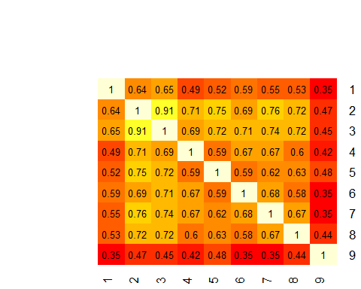

####Data Preparation Phase#### #As all variables are already scaled 1-10, we will not perform any standardization #Separate the data into training and validation set

# remove the unique identifier, which is useless and would confuse the machine learning algorithms  
BreastCancer.df$Id <- NULL   
  
# partition the data set for 80% training and 20% evaluation  
train.index <- sample(c(1:dim(BreastCancer.df)[1]), dim(BreastCancer.df)[1]*0.8)   
train.df <- BreastCancer.df[train.index, ]  
valid.df <- BreastCancer.df[-train.index, ]

####Modeling Phase#### #Develop and train models using the training data set. Then, use these models to predict the class of the validation data set. #The models will later be combined to provide a consolidated prediction based on majority rules.

#01. Model using decision tree  
library(rpart)  
library(rpart.plot)

## Warning: package 'rpart.plot' was built under R version 4.0.4

x.rp <- rpart(Class ~ ., data=train.df)  
plot(x.rp, main="Decision tree created using rpart")

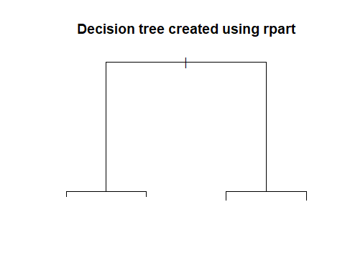

prp(x.rp, type = 1, extra = 1, split.font = 1, varlen = -10)

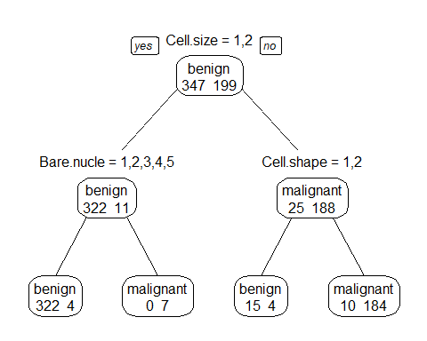

#prediction  
# predict classes for the evaluation data set  
x.rp.pred <- predict(x.rp, type="class", newdata=valid.df) # to ensemble  
# score the evaluation data set (extract the probabilities)  
x.rp.prob <- predict(x.rp, type="prob", newdata=valid.df)  
table(x.rp.pred,valid.df$Class)

##   
## x.rp.pred benign malignant  
## benign 86 2  
## malignant 11 38

#02. Model using Leave-1-Out Cross Validation (LOOCV)  
ans <- numeric(nrow(BreastCancer.df))  
for (i in 1:nrow(BreastCancer.df)) {  
 mytree <- rpart(Class ~ ., BreastCancer.df[-i,])  
 mytree.pred <- predict(mytree,BreastCancer.df[i,],type="class")  
 ans[i] <- mytree.pred  
}  
ans <- factor(ans,labels=levels(BreastCancer.df$Class))  
table(ans,BreastCancer.df$Class)

##   
## ans benign malignant  
## benign 430 20  
## malignant 14 219

#03. Model using random forest x bagging  
require(party)

## Loading required package: party

## Warning: package 'party' was built under R version 4.0.5

## Loading required package: grid

## Loading required package: mvtnorm

## Loading required package: modeltools

## Loading required package: stats4

## Loading required package: strucchange

## Warning: package 'strucchange' was built under R version 4.0.5

## Loading required package: zoo

## Warning: package 'zoo' was built under R version 4.0.4

##   
## Attaching package: 'zoo'

## The following objects are masked from 'package:base':  
##   
## as.Date, as.Date.numeric

## Loading required package: sandwich

x.cf <- cforest(Class ~ ., data=train.df, control = cforest_unbiased(mtry = 9)) #?cforest_unbiased, bagging? #500 trees  
  
x.cf.pred <- predict(x.cf, newdata=valid.df)  
x.cf.prob <- 1- unlist(treeresponse(x.cf, valid.df), use.names=F)[seq(1,nrow(valid.df)*2,2)]  
table(x.cf.pred,valid.df$Class)

##   
## x.cf.pred benign malignant  
## benign 92 0  
## malignant 5 40

#04. Model using SVM  
require(e1071)

## Loading required package: e1071

# svm requires tuning  
x.svm.tune <- tune(svm, Class~., data = train.df,  
 ranges =list(gamma = 2^(-8:1), cost = 2^(0:4)),  
 tunecontrol = tune.control(sampling = "fix"))   
# display the tuning results (in text format)  
x.svm.tune

##   
## Parameter tuning of 'svm':  
##   
## - sampling method: fixed training/validation set   
##   
## - best parameters:  
## gamma cost  
## 0.0625 2  
##   
## - best performance: 0.03296703

# If the tuning results are on the margin of the parameters (e.g., gamma = 2^-8),  
# then widen the parameters.  
# manually copied the cost and gamma from console messages above to parameters below.  
x.svm <- svm(Class~., data = train.df, cost=1, gamma=0.03125, probability = TRUE)   
  
x.svm.pred <- predict(x.svm, type="class", newdata=valid.df) #ensemble; only give the class  
x.svm.prob <- predict(x.svm, type="prob", newdata=valid.df, probability =TRUE) # has to include probability = TRUE while type="prob" is not needed  
t <- attr(x.svm.prob, "probabilities") # only give the probabilities  
table(x.svm.pred,valid.df$Class)

##   
## x.svm.pred benign malignant  
## benign 92 1  
## malignant 5 39

#05. Model using Naive Bayes Classification  
library(klaR)

## Warning: package 'klaR' was built under R version 4.0.5

## Loading required package: MASS

x.nb <- NaiveBayes(Class~., data = train.df)  
x.nb.pred <- predict(x.nb,valid.df)$class #ensemble

## Warning in FUN(X[[i]], ...): Numerical 0 probability for all classes with  
## observation 1

## Warning in FUN(X[[i]], ...): Numerical 0 probability for all classes with  
## observation 7

## Warning in FUN(X[[i]], ...): Numerical 0 probability for all classes with  
## observation 8

## Warning in FUN(X[[i]], ...): Numerical 0 probability for all classes with  
## observation 9

## Warning in FUN(X[[i]], ...): Numerical 0 probability for all classes with  
## observation 11

## Warning in FUN(X[[i]], ...): Numerical 0 probability for all classes with  
## observation 12

## Warning in FUN(X[[i]], ...): Numerical 0 probability for all classes with  
## observation 16

## Warning in FUN(X[[i]], ...): Numerical 0 probability for all classes with  
## observation 21

## Warning in FUN(X[[i]], ...): Numerical 0 probability for all classes with  
## observation 23

## Warning in FUN(X[[i]], ...): Numerical 0 probability for all classes with  
## observation 24

## Warning in FUN(X[[i]], ...): Numerical 0 probability for all classes with  
## observation 25

## Warning in FUN(X[[i]], ...): Numerical 0 probability for all classes with  
## observation 29

## Warning in FUN(X[[i]], ...): Numerical 0 probability for all classes with  
## observation 32

## Warning in FUN(X[[i]], ...): Numerical 0 probability for all classes with  
## observation 41

## Warning in FUN(X[[i]], ...): Numerical 0 probability for all classes with  
## observation 44

## Warning in FUN(X[[i]], ...): Numerical 0 probability for all classes with  
## observation 47

## Warning in FUN(X[[i]], ...): Numerical 0 probability for all classes with  
## observation 50

## Warning in FUN(X[[i]], ...): Numerical 0 probability for all classes with  
## observation 51

## Warning in FUN(X[[i]], ...): Numerical 0 probability for all classes with  
## observation 55

## Warning in FUN(X[[i]], ...): Numerical 0 probability for all classes with  
## observation 56

## Warning in FUN(X[[i]], ...): Numerical 0 probability for all classes with  
## observation 57

## Warning in FUN(X[[i]], ...): Numerical 0 probability for all classes with  
## observation 58

## Warning in FUN(X[[i]], ...): Numerical 0 probability for all classes with  
## observation 59

## Warning in FUN(X[[i]], ...): Numerical 0 probability for all classes with  
## observation 61

## Warning in FUN(X[[i]], ...): Numerical 0 probability for all classes with  
## observation 63

## Warning in FUN(X[[i]], ...): Numerical 0 probability for all classes with  
## observation 65

## Warning in FUN(X[[i]], ...): Numerical 0 probability for all classes with  
## observation 68

## Warning in FUN(X[[i]], ...): Numerical 0 probability for all classes with  
## observation 70

## Warning in FUN(X[[i]], ...): Numerical 0 probability for all classes with  
## observation 71

## Warning in FUN(X[[i]], ...): Numerical 0 probability for all classes with  
## observation 75

## Warning in FUN(X[[i]], ...): Numerical 0 probability for all classes with  
## observation 77

## Warning in FUN(X[[i]], ...): Numerical 0 probability for all classes with  
## observation 90

## Warning in FUN(X[[i]], ...): Numerical 0 probability for all classes with  
## observation 94

## Warning in FUN(X[[i]], ...): Numerical 0 probability for all classes with  
## observation 117

x.nb.prob <- predict(x.nb,valid.df)$posterior

## Warning in FUN(X[[i]], ...): Numerical 0 probability for all classes with  
## observation 1

## Warning in FUN(X[[i]], ...): Numerical 0 probability for all classes with  
## observation 7

## Warning in FUN(X[[i]], ...): Numerical 0 probability for all classes with  
## observation 8

## Warning in FUN(X[[i]], ...): Numerical 0 probability for all classes with  
## observation 9

## Warning in FUN(X[[i]], ...): Numerical 0 probability for all classes with  
## observation 11

## Warning in FUN(X[[i]], ...): Numerical 0 probability for all classes with  
## observation 12

## Warning in FUN(X[[i]], ...): Numerical 0 probability for all classes with  
## observation 16

## Warning in FUN(X[[i]], ...): Numerical 0 probability for all classes with  
## observation 21

## Warning in FUN(X[[i]], ...): Numerical 0 probability for all classes with  
## observation 23

## Warning in FUN(X[[i]], ...): Numerical 0 probability for all classes with  
## observation 24

## Warning in FUN(X[[i]], ...): Numerical 0 probability for all classes with  
## observation 25

## Warning in FUN(X[[i]], ...): Numerical 0 probability for all classes with  
## observation 29

## Warning in FUN(X[[i]], ...): Numerical 0 probability for all classes with  
## observation 32

## Warning in FUN(X[[i]], ...): Numerical 0 probability for all classes with  
## observation 41

## Warning in FUN(X[[i]], ...): Numerical 0 probability for all classes with  
## observation 44

## Warning in FUN(X[[i]], ...): Numerical 0 probability for all classes with  
## observation 47

## Warning in FUN(X[[i]], ...): Numerical 0 probability for all classes with  
## observation 50

## Warning in FUN(X[[i]], ...): Numerical 0 probability for all classes with  
## observation 51

## Warning in FUN(X[[i]], ...): Numerical 0 probability for all classes with  
## observation 55

## Warning in FUN(X[[i]], ...): Numerical 0 probability for all classes with  
## observation 56

## Warning in FUN(X[[i]], ...): Numerical 0 probability for all classes with  
## observation 57

## Warning in FUN(X[[i]], ...): Numerical 0 probability for all classes with  
## observation 58

## Warning in FUN(X[[i]], ...): Numerical 0 probability for all classes with  
## observation 59

## Warning in FUN(X[[i]], ...): Numerical 0 probability for all classes with  
## observation 61

## Warning in FUN(X[[i]], ...): Numerical 0 probability for all classes with  
## observation 63

## Warning in FUN(X[[i]], ...): Numerical 0 probability for all classes with  
## observation 65

## Warning in FUN(X[[i]], ...): Numerical 0 probability for all classes with  
## observation 68

## Warning in FUN(X[[i]], ...): Numerical 0 probability for all classes with  
## observation 70

## Warning in FUN(X[[i]], ...): Numerical 0 probability for all classes with  
## observation 71

## Warning in FUN(X[[i]], ...): Numerical 0 probability for all classes with  
## observation 75

## Warning in FUN(X[[i]], ...): Numerical 0 probability for all classes with  
## observation 77

## Warning in FUN(X[[i]], ...): Numerical 0 probability for all classes with  
## observation 90

## Warning in FUN(X[[i]], ...): Numerical 0 probability for all classes with  
## observation 94

## Warning in FUN(X[[i]], ...): Numerical 0 probability for all classes with  
## observation 117

table(x.nb.pred,valid.df$Class)

##   
## x.nb.pred benign malignant  
## benign 93 0  
## malignant 4 40

#06. Model using neural net  
library(nnet)  
x.nnet <- nnet(Class ~ ., data = train.df, size=1)

## # weights: 83  
## initial value 359.793960   
## iter 10 value 43.135046  
## iter 20 value 21.398025  
## iter 30 value 15.650267  
## iter 40 value 15.620328  
## iter 50 value 15.610292  
## iter 60 value 15.608443  
## iter 70 value 15.607157  
## iter 80 value 15.607052  
## iter 90 value 15.606849  
## iter 100 value 15.606744  
## final value 15.606744   
## stopped after 100 iterations

x.nnet.pred <- as.factor(predict(x.nnet, newdata=valid.df ,type="class"))  
table(x.nnet.pred,valid.df$Class)

##   
## x.nnet.pred benign malignant  
## benign 88 0  
## malignant 9 40

#07. MOdel using regularised Discriminant Analysis  
library(klaR)  
x.rda <- rda(Class ~ ., data=train.df)  
x.rda.pred <- predict(x.rda, newdata=valid.df)  
table(x.rda.pred$class,valid.df$Class)

##   
## benign malignant  
## benign 93 0  
## malignant 4 40

####Evaluation Phase#### #Plot ROC curves to compare the performance of the individual classifiers

# Output the plot to a PNG file for display on web.  
#png(filename="roc_curve_5_models.png", width=700, height=700)  
  
# load the ROCR package   
require(ROCR)

## Loading required package: ROCR

# Create an ROCR curve from rpart() probabilities  
x.rp.prob.rocr <- prediction(x.rp.prob[,2], valid.df$Class)  
x.rp.perf <- performance(x.rp.prob.rocr, "tpr","fpr")  
#plot(x.rp.perf, col=2, main="ROC curves comparing classification performance of five machine learning models")  
  
# ROCR curve for cforest  
x.cf.prob.rocr <- prediction(x.cf.prob, valid.df$Class)  
x.cf.perf <- performance(x.cf.prob.rocr, "tpr","fpr")  
#plot(x.cf.perf, col=4, add=TRUE)  
  
#ROCR curve for SVM  
x.svm.prob.rocr <- prediction(attr(x.svm.prob, "probabilities")[,2], valid.df$Class)  
x.svm.perf <- performance(x.svm.prob.rocr, "tpr","fpr")  
#plot(x.svm.perf, col=6, add=TRUE)  
  
# Draw a legend.  
#legend(0.6, 0.6, c('rpart', 'ctree', 'cforest','bagging','svm'), 2:6)  
  
# Close and save the PNG file.  
#dev.off()

####Deployment Phase#### #Combine the models into the ensemble and make a final prediction

#Combine predictions from models into a single dataframe  
predictions.df <- as.data.frame(cbind(x.rp.pred, x.cf.pred, x.svm.pred, x.nb.pred, x.nnet.pred))  
  
#Replace all 1's with 0's and then all 2's with 1's. This will allow quick summing of the rows to determine the majority vote for each observation in the validation set  
predictions.df[predictions.df==1] <- 0   
predictions.df[predictions.df==2] <- 1   
  
#Sum each row to determine majority vote. Each 1 is a prediction for Malignant and each 0 is a prediction for Benign. Therefore, for each row with a sum of 3 or more indicates that the majority of our models predict the observation will be Malignant. Any row with a sum of 2 or less indicates that the majority of our models predict the observation will be Benign.   
majority <- as.factor(rowSums(predictions.df))  
predictions.df$Majority <- majority  
predictions.df$Majority_Class = ifelse(as.numeric(predictions.df$Majority)>=3,"Malignant","Benign")