OpenFibre
Summary

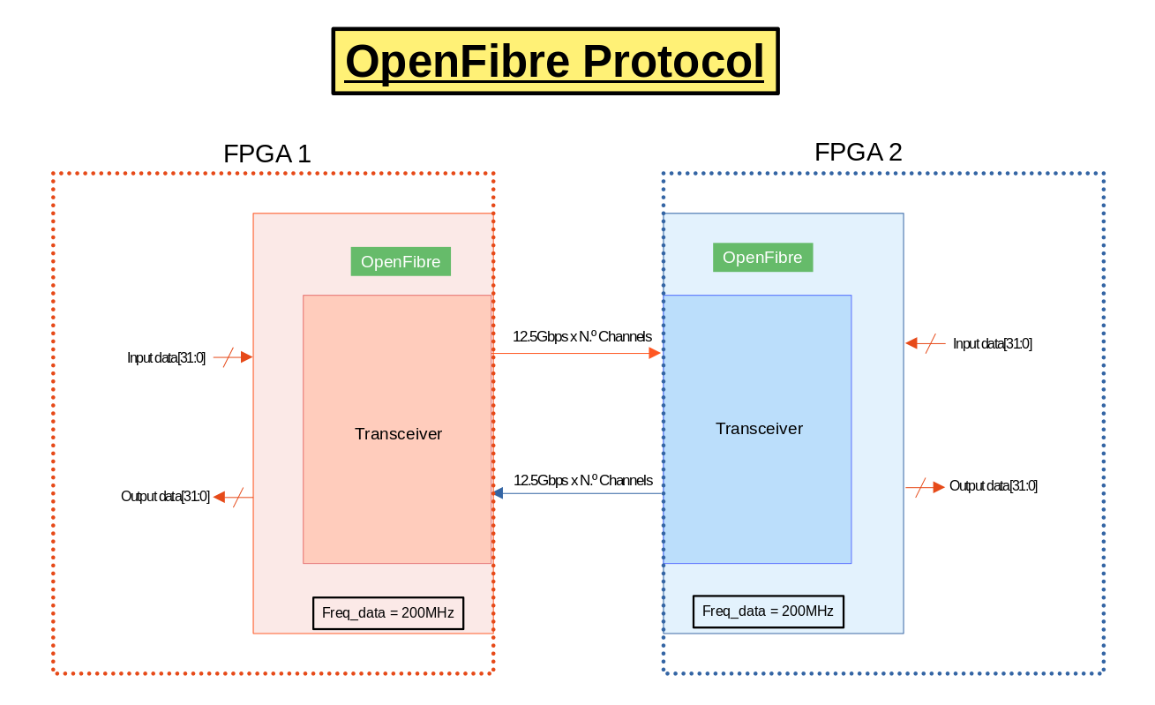

- 8b/10b.

