Pinout
Pin Name | Pin Number | Direction | Voltage | FPGA bank
CLK_50MHz | R18 | In | 1.8V | 0
LED1_{(LOW LEVEL ACTIVE)} | T18 | Out | 1.8V | 0
LED2_{(LOW LEVEL ACTIVE)} | V17 | Out | 1.8V | 0
LED3_{(LOW LEVEL ACTIVE)} | U20 | Out | 1.8V | 0
LED4_{(LOW LEVEL ACTIVE)} | U21 | Out | 1.8V | 0
LED5_{(LOW LEVEL ACTIVE)} | AA18 | Out | 1.8V | 0
LED6_{(LOW LEVEL ACTIVE)} | V16 | Out | 1.8V | 0
LED7_{(LOW LEVEL ACTIVE)} | U15 | Out | 1.8V | 0
LED8_{(LOW LEVEL ACTIVE)} | E1 | Out | 3.3V | 2
SWITCH1 _{(LOW LEVEL ACTIVE)} | T19 | In | 1.8V | 0
SWITCH2 _{(LOW LEVEL ACTIVE)} | U18 | In | 1.8V | 0
DIP1 _{(LOW LEVEL ACTIVE)} | U17 | In | 1.8V | 0
DIP2 _{(LOW LEVEL ACTIVE)} | Y16 | In | 1.8V | 0
DIP3 _{(LOW LEVEL ACTIVE)} | R17 | In | 1.8V | 0
DIP4 _{(LOW LEVEL ACTIVE)} | AA15 | In | 1.8V | 0
DIP5 _{(LOW LEVEL ACTIVE)} | AA20 | In | 1.8V | 0
DIP6 _{(LOW LEVEL ACTIVE)} | Y20 | In | 1.8V | 0
DIP7 _{(LOW LEVEL ACTIVE)} | V21 | In | 1.8V | 0
DIP8 _{(LOW LEVEL ACTIVE)} | AA19 | In | 1.8V | 0
DISP7SEG1 | V18 | Out | 1.8V | 0
DISP7SEG2 | W20 | Out | 1.8V | 0
DISP7SEG3 | Y19 | Out | 1.8V | 0
DISP7SEG4 | T17 | Out | 1.8V | 0
DISP7SEG5 | W16 | Out | 1.8V | 0
DISP7SEG6 | AA17 | Out | 1.8V | 0
DISP7SEG7 | V15 | Out | 1.8V | 0
DISP7SEG8 | Y15 | Out | 1.8V | 0
UART_TX | W21 | Out | 1.8V | 0
UART_RX | Y21 | In | 1.8V | 0
RPI_GPIO3 | E18 |  | 2.5V/3.3V (J45)* | 1
RPI_GPIO5 | F18 |  | 2.5V/3.3V (J45)* | 1
RPI_GPIO7 | E12 |  | 2.5V/3.3V (J45)* | 1
RPI_GPIO8 | A20 |  | 2.5V/3.3V (J45)* | 1
RPI_GPIO10 | B21 |  | 2.5V/3.3V (J45)* | 1
RPI_GPIO11 | G18 |  | 2.5V/3.3V (J45)* | 1
RPI_GPIO12 | E10 |  | 2.5V/3.3V (J45)* | 1
RPI_GPIO13 | F21 |  | 2.5V/3.3V (J45)* | 1
RPI_GPIO15 | F20 |  | 2.5V/3.3V (J45)* | 1
RPI_GPIO16 | E21 |  | 2.5V/3.3V (J45)* | 1
RPI_GPIO18 | F19 |  | 2.5V/3.3V (J45)* | 1
RPI_GPIO22 | A19 |  | 2.5V/3.3V (J45)* | 1
RPI_GPIO29 | D17 |  | 2.5V/3.3V (J45)* | 1
RPI_GPIO31 | D18 |  | 2.5V/3.3V (J45)* | 1
RPI_GPIO32 | B20 |  | 2.5V/3.3V (J45)* | 1
RPI_GPIO33 | A15 |  | 2.5V/3.3V (J45)* | 1
RPI_GPIO35 | B19 |  | 2.5V/3.3V (J45)* | 1
RPI_GPIO36 | B15 |  | 2.5V/3.3V (J45)* | 1
RPI_GPIO37 | B17 |  | 2.5V/3.3V (J45)* | 1
RPI_GPIO38 | B14 |  | 2.5V/3.3V (J45)* | 1
RPI_GPIO40 | E13 |  | 2.5V/3.3V (J45)* | 1
MIKROBUS_AN | G12 |  | 2.5V/3.3V (J45)* | 1
MIKROBUS_RST_{(PULL-UP)} | B16 |  | 2.5V/3.3V (J45)* | 1
MIKROBUS_CS_{(PULL-UP)} | C16 |  | 2.5V/3.3V (J45)* | 1
MIKROBUS_SCK | E17 |  | 2.5V/3.3V (J45)* | 1
MIKROBUS_MISO | A18 |  | 2.5V/3.3V (J45)* | 1
MIKROBUS_MOSI | E11 |  | 2.5V/3.3V (J45)* | 1
MIKROBUS_PWM | D13 |  | 2.5V/3.3V (J45)* | 1
MIKROBUS_INT_{(PULL-UP)} | G17 |  | 2.5V/3.3V (J45)* | 1
MIKROBUS_RX | E14 |  | 2.5V/3.3V (J45)* | 1
MIKROBUS_TX | E15 |  | 2.5V/3.3V (J45)* | 1
MIKROBUS_SCL_{(PULL-UP)} | D11 |  | 2.5V/3.3V (J45)* | 1
MIKROBUS_SDA_{(PULL-UP)} | D12 |  | 2.5V/3.3V (J45)* | 1
ETH_MDC_{(PULL-UP)} | D15 | Out | 2.5V/3.3V (J45)* | 1
ETH_MDIO_{(PULL-UP)} | J9 | Out | 2.5V/3.3V (J45)* | 1
ETH_MDINTB_{(PULL-UP)} | A13 | Out | 2.5V/3.3V (J45)* | 1
ETH_RESETn_{(PULL-UP)} | A14 | Out | 2.5V/3.3V (J45)* | 1
ETH_RXLOS | A17 | Out | 2.5V/3.3V (J45)* | 1
ETH_TXDISn_{(PULL-UP)} | E20 | Out | 2.5V/3.3V (J45)* | 1
GPIO_MIPI_RX_N0 | B11 | Out | 2.5V/3.3V (J45)* | 1
GPIO_MIPI_RX_P0 | C11 | Out | 2.5V/3.3V (J45)* | 1
GPIO_MIPI_RX_N1 | A10 | Out | 2.5V/3.3V (J45)* | 1
GPIO_MIPI_RX_P1 | B10 | Out | 2.5V/3.3V (J45)* | 1
GPIO_MIPI_RX_CKN | B12 | Out | 2.5V/3.3V (J45)* | 1
GPIO_MIPI_RX_CKP | A12 | Out | 2.5V/3.3V (J45)* | 1
CAM_EN | Y14 | In | 1.8V | 0
CAM_I2C_SDA_{(PULL-UP)} | T20 | In | 1.8V | 0
CAM_I2C_SCL_{(PULL-UP)} | T21 | In | 1.8V | 0
CAM_GPIO | Y17 | In | 1.8V | 0

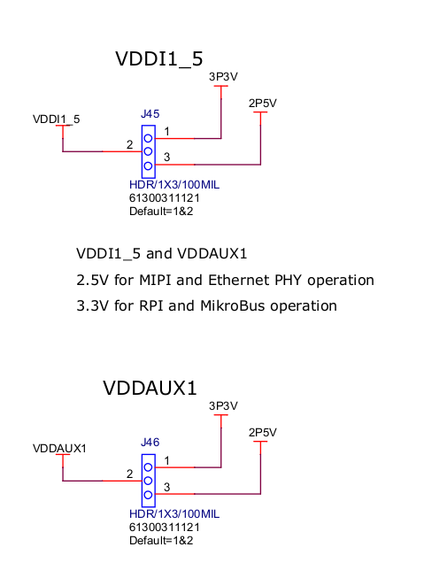
*

Live Probes (J12). Debugging pins:
Pin | Name | Function
1 | LPRB_B (C20) | Live Probe B
2 | LPRB_A (C21) | Live Probe A
3 | GND
4 | GND

Raspberry Pi 4 Interface
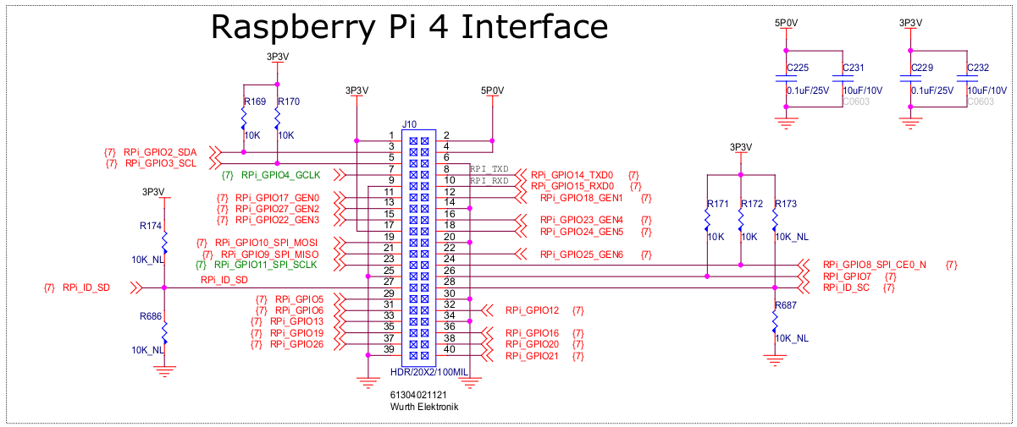
PIN CONNECTOR | PIN FPGA | TYPE PIN | VOLTAGE | BANK
1 |  | SOURCE | 3.3V
2 |  | SOURCE | 5V
3 | E18 | HSIO | 2.5V/3.3V (J45) | 1
4 |  | SOURCE | 5V
5 | F18 | HSIO | 2.5V/3.3V (J45) | 1
6 |  | SOURCE | GND
7 | E12 | HSIO | 2.5V/3.3V (J45) | 1
8 | A20 | HSIO | 2.5V/3.3V (J45) | 1
9 |  | SOURCE | GND
10 | B21 | HSIO | 2.5V/3.3V (J45) | 1
11 | G18 | HSIO | 2.5V/3.3V (J45) | 1
12 | E10 | HSIO | 2.5V/3.3V (J45) | 1
13 | F21 | HSIO | 2.5V/3.3V (J45) | 1
14 |  | SOURCE | GND
15 | F20 | HSIO | 2.5V/3.3V (J45) | 1
16 | E21 | HSIO | 2.5V/3.3V (J45) | 1
17 |  | SOURCE | 3.3V
18 | F19 | HSIO | 2.5V/3.3V (J45) | 1
19 | A4 | MSS | 3.3V | 2
20 |  | SOURCE | GND
21 | B4 | MSS | 3.3V | 2
22 | A19 | HSIO | 2.5V/3.3V (J45) | 1
23 | D6 | MSS | 3.3V | 2
24 | D5 | MSS | 3.3V | 2
25 |  | SOURCE | GND
26 | B2 | MSS | 3.3V | 2
27 | D1 | MSS | 3.3V | 2
28 | C2 | MSS | 3.3V | 2
29 | D17 | HSIO | 2.5V/3.3V (J45) | 1
30 |  | SOURCE | GND
31 | D18 | HSIO | 2.5V/3.3V (J45) | 1
32 | B20 | HSIO | 2.5V/3.3V (J45) | 1
33 | A15 | HSIO | 2.5V/3.3V (J45) | 1
34 |  | SOURCE | GND
35 | B19 | HSIO | 2.5V/3.3V (J45) | 1
36 | B15 | HSIO | 2.5V/3.3V (J45) | 1
37 | B17 | HSIO | 2.5V/3.3V (J45) | 1
38 | B14 | HSIO | 2.5V/3.3V (J45) | 1
39 |  | SOURCE | GND
40 | E13 | HSIO | 2.5V/3.3V (J45) | 1

MIKROBUS
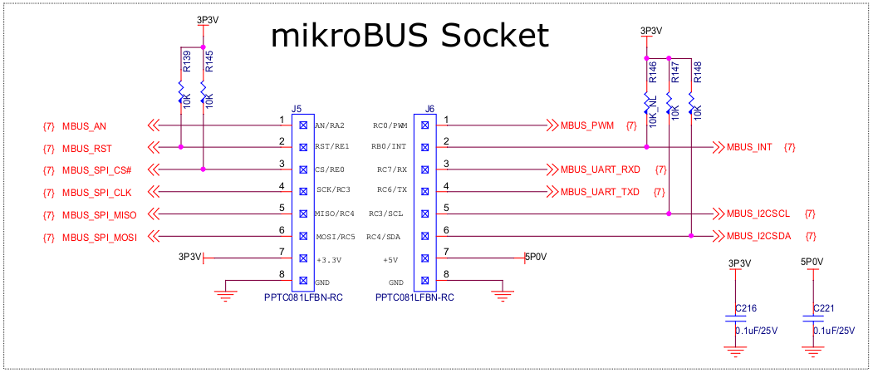

CONNECTOR | PIN | NAME | FPGA PIN | VOLTAGE | BANK
J5 | 1 | MIKROBUS_AN | G12 | 2.5V/3.3V (J45) | 1
J5 | 2 | MIKROBUS_RST_{(PULL-UP: 3V3)} | B16 | 2.5V/3.3V (J45) | 1
J5 | 3 | MIKROBUS_CS_{(PULL-UP: 3V3)} | C16 | 2.5V/3.3V (J45) | 1
J5 | 4 | MIKROBUS_SCK | E17 | 2.5V/3.3V (J45) | 1
J5 | 5 | MIKROBUS_MISO | A18 | 2.5V/3.3V (J45) | 1
J5 | 6 | MIKROBUS_MOSI | E11 | 2.5V/3.3V (J45) | 1
J5 | 7 | 3V3
J5 | 8 | GND
J6 | 1 | MIKROBUS_PWM | D13 | 2.5V/3.3V (J45) | 1
J6 | 2 | MIKROBUS_INT_{(PULL-UP: 3V3)} | G17 | 2.5V/3.3V (J45) | 1
J6 | 3 | MIKROBUS_RX | E14 | 2.5V/3.3V (J45) | 1
J6 | 4 | MIKROBUS_TX | E15 | 2.5V/3.3V (J45) | 1
J6 | 5 | MIKROBUS_SCL_{(PULL-UP: 3V3)} | D11 | 2.5V/3.3V (J45) | 1
J6 | 6 | MIKROBUS_SDA_{(PULL-UP: 3V3)} | D12 | 2.5V/3.3V (J45) | 1
J6 | 7 | 5V
J6 | 8 | GND

ETHERNET (GPIO & MSS Pins)
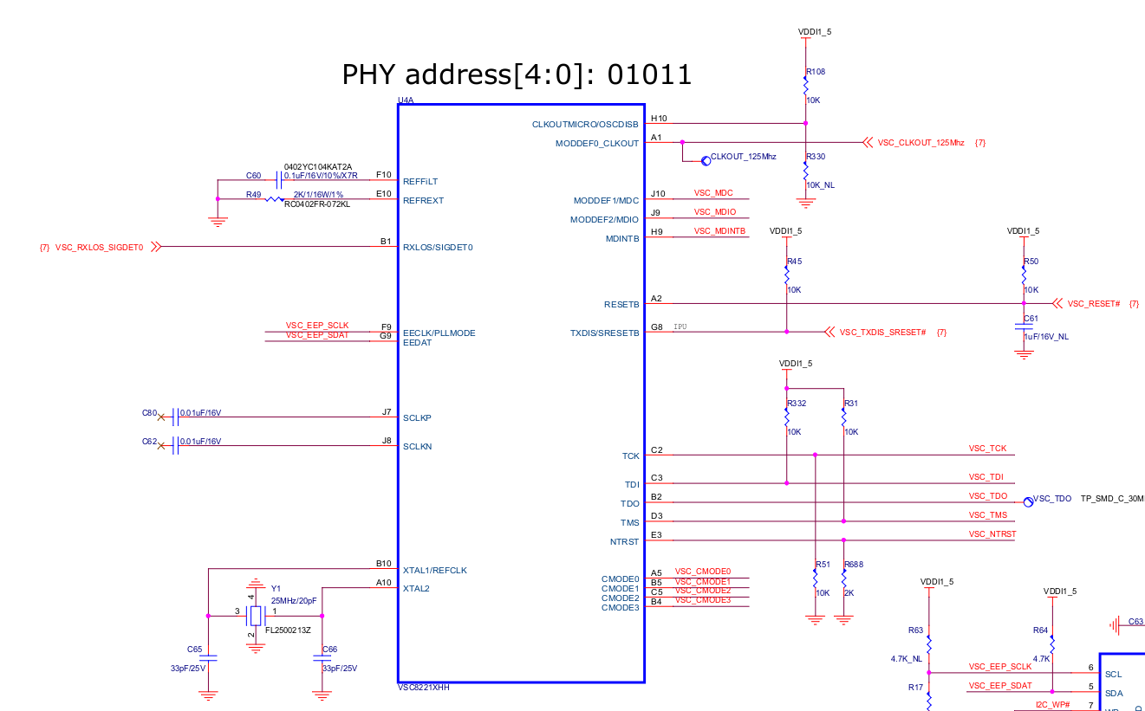

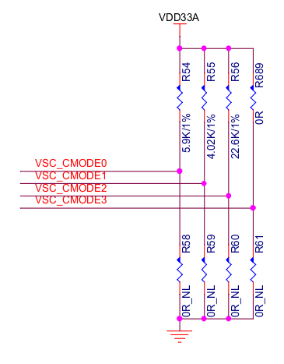
*R58, R59, R60, R61 : NM → CMODE: 2
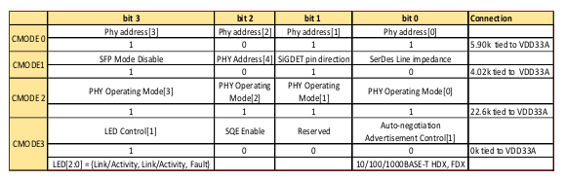

Name | FPGA Pin | Type | Voltage | Bank
ETH_MDC_{(PULL-UP)} | D15 | Out | 2.5V/3.3V (J45) | 1
ETH_MDIO_{(PULL-UP)} | J9 | Out | 2.5V/3.3V (J45) | 1
ETH_MDINTB_{(PULL-UP)} | A13 | Out | 2.5V/3.3V (J45) | 1
ETH_RESETn_{(PULL-UP)} | A14 | Out | 2.5V/3.3V (J45) | 1
ETH_RXLOS | A17 | Out | 2.5V/3.3V (J45) | 1
ETH_TXDISn_{(PULL-UP)} | E20 | Out | 2.5V/3.3V (J45) | 1

… Other pins are MSS pins

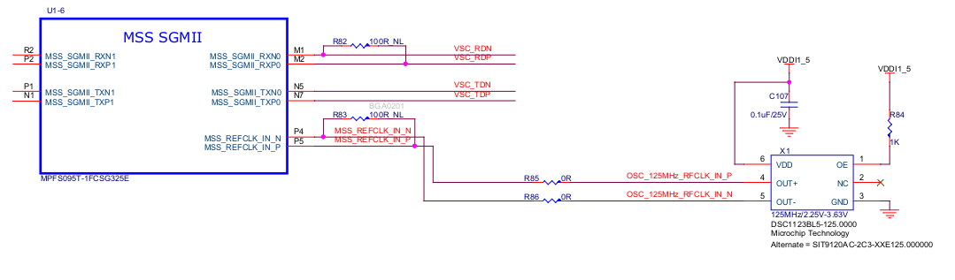

MIPI Conector

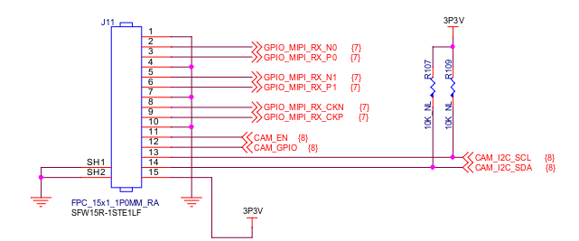

Pin | Name | FPGA Pin | Type | Voltage | Bank
1 | GND
2 | GPIO_MIPI_RX_N0 | B11 | Out | 2.5V/3.3V (J45) | 1
3 | GPIO_MIPI_RX_P0 | C11 | Out | 2.5V/3.3V (J45) | 1
4 | GND
5 | GPIO_MIPI_RX_N1 | A10 | Out | 2.5V/3.3V (J45) | 1
6 | GPIO_MIPI_RX_P1 | B10 | Out | 2.5V/3.3V (J45) | 1
7 | GND
8 | GPIO_MIPI_RX_CKN | B12 | Out | 2.5V/3.3V (J45) | 1
9 | GPIO_MIPI_RX_CKP | A12 | Out | 2.5V/3.3V (J45) | 1
10 | GND
11 | CAM_EN | Y14 | In | 1.8V | 0
12 | CAM_GPIO | Y17 | In | 1.8V | 0
13 | CAM_I2C_SDA_{(PULL-UP)} | T20 | In | 1.8V | 0
14 | CAM_I2C_SCL_{(PULL-UP)} | T21 | In | 1.8V | 0
15 | GND

SD CARD (MSS Pins)
