CE154_assignment1
The following is the report on the website developed for CE154 assignment 1, the task given was to find an artist and create a website for them, the requirements are that the website needs a home page, about page, a listing page for merchandise, a details page for the merchandise and a basket for purchasing merchandise. The genre I chose is horror.
Home page - purpose is to entice the user and display several images and pieces of information so that the user can gather some information without needing to access the other pages.
About page - provides details about the artist such as a biography, previous works and pieces they may be well known for.
Listing/merchandise page - provides a page for users to scroll through and find merchandise they may want to purchase.
Details page – provides information and specifications for the merchandise.
Basket – allows users to accrue merchandise to a list which they can purchase in one go.
User personas:
As I’m developing a website to target an audience, I must consider what a variety of people may want from the website, to achieve this I have come up with 3 personas of which I’d try to consider their point of view while developing the website.
User 1 –
Name – AJ
Age – 23
Motivations – Horror fan, interest in the artist
Devices – Laptop, phone
User 2 –
Name – AO
Age – 19
Motivations – Aspiring horror artist looking for inspiration
Devices – Desktop, phone
User 3 –
Name – PO
Age – 26
Motivations – Agent looking for new artists
Devices – Desktop, laptop, phone

Similar website research:
The first step for development of the website is to look up other artists websites to gain ideas and inspiration, also to look at what they’ve done well and what can be improved on, as well as to check if the websites meet similar requirements to the website we were tasked to make.
Website 1 - https://www.jamesjean.com
This website is very close to the requirements as it features a home page, about page, a listing page, a details page for the merchandise and a basket, however I feel its lacking in details in the about page, and I don’t like the layout of the home page as it just displays a large display of the artists’ works and all the navigation is in the top right which didn’t appear for me at first.
Website 2 - https://mirabyler.com
This website also meets the requirements for our task as it features the required pages, compared to the first website I viewed I prefer the layout and design much more as there are more details and information on the home page and the about page contains more information on the artist. I will be using this site as inspiration.
Website 3 - https://www.luannudell.com
This website almost meets the requirements, however the shop page takes the user to a different website (the artists etsy page) and the layout/design is very simple and basic, which I do not like.
Wireframe layout:
Home page:
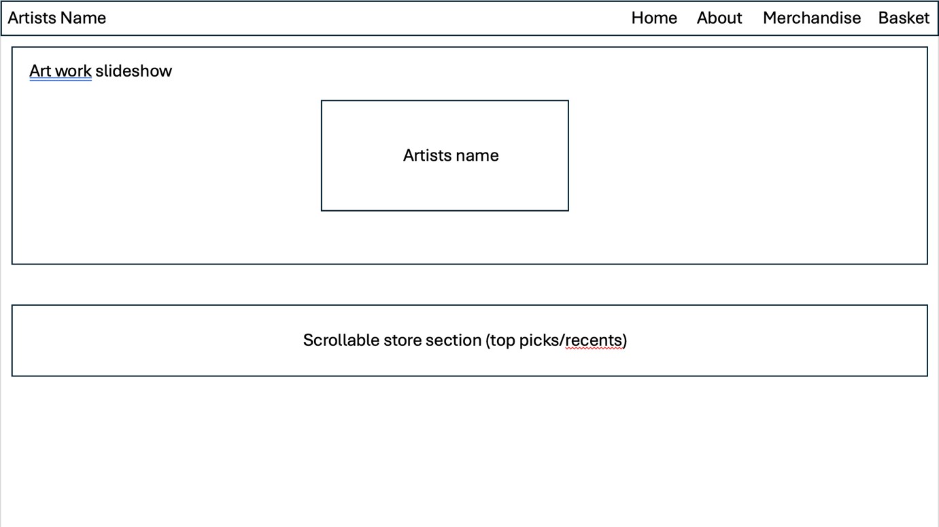
I laid my home page like this so that when a user opens the website, they get a view of some of the artist’s work in the art work slide show, there’s also a scrollable store section so that users can see most recent additions or artists top picks from the store. As I’ve chosen a horror genre the home page, as well as all other pages will be coloured in black, white and grey, which also provides great contrast.
About page:
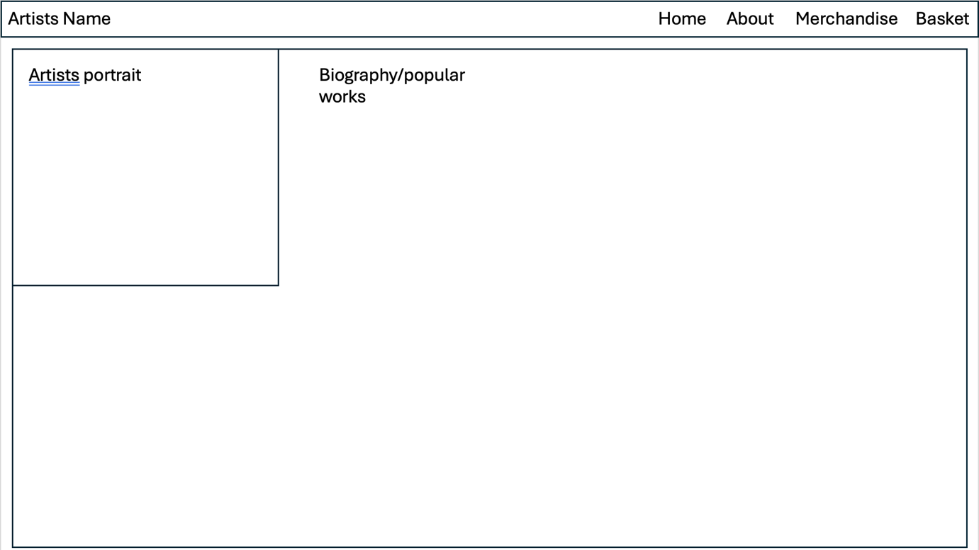
I laid the about section out like this to keep it clean and minimal, there’s also a lack of need of many other sections to achieve the goal of the about page, I chose to add a picture so that the user can see who the artist is, the portrait is a floating image with text about the artist wrapped to the right of it.
Merchandise page:

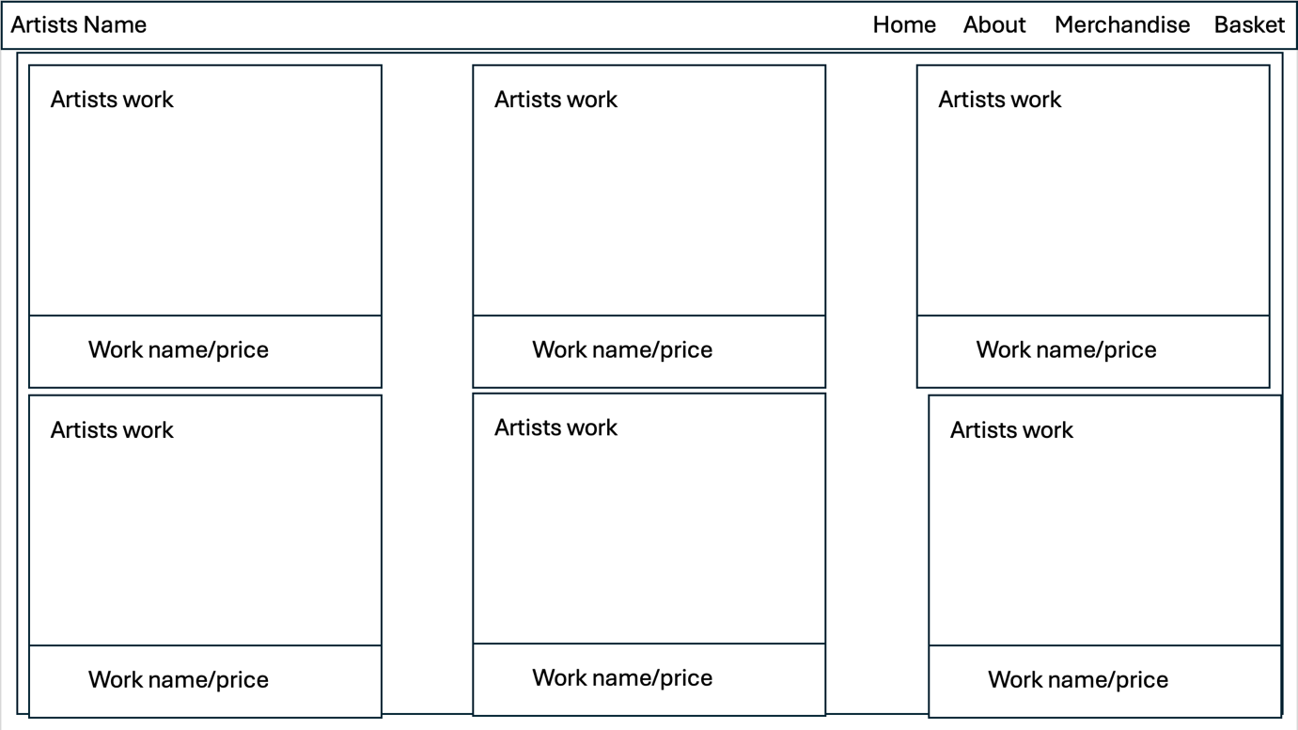
For the merchandise page I chose to use a grid layout where there’s a thumbnail with the works name and price directly below the thumbnail, the works can then be clicked on to view more details. I chose a grid layout for simplicity and because it will scale better with different resolutions.
Merchandise info page:
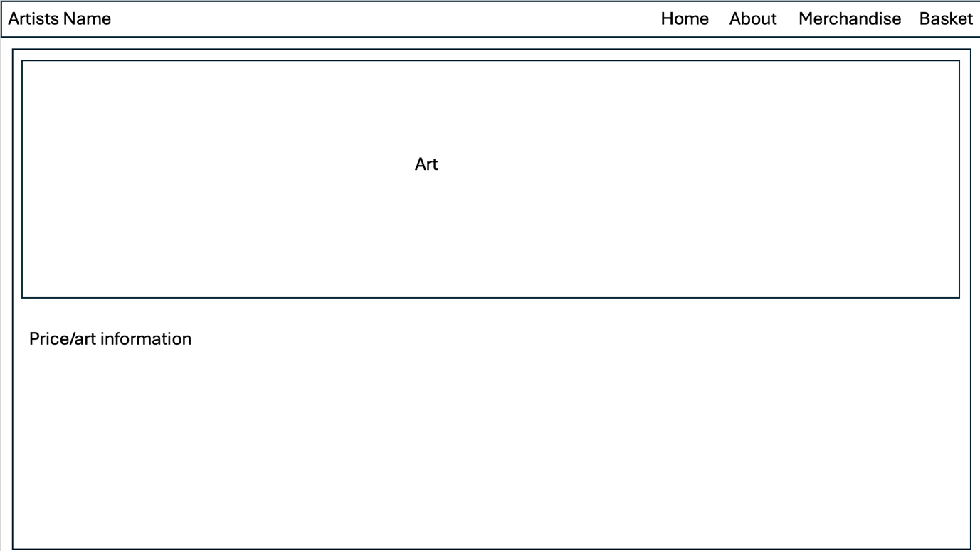
For the merchandise information page, I chose to display a large image of the work, with a description and details below it, the large picture allows the user to see more details of what they’re buying while the description and details fill in what the user can’t gather from just looking at the picture.
Basket page:
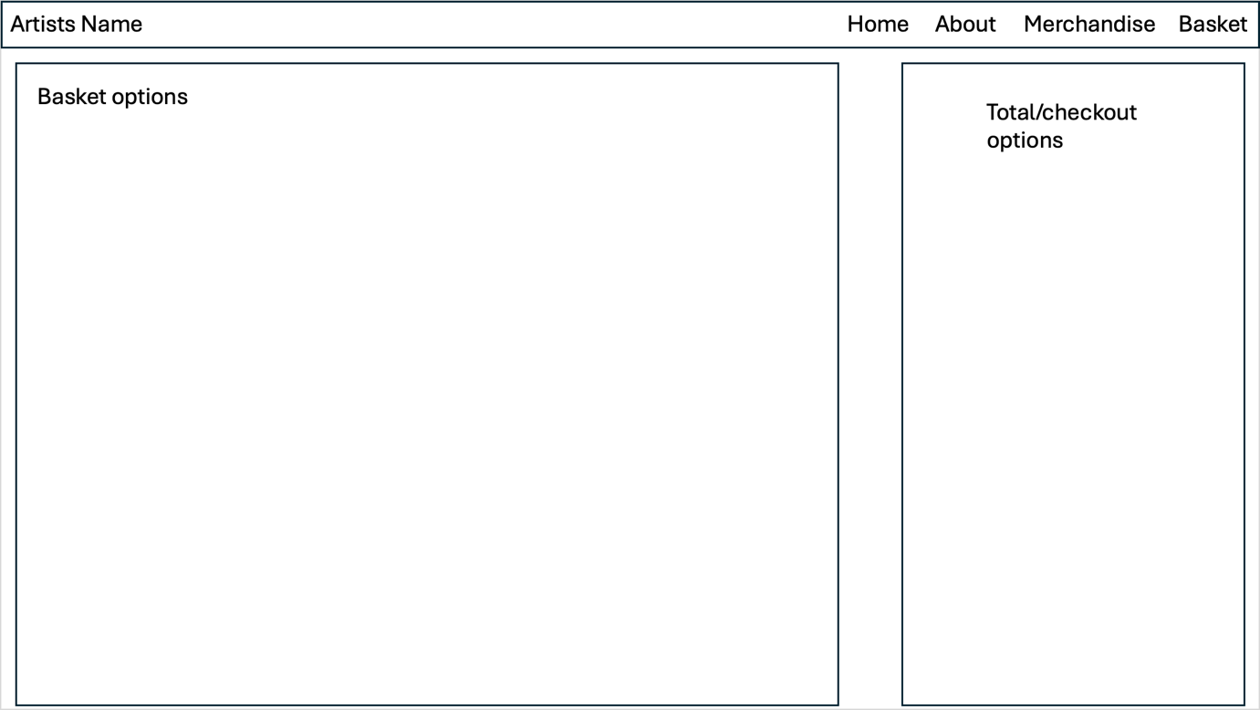
For the basket page I chose to use a large box containing a list of the added merchandise along with another box to the right which contains the checkout options.
Website review:
For the review I came up with a few questions to gage how well my website performs and suits the brief. The questions I came up with are as follows:
- Is the website engaging?
- On a scale of 1-10 how well does the site perform on your device?
- Are the features on the site discernible?
I asked 3 people to answer these questions.
Person 1 –
- Is the website engaging?
Yes, I really like the layout and it’s easy to navigate the menus and find what I need.
- On a scale of 1-10 how well does the site perform on your device?
10/10 on a pc.
- Are the features on the site discernible?
Yes, everything on the site is easily discernible.
Person 2 –
- Is the website engaging?
It’s okay.
- On a scale of 1-10 how well does the site perform on your device?
8/10, I don’t like how the header looks on phone.
- Are the features on the site discernible?
Yeah, it’s quite good, I like the colour scheme.
Person 3 –
- Is the website engaging?
I’m not really a fan as it looks too modern and clean for a horror-based artist.
- On a scale of 1-10 how well does the site perform on your device?
10/10 looks good on laptop
- Are the features on the site discernible?
Yes, the colour scheme works well.

From these responses I can ascertain that the website is designed well and looks good across computers however more can be done to achieve the desired look on mobile. However, person 3 stated that some changes can be made to suit the horror genre better.
Iterative development:
In the future I wish to change the header and make slight differences to the colour scheme, also focus more on making the site look good on mobile devices. I’ve also noticed a slight problem with the footer in the basket page where it consumes half of the view port. I would also like to include an add to basket function as the button is there however there is no script for the button to work, the add to basket feature is an important aspect of any online store and without it the website will fail to serve its purpose.
Code evaluation
Index.html
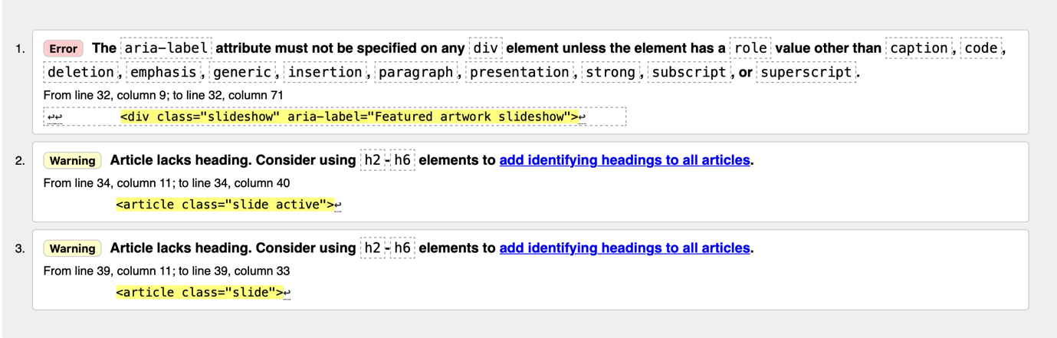
About.html
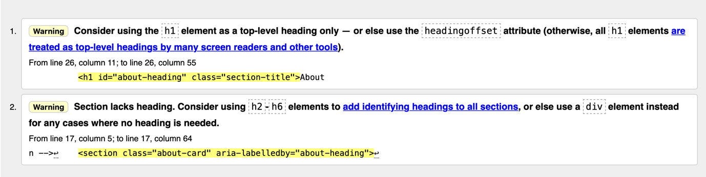
Merchandise.html
Basket.html
Product-details.html
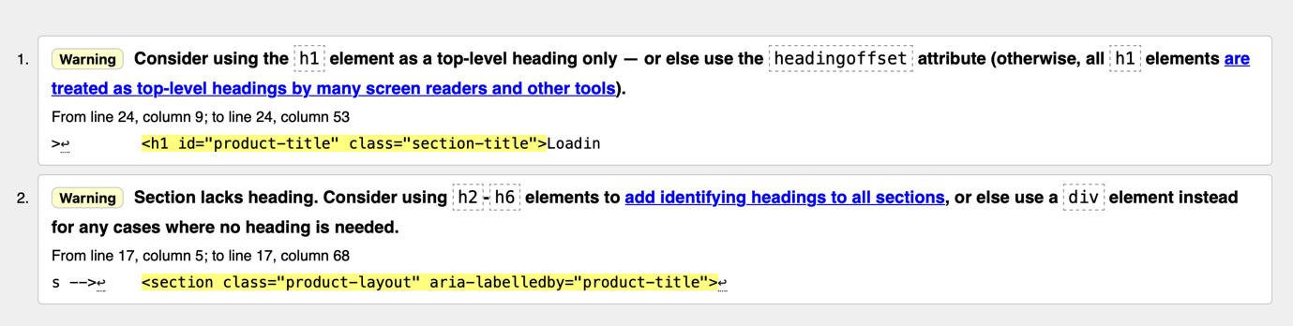
Style.css
Self-appraisal:
I believe I performed extremely well in creating the website, I achieved all my goals and fulfilled all the requirements for the assignment. However, there are a few thing I could have done better such as the header and footer on some pages and by gathering more opinions on the site and applying it, also by checking my code consistently against the evaluators during development to reduce the number of errors I receive at the end of development. There is also a need to add important functions to the website in order for it to work as is required (adding to basket)

Checklist for CE154 Assignment 1 (approx. total time 40 hours)
Task 1 (submitted in report) – 20% approx. 8 hours
Assignment Word doc is called CE154_assignment_1.doc
Similar website content research included (list sites and discuss)
Define sections of content (purpose and names): e.g., home, about, listing, detail, basket
User personas enough to cover main user groups and any specific user characteristics mentioned
User stories (enough to cover the main roles and functions of the site)
Wireframe template for layout for specified resolutions
Task 2 (submitted in report) – 20% approx. 8 hours
Design inspiration research included (list and discuss)
Art genre explicitly stated
Add design details to wireframe
Graphical mockup
Justification of design
Task 3 (submitted in code zip) – 40% approx. 16 hours
Lorum ipsum text used for content
Files correctly named (e.g., index.html and style.css)
Files in specified folder structure
Source credited in code/reference doc
At least 5 pages
At least 5 items in product list
No horizontal scrolling
Minimum data transfer (no massive video or image files)
The pages must take the following aspects into account:
  - the correct type of graphics files for the images you want to show
  - suitable font types and sizes
  - appropriate use of colour and contrast
  - functional navigation based on a linked unordered list
  - avoid text in graphics
  - add suitable alt tags to hyperlinks and images (for users with restricted vision)
  - include copyright and updating information the page footer
Code comments
Task 4 (submitted in report) – 20% approx. 8 hours
Questionnaire (min 3 questions) evidence
Results and analysis
Iterative evaluation evidence – What did you change? What will you change in the future?
Code evaluation against HTML
Code evaluation against CSS
Code report and bug fixing log
Self-appraisal
Skill tree screenshot
Checklist completed

