Unicom TIC Management System - Project Report

# 1. Project Overview

## Key Features Implemented

* **Login System**: Role-based access for Admin, Staff, Students, Lecturers.
* **Course & Subject Management**: Admin manages courses/subjects; all roles view read-only.
* **Student Management**: Admin handles student records; Students view own details.
* **Exam & Marks Management**: Admin/Staff manage exams; Admin/Lecturers manage marks; Students view marks.
* **Timetable Management**: Admin assigns labs/halls to timetables; all roles view.
* **Room Allocation**: Admin selects rooms via ComboBox with validation.
* **Bonus Feature**: Error logging to error.log for debugging.

## Technologies Used

* **C# WinForms**: Builds UI with forms, buttons, ComboBoxes, DataGridViews.
* **SQLite**: Stores data, managed via System.Data.SQLite NuGet.
* **MVC Architecture**: Organizes code with Models (data), Views (UI), Controllers (logic).
* **Async/Await**: Keeps UI responsive during database tasks.
* **Visual Studio**: Used for development with Form Designer.

## Challenges Faced and Solutions

* **Challenge**: Room Filter didn’t work at first try.
  + **Solution**: Instead of filter using room type, I filter them by searching for the string “Room” or “Hall” in their name.
* **Challenge**: Role-based UI access control.
  + **Solution**: GetUserRoleAsync toggles dashboard buttons by role.
* **Challenge**: Validating timetable inputs (e.g., room selection).
  + **Solution**: Controller validation with error messages via MessageBox.

# 2. Code Sections regarding my best work

Below are descriptions of key code samples that demonstrate the best work in this project.

**1. Changing password logic implementation (ProfileForm.cs)**

Description: Changing password if it matches in both fields and update the new password to the database with needed error handlings

**2. Optional Register option (LoginForm.cs)**

Description: Instead of a new register form. I have added an checkbox to show the register options.

**3. Timetable Room Filter Alternative method (TimetableForm.cs)**

Description: Filter rooms by using keywords, if they have string” hall” or “lab” in their name. I have done this because filter by type is not working.

**4. Error Logging (DatabaseManager.cs)**

Description: The LogToFile method writes errors to error.log with timestamps, used across all database operations.

**5. Student Management by admin (StudentForm.cs)**

Description: Admin will get new users who register them self as students in the dropdown, only they can add them to the students’ table.

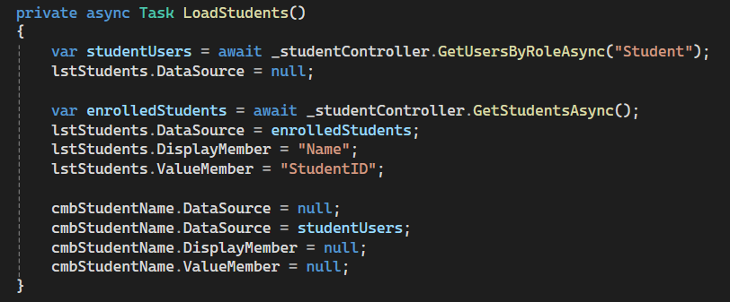

6. Role based authorization (MainForm.cs)

o Description: Allow users to only the features which they are allowed based on their role

# 3. How to use and Assumptions

Login Process: Users enter their username and password in a login form. The ValidateUserAsync method verifies credentials against the Users table, retrieves the role, and directs users to a dashboard with role-specific buttons (e.g., Admin sees "Add Course," Students see "View Marks").

* **User Registration:** Users can register, but only Admin adds them to the specific table (currently only for students due to assignment structure)
* **Pre-defined rooms:** Users can only add rooms by choosing redefined items.
* **No Conflict Checking:** The Timetable ignores room/time conflicts for simplicity.
* **Sample Data:** Initialized for testing (users, rooms, subjects, timetables).

# 4. Bonus Features

* **Error Logging**: LogToFile saves errors (e.g., login failures) to error.log.
* **Room Filter**: Timetable dropdown filters labs or halls.
* **Top Marks**: Displays top 3 students by exam marks.
* **Messages**: Shows pop-ups (e.g., "Timetable saved!").
* **Attendance Management**: Lecturers mark attendance (Present/Absent/Late/Excused); Admin edits/views all records; Students view own attendance.