Youth Depression Risk Profiling
Identifying Priority Groups For Mental Health Support

Subject: Data Science
Professor: 조풍진

Team 4
202136385 한원준
202231836 장세창
202234852 강호현
202236920 박민기
202334280 김진서
2026

Table of Contents
1. Introduction
1.1 Project Overview
1.2 Analytical Objective
2. Dataset Description
2.1 Dataset Overview
2.2 Feature Classification
3. Exploratory Data Analysis (EDA)
3.1 Target Variable Distribution
3.2 Missing Value Analysis
3.3 Categorical Variable Analysis
3.4 Continuous Variable Analysis
3.5 Outlier and Skewness Analysis
3.6 Group Comparison Analysis
4. Data Preprocessing
4.1 Target Variable Transformation
4.2 Removal of Unnecessary Columns
4.3 Missing Value Handling and Feature Engineering
4.4 Ordinal Variable Processing
4.5 Nominal Variable Processing
4.6 Continuous Variable Transformation and Scaling
4.7 Algorithm-Specific Scaling and Code Separation
5. Modeling and Evaluation
5.1 Classification Model Overview
5.2 Logistic Regression
5.2.1 VIF Analysis of the LR_FULL Model
5.2.2 Comparison of LR_FULL and LR_WORK
5.2.3 C-Value Tuning Results
5.3 Random Forest
5.3.1 Baseline Model
5.3.2 Hyperparameter-Tuned Model
5.3.3 Feature Importance Based on the Optimized Model
6. Feature Importance Analysis
6.1 Selection of the Top 10 Features
6.2 Criteria for Selecting the Top Features
6.2.1 Common Features Across Both Models
6.2.2 Additional Features Selected Based on Logistic Regression
7. Clustering Analysis
7.1 Objective of Clustering Analysis
7.2 K-Means Clustering
7.3 High-Risk Cluster Analysis
7.3.1 Identification of the Depression High-Risk Group
7.3.2 Full Descriptive Comparison Based on Summary Statistics
7.3.3 Final Persona Summary of the Depression High-Risk Group
8. Policy Implications and Deployment Plan

1. Introduction

1.1 Project Overview
This project aims to analyze the relationship between youth life, economic, health, and social characteristics and the prevalence of depressive symptoms using the 2024 Youth Life Survey dataset.
In addition, by identifying which groups of young adults show higher rates of depressive symptoms, this project seeks to help policymakers determine which groups should be prioritized when allocating mental health support resources.
The analytical workflow of this project is as follows.
- First, the structure and characteristics of the dataset are examined. This includes checking feature distributions, missing value rates, the composition of categorical and continuous variables, and the distribution of depressive symptom prevalence.
- Second, the data are preprocessed to make them suitable for model training. Missing value handling, encoding, and scaling are performed to transform the data into an analysis-ready format.
- Third, Logistic Regression and Random Forest models are used to predict depressive symptom prevalence, and their performance is compared.
- Fourth, key features that the models use to predict depressive symptom prevalence are extracted.
- Fifth, K-Means clustering is performed using approximately 10 key features identified as important by the models. Using all features directly was judged likely to reduce clustering quality and interpretability due to the curse of dimensionality.
- Sixth, the characteristics of each cluster are compared based on the clustering results. In particular, the cluster with the highest depressive symptom rate is analyzed in terms of its life patterns, social relationships, labor environment, and economic characteristics compared with other clusters.
- Finally, the characteristics of youth groups at high risk of depressive symptoms are summarized, and directions for mental health policy and support are proposed for those groups.
This project is meaningful in that it goes beyond predicting depressive symptom prevalence and identifies youth groups that are relatively vulnerable from a mental health perspective, thereby deriving policy implications.

1.2 Analytical Objective
Depression is recognized not only as an individual issue but also as a social problem. In particular, mental health issues among young adults are closely linked to multiple factors such as economic instability, social isolation, labor conditions, and life patterns. However, because depressive symptoms are not easily visible externally, it is difficult to identify which youth groups have relatively higher risk.
Moreover, mental health policies and support resources are limited. Therefore, rather than allocating the same level of resources to all groups, it is important to identify and support vulnerable groups with higher depressive symptom risk first.
Accordingly, this project uses the 2024 Youth Life Survey dataset to analyze the relationship between young adults life, economic, health, and social characteristics and depressive symptom prevalence.
To achieve this, machine learning-based classification models are used to predict depressive symptom prevalence, and the key features used by the models are extracted. K-Means clustering is then performed based on those features to segment young adults into groups, and the characteristics and depressive symptom rates of each cluster are compared.
Ultimately, this project aims to identify the characteristics of youth groups that are relatively vulnerable in terms of mental health and to help policymakers determine which groups should receive priority support resources.

2. Dataset Description

2.1 Dataset Overview
This study uses the 2024 Youth Life Survey dataset, which targets young adults aged 19 to 34 as of 2024. The dataset includes multiple domains such as housing, health, economic activity, social participation, relationships, living expenses, income, debt, and assets, making it suitable for multidimensional analysis of youth mental health issues.
Item | Description
Dataset | 2024 Youth Life Survey
Observations | 15,098 rows
Number of Features | 50 features
Target Variable | Depressive symptom prevalence: 1 = No, 2 = Yes
Data Type | Mixed categorical, ordinal, binary, and continuous variables
Missing Values Characteristics | Structural Missing Values exist due to survey branching structure

2.2 Feature Classification
The 50 features were classified as follows according to the purpose of analysis. Most variables are categorical or ordinal, while the economic variables are continuous.
Category | Example Features | Analytical Role
Demographic | Gender, age group, region, marital status | Controls for basic demographic characteristics and supports group comparison
Housing | Living with parents, housing tenure, public rental housing experience | Examines the relationship between housing stability and mental health
Health & Lifestyle | Smoking, drinking, exercise, eating out, health perception | Analyzes lifestyle and health perception
Labor & Economy | Economic activity status, employment type, overtime work, allowances, income, debt, assets | Analyzes economic burden and labor environment
Social Relationship | Presence of social contacts, frequency of going out, relationship status, marriage plans | Analyzes social isolation and relationship characteristics
Target | Depressive symptom prevalence | Classification target

3. Exploratory Data Analysis (EDA)

3.1 Target Variable Distribution
The target distribution showed that 90.7% of respondents had no depressive symptoms, while 9.3% had depressive symptoms. Because the minority class is relatively small, models may become biased toward the no-depression class. Therefore, using Accuracy alone for model evaluation may fail to properly assess whether the model detects the actual depressive-symptom group.
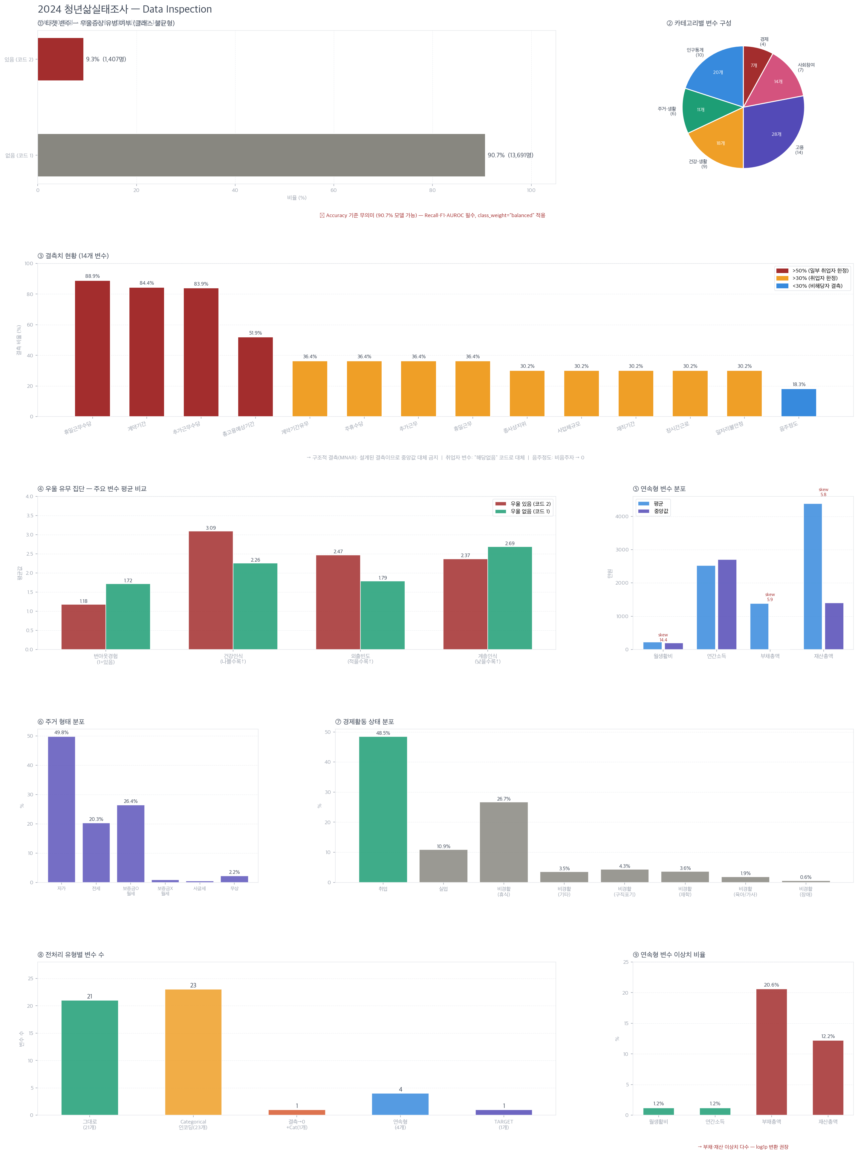

3.2 Missing Value Analysis
The missing value analysis showed very high missing rates in several labor-related variables. These are not simple nonresponses; rather, they are structural missing values caused by survey branching, where specific questions were presented only to employed respondents or respondents with relevant experience.
Variable | Missing Rate
Holiday Work Allowance | 88.9%
Employment Contract Period | 84.4%
Overtime Allowance | 83.9%
Expected Total Employment Period | 51.9%
Missing values in the drinking amount variable were also found to occur because the question was not applicable to nondrinkers.

3.3 Categorical Variable Analysis
The categorical variable analysis showed that nonsmokers accounted for the largest share at 67.1%, and unmarried respondents accounted for 84.9% of the total. In terms of housing tenure, owner-occupied housing had the highest proportion, and for economic activity status, employment had the highest proportion at 48.5%. These distributions reflect general characteristics of young adults and also indicate the possibility that future models may become biased toward dominant categories.


3.4 Continuous Variable Analysis
The continuous variables consist of monthly living expenses, annual youth income, total debt, and total assets. The analysis showed large differences between the mean and median for some variables, which suggests the influence of outliers and skewness.

Distribution of Continuous Variables
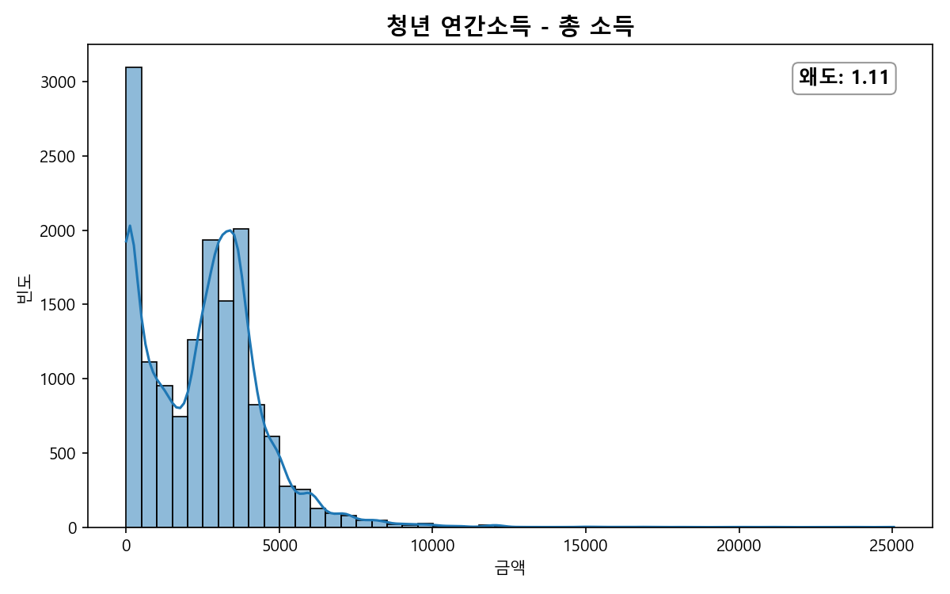
Annual Total Income
The skewness was 1.11, indicating a relatively moderate skew compared to the other economic variables. However, since the 0 won response and some high-income outliers exist together, distribution distortion was mitigated through log1p transformation, and the effect of outliers was further mitigated by applying RobustScaler
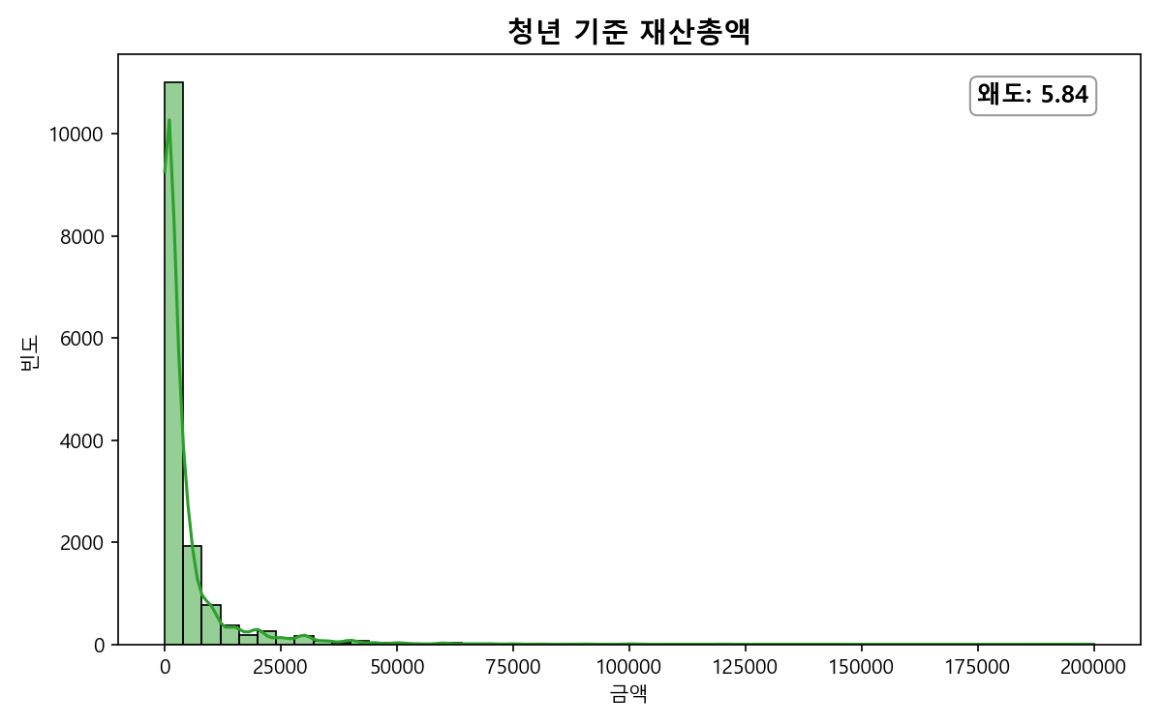
- Total Assets
  - The skewness value is 5.84, indicating a substantial imbalance between respondents with zero assets and respondents with large asset amounts.
  - To prevent information loss for respondents with zero assets, the np.log1p transformation was applied to reduce distributional distortion.
  - Afterward, RobustScaler was considered appropriate to prevent the model weights from being overly influenced by respondents with large asset amounts.

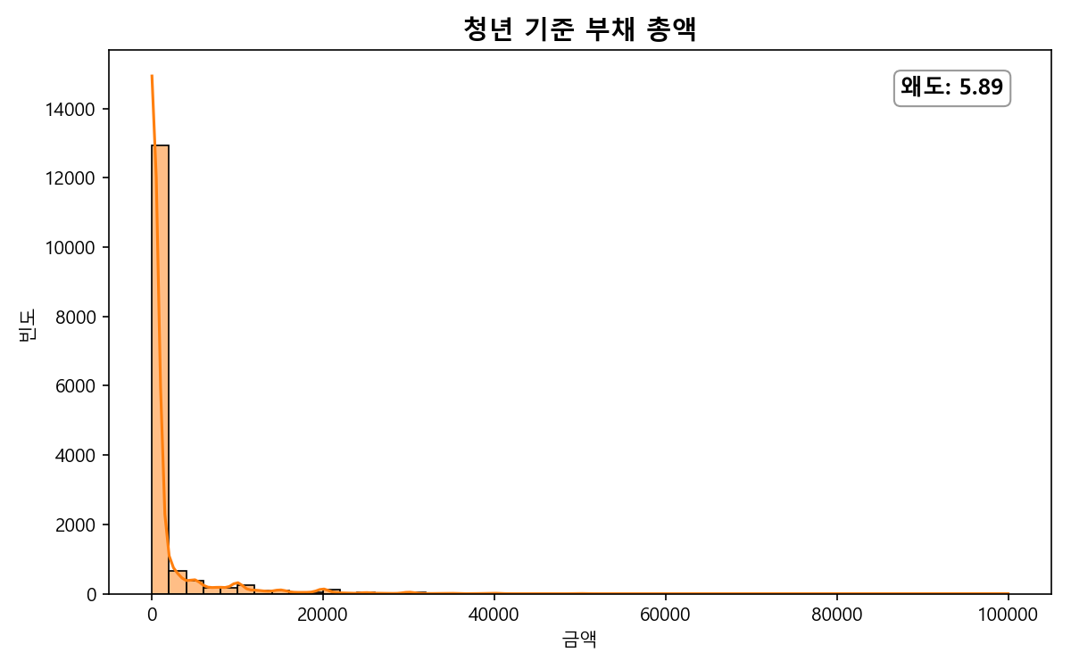
- Total Debt
  - The skewness value is 5.89. Although most respondents have no debt, a small number of respondents have large debt amounts.
  - To prevent information loss for respondents with zero debt, the np.log1p transformation was applied to reduce distributional distortion.
  - Afterward, RobustScaler was considered appropriate to prevent the model from being overly biased by respondents with large debt amounts.

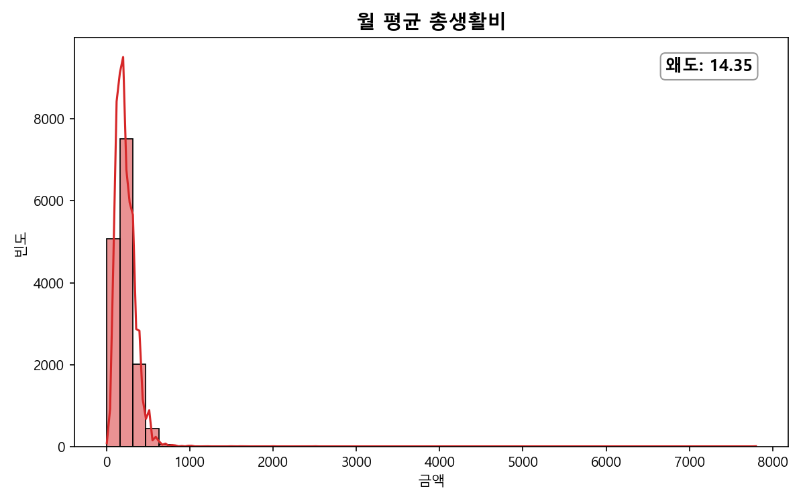
- Average Monthly Living Expenses
  - The skewness value is 14.35, indicating the most highly asymmetric distribution.
  - Most respondents fall within a certain range, but some respondents reported very high living expenses.
  - Therefore, the np.log1p log transformation was applied to reduce skewness.
  - Afterward, StandardScaler was considered appropriate to reduce differences in scale across variables.

3.5 Outlier and Skewness Analysis
The distribution of continuous variables showed high skewness in average monthly living expenses, total debt, and total assets. In particular, total debt and total assets showed strong skewness and relatively high outlier rates. Therefore, the log1p transformation was applied to variables with high skewness.


3.6 Group Comparison Analysis
Comparing key variable distributions by depressive symptom status showed that the depressive-symptom group tended to have lower self-rated health and was relatively vulnerable in terms of social relationships and frequency of going out. This suggests that mental health issues are not driven by a single factor but are associated with a combination of health perception, life patterns, social isolation, and economic conditions.
When comparing major variable distributions by depressive symptom status, the depressive-symptom group showed the following characteristics.
- Self-rated health was lower.
- The proportion of burnout experience was relatively higher.
- Some differences were also observed in economic variables.
These results suggest a possible relationship between mental health, lifestyle, and economic status.


4. Data Preprocessing

4.1 Target Variable Transformation
Depressive symptom prevalence was transformed into a binary target variable for classification modeling. Since the original value 1 indicates no depressive symptoms and the original value 2 indicates depressive symptoms, the target was remapped to 0 = no depressive symptoms and 1 = depressive symptoms for model training.

4.2 Removal of Unnecessary Columns
The purpose of this project is not simply to identify variables directly associated with depressive symptoms, but to analyze the characteristics of youth groups at high risk of depressive symptoms and identify groups that require policy support.
Therefore, the variable "burnout experience in the past year" was excluded from the analysis. Burnout and depressive symptoms are likely to have a very direct relationship, and people who experienced burnout may also show depressive symptoms. However, such a result alone has limitations in determining which groups should receive policy resources.
For example, the finding that "depressive symptoms are higher among those who experienced burnout" does not sufficiently explain the following.
- What kinds of life patterns these individuals have
- What economic characteristics these individuals have
- What social environments these individuals are in

Therefore, the burnout variable was removed in order to conduct a more structural analysis of vulnerable groups.

4.3 Missing Value Handling and Feature Engineering
Because this is survey data, many missing values arise from conditional survey questions.
The main reasons for missing values are as follows.
Cases where respondents could not answer because they were not currently employed
- Overtime work, holiday work, overtime allowance receipt, and related items
Cases where respondents could not answer because they were nondrinkers
- Drinking amount
To address this issue, missing values were handled as follows.
For work-related ordinal variables
- Not employed -> 0
- Actual response values -> values of 1 or higher
They were mapped in this form.
However, in this case, the model may interpret "not employed (0)" and "the minimum actual response level (1)" as a simple continuous relationship. For example, although "not employed" and "not doing overtime" have different meanings, the model may treat the two values as adjacent states.
To compensate for this issue, a derived feature indicating current employment status was added.
- Currently employed -> 1
- Not employed -> 0
This allowed the model to more clearly distinguish between non-employed respondents and respondents with actual work-related responses.
For work-related nominal variables, missing values were replaced with the "not applicable" category and then One-Hot Encoding (OHE) was applied. This allowed the non-employed status itself to be used as categorical information.

4.4 Ordinal Variable Processing
Ordinal variables representing frequency, level, or intensity were converted into numerical values while preserving their ordinal information.
In particular, they were remapped so that higher values indicate higher frequency, intensity, or level.
Examples include the following.
- Frequency of Going Out
- Level of Political Interest
- Smoking Status
- Drinking Frequency
- Subjective Class Perception
In the original data, some of these variables assigned lower values to higher levels, or placed "not applicable" as the highest value. Therefore, the variables were remapped so that higher levels correspond to larger values.
This allowed the model to reflect the ordinal information of the variables.

4.5 Nominal Variable Processing
One-Hot Encoding (OHE) was applied to categorical variables without an inherent order.
Examples include the following.
- Gender
- Region
- Marital Status
- Economic Activity Status
- Current Relationship Status
- Overtime Allowance Receipt Status
These variables were converted into independent dummy variables.
This prevented the model from incorrectly learning an artificial magnitude relationship among categories.

4.6 Continuous Variable Transformation and Scaling
Continuous variables such as income, debt, and assets showed large variability and outliers.
Therefore, the log1p transformation was applied to the following variables.
- Youth Annual Income - Total Income
- Total Debt of Youth Respondent
- Total Assets of Youth Respondent
- Average Monthly Living Expenses
This reduced skewness.
Next, scaling was applied for the Logistic Regression model to reduce differences in scale among variables.
- Variables strongly affected by outliers -> RobustScaler
- General ordinal and continuous variables -> StandardScaler
In contrast, Random Forest is a tree-based model and is relatively less affected by scaling, so no separate scaling was applied.
In addition, dummy variables generated by One-Hot Encoding were excluded from scaling because they already consist of 0/1 values.

4.7 Algorithm-Specific Scaling and Code Separation
In this project, different scaling strategies were applied depending on the characteristics of each machine learning algorithm.
- For Logistic Regression, economic indicators such as income, debt, and assets can be strongly affected by extreme outliers, so the median-based RobustScaler was applied. For general ordinal and continuous variables, StandardScaler was applied to reduce scale differences and enable stable learning.
- For Random Forest, because it is a decision tree-based ensemble model, splits are based on relative ordering among variables rather than their absolute scale. Therefore, scaling was considered to have relatively little effect and was not applied separately.
- In addition, to improve usability and code maintainability, the preprocessing pipelines for Logistic Regression and Random Forest were separated inside the function. This made it possible to apply algorithm-specific preprocessing independently to the same dataset.

5. Modeling and Evaluation

5.1 Classification Model Overview
This project used Logistic Regression (LR) and Random Forest (RF) models to analyze the relationship between youth life, economic, health, and social characteristics and depressive symptom prevalence. Because both models can provide feature importance or interpretable coefficients, they were considered suitable not only for prediction but also for identifying key factors.
First, classification models were built using Logistic Regression and Random Forest to predict depressive symptom prevalence. Then, based on feature importance calculated from each model, the top 15 features with key influence on depressive symptom prediction were extracted. Finally, the top 10 features for clustering were selected, focusing on features that were commonly important in both models.
Because the dataset has class imbalance in depressive symptom prevalence, stratified splitting and class_weight="balanced" were applied to reduce underlearning of the minority class. Since this project prioritizes not missing individuals with actual depressive symptoms, model performance was evaluated mainly using Recall and F1-score rather than Accuracy.

5.2 Logistic Regression

5.2.1 VIF Analysis of the LR_FULL Model
VIF (Variance Inflation Factor) analysis was conducted on the LR_FULL model to examine multicollinearity. In general, a VIF value of 10 or higher indicates severe multicollinearity, and values above 5 may also require attention.
The results showed that all VIF values for work-related numerical columns were below 5, mostly ranging from 2 to 4. This means that the detailed work-related variables do not have strong linear dependency, and multicollinearity was not considered severe.
Therefore, including detailed work-related columns in LR_FULL was not expected to create multicollinearity severe enough to make the model unstable.
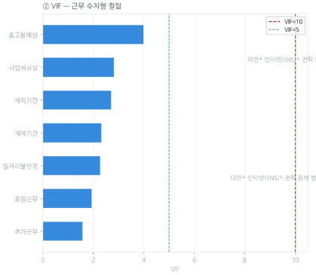

5.2.2 Comparison of LR_FULL and LR_WORK
LR_FULL, which uses all columns, was compared with LR_WORK, which removes detailed work-related columns and retains only current employment status, to examine whether the detailed work-related columns meaningfully affect model performance.
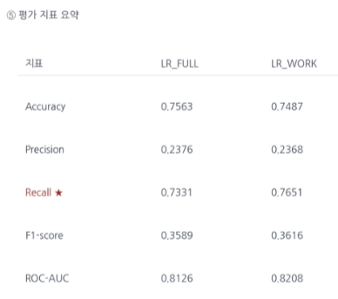
The comparison showed that LR_WORK performed better in Recall (0.765 vs. 0.733) and AUC (0.821 vs. 0.813), while LR_FULL showed slightly higher Accuracy and Precision. However, because detecting the actual depressive-symptom group is important in this project, Recall and overall classification performance were given greater importance.
Overall, the performance difference between the two models was small, and including detailed work-related columns did not lead to meaningful performance improvement. Therefore, LR_WORK was used in subsequent Logistic Regression analysis to reduce unnecessary variables and improve interpretability and simplicity.

5.2.3 C-Value Tuning Results (Optimal C = 0.01)
Using LR_WORK as the baseline, Grid Search was conducted over the C parameter to find a more appropriate Logistic Regression model. The candidate values were [0.001, 0.01, 0.1, 1, 10].
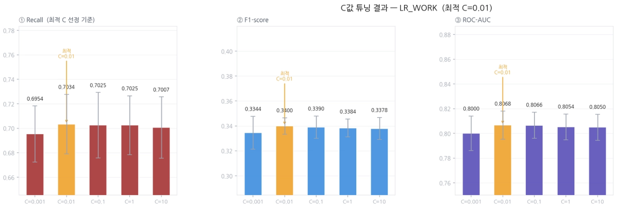
Among the five C values, C = 0.01 achieved the best performance in Recall, F1, and AUC, and was therefore selected as the optimal C value.

The performance of the optimized model with C = 0.01 is as follows.
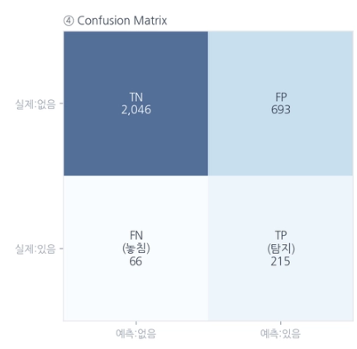
- Recall: 0.765 - approximately 7.7 out of 10 actual depressive-symptom cases were detected
- FN (missed cases): 66 - 66 out of 281 actual depressive-symptom cases were not detected
- AUC: 0.821
Top 15 Feature Importance Based on the Optimized Model
In the LR analysis, One-Hot Encoding (OHE) separates a single variable into multiple columns. To analyze related columns as one variable-level importance score, the absolute values of coefficients belonging to the same variable were summed. To prevent variables with more categories from being overly favored, the summed value was divided by the number of OHE columns to calculate the final feature importance.
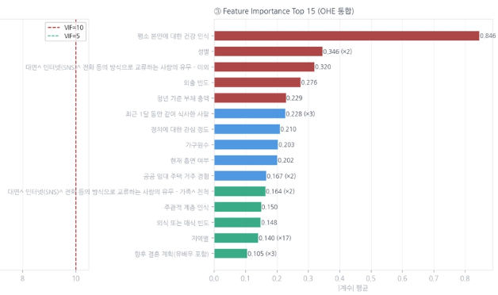

5.3 Random Forest
Notebook used: modeling_evaluation_Jang.ipynb

Random Forest is an ensemble model that combines multiple Decision Trees and can capture nonlinear relationships and interactions among variables. It can also produce feature importance, making it suitable for comparing key variables with Logistic Regression.

5.3.1 Baseline Model
The initial Random Forest model was trained using the default settings.
- Accuracy: 0.9093
- Recall: 0.0412
- F1 Score: 0.0780
- Precision: 0.7362

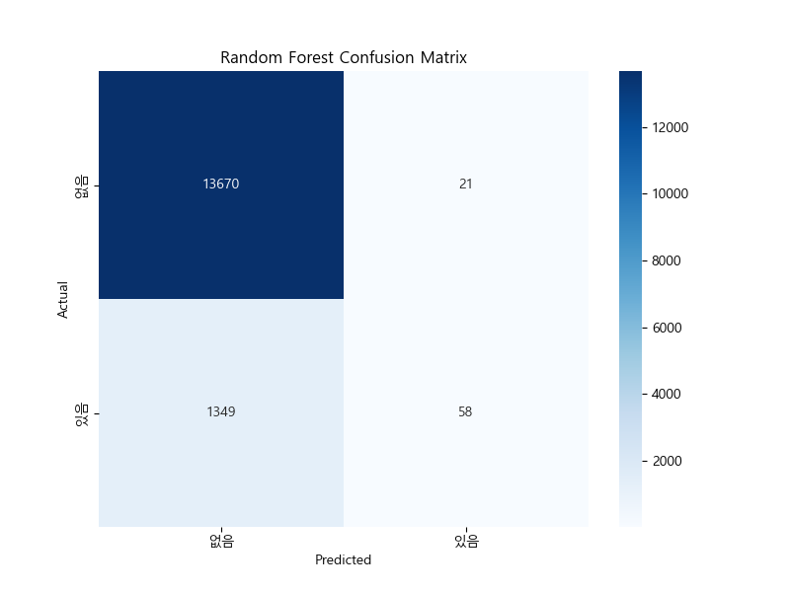
Figure 13. Baseline Random Forest confusion matrix
As a result, Accuracy was high at 0.9093, but Recall was only 0.0412. This means that the model failed to detect most actual depressive-symptom cases and predicted most observations as "no depressive symptoms." In other words, the model was biased toward the majority class due to class imbalance.
Precision was high at 0.7362 because the model predicted depressive symptoms only when it was highly confident. However, because it detected very few actual depressive-symptom cases, it was considered unsuitable for the objective of this project.

5.3.2 Hyperparameter-Tuned Model
Because this project prioritizes not missing individuals with actual depressive symptoms, model performance improvement focused on Recall and F1-score.
The following methods were applied.
- StratifiedKFold was used to preserve the class ratio in each fold.
- class_weight="balanced" was applied to increase the learning weight of the minority class (depressive symptoms).
In addition, the following hyperparameters were tuned using Grid Search.
- Number of trees (n_estimators)
- Maximum depth (max_depth)
- Minimum samples for splitting (min_samples_split)
The optimal hyperparameter combination was searched.
As a result, the following combination was selected as the optimized model.
- Decision Threshold = 0.23
- Number of trees = 200
- Maximum depth = unlimited
- Minimum samples for splitting = 5
- class_weight = "balanced"
The model performance is as follows.
- Accuracy: 0.8536
- Recall: 0.5153
- F1 Score: 0.3961
- Precision: 0.3217
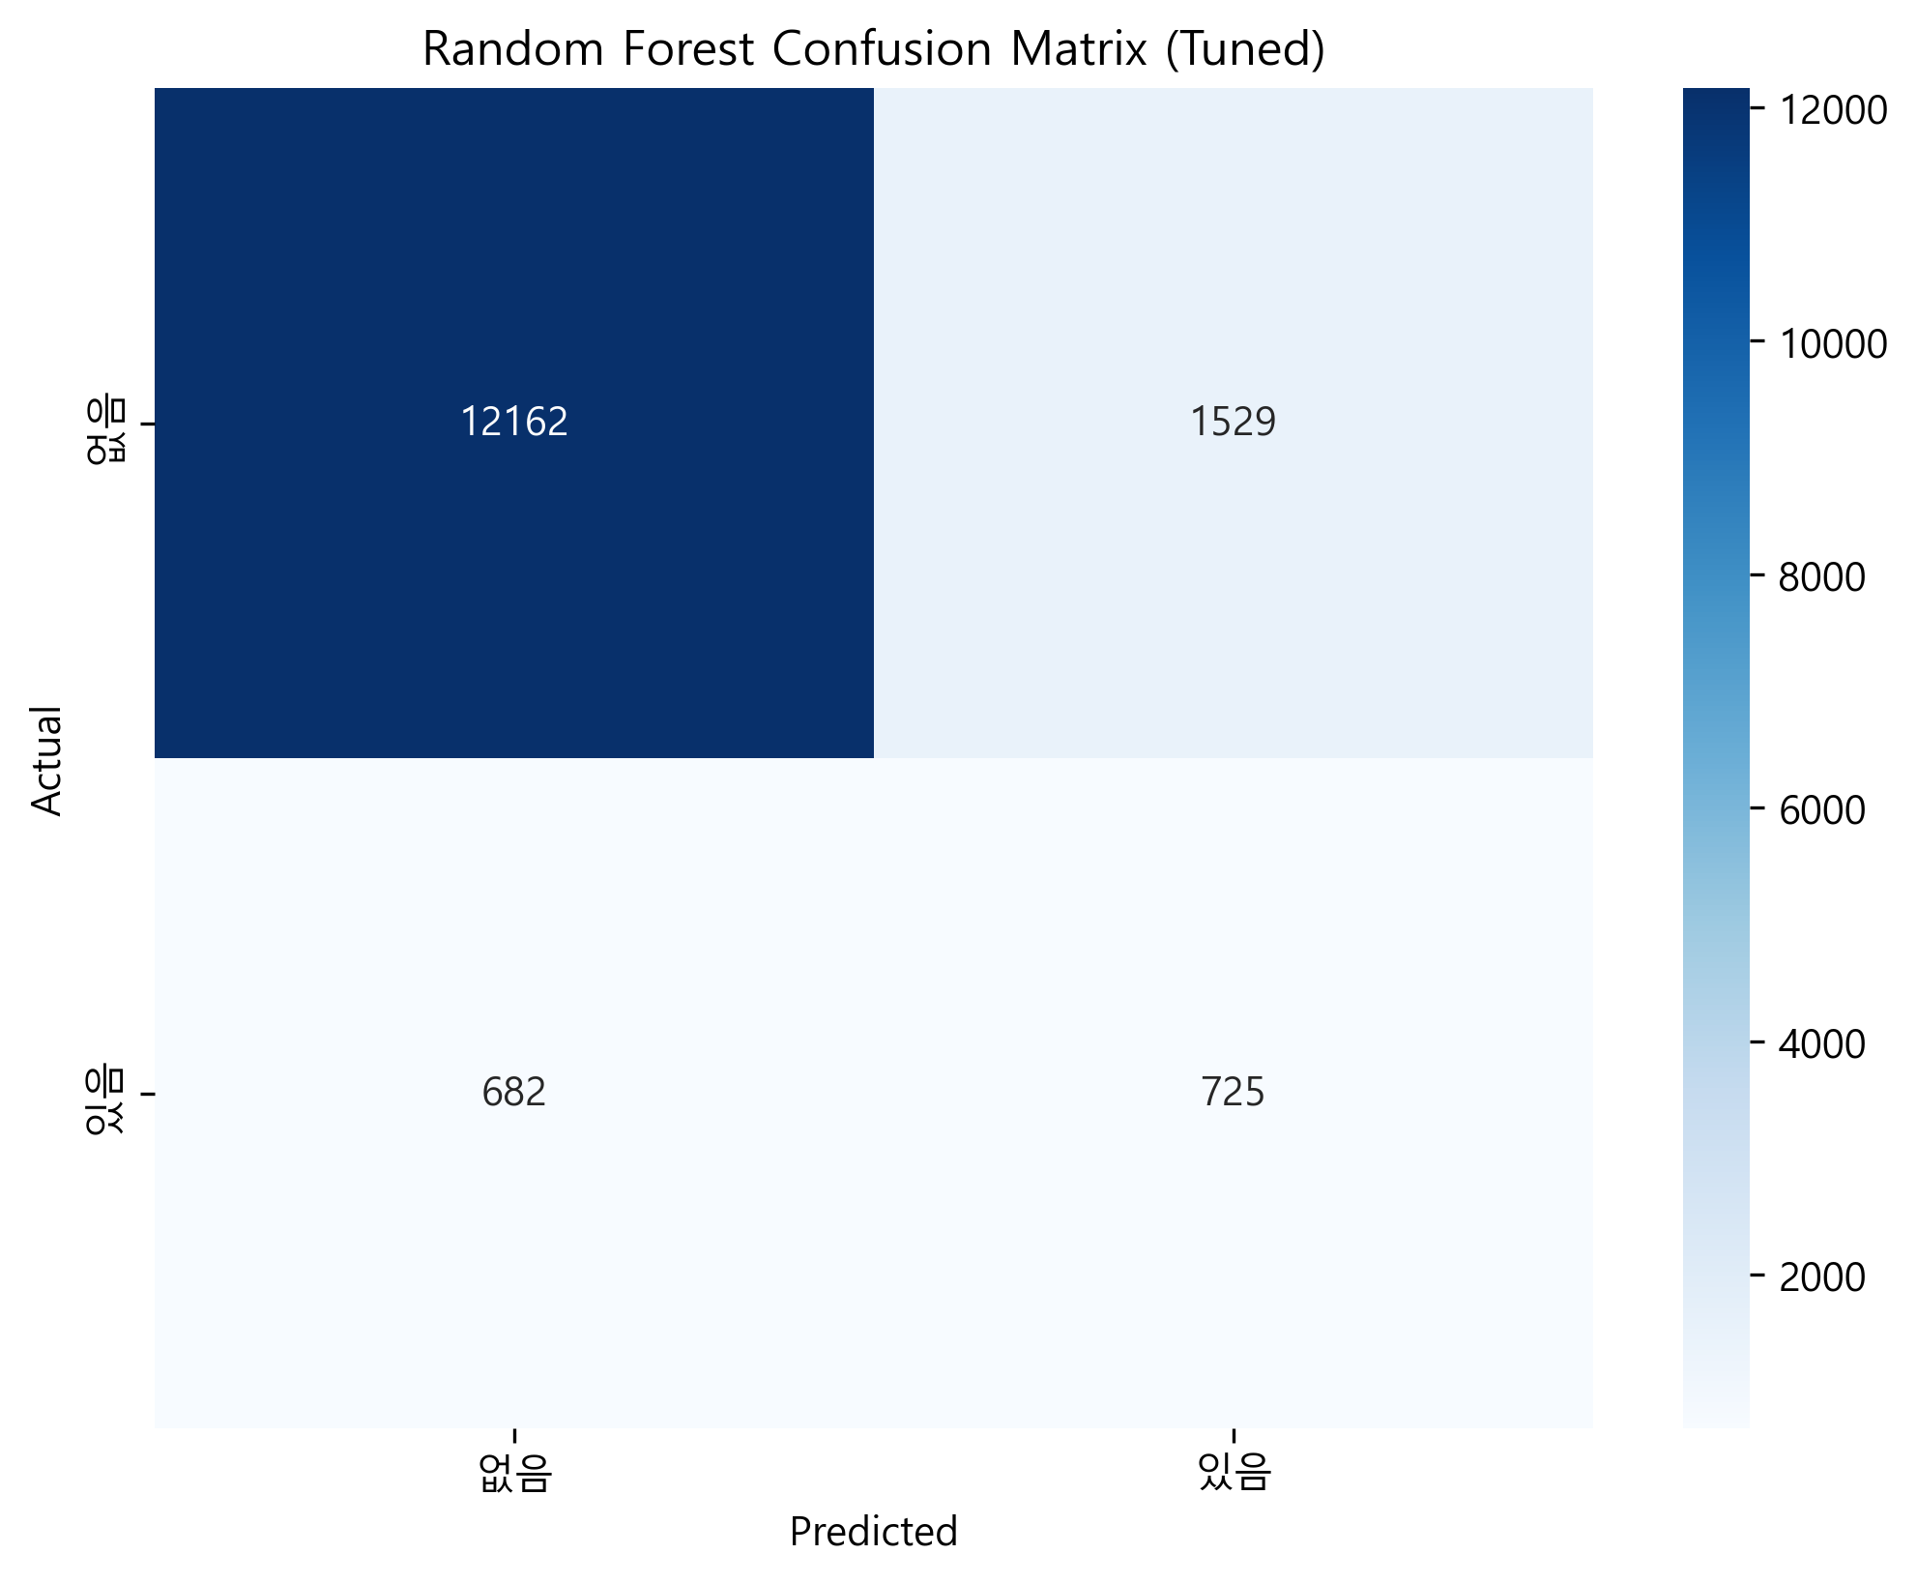
After hyperparameter tuning, Recall increased substantially from 0.0412 to 0.5153. This means that the tuned model was able to detect more than half of the depressive-symptom cases that the baseline model had barely detected.
In contrast, Accuracy decreased from 0.9093 to 0.8536. This occurred because False Positives increased as the model became more aggressive in detecting depressive-symptom cases. However, because this project values detecting actual depressive-symptom cases more than simple Accuracy, this trade-off is considered reasonable.
F1-score also increased from 0.0780 to 0.3961, indicating an improved balance between Recall and Precision.

5.3.3 Feature Importance Based on the Optimized Model
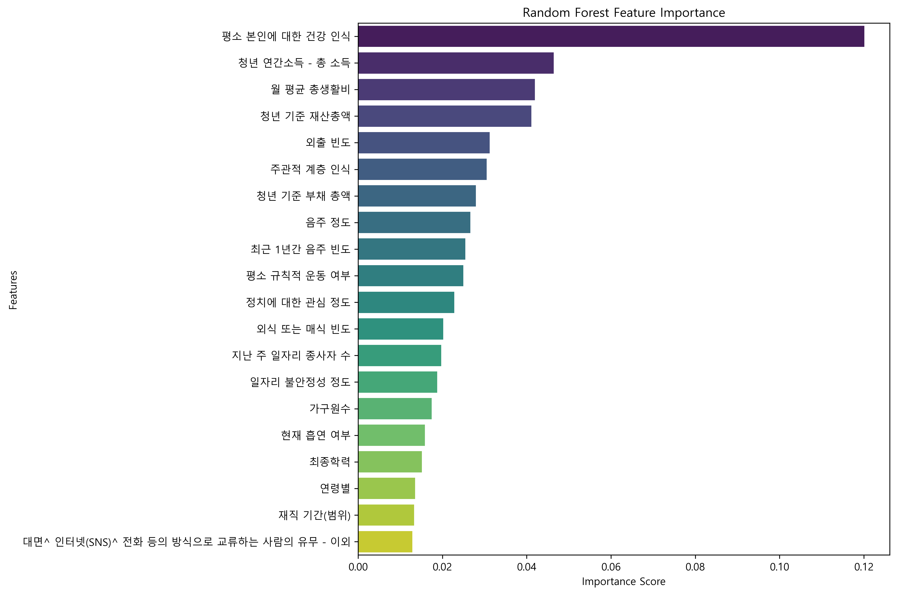

6. Feature Importance Analysis

6.1 Selection of the Top 10 Features
The final features selected based on the top features from both models are as follows.
- Self-Rated Health Status
- Frequency of Going Out
- Total Debt of Youth Respondent
- Level of Political Interest
- Household Size
- Subjective Class Perception
- Frequency of Eating Out or Buying Prepared Meals
- Gender
- Presence of Social Interaction Through Face-to-Face, Internet/SNS, or Phone - Others
- Main Meal Companion During the Past Month

6.2 Criteria for Selecting the Top Features

6.2.1 Features Commonly Included in the Top 15 of Both Models
The following seven features were commonly included in the top 15 features of both models.
- Self-Rated Health Status
- Frequency of Going Out
- Total Debt of Youth Respondent
- Level of Political Interest
- Household Size
- Subjective Class Perception
- Frequency of Eating Out or Buying Prepared Meals
Because these features were important in both Logistic Regression and Random Forest, they were prioritized for clustering analysis.

6.2.2 Remaining Features Selected Based on Logistic Regression Importance
To complete the top 10 feature set, the remaining three features were selected based on the feature importance ranking from Logistic Regression. This is because the Logistic Regression model achieved higher Recall in predicting depressive symptom prevalence.
Excluding the common features, the following three features had high importance in Logistic Regression.
- Gender
- Presence of Social Interaction Through Face-to-Face, Internet/SNS, or Phone - Others
- Main Meal Companion During the Past Month

7. Clustering Analysis

7.1 Objective of Clustering Analysis
In this stage, K-Means clustering was performed using the 10 key features selected from the previous classification models (Logistic Regression and Random Forest) to segment young adults according to similar life and environmental characteristics.

7.2 K-Means Clustering
Search for the Optimal Number of Clusters (K)
Quantitative indicators were examined by varying K from 2 to 10. After jointly evaluating the Elbow Point, where within-cluster variance decreases, and the Silhouette Score, which measures cluster cohesion and separation, K = 3 was selected as the optimal number of clusters because it achieved the highest Silhouette Score (0.136).
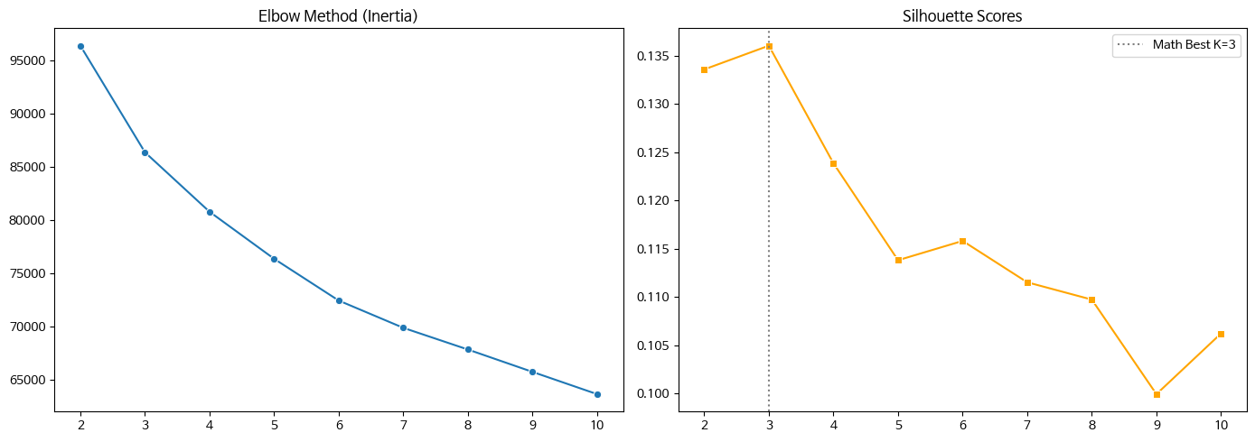Although the Silhouette Score was relatively low at 0.136, the clustering result was still considered meaningful for the purpose of this study. The objective of clustering in this project was not to discover perfectly separated natural clusters, but to segment youth groups according to key life, economic, and social characteristics. Therefore, K=3 was selected based on a comprehensive consideration of both the Elbow Point and the Silhouette Score.

7.3 High-Risk Cluster Analysis

7.3.1 Identification of the Depression High-Risk Group
After completing clustering with K = 3, the unsupervised cluster labels were combined with the observed target variable (depressive symptom prevalence) to calculate the prevalence rate for each cluster.
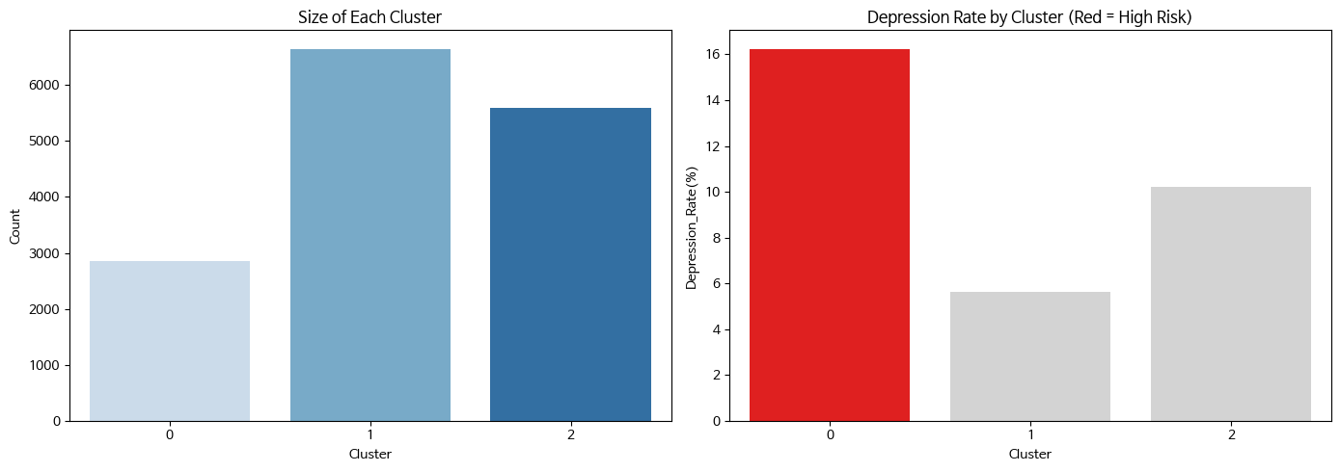
The analysis showed that Cluster 0 had the highest depressive symptom prevalence rate (16.24%) among all clusters. Therefore, Cluster 0 was identified as the depression high-risk group and was analyzed in depth.

7.3.2 Full Descriptive Comparison Based on Summary Statistics
To examine how the identified depression high-risk group (Cluster 0) differs environmentally and structurally from the other general youth clusters, a full descriptive comparison was conducted between the high-risk group and the remaining clusters using all variables in the dataset (X_all).
In this analysis, the comparison method was divided into two approaches to prevent bias caused by differences in variable scales (scale distortion).
- Categorical variables: The difference in category-level proportions between the two groups was calculated. After mathematically removing symmetric duplicate derived variables, the top five key variables with the largest pure proportion differences were selected.
- Ordinal and numerical variables: Based on the scaled data, mean differences between the two groups were calculated, and the top five key variables with the largest gaps were selected.

The key features that showed large differences between the high-risk group and the remaining clusters are as follows.
- Frequency of going out: The high-risk group showed a relatively lower frequency of going out than the general groups.
- Degree of job insecurity: The high-risk group showed a relatively lower perception that they could easily find a job with a similar income level even if they quit or lost their current job.
- Employment tenure: The high-risk group had a relatively shorter average employment tenure.
- Number of workers at the workplace last week: The high-risk group showed a relatively lower level of job participation.
- Youth annual income (total income): The high-risk group had a relatively lower average income level.
- Experience of working at least one hour for income last week: The proportion with this experience was lower than in the general groups.
- Employment status last week - Not applicable: The high-risk group had a relatively higher proportion of "not applicable" responses.
- Existence of employment contract period - Not applicable: The high-risk group had a relatively higher proportion of "not applicable" responses.
- Long working-hours experience: The proportion of long working-hours experience was relatively lower.
- Economic activity status: The level of participation in economic activity was relatively lower.
The visualization results for the top four features are as follows.
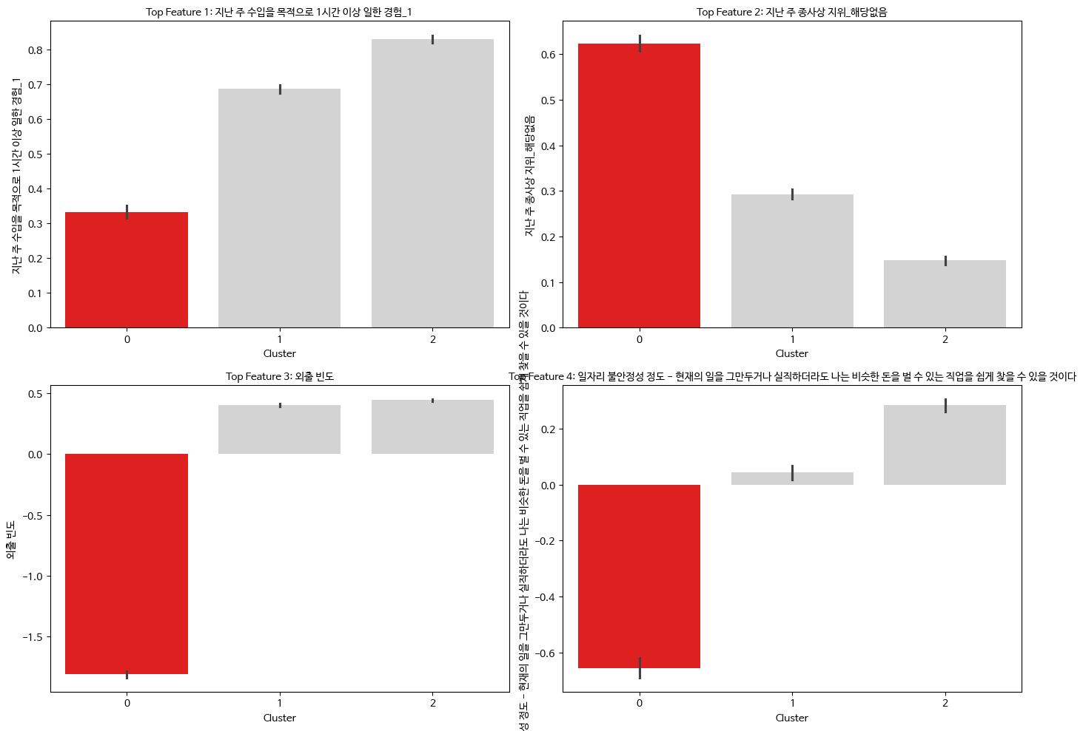

7.3.3 Final Persona Summary of the Depression High-Risk Group
1. Low Frequency of Going Out
The high-risk group showed a lower frequency of going out compared with other clusters. This suggests that the high-risk group tends to have relatively low levels of outdoor and social activity participation.
2. Low Level of Economic Activity Participation
In the high-risk group, various economic activity-related variables such as employment tenure, income level, and participation in economic activity showed generally lower values. This suggests that the high-risk group may be relatively vulnerable in terms of economic activity participation and employment stability.

8. Policy Implications and Deployment Plan
The depression high-risk group showed generally low frequency of going out and low levels of social and economic activity participation. In particular, the large differences observed in work-related variables suggest that the high-risk group may be relatively vulnerable in terms of employment stability and participation in economic activity. The lower frequency of going out also suggests a possible association with lower social activity participation.
However, these results do not identify the direct causes of depressive symptoms or prove causality. It is also possible that depressive symptoms led to reduced participation in social and economic activities, or that the two factors influence each other. Nevertheless, the results are meaningful because they suggest that youth depressive symptoms may be closely connected to social and economic isolation.
Therefore, policies aimed at alleviating depressive symptoms among young adults should not be limited to psychological counseling support alone. They should also consider social and economic dimensions, such as expanding participation in social activities, supporting stable economic activity participation, and improving employment stability.

