Process/Insight

Some of the models that we tested were Linear Regression, Decision Tree Regressor, XGB and finally for our final model we opted with a LightGBM Regressor (LGBMR). LightGBM is a gradient boosting framework that uses a tree-based algorithm. The LGBMR is most similar to the popular ML algorithm that is XGBoost. The biggest difference being that while XGBoost splits the tree nodes one level at a time, the LGBMR splits one node at a time. LGBM also boasts more parameters, much faster speed, all with comparable accuracy metrics. After cleaning the data and applying NLP, fitting it through the pipeline, and doing hyperparamter optimization we have:

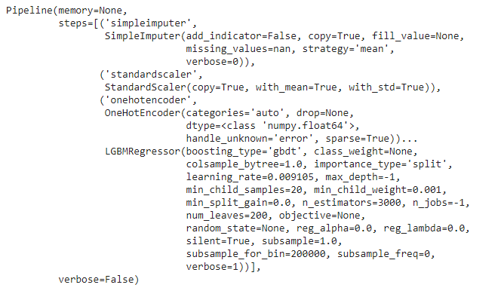

Some of the parameters that we spent the most time tuning were the learning_rate and n_estimators.

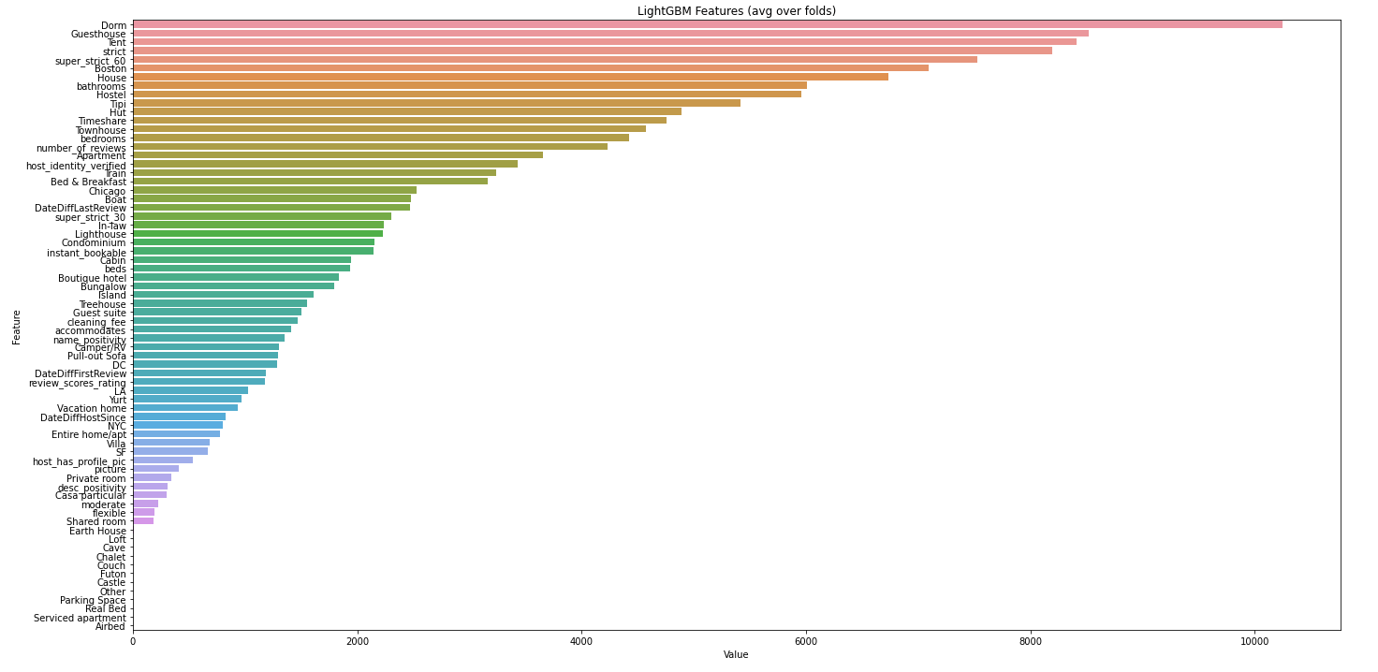

We were able to extract many features, some more useful than others. Here we can see the value of each feature in figuring out the optimal price for a given Airbnb. Some of the new created features that were not so evident in the base model include features such as: strict and super_strict_60. This makes sense because it shows that the cancellation policy is very telling when it come to predicting an Airbnb price. A super strict 60 day policy on an Airbnb would certainly imply a higher demand than properties with a much more lenient cancellation policy.