**Name: Dilpreet**

**ID: 3156915**

**Title: Software Requirement System**

**Task 1 - Identify the problem**

**Call Discussion with Client: Leo**

I am writing the matter call record with Leo. He has his software company. he needs a software to maintain the records of softwares. He wants to maintain all the parts in his business where he is facing so many problems to maintain the record. he always wastes so much time to find the maintain record on manually. so he has to face so many difficulties to maintain the record for future. So he needs an application for the record maintence.

**Task 2 - Define and document requirements**

Requirement of The Software

Scope of Work

*Features: I am going to create software of Software management System. Which will be fully automated and leo can maintain and store the data for future. He can see all the software and contract records through this application online. This application would be fully secure. Data will be saved in the future efficiently. And no unauthorized person can make changes in it. So Application would be very effective and efficiency.*

*Functional Requirements: Demanded requirements by end user:-*

1. *He wants software contract module save update and delete and list of customers to view.*
2. *Then he wants software contract category module in the software.*
3. *He wants task orders module in the software.*
4. *He wants the record of his labour.*
5. *He wants login and logout facility in the software.*

*Non-functional requirements:*

1. System should be secure.
2. System should be portable.
3. Performance of system should be good.
4. System should be flexible.
5. System should be reliable.

Time: It will take minimum 20 days to complete.

The 4 essential steps of the Risk Management Process are:

1. Identify the risk.
2. Assess the risk.
3. Treat the risk.
4. Monitor and Report on the risk.

Cost: $430

Project Management: project management has always been practiced informally, but it began to emerge as a distinct profession in the mid-20th century when a group of forward-thinking individuals from the aerospace, engineering, pharmaceutical, and telecommunications fields realized a changing world needed new tools.

**Task 3 - Design mockups**

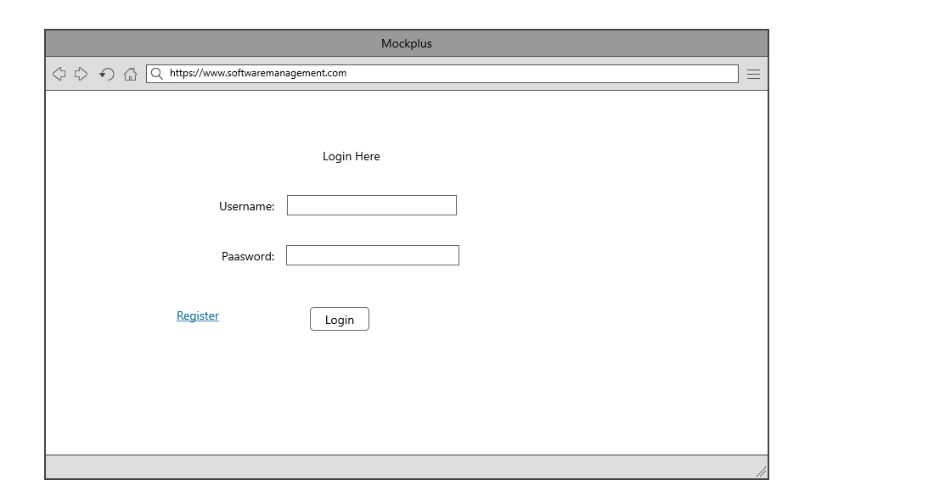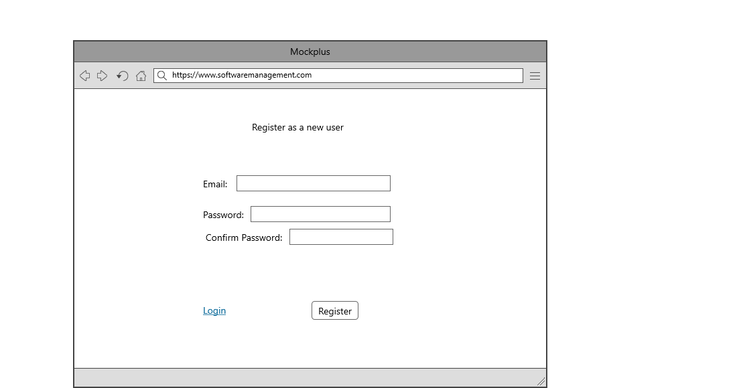

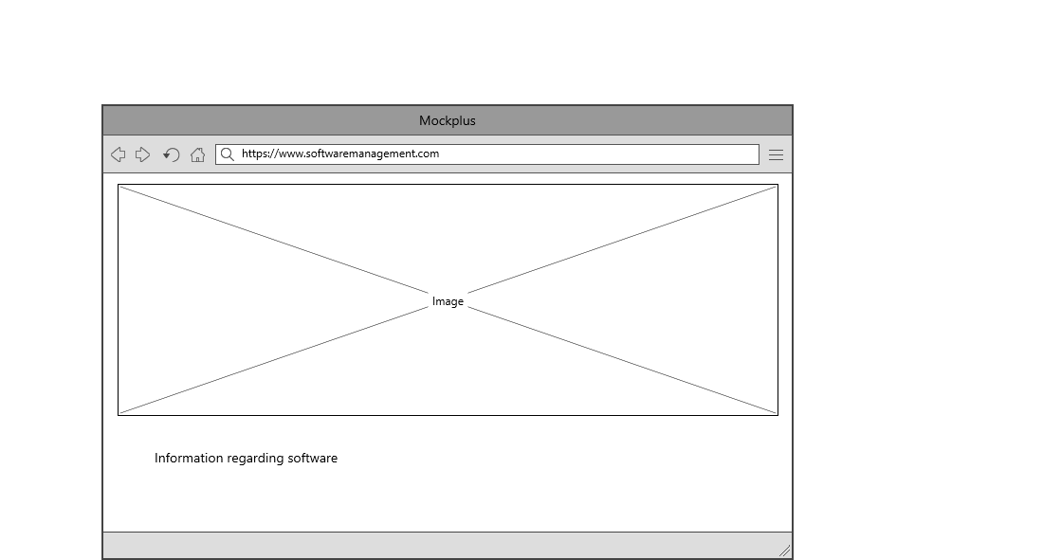

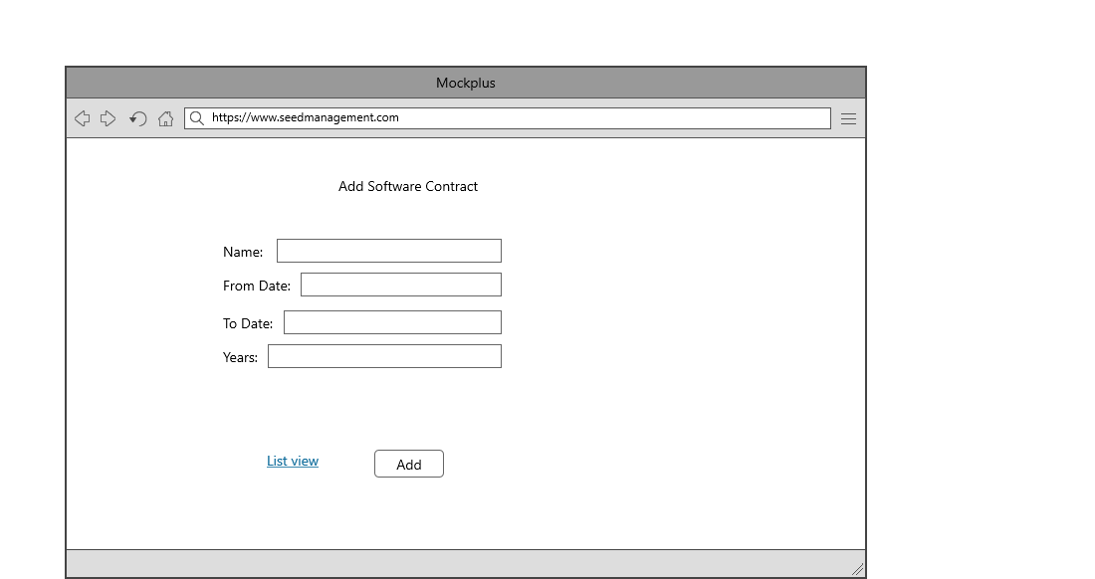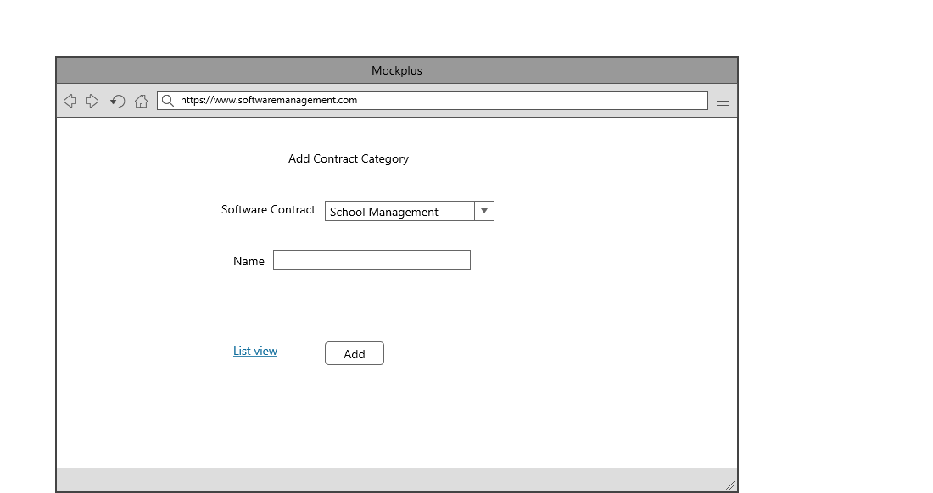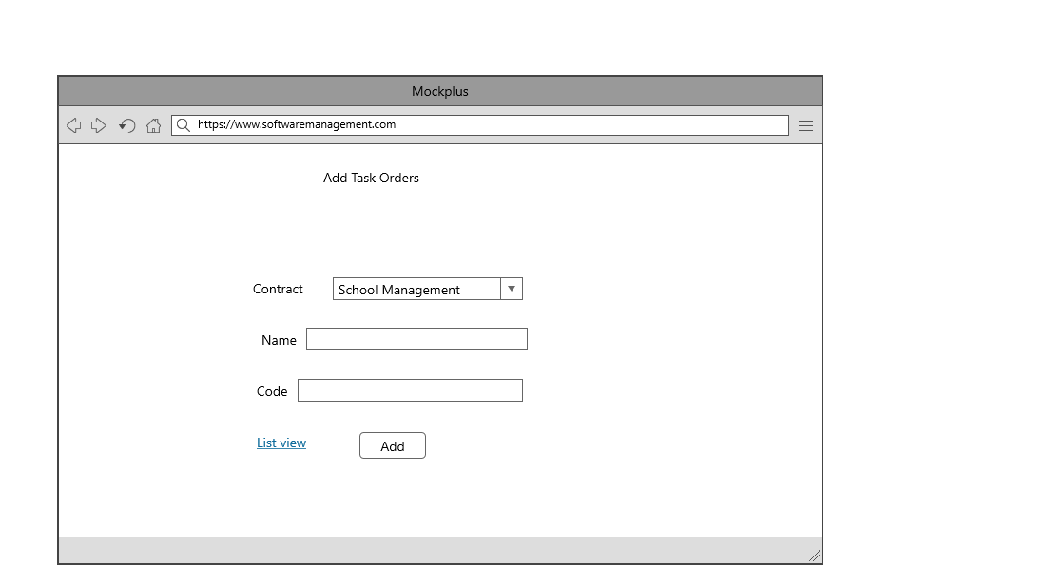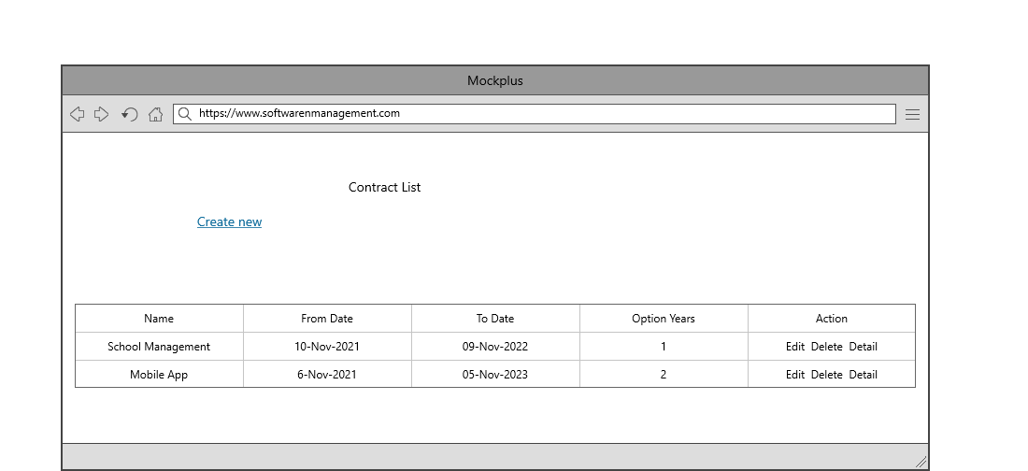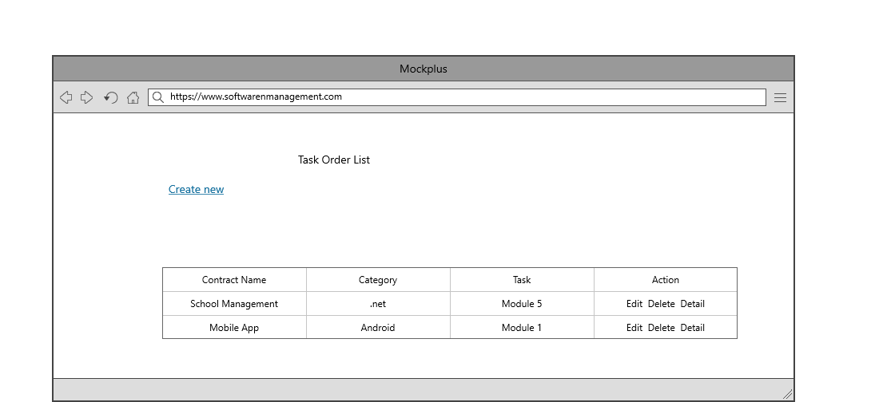

## Task 5- usability testing

|  |  |  |  |  |  |
| --- | --- | --- | --- | --- | --- |
| **User #** | **Login form** | **Contract form** | **Task Order Module** | **Pass / Fail / Not executed / Suspended** | **Reviews** |
| Leo | completed as expected | This module helps me to save the whole contracts | Task order is very helpful for save the records of Tasks orderwise. | Pass | Excellent work |
| Gurjinder | Very good | Whole contracts of our company we can solve here. | should some changes and expand more | Pass | All modules are marvellous |
| Satbir | looking good | This module is working as expected. | Nice | Pass | all modules are as expected |
| Jagbir | nice | This is very beneficial | Perfect | Pass | nice |

**Task 6 - Meet with your client**

Client Meeting:

|  |
| --- |
| Meeting Details |
| * Date and time: 25-Oct-2021 * Location: Newzealand |
| Attendees: Leo and Diljit |
| Agenda: Discussion of Software of Software management system |
| Discussion (Important Points): He wants neat and clean software which will work effectively |
| My To Dos (Actions): Firstly I have to make the mockups of the application. Then Starting the application after the next meeting. |
| Questions requiring Follow- Up: Discussion of the mock ups |
| Comments: Leo is good person and he described regarding software very wisely. |
| Next meeting  Date and Time: 5- Nov-2021 1:00 Pm  Location: Newzealand  Agenda: Showing the mock ups to the client and discussion about further development. |

**Task 7- Presentation**

<video1854046151.mp4>

**Task 8 - Software development life cycle stages**

**Planning :-** The first stage of SDLC is all about “What do we want?” Project planning is a vital role in the software delivery lifecycle since this is the part where the team estimates the cost and defines the requirements of the new software.

**Requirement :-** The second step of SDLC is gathering maximum information from the client requirements for the product. Discuss each detail and specification of the product with the customer. The development team will then analyze the requirements keeping the design and code of the software in mind. Further, investigating the validity and possibility of incorporating these requirements into the software system. The main goal of this stage is that everyone understands even the minute detail of the requirement. Hardware, operating systems, programming, and security are to name the few requirements.

**Software Design and prototyping :-** In the design phase (3rd step of SDLC), the program developer scrutinizes whether the prepared software suffices all the requirements of the end-user. Additionally, if the project is feasible for the customer technologically, practically, and financially. Once the developer decides on the best design approach, he then selects the program languages like Oracle, Java, etc., that will suit the software.

**Screenshots**

Login Page

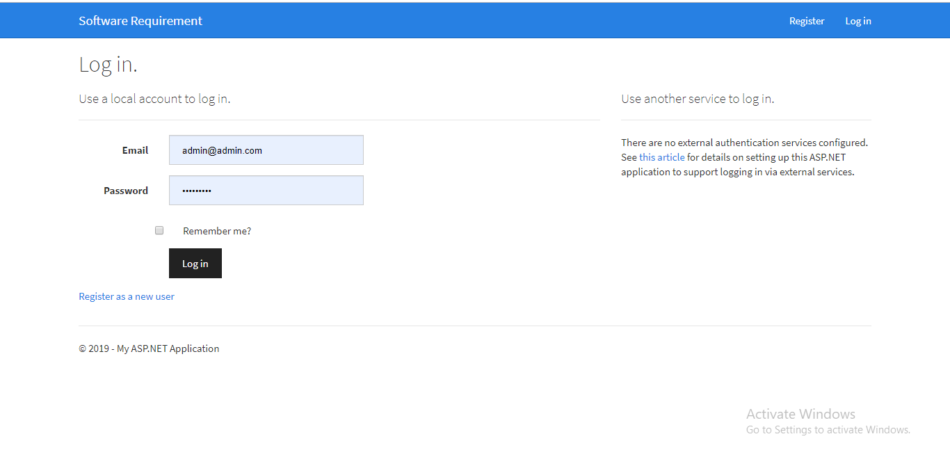

Dashboard Landing Page

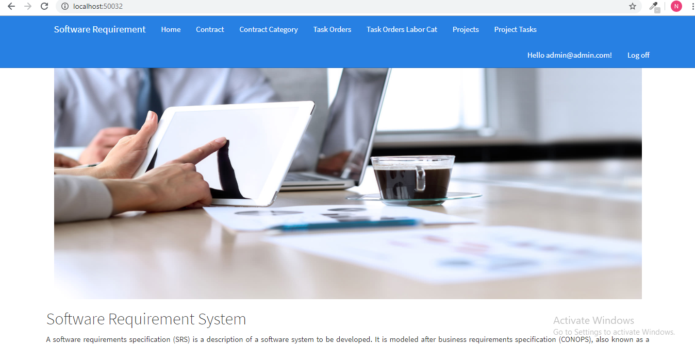

Contracts List

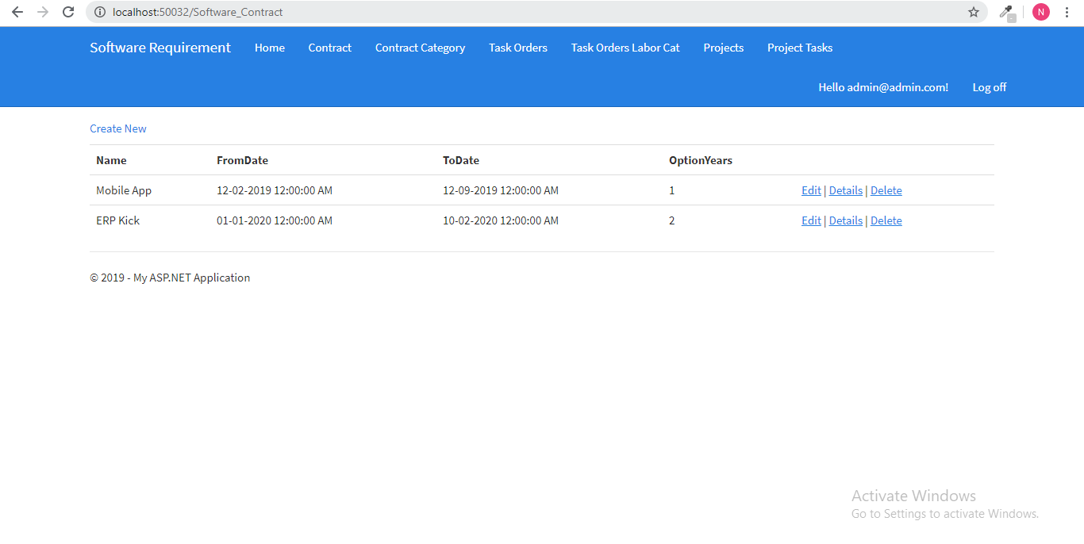

Create Contract

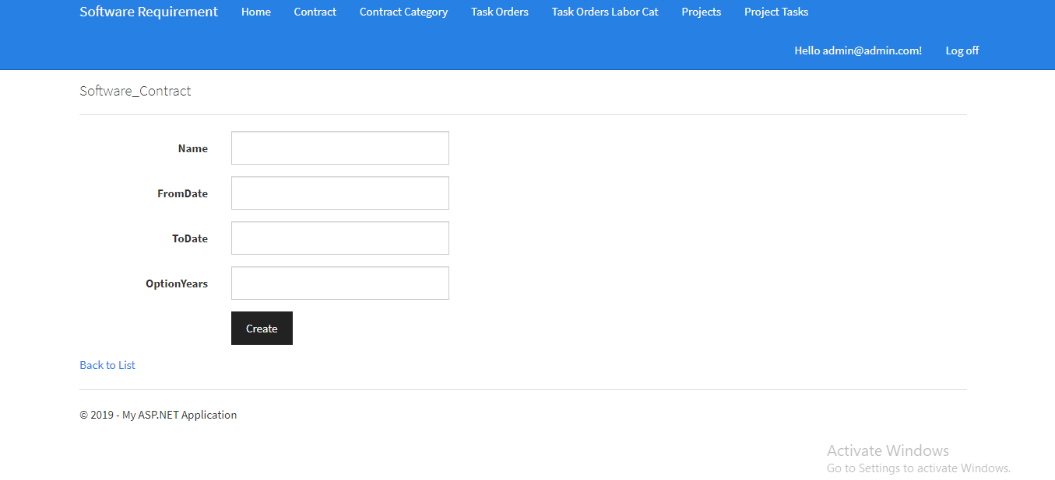

Contract Category

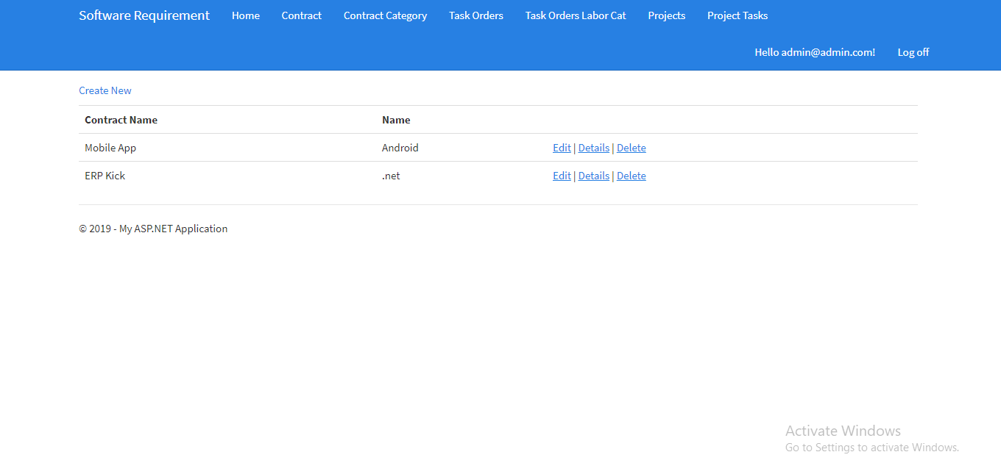

Create Contract Category

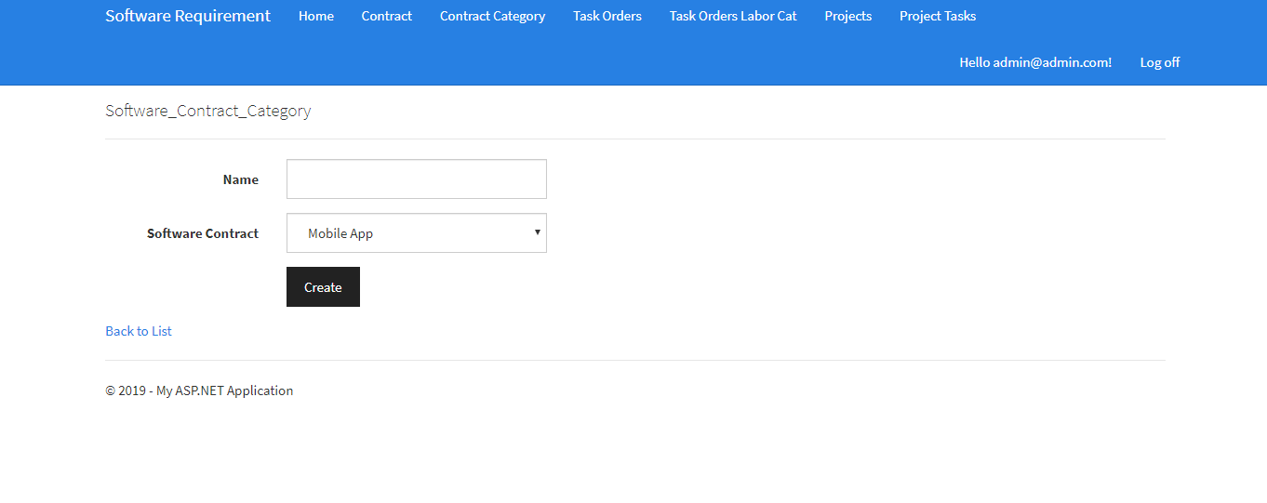

Task Order List

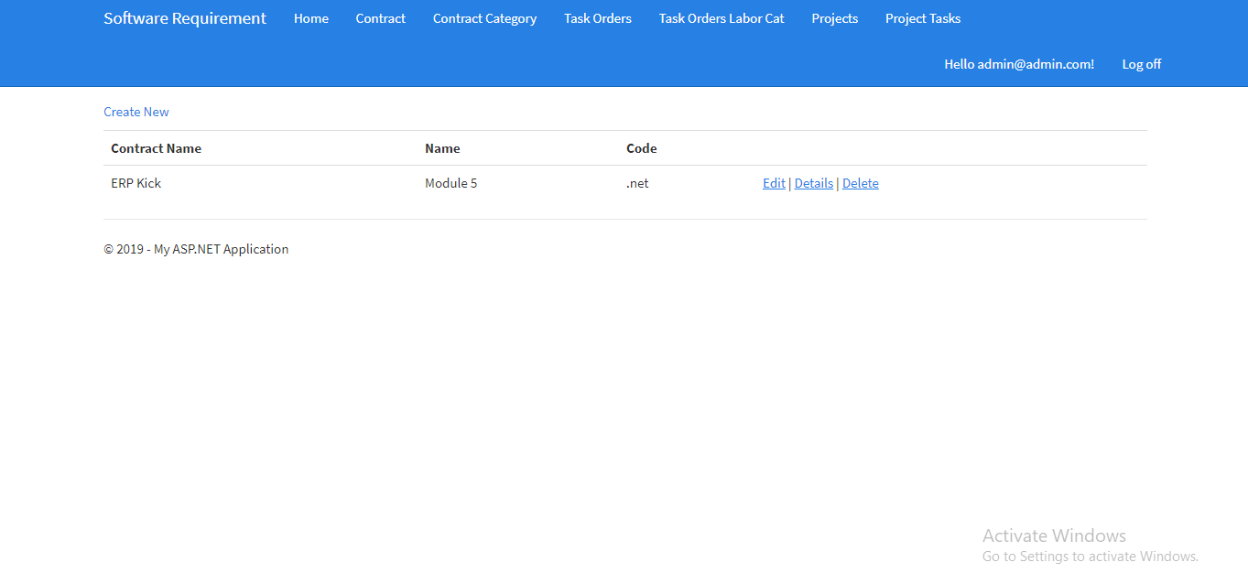

Create Task Order

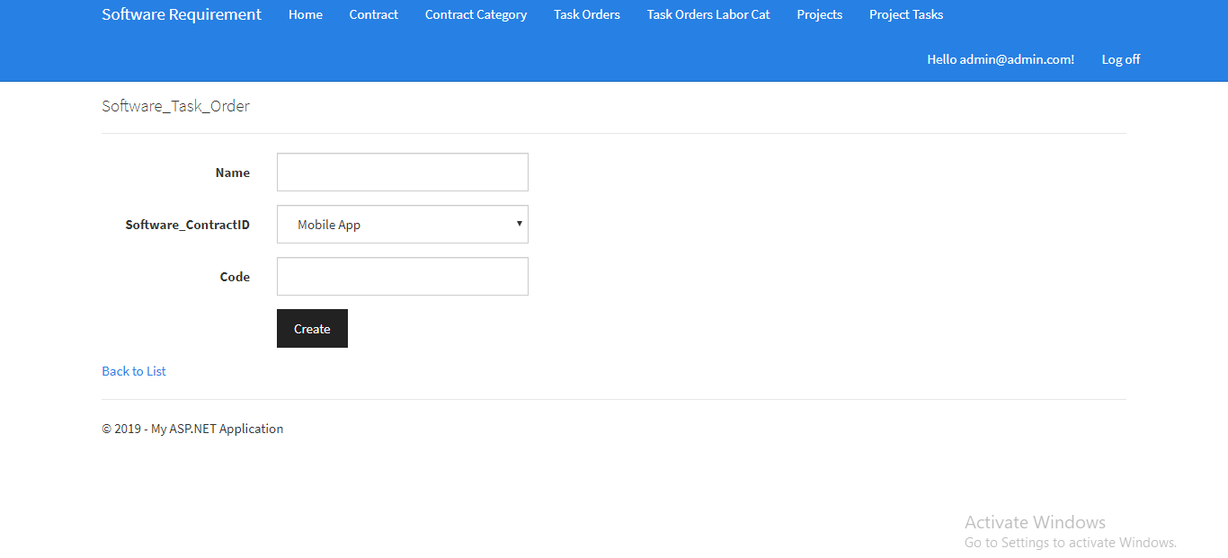

Labor Category Screen List

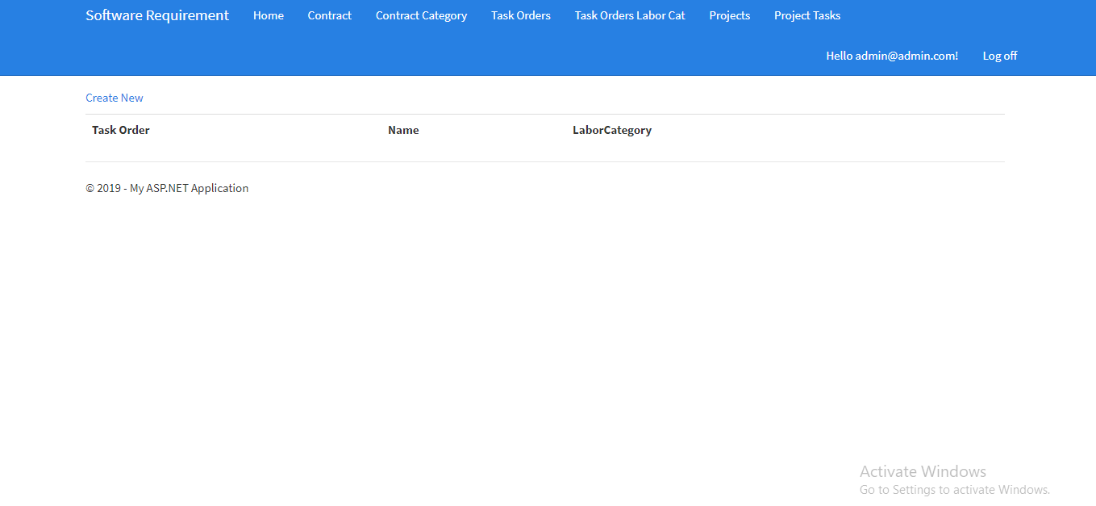

Add Labor Category

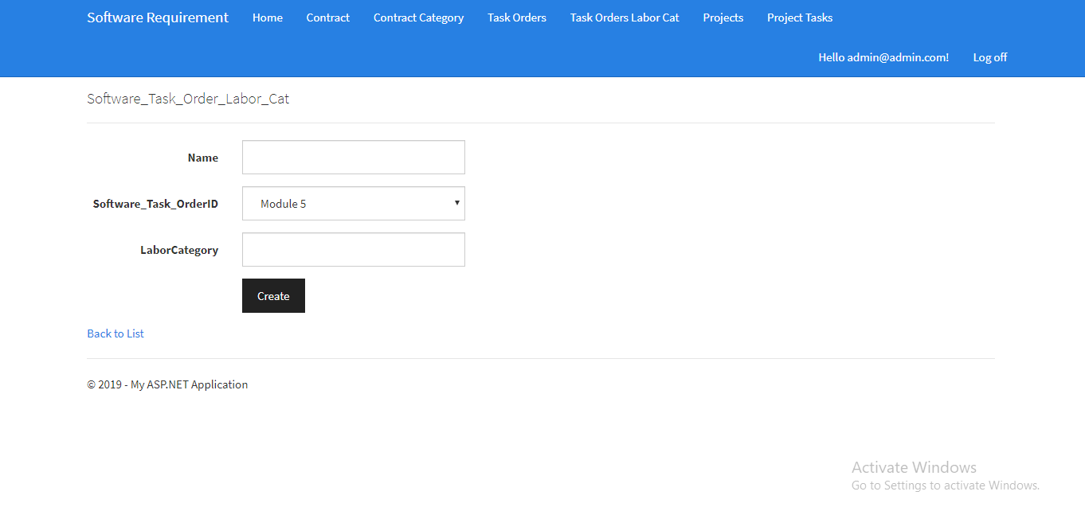

Project

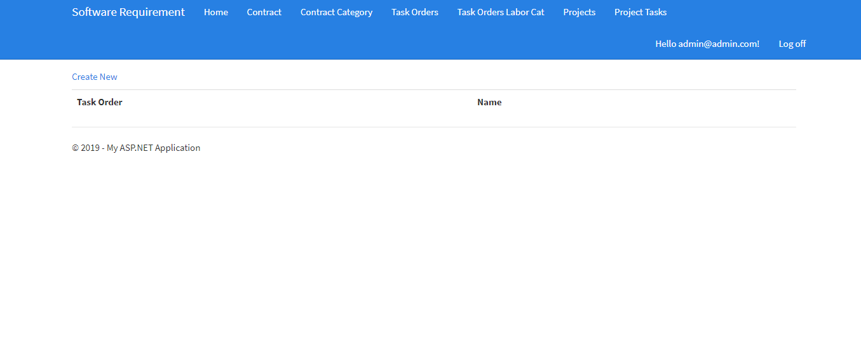

**Software Development:** Time to code! It means translating the design to a computer-legible language. In this fourth stage of SDLC, the tasks are divided into modules or units and assigned to various developers. The developers will then start building the entire system by writing code using the programming languages they chose. This stage is considered to be one of the longest in SDLC. The developers need certain predefined coding guidelines, and programming tools like interpreters, compilers, debugger to implement the code.

**Testing:** Once the developers build the software, then it is deployed in the testing environment. Then the testing team tests the functionality of the entire system. In this fifth phase of SDLC, the testing is done to ensure that the entire application works according to the customer requirements.

After testing, the QA and testing team might find some bugs or defects and communicate the same with the developers. The development team then fixes the bugs and send it to QA for a re-test. This process goes on until the software is stable, bug-free and working according to the business requirements of that system.

**Task 9- Project management**

In a project management guide, if you are somehow in a position where you are expected to manage projects for your organization and are feeling overwhelmed, it’s better to start learning the basic stages of the project life cycle phases.

The 5 basic phases which we implemented in our project management process are:

1. Project Initiation
2. Project Planning
3. Project Execution
4. Project Monitoring and Controlling
5. Project Closing

**Project initiation**

The project initiation phase is the first stage of turning an abstract idea into a meaningful goal. In this stage, you need to develop a business case and define the project on a broad level. In order to do that, you have to determine the need for the project and create a project charter.

**Project planning**

The project planning stage requires complete diligence as it lays out the project’s roadmap. Unless you are using a modern project management methodology like agile project management, the second phase of project management is expected to take almost half of the entire project’s timespan.

**Project execution**

The project execution stage is where your team does the actual work. As a project manager, your job is to establish efficient workflows and carefully monitor the progress of your team.

**Project monitoring and controlling**

In the project management process, the third and fourth phases are not sequential in nature. The project monitoring and controlling phase run simultaneously with project execution, thereby ensuring that objectives and project deliverables are met.

**Project closing**

This is the final phase of the project management process. The project closure stage indicates the end of the project after the final delivery. There are times when external talent is hired specifically for the project on contract. Terminating these contracts and completing the necessary paperwork is also the responsibility of the project manager.