Stat 585 - Working in teams: Sample solution for the test case

Heike Hofmann

# Solution to the test case

The dataset brfss_iowa.csv (linked from website) contains 6227 records from the Behavioral Risk Factor Surveillance System (BRFSS) for Iowans.

The Behavioral Risk Factor Surveillance System (BRFSS) is the nation’s premier system of health-related telephone surveys that collect state data about U.S. residents regarding their health-related risk behaviors.

It is conducted annually by the Center for Disease Control and Prevention (CDC).

Codebook with detailed explanations of variables is [available here](https://www.cdc.gov/brfss/annual_data/2015/pdf/codebook15_llcp.pdf).

## The Problem

1. Complete the following tasks and **write instructions / documentation** for a collaborator to be able to reproduce your findings.
2. Verify that there are 6227 cases (= number of interviews) in the data.
3. Verify that there are variables WEIGHT2 and HEIGHT3 in the data and read the description of the variables in the codebook.
4. How are height and weight related? Find correlations of weight and height by gender (SEX). How many values are the correlations based on for each gender?
5. Write a short report of your findings. Address potential problems in the data.

### Read the data and check dimensions

library(tidyverse)  
iowa <- readr::read_csv("https://github.com/Stat585-at-ISU/materials/raw/master/01_collaborative-environment/data/brfss_iowa.csv")

## Warning: One or more parsing issues, see `problems()` for details

# the read_csv function from the readr package is faster than the standard read.csv  
# but the output is a tibble (we'll come back to that)  
  
dim(iowa)

## [1] 6227 330

# Yes, there are 6227 observations (rows) in the data set and a lot of columns/variables  
head(iowa)

## # A tibble: 6 × 330  
## X_STATE FMONTH IDATE IMONTH IDAY IYEAR DISPCODE SEQNO X_PSU CTELENUM  
## <dbl> <dbl> <chr> <chr> <chr> <dbl> <dbl> <dbl> <dbl> <dbl>  
## 1 19 7 07082015 07 08 2015 1200 2015000001 2.02e9 NA  
## 2 19 3 03212015 03 21 2015 1200 2015000002 2.02e9 NA  
## 3 19 10 01102016 01 10 2016 1200 2015000003 2.02e9 NA  
## 4 19 4 05092015 05 09 2015 1200 2015000004 2.02e9 NA  
## 5 19 5 06242015 06 24 2015 1200 2015000005 2.02e9 NA  
## 6 19 7 08032015 08 03 2015 1200 2015000006 2.02e9 NA  
## # … with 320 more variables: PVTRESD1 <dbl>, COLGHOUS <lgl>, STATERES <dbl>,  
## # CELLFON3 <dbl>, LADULT <lgl>, NUMADULT <dbl>, NUMMEN <dbl>, NUMWOMEN <dbl>,  
## # CTELNUM1 <dbl>, CELLFON2 <dbl>, CADULT <dbl>, PVTRESD2 <dbl>,  
## # CCLGHOUS <dbl>, CSTATE <dbl>, LANDLINE <dbl>, HHADULT <dbl>, GENHLTH <dbl>,  
## # PHYSHLTH <dbl>, MENTHLTH <dbl>, POORHLTH <dbl>, HLTHPLN1 <dbl>,  
## # PERSDOC2 <dbl>, MEDCOST <dbl>, CHECKUP1 <dbl>, BPHIGH4 <dbl>, BPMEDS <dbl>,  
## # BLOODCHO <dbl>, CHOLCHK <dbl>, TOLDHI2 <dbl>, CVDINFR4 <dbl>, …

### Variables HEIGHT3 and WEIGHT2

library(tidyverse)  
iowa %>% select(HEIGHT3, WEIGHT2) %>% head()

## # A tibble: 6 × 2  
## HEIGHT3 WEIGHT2  
## <dbl> <dbl>  
## 1 511 191  
## 2 7777 140  
## 3 503 135  
## 4 504 115  
## 5 NA NA  
## 6 510 210

Variables are there … but … some data values look odd.

Let’s follow up by having a look at the Codebook.

From the [codebook](https://www.cdc.gov/brfss/annual_data/2015/pdf/codebook15_llcp.pdf): HEIGHT3 and WEIGHT2 are the originally recorded variables.

Let’s plot that …

Load the ggplot2 package to plot weight versus height:

library(ggplot2)  
library(tidyverse)  
iowa %>%   
 ggplot(aes(x = WEIGHT2, y = HEIGHT3)) + geom_point()

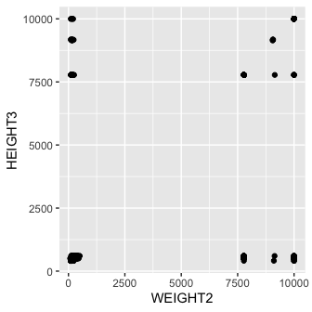

Height and weight should show a somewhat positive correlation. These clusters are an indication of the data coding.

### Next steps

Obviously, we need to spend some time cleaning these variables before we can make use of them.

We have a couple of choices:

1. We can buckle down and do that clean-up and then move on to the calculation.
2. We can take another look at the variables and investigate what HTIN4, HTM4, and WTKG3 are …

## Route 2

Let’s take the second route first and draw a picture of height and weight in metric units:

iowa %>%   
 ggplot(aes(x = HTM4, y = WTKG3)) + geom_point(alpha = 0.2) +   
 facet_grid(.~SEX) +  
 geom_smooth()

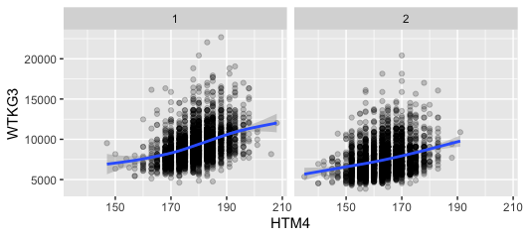

These charts look much better! We see a general increase in weight as height increases. The variability in weight is huge, though. On average, women (SEX = 2) are shorter and lighter.

### Correlations of height and weight by gender (Route 2)

Based on variables HTM4 and WTKG3

iowa %>%   
 group_by(SEX) %>%  
 summarize(  
 n = n(),  
 cor = cor(HTM4, WTKG3, use="pairwise.complete"),  
 non_missing = sum(!is.na(HTM4) & !is.na(WTKG3)),  
 non_missing_perc = non_missing/n*100  
 )

## # A tibble: 2 × 5  
## SEX n cor non_missing non_missing_perc  
## <dbl> <int> <dbl> <int> <dbl>  
## 1 1 2704 0.398 2589 95.7  
## 2 2 3523 0.275 3051 86.6

## Route 1

This is a bit more work.

# first of all, replace all missing values by NAs  
iowa <- iowa %>% mutate(  
 HEIGHT3 = replace(HEIGHT3, HEIGHT3 %in% c(7777,9999), NA),  
 WEIGHT2 = replace(WEIGHT2, WEIGHT2 %in% c(7777,9999), NA)  
)

Let’s take on height first:

iowa <- iowa %>% mutate(  
 feet = HEIGHT3 %/% 100, # feet and inch only make sense for standard values,  
 inch = HEIGHT3 %% 100, # but we can calculated them for all  
 height = ifelse(HEIGHT3 >= 9000,   
 HEIGHT3 - 9000, # transform all metric values by subtracting 9000  
 feet *30.48 + 2.54*inch # add feet and inch converted to centimeter  
 )  
)

### Now plot!

iowa %>% filter(!is.na(height)) %>%  
 ggplot(aes(x = height)) + geom_histogram(binwidth = 2.5) +  
 facet_grid(SEX~.)

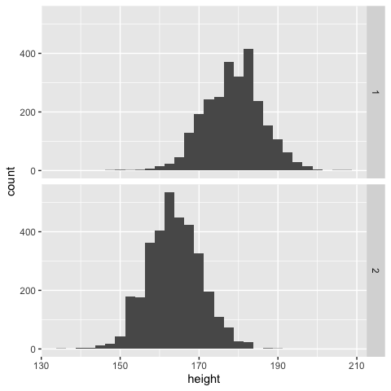

We get similar findings - for height at least: women are on average shorter than men.

Now we do the same thing for weight as we did for height before: 1 pound is 0.454 kg

iowa <- iowa %>% mutate(  
 weight = ifelse(WEIGHT2 >= 9000,   
 WEIGHT2 - 9000, # transform all metric values by subtracting 9000  
 WEIGHT2*.454 # 1 lbs = 0.454 kg  
 )  
)

### Correlations of weight and height by gender (Route 1)

iowa %>%   
 group_by(SEX) %>%  
 summarize(  
 n = n(),  
 cor = cor(height, weight, use="pairwise.complete"),  
 non_missing = sum(!is.na(height) & !is.na(weight)),  
 non_missing_perc = non_missing/n*100  
 )

## # A tibble: 2 × 5  
## SEX n cor non_missing non_missing_perc  
## <dbl> <int> <dbl> <int> <dbl>  
## 1 1 2704 0.398 2589 95.7  
## 2 2 3523 0.276 3051 86.6

## Recap 1

* Route 1 and 2 give identical solutions
* Read the codebook, visualize the data, even if the question does not ask for it.

## Recap 2

* the solution is disseminated from an R Markdown document, located at [a github repo](https://github.com/Stat585-at-ISU/materials-2019/tree/master/01_collaborative-environment).
* code and text/documentation are interwoven: reproducible and self-documenting.
* extend or refine analyses by copying and modifying code blocks.
* disseminate your work by sharing the RMarkdown file