Assignment 1

Online Energy Utility Platform

Realizat de: Izabella Bartalus

Grupa: 30241

1. Conceptual architecture of the online platform.

Layered Architecture Pattern:

* Components within the layered architecture pattern are organized into horizontal layers, each layer performing a specific role within the application (e.g. presentation logic or business logic).

Model-View-Controller: also known as MVC pattern, divides an interactive application in to 3 parts as:

* + model  - contains the core functionality and data;
  + view - displays the information to the user (more than one view may be defined);
  + controller - handles the input from the user.

We will use a relational database to store out data, and this is how we will be manipulating our data

Working functionalities:

* REST Services and Frontend for CRUD operations for Administrator Role
* Database
* Log-in with redirect
* Administrator associates devices to users
* Minimum Security: The users will not be able to enter other users’ pages (filters according to role and sessions)

Login as an Admin you can perform the following operations:

* CRUD on users
  + View a list of all users (admins and clients)
  + Add a new user (admin or client)
  + Edit an existing user
  + Delete an existing user
* CRUD on devices
  + View a list of existing devices
  + Add a new device
  + Edit an existing device
  + Delete an existing device
* Map a device to a user
  + By introducing the user’s id and the device’s id in a form, the mapping will be created

Login as a Client you can perform the following operations:

* View the list of your own devices

1. DB design.

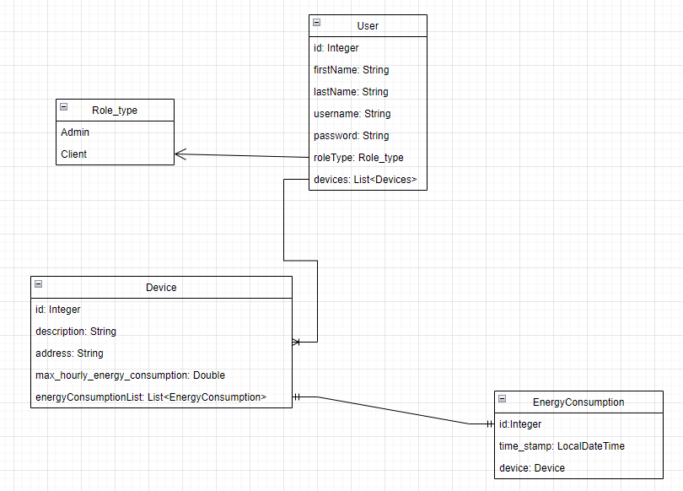

1. UML Deployment diagram.

1. Readme file containing build and execution considerations.

Pentru a porni aplicatia, din root-ul proiectului se deschide wsl-ul si se introduce comanda

docker-compose up -d