Assignment 2

Soponari Beatrice-Valentina

Grupa 30241

1. **Conceptual architecture of the online platform**

Functionalities

* REST Services and Frontend for CRUD operations for Administrator Role:
  + - CRUD operations on users
    - CRUD operations on devices
* Database
* Log-in with redirect
* Minimum Security: The users will not be able to enter other users’ pages (filters according to role and sessions)

Login as an Admin you can perform the following operations:

* CRUD on users
  + View a list of all users (admins and clients)
  + Add a new user (admin or client)
  + Edit an existing user
  + Delete an existing user
* CRUD on devices
  + View a list of existing devices
  + Add a new device
  + Edit an existing device
  + Delete an existing device
* Map a device to a user
  + By introducing the user’s id and the device’s id in a form, the mapping will be created

b) Database design

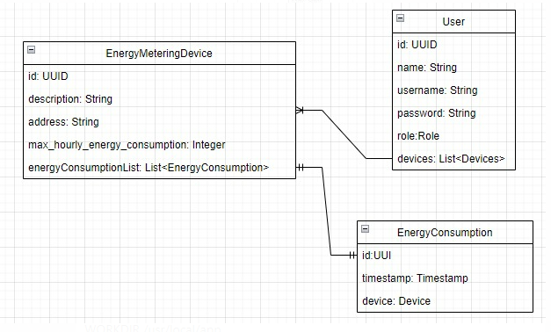

c) UML Deployment diagram.

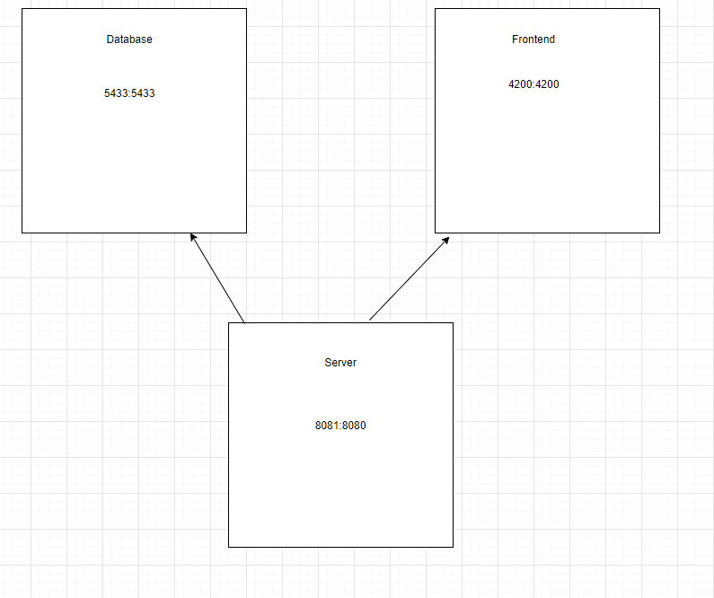

4) Readme file containing build and execution considerations

Pentru a rula aplicatia este necesara rularea din linia de comanda a comenzii:

docker-compose up –d

Din interiorul fisierului in care se afla docker-compose.yaml

5) RabbitMQ

RabbitMQ is a messaging broker - an intermediary for messaging. It gives your applications a common platform to send and receive messages, and your messages a safe place to live until received.

Rabbit MQ is the message broker which acts as a middleware while using multiple microservices