*Documentation*

Assignment 1



Teacher: prof. Oana Andreea Marin

Student: Ivan Alexandru

Contents

1.The architecture of the application 2

2.Database Design 2

3.UML Deployment diagram 2

4.How to run the application 2

# 1. The architecture of the application

The application is a basic Client-Server architecture application that lets the client(frontend) communicate with the server(backend) with the help of HTTP requests. This is the most common type of application nowadays and it’s used by most of the web and mobile applications.

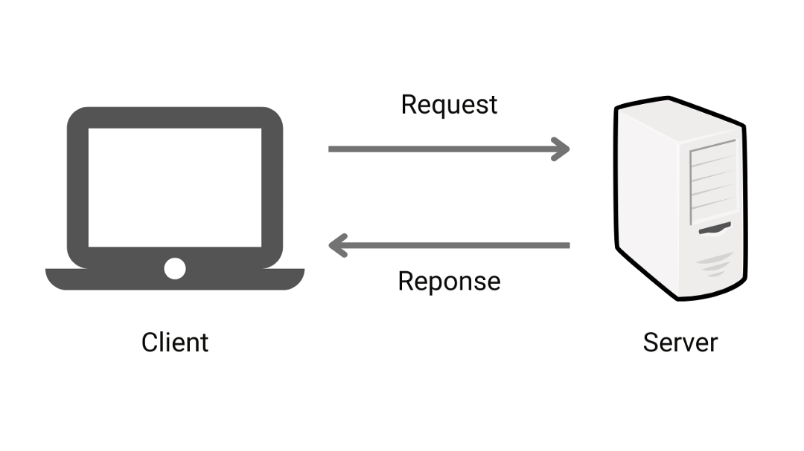

The Client sends HTTP requests to the server. These requests are sent at already defined endpoints which were created and documented by the server side. The server then receives the request and executes what the specification says. Then the server side sends back a response to the client, with some data or without. Because this form of communication was already specified, both sides know what to do in what case: because certain requests might throw errors or not execute the same thing if different parameters are provided. The are certain rules when it comes to HTTP requests. There are HTTPS methods, which are more of a guideline of how to make the communication between server and client, but they also impose certain restrictions. For example, the are GET requests, which are mostly used to retrieve data from the server to the client, whereas POST requests make modifications in the backend, such as database inserts or updates or some other kind of operations which modify the data.

# 

# 2. Database Design

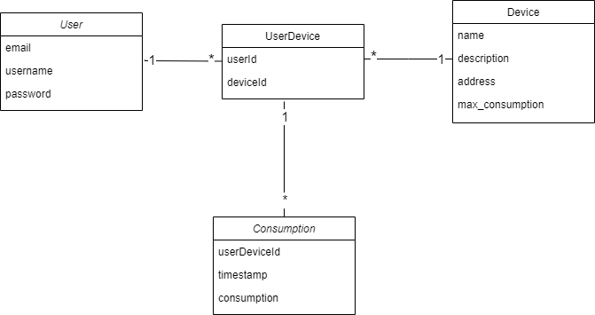

# 

# 3. UML Deployment diagram

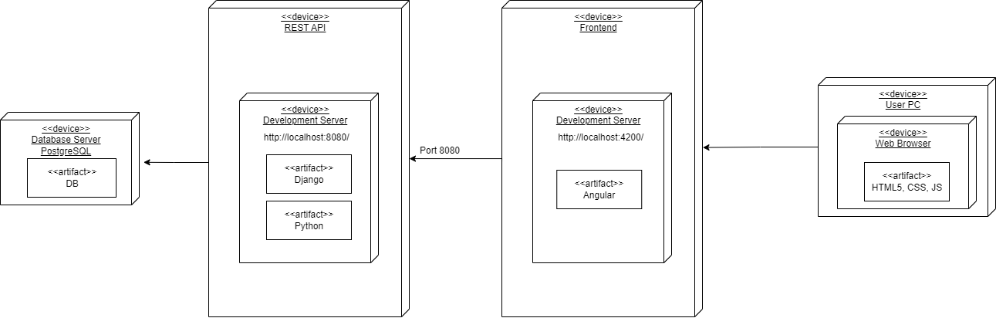

# 4. How to run the application

To run the application, one must first ensure that both the frontend and the backend are deployed locally. We must:

* Ensure Docker desktop is up and running
* Go in EUP_backend folder and open a command prompt
  + run the **docker-compose up -d** command
* Go in EUP_frontend folder and open a command prompt
  + run the **docker-compose up -d** command
* We can now access the web application at **localhost:4200** or, if we are more advanced and actually clever, make some requests to our REST API at **localhost:8000.**

# 5. Bibliography

* None.