CPP 523: Foundations of Program Evaluation I

Lab #1

Type out your responses (show your work) and submit via Canvas.

Name your file **Lab-##-LastName.doc**.

In this assignment you will be working with a very small data set. You need to build a regression from the ground up. Read pages 9-25 in the Lewis-Beck text, *Applied Regression,* posted on the course website to review basic regression formulas.

I want you to focus on your understanding of the regression error term (often called the “residual”). Can you have an error term without first having a regression line?

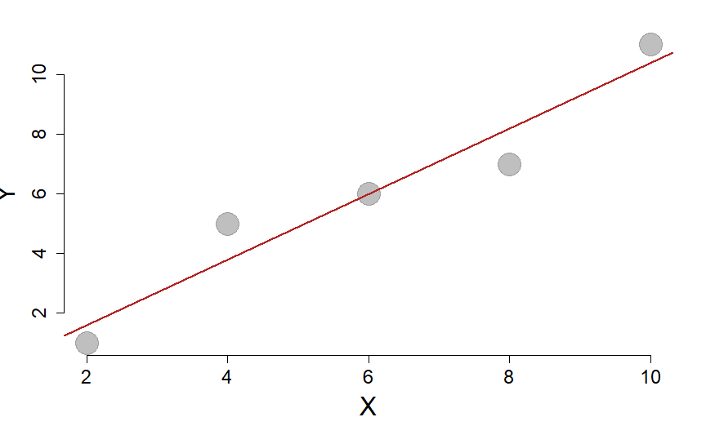

|  |  |  |  |  |
| --- | --- | --- | --- | --- |
| **X** | **Y** |  | **e** | **e2** |
| 2 | 1 |  |  |  |
| 4 | 5 |  |  |  |
| 6 | 6 |  |  |  |
| 8 | 7 |  |  |  |
| 10 | 11 |  |  |  |
| Mean=6 | Mean=6 | Mean=6 | Sum=0 | Sum= |

Regression model: 

*var(x):* 10

*var(y):* 13

*cov(x,y):* 11

*(1) Calculate b1 using the knowledge the slope can be calculated as cov(x,y) / var(x).*

*(2) Interpret the coefficient b1 in plain English.*

*(3) Calculate b0 (recall that*  *)*

*(4) What is the predicted value of Y when X has a value of 14?*

*(5) Calculate the sum of the squared errors (see page Lewis-Beck, p14) by completing the table above.*

*(6) Calculate the regression sum of squares (Lewis-Beck p21). You can check your work for questions 5-6 against the ANOVA table below.*

*(7) Calculate the R2 using the sum of squares in the table.*

| *Analysis of Variance Table* | | | | | |
| --- | --- | --- | --- | --- | --- |
|  | ***Df*** | ***Sum Sq*** | ***Mean Sq*** | ***F value*** | ***Pr(>F)*** |
| ***x*** | *1* | *48.4* | *48.4* | *40.33* | *0.007898* |
| ***Residuals*** | *3* | *3.6* | *1.2* | *NA* | *NA* |