CPP 524: Study Guide for the Final Exam

**Exam Format**

Similar to CPP 523, the final exam is a two-hour test on Canvas.

The final exam is worth 10% of your final grade.

The exam shell will remain open for four days. You can take the exam at any point in this window of time, but once you start you cannot pause the time limit.

It is open notes and calculators are permitted. Any questions with numbers will be *primarily* interpretive, not mathematical (for example, interpret output from a table vs. run analysis or calculate a statistic by hand). Questions like tabulate a group mean from a regression with dummy variables or determine the adjusted alpha with a Bonferroni correction are fair game.

**Core Concepts**

**Counterfactual Reasoning**

1. Explain the reasoning behind the following statistical representation of the counterfactual:

Program Effect = [ Mean(y) | Treatment=TRUE ] – [ Mean(y) | Treatment=FALSE ]

OR

Program Effect = y(t) – y(c)

1. Why is randomization considered the gold standard for counterfactual analysis?

**True or False:**

1. Quasi-experiments will produce different estimates of program effects than experiments.
2. If two variables have a very high correlation then they must be causally related.
3. The lower the p-value that we observe on a slope in a regression model the less likely there is to be significant bias in the slope.
4. If randomization is successful, the pre-treatment group traits in the control and treatment groups should be mathematically identical.
5. After happy randomization both observed and unobserved characteristics of the study groups will be the same (equivalent).
6. If we have a high level of attrition in a study we should not trust the results because they will be biased.
7. If someone is assigned to the treatment group in a study and refuses the treatment then they are considered attrition.

**Regression Slopes**

1. When we see a p-value reported in a table, does that always mean a hypothesis is being tested?
2. What is the default null hypothesis in every regression model?
3. Explain “the selection problem” in evaluation studies.
4. Explain the difference between “selection in” and “selection out”.
5. Explain the conditions that are necessary to interpret b1 as a causal relationship in this example:

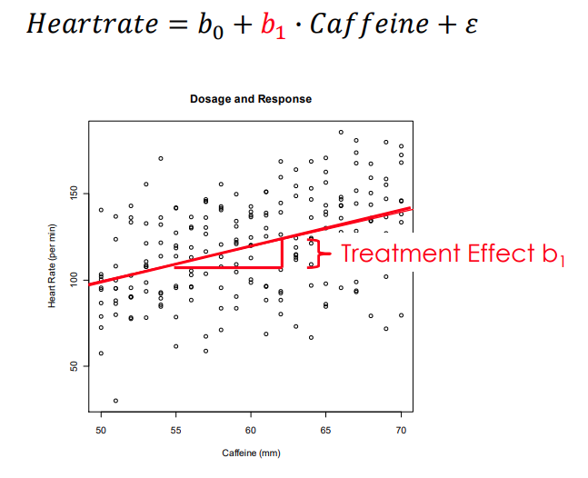

1. Explain the difference in the interpretation of b1 when X is continuous versus when X is a binary (group ID) dummy variable.   
     
   y = b0 + b1(X) + e vs y = b0 + b1(D) + e

**Dummy Variable Models and T-Tests**

1. If D is a dummy variable that is coded 1 for each person in the treatment group and zero for each person in the control, then what does the p-value associated with b1 represent? Specifically, what is the null hypothesis that is being tested here?   
     
   y = b0 + b1(D) + e
2. If we have a new muscle-building supplement that is supposed to make you gain more strength with the same time spent at the gym. We would like to test whether it is efficacious, and we would also like to confirm it has the same effect on men and women. We run the following model:   
     
   y = b0 + b1(male_dummy) + b2(treat_dummy) + b3(male_treat_dummy) + e

What does the reference group b0 represent here?

1. What hypothesis does each coefficient represent?   
     
   b0:  
   b1:  
   b2:  
   b3:
2. How would we construct the following group means using coefficient?   
     
   Women in the treatment:   
   Women in the control:   
   Men in the treatment:   
   Men in the control:

**Randomization**

1. What is “happy” randomization?
2. How does one test for happy randomization?
3. Explain the reason that we use a Bonferroni correction.
4. What is the difference between random and non-random attrition in a study?
5. Explain three ways that one might test for non-random attrition.
6. What is an example of a “natural experiment” and how does it differ from an Randomized Control Trial?

**Compliance**

1. What does it mean that we typically estimate “average effects” in evaluation studies?
2. Explain the difference between the Treatment on the Treated (TOT) effect and the Intention to Treat (ITT) effect.
3. Using an implementation framework explain the interpretation of each of these two measures of program effectiveness.
4. Which measure is more conservative (less likely to overstate true program effects)?

**Estimators**

1. What is an estimator?
2. What does it mean for an estimator to be “valid”?
3. True or False: all estimators require that the treatment and control groups are equivalent prior to treatment for the estimator to be valid.
4. List each of the three estimators and explain their primary identification assumption.
5. Give an example where a reflexive estimator would be impossible (i.e. not just inappropriate) to use.

**Measurement**

1. Define “latent construct”
2. What is an “instrument” in the social sciences?
3. How can we tell if an instrument is reliable?
4. What is predictive validity?   
     
   It is common to create categories of things that have high reliability but low validity. For example, “red-headed students” is easy enough to define and observe, but it would not predict much in the classroom. Meyers Briggs tests have decent reliability but very low predictive power (employers should never give the test to determine candidate fit with the organization!). The Big Five personality test, on the other hand, does predict performance in many contexts.
5. Define statistical measurement error.
6. TRUE or FALSE: Latent constructs will ALWAYS be measured with error.
7. TRUE or FALSE: The alpha metric of the instrument (for example, Cronbach’s alpha, not to be confused with the alpha in a hypothesis test) is an indicator of the level of measurement error present in a variable.

**Campbell Scores**

1. Explain the difference between internal and external validity. Which does the Campbell Score measure?
2. Explain which criteria are “guilty until proven innocent” and why.
3. Give an example of a dependent variable with measurement error and one without measurement error.
4. What are the implications of measurement error in the DV versus in the policy variable?
5. When would we worry about regression to the mean?
6. What is the fix for seasonality?
7. True or false: an intervening event means an event that only impacts one of the two study groups.
8. True or false: if a study does not score a 10 out of 10 then we should throw out the results.