# How Does Theory of Change Work?

*Center for Theory of Change, Spring 2020*

Theory of Change is essentially a comprehensive description and illustration of how and why a desired change is expected to happen in a particular context. It is focused in particular on mapping out or “filling in” what has been described as the “missing middle” between what a program or change initiative does (its activities or interventions) and how these lead to desired goals being achieved. It does this by first identifying the desired long-term goals and then works back from these to identify all the conditions (outcomes) that must be in place (and how these related to one another causally) for the goals to occur. These are all mapped out in an Outcomes Framework.

The Outcomes Framework then provides the basis for identifying what type of activity or intervention will lead to the outcomes identified as preconditions for achieving the long-term goal. Through this approach the precise link between activities and the achievement of the long-term goals are more fully understood. This leads to better planning, in that activities are linked to a detailed understanding of how change actually happens. It also leads to better evaluation, as it is possible to measure progress towards the achievement of longer-term goals that goes beyond the identification of program outputs.

# TOC maps out your initiative through 6 stages:

1. Identifying long-term goals
2. Backwards mapping and connecting the preconditions or requirements necessary to achieve that goal and explaining why these preconditions are necessary and sufficient.
3. Identifying your basic assumptions about the context.
4. Identifying the interventions that your initiative will perform to create your desired change.
5. Developing indicators to measure your outcomes to assess the performance of your initiative.
6. Writing a narrative to explain the logic of your initiative.

The TOC process hinges upon defining all of the necessary and sufficient conditions required to bring about a given long term outcome. TOC uses backwards mapping requiring planners to think in backwards steps from the long-term goal to the intermediate and then early-term changes that would be required to cause the desired change. This creates a set of connected outcomes known as a “pathway of change”. A “pathway of change” graphically represents the change process as it is understood by the initiative planners and is the skeleton around which the other elements of the theory are developed.

During the process of creating the pathway of change, participants are required to articulate as many of their assumptions about the change process as they can so that they can be examined and even tested to determine if any key assumptions are hard to support (or even false). There are typically three important types of assumptions to consider: (a) assertions about the connections between long term, intermediate and early outcomes on the map; (b) substantiation for the claim that all of the important preconditions for success have been identified; and (c) justifications supporting the links between program activities and the outcomes they are expected to produce. A fourth type of assumption which outlines the contextual or environmental factors that will support or hinder progress toward the realization of outcomes in the pathway of change is often an additional important factor in illustrating the complete theory of change.

TOC approach to planning is designed to encourage very clearly defined outcomes at every step of the change process. Users are required to specify a number of details about the nature of the desired change — including specifics about the target population, the amount of change required to signal success, and the timeframe over which such change is expected to occur. This attention to detail often helps both funders and grantees reassess the feasibility of reaching goals that may have initially been vaguely defined, and in the end, promotes the development of reasonable long-term outcome targets that are acceptable to all parties.

# Identifying Long-term Goals

In the first stage of theory development, TOC participants discuss, agree on, and get specific about, the long-term goal or goals. This can be done in a variety of ways, (see our facilitator’s guide), but the important thing is to set a good, clear outcome. The quality of the rest of the theory hinges on doing this right!

Then, TOC participants start to design a simple map of the preconditions required to bring about the long-term goal. Beginning the mapping process helps stakeholders to visualize and prioritize their goals as well as specify what they expect to change and for which outcomes they want to be held accountable.

For this example, the long-term outcome is the long-term employment of domestic violence survivors at a livable wage. To achieve that goal, the program designers identify three preconditions: survivors attain coping skills, survivors have marketable skills in non-traditional jobs and survivors know and have appropriate workplace behavior. The program designers identified these preconditions from their experience and from research. To illustrate the logical importance of the three preconditions, we use solid, arrowed lines to show that the preconditions MUST come before the final long-term outcome.

Stage 1: Identifying Goals and Outcomes



# Backwards Mapping and Connecting Outcomes

After the first step of laying out the long-term goals and a simple change framework, comes a more detailed stage of the mapping process. Building upon the initial framework, we continue to map backwards until we have a framework that tells the story we think is appropriate for the purposes of planning. Sometimes, this will require much more detail because stakeholders want to identify the “root” causes of the problem they hope to resolve. In other cases, the map will illustrate three or four levels of change, which display a reasonable set of early and intermediate steps toward the long term goal.

Because this work is challenging and most social change programs or broader initiatives have a lot of moving parts, change frameworks usually go through many revisions. Outcomes are added, moved and deleted until a map eventually emerges that tells a story the group can agree on. For the users, the debate is often the most valuable component of TOC because they are now jointly defining the expectations, assumptions and features of the change process. TOC participants are required to make explicit, and agree upon, the underlying logic of the initiative improving which improves the productivity and accountability.

For the Project Superwomen example, program designers asked themselves what women would need if they were going to have long-term employment. Specifically, how would the project’s participants achieve the three identified preconditions (coping skills, marketable skills, and appropriate workplace behavior) to the ultimate outcome? That required identifying what it would take for women to achieve coping skills, job skills and knowledge of workplace behavior.

[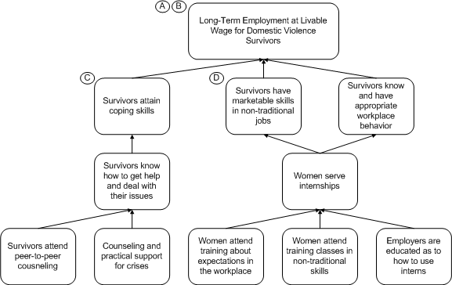](https://www.theoryofchange.org/images/T2.gif)

## Drawing Connections

We continue illustrating how the long-term outcomes are linked to the intermediate ones. In stage 1, we connected the final long-term outcome of employment at a livable wage to the three intermediate outcomes with solid, arrowed lines, indicating that they are preconditions. This process holds for the intermediate outcomes as well. For “Survivors know how to get help and deal with their issues” we use arrowed lines to show that the two outcomes below it are direct preconditions of it.

Illustrating connections helps to spot-check the initiative’s logic as well as identifying where the initiative should intervene. Following the logical path from outcome to proposed precondition often points out inconsistencies. TOC participants are able to readjust their frameworks and drop or add outcomes as necessary. They also understand when these outcomes will take place on their own or require an intervention by the initiative to make it happen, such as a program activity.

# Completing the Outcomes Framework

To complete the framework the preconditions are fleshed out all the way back to the initial condition—a coalition of organizations working to develop employment programs for domestic violence survivors. Again, explaining preconditions remains important, hence for “Women enroll in program” the assumption:

The program cannot help all women and so entry into the program must include screening so that women who have sufficient literacy and math skills to take the training and lives stable enough to attend classes are admitted. The program does not have the resources to handle providing basic skills or major social services.

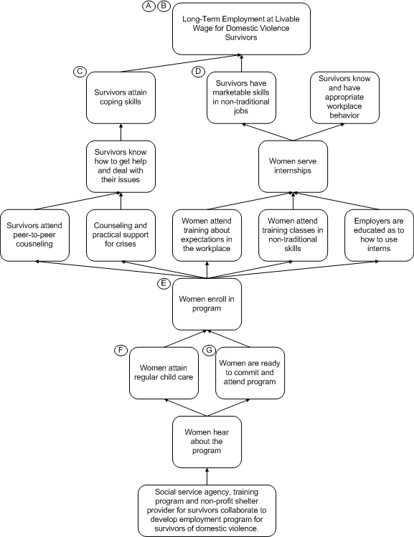

Early on in the planning process, the group realized that they only had the resources to provide assistance to women who had already begun to stabilize their own lives. The program could take care of the temporary issues, such as emergency housing but not something more permanent or serious, such as substance abuse.

Because of the relative simplicity of this framework, it seems as if the connections are all given. At this stage, you might think: “If it’s below another outcome, then it must be a precondition. Why all the arrowed lines?” While in this example, it is not difficult to organize preconditions, in more complex frameworks, boxes can be near each other without a direct relationship, connections can be made across the framework, etc. For the clarity of the framework, connections are irreplaceable.

# Identifying Assumptions

As previously discussed, the program designers realized that the program could only effectively work with women who had already begun to stabilize their lives. Any initiative is only as sound as its assumptions. Unfortunately, these assumptions are too often unvoiced or presumed frequently leading to confusion and misunderstanding in the operation and evaluation of the initiative. To address that problem, TOC documents assumptions to ensure agreement for planning and posterity.

**For the long-term outcome: “Long-term employment at livable wages for domestic violence survivors”, these assumptions must be met for the outcome to be achievable:**

*A. There are jobs available in non-traditional skills for women.*

*B. Jobs in non-traditional areas of work for women, such as electrical, plumbing, carpentry and building management are more likely to pay livable wages and are more likely to be unionized and provide job security. Some of these jobs also provide a ladder of upward mobility, from apprenticeship to master, giving entry-level employees a career future.*

*These two assumptions make explicit why the participants believe this program can work: there are jobs in non-traditional work and that those jobs can offer better financial and professional*

**For the outcome: “Survivors attain coping skills”, (which is also a precondition of the long-term outcome): the assumption is:**

*C. Women who have been abused need more than just skills, they need to be emotionally ready for work as well. Again, this assumption clarifies why and how this program is different from traditional job-training programs, i.e., the special psychological supports needed for the initiative’s clients.*

**For the outcome: “Survivors have marketable skills in non-traditional jobs”, it is assumed that:**

*D. Women can learn non-traditional skills and compete in the marketplace. This assumption is an article of faith that women can compete and succeed in this new labor market.*

Documenting assumptions and justifications is a continuous process. As outcomes are added and moved on the framework, it remains necessary to question and explain how and why they are necessary.

# Developing Indicators

The Indicators stage is when details are added to the change framework. This stage focuses on how to measure the implementation and effectiveness of the initiative. By collecting data on each outcome, the initiative can identify what it is or isn’t happening and find out why.

* **Indicator** is the actual variable being measured, such as average test scores or proficiency in a particular skill.
* **Population** is the group that you are measuring, such as a program’s clients.
* **Threshold** represents the minimum for the outcome to be successfully achieved. (E.g. the threshold for a successful election between two candidates is 51% of the vote; if there were three or more candidates, the threshold would be lower, because only a majority of the votes would be required to be successful.)

Each indicator has four parts: population, target, threshold and timeline. But you can forget the jargon. Simply put, for each indicator you want to ask:

* Who is changing? (women enrolled in the program)
* How many do we expect will succeed? (perhaps 90% of the enrolled women)
* How much is good enough? (a $12 per hour job for at least six months?)
* By when does this outcome need to happen? (perhaps within two months of graduation)

Here are some sample indicators for Project Superwomen:

**Outcome 1: Long-term employment at a livable wage for domestic violence survivors**

* Indicator : Employment
* Population: Program graduates
* Threshold: Remain in job at least 6 months and earn at least $12 per hour

**Outcome 2: Survivors have marketable skills in non-traditional jobs**

* Indicator : Skill in electrical, plumbing carpentry or building maintenance
* Population: Program participants
* Threshold: Successfully complete internship

**Outcome 2: Survivors have marketable skills in non-traditional jobs**

* Indicator : Program graduation
* Population: Program participants
* Threshold: Do graduate (yes/no)

**Outcome 3: Women attend training classes in non-traditional skills**

* Indicator : Attendance
* Population: Program participants
* Threshold: Women miss no more than three classes

# Identifying interventions

After laying out the near complete change framework, we now focus on the role of interventions (those things that the program (or initiative) must do to bring about outcomes).

## Interventions

At this stage, note that some arrows have solid lines while others are dashed. The solid lines represent connections that will occur without the need for intervention. As long as the prior preconditions are met, these outcomes will be met. We represent interventions, an initiative’s program activities, as arrows with dashed lines for three reasons:

1. We believe the outcomes those arrows lead to will not occur at a sufficient level without an intervention.
2. They represent actions by the initiative and thus something that the initiative is responsible for
3. Because these outcomes are control variables, they need to be measured to evaluate the interventions’ effectiveness.

By identifying interventions, the stakeholders explain how their work is going to change the community. Until this point, the change framework has been like a gumbo recipe without directions, a literal listing of intermediate ingredients—roux, shrimp, onions, okra, etc. But until this point our “recipe” hasn’t explained explain how these components are used and put together, i.e., how to make roux by browning flour in hot oil; when to add the shrimp (previously peeled and cleaned), etc. The interventions explain what the stakeholders are going to do to achieve their desired outcomes. Hence the first intervention (1), an outreach campaign, is of course necessary to publicize the program. While this example seems obvious, the point is again to be clear about what the stakeholders expect the initiative to do—something that is often taken for granted, but never clearly or consistently expressed.

We also identify each intervention with boxed numbers. Often a dashed interventions arrow will have multiple boxes because the outcome requires multiple activities for it to happen.

## Reality Checking

At every stage of the TOC process, there is a need for stakeholders to question whether new revelations reveal an inconsistency in their logic: Does specifying interventions highlight an important gap in the outcomes framework? Do any of the assumptions suggest an additional change pathway (with additional early and intermediate outcomes)? Stakeholders should ask themselves if what they are creating “makes sense” by thinking about whether their map reflects a plausible theory, and whether the set of interventions are actually feasible for them to implement, given the resources they have at their disposal.

## About this Document

The Center for Theory of Change is a non-profit organization established to promote quality standards and best practice for the development and implementation of Theory of Change, with a particular focus on its use and application in the areas of international development, sustainability, education, human rights and social change. Theory of Change has the power to radically enhance the capacity of social change organizations and initiatives to achieve their goals and demonstrate their impact. It grounds planning and strategy in the reality and evidence base of what is necessary to achieve change. Theory of Change is also critical to evaluation, providing a framework that allows organizations to know what to evaluate and when. It builds on – and can usefully incorporate data gathered through – other approaches that have been developed to improve planning and evaluation, including ‘logic models/logframes’ and ‘results frames’.

This example was retrieved from the Center for Theory of Change website: <https://www.theoryofchange.org/what-is-theory-of-change/how-does-theory-of-change-work/>