CPP 524: Prog Eval II

Prof. Jesse Lecy

**Lab 01 – Counterfactual Reasoning with RCTs**

Submit answers via Canvas

Provide answers to the questions below after reading Chapter 5 from:

*Bingham, R., & Felbinger, C. (2002). Evaluation in practice: A methodological approach. CQ Press.*

CH-05: Improving Cognitive Ability in Chronically Deprived Children [[pdf](https://github.com/DS4PS/cpp-524-spr-2020/raw/master/pubs/evaluation-in-practice-CH5-pre-post-with-control.pdf)]

**Question 1:**

You have 60 seconds to give an elevator pitch to a donor that is interested in funding another pilot study. As clearly and succinctly as possible, describe the **proposed program model** (you will need some detail to distinguish your program from other early childhood education programs they are considering funding), **the population it will serve** (assume it will be similar to the population but in other communities), and the impact you believe the program will achieve. You have one paragraph.

**Question 2:**

How would you describe the treatment in this study? Be specific about the activities, dosage and time-frame *of the treatment*.

**Question 3:**

What primary outcome was measured in this impact study (p67)? Is this a latent construct, and why?

**Question 4:**

Explain the theory of change of this study.

**Question 5:**

What is the population of the study? Is this a unique group, or is it a specific instance of a more general population that the program hopes to reach? Asked differently, are the results generalizable?

**Question 6:**

The research design in the study includes six groups: T0 T1 T2 T3 T4 HS

Which group is the treatment group? Which group is the control group?

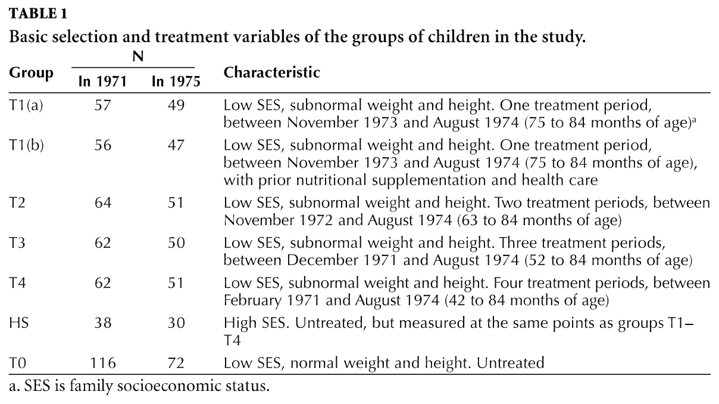

**Question 7:**

Is this a pure RCT? Did the study randomly assign all study participants to groups T0 through T4? How were students assigned?

**Question 8:**

Based upon Table 2, would you argue that randomization was “happy” or successful in this study? How can you tell?

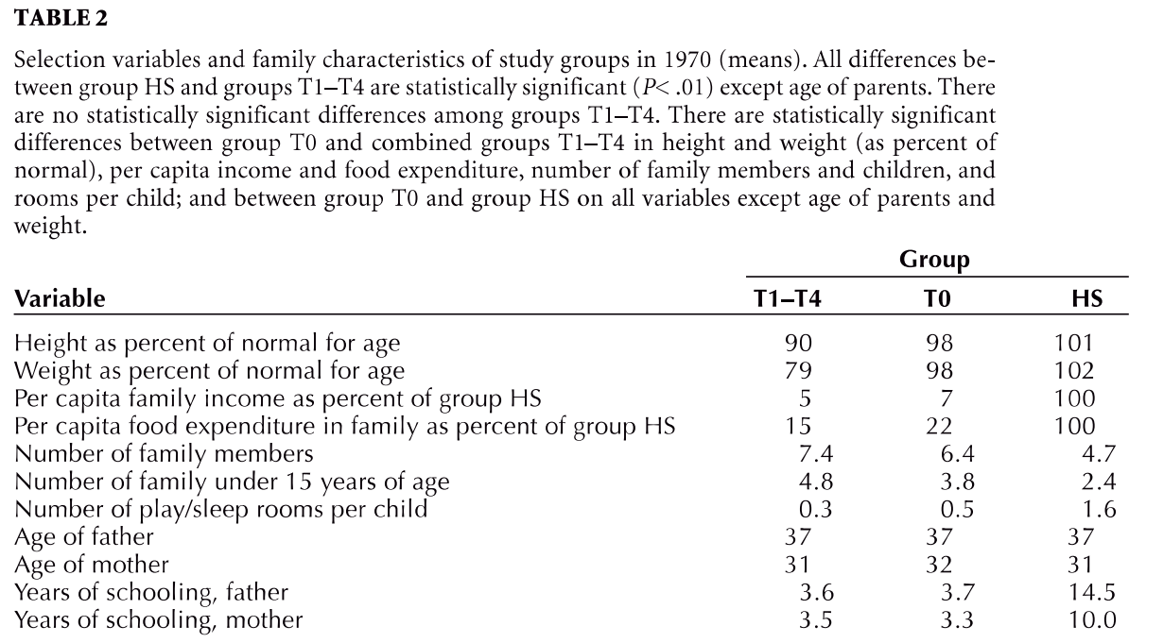

**Question 9:**

What is the time period for the treatment? This may vary by group.

**Question 10:**

What is the time-frame for the study?

**Question 11:**

If we are looking at the end of the second time period in the study (Nov 1972) how would we interpret the impact of the program? What is our treatment group, and what is our control group?

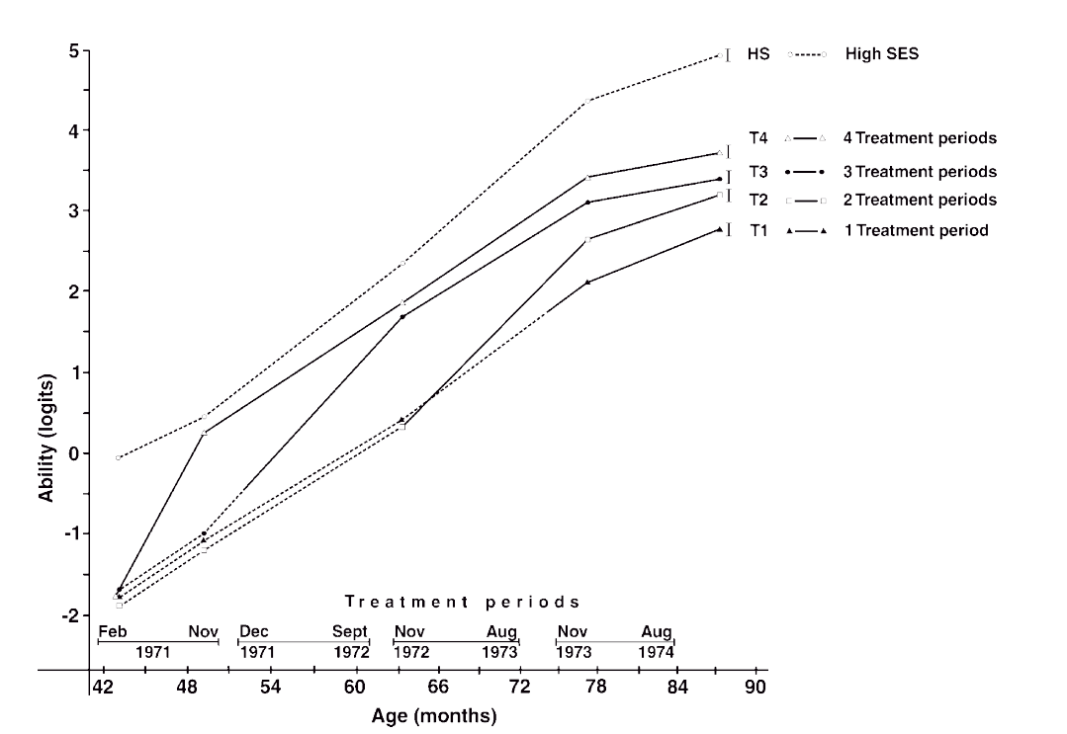

**Question 12:**

Was there attrition within the study? Did it differ between study groups?