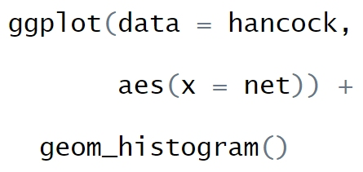

**Geometry Layer**

…turn all that into a histogram.

…to show “hancock”…

THEN

AND

Use the data…

…to show “net”…

…use the X-Axis…

**Aesthetics Layer**

**Data Layer**