Stats1_Project

Sandeep Daddala

2024-11-13

getwd()

## [1] "/Users/sandeepdaddala/Desktop/Stats1/AdvStats1_HW4"

library(ggplot2)  
library(corrplot)

## corrplot 0.94 loaded

library(GGally)

## Registered S3 method overwritten by 'GGally':  
## method from   
## +.gg ggplot2

library(readr)  
library(gridExtra)  
library(caret)

## Loading required package: lattice

library(car)

## Loading required package: carData

library(leaps)  
  
# Read the data and remove Cooling Load (Y2)  
building_data <- read_csv("/Users/sandeepdaddala/Desktop/Stats1/ENB2012_data.csv")

## Rows: 768 Columns: 10

## ── Column specification ────────────────────────────────────────────────────────  
## Delimiter: ","  
## dbl (10): X1, X2, X3, X4, X5, X6, X7, X8, Y1, Y2  
##   
## ℹ Use `spec()` to retrieve the full column specification for this data.  
## ℹ Specify the column types or set `show_col_types = FALSE` to quiet this message.

building_data_no_y2 <- building_data[, !names(building_data) %in% c("Y2")]  
  
# Rename variables for clarity  
names(building_data_no_y2) <- c("Relative_Compactness", "Surface_Area", "Wall_Area", "Roof_Area",  
 "Overall_Height", "Orientation", "Glazing_Area",   
 "Glazing_Area_Distribution", "Heating_Load")  
  
# Summary of a linear model for checking multicollinearity  
summary(lm(Heating_Load ~ ., data = building_data_no_y2))

##   
## Call:  
## lm(formula = Heating_Load ~ ., data = building_data_no_y2)  
##   
## Residuals:  
## Min 1Q Median 3Q Max   
## -9.8965 -1.3196 -0.0252 1.3532 7.7052   
##   
## Coefficients: (1 not defined because of singularities)  
## Estimate Std. Error t value Pr(>|t|)   
## (Intercept) 84.014521 19.033607 4.414 1.16e-05 ***  
## Relative_Compactness -64.773991 10.289445 -6.295 5.19e-10 ***  
## Surface_Area -0.087290 0.017075 -5.112 4.04e-07 ***  
## Wall_Area 0.060813 0.006648 9.148 < 2e-16 ***  
## Roof_Area NA NA NA NA   
## Overall_Height 4.169939 0.337990 12.337 < 2e-16 ***  
## Orientation -0.023328 0.094705 -0.246 0.80550   
## Glazing_Area 19.932680 0.813986 24.488 < 2e-16 ***  
## Glazing_Area_Distribution 0.203772 0.069918 2.914 0.00367 **   
## ---  
## Signif. codes: 0 '***' 0.001 '**' 0.01 '*' 0.05 '.' 0.1 ' ' 1  
##   
## Residual standard error: 2.934 on 760 degrees of freedom  
## Multiple R-squared: 0.9162, Adjusted R-squared: 0.9154   
## F-statistic: 1187 on 7 and 760 DF, p-value: < 2.2e-16

# Remove Surface Area and Roof Area due to high correlation  
building_data_reduced <- building_data_no_y2[, !names(building_data_no_y2) %in% c("Surface_Area", "Roof_Area")]  
  
# Check for NULL values and duplicates  
sum(is.na(building_data_reduced))

## [1] 0

colSums(is.na(building_data_reduced))

## Relative_Compactness Wall_Area Overall_Height   
## 0 0 0   
## Orientation Glazing_Area Glazing_Area_Distribution   
## 0 0 0   
## Heating_Load   
## 0

duplicate_rows <- sum(duplicated(building_data_reduced))  
summary(building_data_reduced)

## Relative_Compactness Wall_Area Overall_Height Orientation   
## Min. :0.6200 Min. :245.0 Min. :3.50 Min. :2.00   
## 1st Qu.:0.6825 1st Qu.:294.0 1st Qu.:3.50 1st Qu.:2.75   
## Median :0.7500 Median :318.5 Median :5.25 Median :3.50   
## Mean :0.7642 Mean :318.5 Mean :5.25 Mean :3.50   
## 3rd Qu.:0.8300 3rd Qu.:343.0 3rd Qu.:7.00 3rd Qu.:4.25   
## Max. :0.9800 Max. :416.5 Max. :7.00 Max. :5.00   
## Glazing_Area Glazing_Area_Distribution Heating_Load   
## Min. :0.0000 Min. :0.000 Min. : 6.01   
## 1st Qu.:0.1000 1st Qu.:1.750 1st Qu.:12.99   
## Median :0.2500 Median :3.000 Median :18.95   
## Mean :0.2344 Mean :2.812 Mean :22.31   
## 3rd Qu.:0.4000 3rd Qu.:4.000 3rd Qu.:31.67   
## Max. :0.4000 Max. :5.000 Max. :43.10

# 1. Correlation Heatmap  
cor_matrix <- cor(building_data_reduced)  
corrplot(cor_matrix, method = "color", type = "upper", order = "hclust",   
 tl.col = "black", tl.srt = 45)

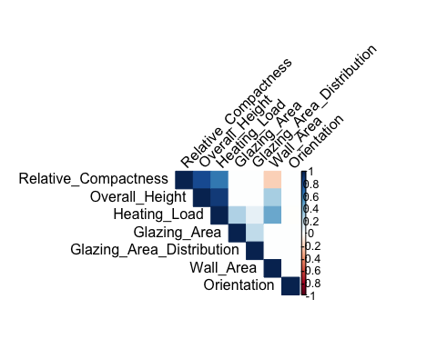

# 2. Histograms  
gg_list_hist <- lapply(names(building_data_reduced), function(var) {  
 ggplot(building_data_reduced, aes(x = .data[[var]])) +  
 geom_histogram(fill = "skyblue", color = "black", bins = 20) +  
 labs(title = paste("Histogram for", var),  
 x = var, y = "Frequency") +  
 theme(plot.title = element_text(hjust = 0.5),  
 axis.title.x = element_text(size = 12),  
 axis.title.y = element_text(size = 12))  
})  
grid.arrange(grobs = gg_list_hist, ncol = 3)

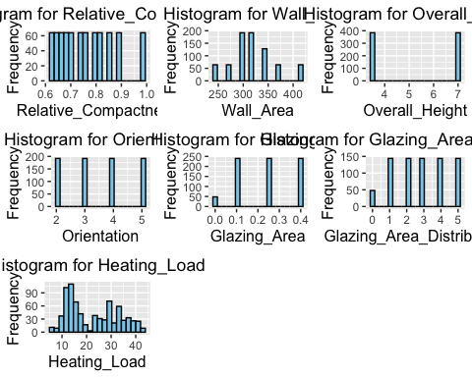

# Box Plot  
gg_list_box <- lapply(names(building_data_reduced), function(var) {  
 ggplot(building_data_reduced, aes(y = .data[[var]])) +  
 geom_boxplot(fill = "skyblue") +  
 labs(title = paste("Box Plot for", var),  
 y = var) +  
 theme(plot.title = element_text(hjust = 0.5),  
 axis.title.x = element_text(size = 12),  
 axis.title.y = element_text(size = 12))  
})  
grid.arrange(grobs = gg_list_box, ncol = 3)

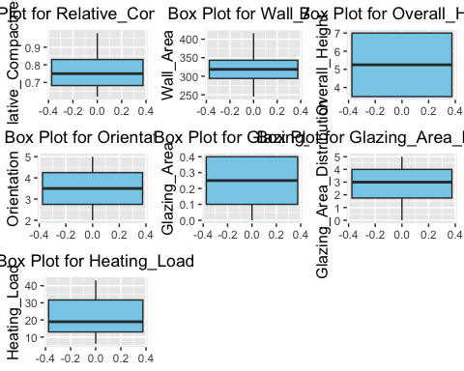

# 4. Scatter plots for Heating Load (Y1)  
scatter_y1 <- lapply(names(building_data_reduced)[1:7], function(var) {  
 ggplot(building_data_reduced, aes(x = .data[[var]], y = Heating_Load)) +  
 geom_point(color = "skyblue") +  
 labs(title = paste("Scatter Plot for Heating Load vs", var),  
 x = var, y = "Heating Load") +  
 theme(plot.title = element_text(hjust = 0.5),  
 axis.title.x = element_text(size = 12),  
 axis.title.y = element_text(size = 12))  
})  
grid.arrange(grobs = scatter_y1, ncol = 3)

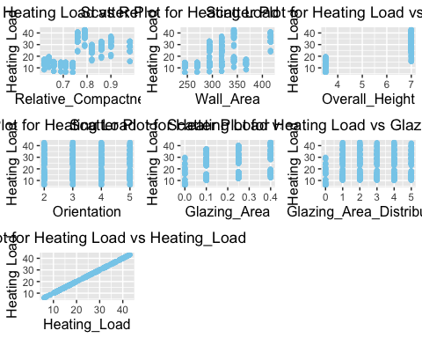

# 5. Pair plot  
ggpairs(building_data_reduced)

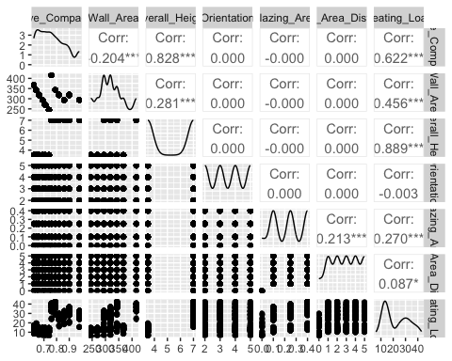

# Check the correlation matrix of the reduced dataset  
cor_matrix_reduced <- cor(building_data_reduced)  
print(cor_matrix_reduced)

## Relative_Compactness Wall_Area Overall_Height  
## Relative_Compactness 1.000000e+00 -2.037817e-01 8.277473e-01  
## Wall_Area -2.037817e-01 1.000000e+00 2.809757e-01  
## Overall_Height 8.277473e-01 2.809757e-01 1.000000e+00  
## Orientation 0.000000e+00 0.000000e+00 0.000000e+00  
## Glazing_Area -4.558152e-17 -8.766699e-18 -1.861418e-18  
## Glazing_Area_Distribution 5.735014e-17 0.000000e+00 0.000000e+00  
## Heating_Load 6.222722e-01 4.556712e-01 8.894307e-01  
## Orientation Glazing_Area Glazing_Area_Distribution  
## Relative_Compactness 0.000000000 -4.558152e-17 5.735014e-17  
## Wall_Area 0.000000000 -8.766699e-18 0.000000e+00  
## Overall_Height 0.000000000 -1.861418e-18 0.000000e+00  
## Orientation 1.000000000 0.000000e+00 0.000000e+00  
## Glazing_Area 0.000000000 1.000000e+00 2.129642e-01  
## Glazing_Area_Distribution 0.000000000 2.129642e-01 1.000000e+00  
## Heating_Load -0.002586534 2.698410e-01 8.736759e-02  
## Heating_Load  
## Relative_Compactness 0.622272179  
## Wall_Area 0.455671157  
## Overall_Height 0.889430674  
## Orientation -0.002586534  
## Glazing_Area 0.269840996  
## Glazing_Area_Distribution 0.087367594  
## Heating_Load 1.000000000

# Visualize the new correlation matrix  
corrplot(cor_matrix_reduced, method = "color", type = "upper", order = "hclust",   
 tl.col = "black", tl.srt = 45)



# Split the data into training and testing sets  
set.seed(123)   
trainIndex <- createDataPartition(building_data_reduced$Heating_Load, p=0.8, list=FALSE)  
train_data <- building_data_reduced[trainIndex, ]  
test_data <- building_data_reduced[-trainIndex, ]

# Create a simple linear model  
lm_model <- lm(Heating_Load ~ ., data = train_data)  
  
# Print the summary of the model  
summary(lm_model)

##   
## Call:  
## lm(formula = Heating_Load ~ ., data = train_data)  
##   
## Residuals:  
## Min 1Q Median 3Q Max   
## -9.9124 -1.4316 0.1062 1.4812 7.5995   
##   
## Coefficients:  
## Estimate Std. Error t value Pr(>|t|)   
## (Intercept) -13.500296 3.014258 -4.479 8.96e-06 ***  
## Relative_Compactness -13.327622 3.437977 -3.877 0.000117 ***  
## Wall_Area 0.037481 0.004919 7.619 9.80e-14 ***  
## Overall_Height 5.524573 0.211862 26.076 < 2e-16 ***  
## Orientation -0.057680 0.106822 -0.540 0.589419   
## Glazing_Area 19.570301 0.930147 21.040 < 2e-16 ***  
## Glazing_Area_Distribution 0.237600 0.079583 2.986 0.002944 **   
## ---  
## Signif. codes: 0 '***' 0.001 '**' 0.01 '*' 0.05 '.' 0.1 ' ' 1  
##   
## Residual standard error: 2.985 on 609 degrees of freedom  
## Multiple R-squared: 0.9128, Adjusted R-squared: 0.912   
## F-statistic: 1063 on 6 and 609 DF, p-value: < 2.2e-16

# Make predictions on the test data  
test_predictions <- predict(lm_model, newdata = test_data)  
  
# Evaluate the model's performance on the test data  
rmse <- sqrt(mean((test_data$Heating_Load - test_predictions)^2))  
rsq <- 1 - sum((test_data$Heating_Load - test_predictions)^2) / sum((test_data$Heating_Load - mean(test_data$Heating_Load))^2)  
  
# Print the test set performance metrics  
cat("Test set RMSE:", rmse, "\n")

## Test set RMSE: 2.978433

cat("Test set R-squared:", rsq, "\n")

## Test set R-squared: 0.9148274

# Set up cross-validation  
train_control <- trainControl(method="cv", number=10)   
  
# Train the model with cross-validation  
lm_model_cv <- train(Heating_Load ~ ., data=train_data, method="lm", trControl=train_control)  
  
# Print the cross-validation results  
print(lm_model_cv)

## Linear Regression   
##   
## 616 samples  
## 6 predictor  
##   
## No pre-processing  
## Resampling: Cross-Validated (10 fold)   
## Summary of sample sizes: 553, 555, 555, 553, 555, 555, ...   
## Resampling results:  
##   
## RMSE Rsquared MAE   
## 2.969655 0.913055 2.195585  
##   
## Tuning parameter 'intercept' was held constant at a value of TRUE

# Get the final model  
final_model <- lm_model_cv$finalModel  
  
# Print the summary of the final model  
summary(final_model)

##   
## Call:  
## lm(formula = .outcome ~ ., data = dat)  
##   
## Residuals:  
## Min 1Q Median 3Q Max   
## -9.9124 -1.4316 0.1062 1.4812 7.5995   
##   
## Coefficients:  
## Estimate Std. Error t value Pr(>|t|)   
## (Intercept) -13.500296 3.014258 -4.479 8.96e-06 ***  
## Relative_Compactness -13.327622 3.437977 -3.877 0.000117 ***  
## Wall_Area 0.037481 0.004919 7.619 9.80e-14 ***  
## Overall_Height 5.524573 0.211862 26.076 < 2e-16 ***  
## Orientation -0.057680 0.106822 -0.540 0.589419   
## Glazing_Area 19.570301 0.930147 21.040 < 2e-16 ***  
## Glazing_Area_Distribution 0.237600 0.079583 2.986 0.002944 **   
## ---  
## Signif. codes: 0 '***' 0.001 '**' 0.01 '*' 0.05 '.' 0.1 ' ' 1  
##   
## Residual standard error: 2.985 on 609 degrees of freedom  
## Multiple R-squared: 0.9128, Adjusted R-squared: 0.912   
## F-statistic: 1063 on 6 and 609 DF, p-value: < 2.2e-16

# Make predictions on the test data  
test_predictions <- predict(lm_model_cv, newdata=test_data)  
  
# Evaluate the model's performance on the test data  
rmse <- sqrt(mean((test_data$Heating_Load - test_predictions)^2))  
rsq <- 1 - sum((test_data$Heating_Load - test_predictions)^2) / sum((test_data$Heating_Load - mean(test_data$Heating_Load))^2)  
# Print the test set performance metrics  
cat("Test set RMSE:", rmse, "\n")

## Test set RMSE: 2.978433

cat("Test set R-squared:", rsq, "\n")

## Test set R-squared: 0.9148274

# Visualization 1: Predicted vs Actual Plot  
ggplot(data.frame(Predicted = test_predictions, Actual = test_data$Heating_Load), aes(x = Actual, y = Predicted)) +  
 geom_point(alpha = 0.5) +  
 geom_abline(intercept = 0, slope = 1, color = "red", linetype = "dashed") +  
 labs(title = "Predicted vs Actual Heating Load",  
 x = "Actual Heating Load",  
 y = "Predicted Heating Load") +  
 theme_minimal()

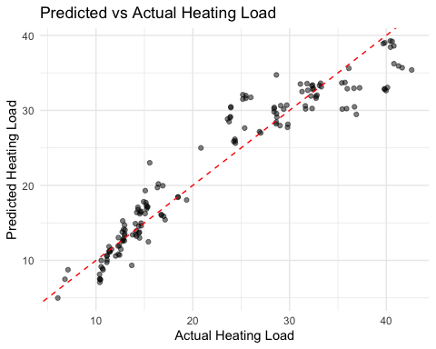

# Set up Leave-One-Out Cross-Validation  
train_control <- trainControl(method = "LOOCV")  
  
# Train the model with LOOCV  
lm_model_loocv <- train(Heating_Load ~ ., data = train_data, method = "lm", trControl = train_control)  
  
# Print the LOOCV results  
print(lm_model_loocv)

## Linear Regression   
##   
## 616 samples  
## 6 predictor  
##   
## No pre-processing  
## Resampling: Leave-One-Out Cross-Validation   
## Summary of sample sizes: 615, 615, 615, 615, 615, 615, ...   
## Resampling results:  
##   
## RMSE Rsquared MAE   
## 3.00365 0.910731 2.200825  
##   
## Tuning parameter 'intercept' was held constant at a value of TRUE

# Get the final model  
final_model <- lm_model_loocv$finalModel  
  
# Print the summary of the final model  
summary(final_model)

##   
## Call:  
## lm(formula = .outcome ~ ., data = dat)  
##   
## Residuals:  
## Min 1Q Median 3Q Max   
## -9.9124 -1.4316 0.1062 1.4812 7.5995   
##   
## Coefficients:  
## Estimate Std. Error t value Pr(>|t|)   
## (Intercept) -13.500296 3.014258 -4.479 8.96e-06 ***  
## Relative_Compactness -13.327622 3.437977 -3.877 0.000117 ***  
## Wall_Area 0.037481 0.004919 7.619 9.80e-14 ***  
## Overall_Height 5.524573 0.211862 26.076 < 2e-16 ***  
## Orientation -0.057680 0.106822 -0.540 0.589419   
## Glazing_Area 19.570301 0.930147 21.040 < 2e-16 ***  
## Glazing_Area_Distribution 0.237600 0.079583 2.986 0.002944 **   
## ---  
## Signif. codes: 0 '***' 0.001 '**' 0.01 '*' 0.05 '.' 0.1 ' ' 1  
##   
## Residual standard error: 2.985 on 609 degrees of freedom  
## Multiple R-squared: 0.9128, Adjusted R-squared: 0.912   
## F-statistic: 1063 on 6 and 609 DF, p-value: < 2.2e-16

# Make predictions on the test data  
test_predictions <- predict(lm_model_loocv, newdata = test_data)  
  
# Evaluate the model's performance on the test data  
rmse <- sqrt(mean((test_data$Heating_Load - test_predictions)^2))  
rsq <- 1 - sum((test_data$Heating_Load - test_predictions)^2) / sum((test_data$Heating_Load - mean(test_data$Heating_Load))^2)  
  
# Print the test set performance metrics  
cat("LOOCV Test set RMSE:", rmse, "\n")

## LOOCV Test set RMSE: 2.978433

cat("LOOCV Test set R-squared:", rsq, "\n")

## LOOCV Test set R-squared: 0.9148274

# Visualization: Predicted vs Actual Plot  
ggplot(data.frame(Predicted = test_predictions, Actual = test_data$Heating_Load), aes(x = Actual, y = Predicted)) +  
 geom_point(alpha = 0.5) +  
 geom_abline(intercept = 0, slope = 1, color = "red", linetype = "dashed") +  
 labs(title = "Predicted vs Actual Heating Load (LOOCV)",  
 x = "Actual Heating Load",  
 y = "Predicted Heating Load") +  
 theme_minimal()

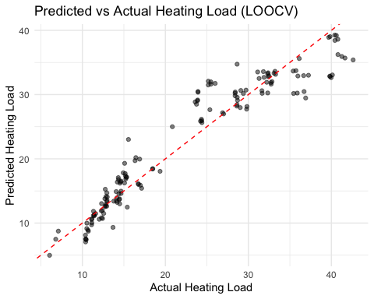

# Backward selection  
  
regfit.bwd <- regsubsets(Heating_Load ~ ., data=train_data, nvmax=6, method="backward")  
regfit.bwd.summary <- summary(regfit.bwd)  
print(regfit.bwd.summary)

## Subset selection object  
## Call: regsubsets.formula(Heating_Load ~ ., data = train_data, nvmax = 6,   
## method = "backward")  
## 6 Variables (and intercept)  
## Forced in Forced out  
## Relative_Compactness FALSE FALSE  
## Wall_Area FALSE FALSE  
## Overall_Height FALSE FALSE  
## Orientation FALSE FALSE  
## Glazing_Area FALSE FALSE  
## Glazing_Area_Distribution FALSE FALSE  
## 1 subsets of each size up to 6  
## Selection Algorithm: backward  
## Relative_Compactness Wall_Area Overall_Height Orientation Glazing_Area  
## 1 ( 1 ) " " " " "*" " " " "   
## 2 ( 1 ) " " " " "*" " " "*"   
## 3 ( 1 ) " " "*" "*" " " "*"   
## 4 ( 1 ) "*" "*" "*" " " "*"   
## 5 ( 1 ) "*" "*" "*" " " "*"   
## 6 ( 1 ) "*" "*" "*" "*" "*"   
## Glazing_Area_Distribution  
## 1 ( 1 ) " "   
## 2 ( 1 ) " "   
## 3 ( 1 ) " "   
## 4 ( 1 ) " "   
## 5 ( 1 ) "*"   
## 6 ( 1 ) "*"

which.min(regfit.bwd.summary$bic)

## [1] 5

coef(regfit.bwd, which.min(regfit.bwd.summary$bic))

## (Intercept) Relative_Compactness Wall_Area   
## -13.68086004 -13.35680683 0.03743411   
## Overall_Height Glazing_Area Glazing_Area_Distribution   
## 5.52701504 19.57350701 0.23853042

cv.errors.bwd <- rep(NA,6)  
mae.bwd <- rep(NA,6)  
cv.r2.bwd <- rep(NA,6)  
test.mat=model.matrix(Heating_Load ~ ., data=building_data_reduced[-trainIndex,])  
for (i in 1:6) {  
   
 coefi=coef(regfit.bwd,id=i)  
 pred=test.mat[,names(coefi)] %*% coefi  
 cv.errors.bwd[i]=mean((building_data_reduced$Heating_Load[-trainIndex]-pred)^2)  
 cv.r2.bwd[i] <- 1 - sum((pred-building_data_reduced$Heating_Load[-trainIndex])^2) / sum((building_data_reduced$Heating_Load[-trainIndex] - mean(building_data_reduced$Heating_Load[-trainIndex]))^2)  
 mae.bwd[i] <- mean(abs(building_data_reduced$Heating_Load[-trainIndex]-pred))  
}  
rmse_bwd <- sqrt(cv.errors.bwd)  
# Print the best model and its performance metrics  
best_model_index <- which.min(regfit.bwd.summary$bic)  
best_model_coefs <- coef(regfit.bwd, best_model_index)  
  
cat("Best Model:\n")

## Best Model:

print(best_model_coefs)

## (Intercept) Relative_Compactness Wall_Area   
## -13.68086004 -13.35680683 0.03743411   
## Overall_Height Glazing_Area Glazing_Area_Distribution   
## 5.52701504 19.57350701 0.23853042

cat("\nPerformance Metrics for the Best Model:\n")

##   
## Performance Metrics for the Best Model:

cat("RMSE:", rmse_bwd[best_model_index], "\n")

## RMSE: 2.974837

cat("MAE:", mae.bwd[best_model_index], "\n")

## MAE: 2.161401

cat("R-squared:", cv.r2.bwd[best_model_index], "\n")

## R-squared: 0.9150329

# Visualization: Plot of BIC scores  
ggplot(data.frame(vars = 1:6, bic = regfit.bwd.summary$bic), aes(x = vars, y = bic)) +  
 geom_line() +  
 geom_point() +  
 labs(title = "BIC Scores for Backward Selection",  
 x = "Number of Variables",  
 y = "BIC") +  
 theme_minimal()

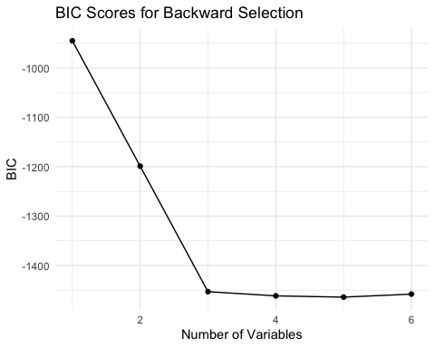

# Visualization: Plot of RMSE, MAE, and R-squared  
performance_df <- data.frame(  
 vars = 1:6,  
 RMSE = rmse_bwd,  
 MAE = mae.bwd,  
 R_squared = cv.r2.bwd  
)  
  
ggplot(performance_df, aes(x = vars)) +  
 geom_line(aes(y = RMSE, color = "RMSE")) +  
 geom_line(aes(y = MAE, color = "MAE")) +  
 geom_line(aes(y = R_squared, color = "R-squared")) +  
 labs(title = "Performance Metrics for Backward Selection",  
 x = "Number of Variables",  
 y = "Metric Value",  
 color = "Metric") +  
 theme_minimal()

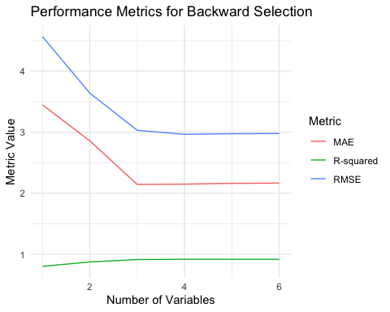

# Visualization: Variable Importance Plot  
var_importance <- data.frame(  
 Variable = names(coef(regfit.bwd, 6))[-1],  
 Importance = abs(coef(regfit.bwd, 6))[-1]  
)  
var_importance <- var_importance[order(-var_importance$Importance),]  
  
ggplot(var_importance, aes(x = reorder(Variable, Importance), y = Importance)) +  
 geom_bar(stat = "identity", fill = "skyblue") +  
 coord_flip() +  
 labs(title = "Variable Importance in Backward Selection",  
 x = "Variables",  
 y = "Absolute Coefficient Value") +  
 theme_minimal()

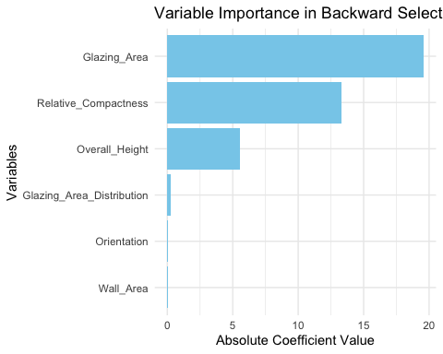

# Forward selection  
regfit.fwd <- regsubsets(Heating_Load ~ ., data=train_data, nvmax=6, method="forward")  
regfit.fwd.summary <- summary(regfit.fwd)  
print(regfit.fwd.summary)

## Subset selection object  
## Call: regsubsets.formula(Heating_Load ~ ., data = train_data, nvmax = 6,   
## method = "forward")  
## 6 Variables (and intercept)  
## Forced in Forced out  
## Relative_Compactness FALSE FALSE  
## Wall_Area FALSE FALSE  
## Overall_Height FALSE FALSE  
## Orientation FALSE FALSE  
## Glazing_Area FALSE FALSE  
## Glazing_Area_Distribution FALSE FALSE  
## 1 subsets of each size up to 6  
## Selection Algorithm: forward  
## Relative_Compactness Wall_Area Overall_Height Orientation Glazing_Area  
## 1 ( 1 ) " " " " "*" " " " "   
## 2 ( 1 ) " " " " "*" " " "*"   
## 3 ( 1 ) " " "*" "*" " " "*"   
## 4 ( 1 ) "*" "*" "*" " " "*"   
## 5 ( 1 ) "*" "*" "*" " " "*"   
## 6 ( 1 ) "*" "*" "*" "*" "*"   
## Glazing_Area_Distribution  
## 1 ( 1 ) " "   
## 2 ( 1 ) " "   
## 3 ( 1 ) " "   
## 4 ( 1 ) " "   
## 5 ( 1 ) "*"   
## 6 ( 1 ) "*"

which.min(regfit.fwd.summary$bic)

## [1] 5

coef(regfit.fwd, which.min(regfit.fwd.summary$bic))

## (Intercept) Relative_Compactness Wall_Area   
## -13.68086004 -13.35680683 0.03743411   
## Overall_Height Glazing_Area Glazing_Area_Distribution   
## 5.52701504 19.57350701 0.23853042

cv.errors.fwd <- rep(NA,6)  
mae.fwd <- rep(NA,6)  
cv.r2.fwd <- rep(NA,6)  
test.mat=model.matrix(Heating_Load ~ ., data=building_data_reduced[-trainIndex,])  
for (i in 1:6) {  
   
 coefi=coef(regfit.fwd,id=i)  
 pred=test.mat[,names(coefi)] %*% coefi  
 cv.errors.fwd[i]=mean((building_data_reduced$Heating_Load[-trainIndex]-pred)^2)  
 cv.r2.fwd[i] <- 1 - sum((pred-building_data_reduced$Heating_Load[-trainIndex])^2) / sum((building_data_reduced$Heating_Load[-trainIndex] - mean(building_data_reduced$Heating_Load[-trainIndex]))^2)  
 mae.fwd[i] <- mean(abs(building_data_reduced$Heating_Load[-trainIndex]-pred))  
}  
rmse_fwd <- sqrt(cv.errors.fwd)  
  
# Print the best model and its performance metrics  
best_model_index <- which.min(regfit.fwd.summary$bic)  
best_model_coefs <- coef(regfit.fwd, best_model_index)  
  
cat("Best Model:\n")

## Best Model:

print(best_model_coefs)

## (Intercept) Relative_Compactness Wall_Area   
## -13.68086004 -13.35680683 0.03743411   
## Overall_Height Glazing_Area Glazing_Area_Distribution   
## 5.52701504 19.57350701 0.23853042

cat("\nPerformance Metrics for the Best Model:\n")

##   
## Performance Metrics for the Best Model:

cat("RMSE:", rmse_fwd[best_model_index], "\n")

## RMSE: 2.974837

cat("MAE:", mae.fwd[best_model_index], "\n")

## MAE: 2.161401

cat("R-squared:", cv.r2.fwd[best_model_index], "\n")

## R-squared: 0.9150329

# Visualization: Plot of BIC scores  
ggplot(data.frame(vars = 1:6, bic = regfit.fwd.summary$bic), aes(x = vars, y = bic)) +  
 geom_line() +  
 geom_point() +  
 labs(title = "BIC Scores for Forward Selection",  
 x = "Number of Variables",  
 y = "BIC") +  
 theme_minimal()

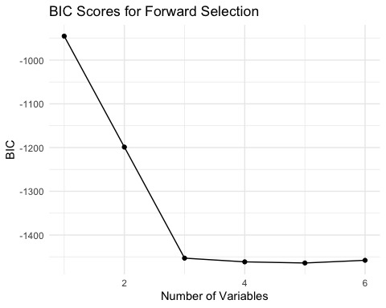

# Visualization: Plot of RMSE, MAE, and R-squared  
performance_df <- data.frame(  
 vars = 1:6,  
 RMSE = rmse_fwd,  
 MAE = mae.fwd,  
 R_squared = cv.r2.fwd  
)  
  
ggplot(performance_df, aes(x = vars)) +  
 geom_line(aes(y = RMSE, color = "RMSE")) +  
 geom_line(aes(y = MAE, color = "MAE")) +  
 geom_line(aes(y = R_squared, color = "R-squared")) +  
 labs(title = "Performance Metrics for Forward Selection",  
 x = "Number of Variables",  
 y = "Metric Value",  
 color = "Metric") +  
 theme_minimal()

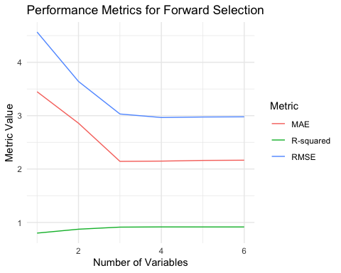

# Visualization: Variable Importance Plot  
var_importance <- data.frame(  
 Variable = names(coef(regfit.fwd, 6))[-1],  
 Importance = abs(coef(regfit.fwd, 6))[-1]  
)  
var_importance <- var_importance[order(-var_importance$Importance),]  
  
ggplot(var_importance, aes(x = reorder(Variable, Importance), y = Importance)) +  
 geom_bar(stat = "identity", fill = "skyblue") +  
 coord_flip() +  
 labs(title = "Variable Importance in Forward Selection",  
 x = "Variables",  
 y = "Absolute Coefficient Value") +  
 theme_minimal()

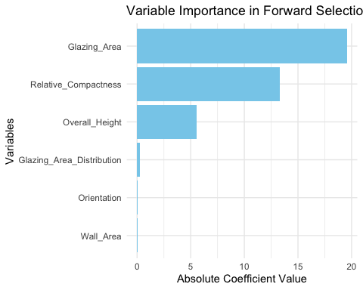

# Create interaction terms for all pairs of predictors  
interaction_formula <- as.formula(paste("Heating_Load ~ (", paste(names(building_data_reduced)[-which(names(building_data_reduced) == "Heating_Load")], collapse=" + "), ")^2"))

# Backward selection with interactions  
regfit.bwd.int <- regsubsets(interaction_formula, data=train_data, nvmax=20, method="backward")  
regfit.bwd.int.summary <- summary(regfit.bwd.int)  
print(regfit.bwd.int.summary)

## Subset selection object  
## Call: regsubsets.formula(interaction_formula, data = train_data, nvmax = 20,   
## method = "backward")  
## 21 Variables (and intercept)  
## Forced in Forced out  
## Relative_Compactness FALSE FALSE  
## Wall_Area FALSE FALSE  
## Overall_Height FALSE FALSE  
## Orientation FALSE FALSE  
## Glazing_Area FALSE FALSE  
## Glazing_Area_Distribution FALSE FALSE  
## Relative_Compactness:Wall_Area FALSE FALSE  
## Relative_Compactness:Overall_Height FALSE FALSE  
## Relative_Compactness:Orientation FALSE FALSE  
## Relative_Compactness:Glazing_Area FALSE FALSE  
## Relative_Compactness:Glazing_Area_Distribution FALSE FALSE  
## Wall_Area:Overall_Height FALSE FALSE  
## Wall_Area:Orientation FALSE FALSE  
## Wall_Area:Glazing_Area FALSE FALSE  
## Wall_Area:Glazing_Area_Distribution FALSE FALSE  
## Overall_Height:Orientation FALSE FALSE  
## Overall_Height:Glazing_Area FALSE FALSE  
## Overall_Height:Glazing_Area_Distribution FALSE FALSE  
## Orientation:Glazing_Area FALSE FALSE  
## Orientation:Glazing_Area_Distribution FALSE FALSE  
## Glazing_Area:Glazing_Area_Distribution FALSE FALSE  
## 1 subsets of each size up to 20  
## Selection Algorithm: backward  
## Relative_Compactness Wall_Area Overall_Height Orientation  
## 1 ( 1 ) " " " " "*" " "   
## 2 ( 1 ) " " " " "*" " "   
## 3 ( 1 ) " " " " "*" " "   
## 4 ( 1 ) " " " " "*" " "   
## 5 ( 1 ) " " " " "*" " "   
## 6 ( 1 ) " " " " "*" " "   
## 7 ( 1 ) "*" " " "*" " "   
## 8 ( 1 ) "*" " " "*" " "   
## 9 ( 1 ) "*" " " "*" " "   
## 10 ( 1 ) "*" " " "*" " "   
## 11 ( 1 ) "*" " " "*" " "   
## 12 ( 1 ) "*" " " "*" " "   
## 13 ( 1 ) "*" " " "*" " "   
## 14 ( 1 ) "*" " " "*" " "   
## 15 ( 1 ) "*" " " "*" " "   
## 16 ( 1 ) "*" " " "*" " "   
## 17 ( 1 ) "*" " " "*" "*"   
## 18 ( 1 ) "*" " " "*" "*"   
## 19 ( 1 ) "*" "*" "*" "*"   
## 20 ( 1 ) "*" "*" "*" "*"   
## Glazing_Area Glazing_Area_Distribution Relative_Compactness:Wall_Area  
## 1 ( 1 ) " " " " " "   
## 2 ( 1 ) " " " " " "   
## 3 ( 1 ) " " " " " "   
## 4 ( 1 ) " " " " "*"   
## 5 ( 1 ) " " " " "*"   
## 6 ( 1 ) " " " " "*"   
## 7 ( 1 ) " " " " "*"   
## 8 ( 1 ) " " " " "*"   
## 9 ( 1 ) "*" " " "*"   
## 10 ( 1 ) "*" " " "*"   
## 11 ( 1 ) "*" "*" "*"   
## 12 ( 1 ) "*" "*" "*"   
## 13 ( 1 ) "*" "*" "*"   
## 14 ( 1 ) "*" "*" "*"   
## 15 ( 1 ) "*" "*" "*"   
## 16 ( 1 ) "*" "*" "*"   
## 17 ( 1 ) "*" "*" "*"   
## 18 ( 1 ) "*" "*" "*"   
## 19 ( 1 ) "*" "*" "*"   
## 20 ( 1 ) "*" "*" "*"   
## Relative_Compactness:Overall_Height Relative_Compactness:Orientation  
## 1 ( 1 ) " " " "   
## 2 ( 1 ) " " " "   
## 3 ( 1 ) "*" " "   
## 4 ( 1 ) "*" " "   
## 5 ( 1 ) "*" " "   
## 6 ( 1 ) "*" " "   
## 7 ( 1 ) "*" " "   
## 8 ( 1 ) "*" " "   
## 9 ( 1 ) "*" " "   
## 10 ( 1 ) "*" " "   
## 11 ( 1 ) "*" " "   
## 12 ( 1 ) "*" " "   
## 13 ( 1 ) "*" " "   
## 14 ( 1 ) "*" " "   
## 15 ( 1 ) "*" "*"   
## 16 ( 1 ) "*" "*"   
## 17 ( 1 ) "*" "*"   
## 18 ( 1 ) "*" "*"   
## 19 ( 1 ) "*" "*"   
## 20 ( 1 ) "*" "*"   
## Relative_Compactness:Glazing_Area  
## 1 ( 1 ) " "   
## 2 ( 1 ) "*"   
## 3 ( 1 ) "*"   
## 4 ( 1 ) "*"   
## 5 ( 1 ) "*"   
## 6 ( 1 ) "*"   
## 7 ( 1 ) "*"   
## 8 ( 1 ) "*"   
## 9 ( 1 ) "*"   
## 10 ( 1 ) "*"   
## 11 ( 1 ) "*"   
## 12 ( 1 ) "*"   
## 13 ( 1 ) "*"   
## 14 ( 1 ) "*"   
## 15 ( 1 ) "*"   
## 16 ( 1 ) "*"   
## 17 ( 1 ) "*"   
## 18 ( 1 ) "*"   
## 19 ( 1 ) "*"   
## 20 ( 1 ) "*"   
## Relative_Compactness:Glazing_Area_Distribution  
## 1 ( 1 ) " "   
## 2 ( 1 ) " "   
## 3 ( 1 ) " "   
## 4 ( 1 ) " "   
## 5 ( 1 ) " "   
## 6 ( 1 ) " "   
## 7 ( 1 ) " "   
## 8 ( 1 ) " "   
## 9 ( 1 ) " "   
## 10 ( 1 ) " "   
## 11 ( 1 ) " "   
## 12 ( 1 ) " "   
## 13 ( 1 ) " "   
## 14 ( 1 ) "*"   
## 15 ( 1 ) "*"   
## 16 ( 1 ) "*"   
## 17 ( 1 ) "*"   
## 18 ( 1 ) "*"   
## 19 ( 1 ) "*"   
## 20 ( 1 ) "*"   
## Wall_Area:Overall_Height Wall_Area:Orientation Wall_Area:Glazing_Area  
## 1 ( 1 ) " " " " " "   
## 2 ( 1 ) " " " " " "   
## 3 ( 1 ) " " " " " "   
## 4 ( 1 ) " " " " " "   
## 5 ( 1 ) " " " " " "   
## 6 ( 1 ) " " " " " "   
## 7 ( 1 ) " " " " " "   
## 8 ( 1 ) "*" " " " "   
## 9 ( 1 ) "*" " " " "   
## 10 ( 1 ) "*" " " "*"   
## 11 ( 1 ) "*" " " "*"   
## 12 ( 1 ) "*" " " "*"   
## 13 ( 1 ) "*" " " "*"   
## 14 ( 1 ) "*" " " "*"   
## 15 ( 1 ) "*" " " "*"   
## 16 ( 1 ) "*" " " "*"   
## 17 ( 1 ) "*" " " "*"   
## 18 ( 1 ) "*" " " "*"   
## 19 ( 1 ) "*" " " "*"   
## 20 ( 1 ) "*" " " "*"   
## Wall_Area:Glazing_Area_Distribution Overall_Height:Orientation  
## 1 ( 1 ) " " " "   
## 2 ( 1 ) " " " "   
## 3 ( 1 ) " " " "   
## 4 ( 1 ) " " " "   
## 5 ( 1 ) " " " "   
## 6 ( 1 ) " " " "   
## 7 ( 1 ) " " " "   
## 8 ( 1 ) " " " "   
## 9 ( 1 ) " " " "   
## 10 ( 1 ) " " " "   
## 11 ( 1 ) " " " "   
## 12 ( 1 ) " " " "   
## 13 ( 1 ) "*" " "   
## 14 ( 1 ) "*" " "   
## 15 ( 1 ) "*" " "   
## 16 ( 1 ) "*" " "   
## 17 ( 1 ) "*" " "   
## 18 ( 1 ) "*" "*"   
## 19 ( 1 ) "*" "*"   
## 20 ( 1 ) "*" "*"   
## Overall_Height:Glazing_Area Overall_Height:Glazing_Area_Distribution  
## 1 ( 1 ) " " " "   
## 2 ( 1 ) " " " "   
## 3 ( 1 ) " " " "   
## 4 ( 1 ) " " " "   
## 5 ( 1 ) " " "*"   
## 6 ( 1 ) " " "*"   
## 7 ( 1 ) " " "*"   
## 8 ( 1 ) " " "*"   
## 9 ( 1 ) " " "*"   
## 10 ( 1 ) " " "*"   
## 11 ( 1 ) " " "*"   
## 12 ( 1 ) "*" "*"   
## 13 ( 1 ) "*" "*"   
## 14 ( 1 ) "*" "*"   
## 15 ( 1 ) "*" "*"   
## 16 ( 1 ) "*" "*"   
## 17 ( 1 ) "*" "*"   
## 18 ( 1 ) "*" "*"   
## 19 ( 1 ) "*" "*"   
## 20 ( 1 ) "*" "*"   
## Orientation:Glazing_Area Orientation:Glazing_Area_Distribution  
## 1 ( 1 ) " " " "   
## 2 ( 1 ) " " " "   
## 3 ( 1 ) " " " "   
## 4 ( 1 ) " " " "   
## 5 ( 1 ) " " " "   
## 6 ( 1 ) " " " "   
## 7 ( 1 ) " " " "   
## 8 ( 1 ) " " " "   
## 9 ( 1 ) " " " "   
## 10 ( 1 ) " " " "   
## 11 ( 1 ) " " " "   
## 12 ( 1 ) " " " "   
## 13 ( 1 ) " " " "   
## 14 ( 1 ) " " " "   
## 15 ( 1 ) " " " "   
## 16 ( 1 ) " " "*"   
## 17 ( 1 ) " " "*"   
## 18 ( 1 ) " " "*"   
## 19 ( 1 ) " " "*"   
## 20 ( 1 ) "*" "*"   
## Glazing_Area:Glazing_Area_Distribution  
## 1 ( 1 ) " "   
## 2 ( 1 ) " "   
## 3 ( 1 ) " "   
## 4 ( 1 ) " "   
## 5 ( 1 ) " "   
## 6 ( 1 ) "*"   
## 7 ( 1 ) "*"   
## 8 ( 1 ) "*"   
## 9 ( 1 ) "*"   
## 10 ( 1 ) "*"   
## 11 ( 1 ) "*"   
## 12 ( 1 ) "*"   
## 13 ( 1 ) "*"   
## 14 ( 1 ) "*"   
## 15 ( 1 ) "*"   
## 16 ( 1 ) "*"   
## 17 ( 1 ) "*"   
## 18 ( 1 ) "*"   
## 19 ( 1 ) "*"   
## 20 ( 1 ) "*"

# Forward selection with interactions  
regfit.fwd.int <- regsubsets(interaction_formula, data=train_data, nvmax=20, method="forward")  
regfit.fwd.int.summary <- summary(regfit.fwd.int)  
print(regfit.fwd.int.summary)

## Subset selection object  
## Call: regsubsets.formula(interaction_formula, data = train_data, nvmax = 20,   
## method = "forward")  
## 21 Variables (and intercept)  
## Forced in Forced out  
## Relative_Compactness FALSE FALSE  
## Wall_Area FALSE FALSE  
## Overall_Height FALSE FALSE  
## Orientation FALSE FALSE  
## Glazing_Area FALSE FALSE  
## Glazing_Area_Distribution FALSE FALSE  
## Relative_Compactness:Wall_Area FALSE FALSE  
## Relative_Compactness:Overall_Height FALSE FALSE  
## Relative_Compactness:Orientation FALSE FALSE  
## Relative_Compactness:Glazing_Area FALSE FALSE  
## Relative_Compactness:Glazing_Area_Distribution FALSE FALSE  
## Wall_Area:Overall_Height FALSE FALSE  
## Wall_Area:Orientation FALSE FALSE  
## Wall_Area:Glazing_Area FALSE FALSE  
## Wall_Area:Glazing_Area_Distribution FALSE FALSE  
## Overall_Height:Orientation FALSE FALSE  
## Overall_Height:Glazing_Area FALSE FALSE  
## Overall_Height:Glazing_Area_Distribution FALSE FALSE  
## Orientation:Glazing_Area FALSE FALSE  
## Orientation:Glazing_Area_Distribution FALSE FALSE  
## Glazing_Area:Glazing_Area_Distribution FALSE FALSE  
## 1 subsets of each size up to 20  
## Selection Algorithm: forward  
## Relative_Compactness Wall_Area Overall_Height Orientation  
## 1 ( 1 ) " " " " " " " "   
## 2 ( 1 ) " " " " " " " "   
## 3 ( 1 ) " " " " " " " "   
## 4 ( 1 ) " " " " " " " "   
## 5 ( 1 ) " " " " " " " "   
## 6 ( 1 ) " " " " " " " "   
## 7 ( 1 ) " " " " " " " "   
## 8 ( 1 ) " " " " " " " "   
## 9 ( 1 ) " " " " " " " "   
## 10 ( 1 ) " " " " "*" " "   
## 11 ( 1 ) " " " " "*" " "   
## 12 ( 1 ) "*" " " "*" " "   
## 13 ( 1 ) "*" " " "*" " "   
## 14 ( 1 ) "*" " " "*" " "   
## 15 ( 1 ) "*" "*" "*" " "   
## 16 ( 1 ) "*" "*" "*" " "   
## 17 ( 1 ) "*" "*" "*" " "   
## 18 ( 1 ) "*" "*" "*" " "   
## 19 ( 1 ) "*" "*" "*" " "   
## 20 ( 1 ) "*" "*" "*" "*"   
## Glazing_Area Glazing_Area_Distribution Relative_Compactness:Wall_Area  
## 1 ( 1 ) " " " " " "   
## 2 ( 1 ) " " " " " "   
## 3 ( 1 ) " " " " " "   
## 4 ( 1 ) " " " " " "   
## 5 ( 1 ) "*" " " " "   
## 6 ( 1 ) "*" " " "*"   
## 7 ( 1 ) "*" " " "*"   
## 8 ( 1 ) "*" "*" "*"   
## 9 ( 1 ) "*" "*" "*"   
## 10 ( 1 ) "*" "*" "*"   
## 11 ( 1 ) "*" "*" "*"   
## 12 ( 1 ) "*" "*" "*"   
## 13 ( 1 ) "*" "*" "*"   
## 14 ( 1 ) "*" "*" "*"   
## 15 ( 1 ) "*" "*" "*"   
## 16 ( 1 ) "*" "*" "*"   
## 17 ( 1 ) "*" "*" "*"   
## 18 ( 1 ) "*" "*" "*"   
## 19 ( 1 ) "*" "*" "*"   
## 20 ( 1 ) "*" "*" "*"   
## Relative_Compactness:Overall_Height Relative_Compactness:Orientation  
## 1 ( 1 ) " " " "   
## 2 ( 1 ) " " " "   
## 3 ( 1 ) " " " "   
## 4 ( 1 ) " " " "   
## 5 ( 1 ) " " " "   
## 6 ( 1 ) " " " "   
## 7 ( 1 ) " " " "   
## 8 ( 1 ) " " " "   
## 9 ( 1 ) " " " "   
## 10 ( 1 ) " " " "   
## 11 ( 1 ) "*" " "   
## 12 ( 1 ) "*" " "   
## 13 ( 1 ) "*" " "   
## 14 ( 1 ) "*" " "   
## 15 ( 1 ) "*" " "   
## 16 ( 1 ) "*" "*"   
## 17 ( 1 ) "*" "*"   
## 18 ( 1 ) "*" "*"   
## 19 ( 1 ) "*" "*"   
## 20 ( 1 ) "*" "*"   
## Relative_Compactness:Glazing_Area  
## 1 ( 1 ) " "   
## 2 ( 1 ) " "   
## 3 ( 1 ) " "   
## 4 ( 1 ) " "   
## 5 ( 1 ) " "   
## 6 ( 1 ) " "   
## 7 ( 1 ) "*"   
## 8 ( 1 ) "*"   
## 9 ( 1 ) "*"   
## 10 ( 1 ) "*"   
## 11 ( 1 ) "*"   
## 12 ( 1 ) "*"   
## 13 ( 1 ) "*"   
## 14 ( 1 ) "*"   
## 15 ( 1 ) "*"   
## 16 ( 1 ) "*"   
## 17 ( 1 ) "*"   
## 18 ( 1 ) "*"   
## 19 ( 1 ) "*"   
## 20 ( 1 ) "*"   
## Relative_Compactness:Glazing_Area_Distribution  
## 1 ( 1 ) " "   
## 2 ( 1 ) " "   
## 3 ( 1 ) " "   
## 4 ( 1 ) " "   
## 5 ( 1 ) " "   
## 6 ( 1 ) " "   
## 7 ( 1 ) " "   
## 8 ( 1 ) " "   
## 9 ( 1 ) " "   
## 10 ( 1 ) " "   
## 11 ( 1 ) " "   
## 12 ( 1 ) " "   
## 13 ( 1 ) " "   
## 14 ( 1 ) "*"   
## 15 ( 1 ) "*"   
## 16 ( 1 ) "*"   
## 17 ( 1 ) "*"   
## 18 ( 1 ) "*"   
## 19 ( 1 ) "*"   
## 20 ( 1 ) "*"   
## Wall_Area:Overall_Height Wall_Area:Orientation Wall_Area:Glazing_Area  
## 1 ( 1 ) "*" " " " "   
## 2 ( 1 ) "*" " " " "   
## 3 ( 1 ) "*" " " " "   
## 4 ( 1 ) "*" " " " "   
## 5 ( 1 ) "*" " " " "   
## 6 ( 1 ) "*" " " " "   
## 7 ( 1 ) "*" " " " "   
## 8 ( 1 ) "*" " " " "   
## 9 ( 1 ) "*" " " "*"   
## 10 ( 1 ) "*" " " "*"   
## 11 ( 1 ) "*" " " "*"   
## 12 ( 1 ) "*" " " "*"   
## 13 ( 1 ) "*" " " "*"   
## 14 ( 1 ) "*" " " "*"   
## 15 ( 1 ) "*" " " "*"   
## 16 ( 1 ) "*" " " "*"   
## 17 ( 1 ) "*" " " "*"   
## 18 ( 1 ) "*" "*" "*"   
## 19 ( 1 ) "*" "*" "*"   
## 20 ( 1 ) "*" "*" "*"   
## Wall_Area:Glazing_Area_Distribution Overall_Height:Orientation  
## 1 ( 1 ) " " " "   
## 2 ( 1 ) " " " "   
## 3 ( 1 ) " " " "   
## 4 ( 1 ) " " " "   
## 5 ( 1 ) " " " "   
## 6 ( 1 ) " " " "   
## 7 ( 1 ) " " " "   
## 8 ( 1 ) " " " "   
## 9 ( 1 ) " " " "   
## 10 ( 1 ) " " " "   
## 11 ( 1 ) " " " "   
## 12 ( 1 ) " " " "   
## 13 ( 1 ) "*" " "   
## 14 ( 1 ) "*" " "   
## 15 ( 1 ) "*" " "   
## 16 ( 1 ) "*" " "   
## 17 ( 1 ) "*" " "   
## 18 ( 1 ) "*" " "   
## 19 ( 1 ) "*" "*"   
## 20 ( 1 ) "*" "*"   
## Overall_Height:Glazing_Area Overall_Height:Glazing_Area_Distribution  
## 1 ( 1 ) " " " "   
## 2 ( 1 ) "*" " "   
## 3 ( 1 ) "*" "*"   
## 4 ( 1 ) "*" "*"   
## 5 ( 1 ) "*" "*"   
## 6 ( 1 ) "*" "*"   
## 7 ( 1 ) "*" "*"   
## 8 ( 1 ) "*" "*"   
## 9 ( 1 ) "*" "*"   
## 10 ( 1 ) "*" "*"   
## 11 ( 1 ) "*" "*"   
## 12 ( 1 ) "*" "*"   
## 13 ( 1 ) "*" "*"   
## 14 ( 1 ) "*" "*"   
## 15 ( 1 ) "*" "*"   
## 16 ( 1 ) "*" "*"   
## 17 ( 1 ) "*" "*"   
## 18 ( 1 ) "*" "*"   
## 19 ( 1 ) "*" "*"   
## 20 ( 1 ) "*" "*"   
## Orientation:Glazing_Area Orientation:Glazing_Area_Distribution  
## 1 ( 1 ) " " " "   
## 2 ( 1 ) " " " "   
## 3 ( 1 ) " " " "   
## 4 ( 1 ) " " " "   
## 5 ( 1 ) " " " "   
## 6 ( 1 ) " " " "   
## 7 ( 1 ) " " " "   
## 8 ( 1 ) " " " "   
## 9 ( 1 ) " " " "   
## 10 ( 1 ) " " " "   
## 11 ( 1 ) " " " "   
## 12 ( 1 ) " " " "   
## 13 ( 1 ) " " " "   
## 14 ( 1 ) " " " "   
## 15 ( 1 ) " " " "   
## 16 ( 1 ) " " " "   
## 17 ( 1 ) " " "*"   
## 18 ( 1 ) " " "*"   
## 19 ( 1 ) " " "*"   
## 20 ( 1 ) " " "*"   
## Glazing_Area:Glazing_Area_Distribution  
## 1 ( 1 ) " "   
## 2 ( 1 ) " "   
## 3 ( 1 ) " "   
## 4 ( 1 ) "*"   
## 5 ( 1 ) "*"   
## 6 ( 1 ) "*"   
## 7 ( 1 ) "*"   
## 8 ( 1 ) "*"   
## 9 ( 1 ) "*"   
## 10 ( 1 ) "*"   
## 11 ( 1 ) "*"   
## 12 ( 1 ) "*"   
## 13 ( 1 ) "*"   
## 14 ( 1 ) "*"   
## 15 ( 1 ) "*"   
## 16 ( 1 ) "*"   
## 17 ( 1 ) "*"   
## 18 ( 1 ) "*"   
## 19 ( 1 ) "*"   
## 20 ( 1 ) "*"

# Function to calculate performance metrics  
calculate_metrics <- function(predictions, actual) {  
 mse <- mean((actual - predictions)^2)  
 rmse <- sqrt(mse)  
 mae <- mean(abs(actual - predictions))  
 r_squared <- 1 - sum((actual - predictions)^2) / sum((actual - mean(actual))^2)  
   
 return(list(mse=mse, rmse=rmse, mae=mae, r_squared=r_squared))  
}

# Evaluate backward selection model with interactions  
best_bwd_model_int <- lm(as.formula(paste("Heating_Load ~", paste(names(coef(regfit.bwd.int, which.min(regfit.bwd.int.summary$bic)))[-1], collapse=" + "))), data=train_data)   
  
bwd_predictions_int <- predict(best_bwd_model_int,newdata=test_data)   
  
bwd_metrics_int<-calculate_metrics(bwd_predictions_int,test_data$Heating_Load)

# Evaluate forward selection model with interactions  
best_fwd_model_int<-lm(as.formula(paste("Heating_Load ~", paste(names(coef(regfit.fwd.int, which.min(regfit.fwd.int.summary$bic)))[-1], collapse=" + "))), data=train_data)   
  
fwd_predictions_int<-predict(best_fwd_model_int,newdata=test_data)   
  
fwd_metrics_int<-calculate_metrics(fwd_predictions_int,test_data$Heating_Load)

# Visualization : Performance Metrics Comparison  
metrics_df <- data.frame(  
 Model = c("Backward", "Forward"),  
 RMSE = c(bwd_metrics_int$rmse, fwd_metrics_int$rmse),  
 MAE = c(bwd_metrics_int$mae, fwd_metrics_int$mae),  
 R_squared = c(bwd_metrics_int$r_squared, fwd_metrics_int$r_squared)  
)  
  
ggplot(metrics_df, aes(x = Model)) +  
 geom_bar(aes(y = RMSE, fill = "RMSE"), stat = "identity", position = "dodge") +  
 geom_bar(aes(y = MAE, fill = "MAE"), stat = "identity", position = "dodge") +  
 geom_point(aes(y = R_squared, color = "R-squared")) +  
 scale_y_continuous(sec.axis = sec_axis(~., name = "R-squared")) +  
 labs(title = "Performance Metrics Comparison",  
 y = "Error Metrics",  
 fill = "Metric",  
 color = "Metric") +  
 theme_minimal()

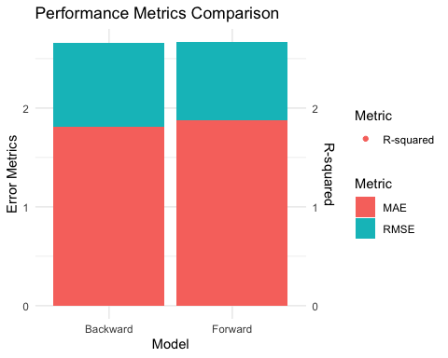

# Visualization: Predicted vs Actual Plot  
plot_predictions <- function(predictions, actual, title) {  
 ggplot(data.frame(Predicted = predictions, Actual = actual), aes(x = Actual, y = Predicted)) +  
 geom_point(alpha = 0.5) +  
 geom_abline(intercept = 0, slope = 1, color = "red", linetype = "dashed") +  
 labs(title = title,  
 x = "Actual Heating Load",  
 y = "Predicted Heating Load") +  
 theme_minimal()  
}  
  
bwd_plot <- plot_predictions(bwd_predictions_int, test_data$Heating_Load, "Backward Selection: Predicted vs Actual")  
fwd_plot <- plot_predictions(fwd_predictions_int, test_data$Heating_Load, "Forward Selection: Predicted vs Actual")  
  
grid.arrange(bwd_plot, fwd_plot, ncol = 2)

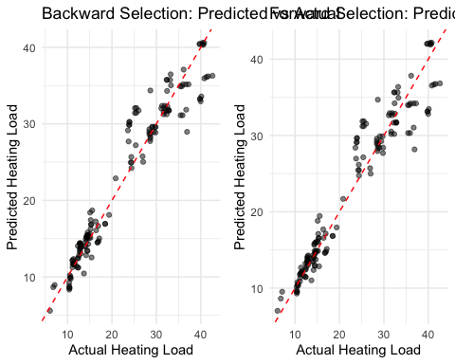

library(glmnet)

## Loading required package: Matrix

## Loaded glmnet 4.1-8

# Prepare the data  
x <- as.matrix(train_data[, !names(train_data) %in% c("Heating_Load")])  
y <- train_data$Heating_Load  
  
# Fit Lasso model  
lasso_model <- cv.glmnet(x, y, alpha = 1)  
  
# Make predictions on test data  
x_test <- as.matrix(test_data[, !names(test_data) %in% c("Heating_Load")])  
lasso_predictions <- predict(lasso_model, newx = x_test, s = "lambda.min")  
  
# Calculate performance metrics  
lasso_rmse <- sqrt(mean((test_data$Heating_Load - lasso_predictions)^2))  
lasso_rsq <- 1 - sum((test_data$Heating_Load - lasso_predictions)^2) / sum((test_data$Heating_Load - mean(test_data$Heating_Load))^2)  
  
cat("Lasso Regression Results:\n")

## Lasso Regression Results:

cat("RMSE:", lasso_rmse, "\n")

## RMSE: 2.982335

cat("R-squared:", lasso_rsq, "\n")

## R-squared: 0.9146041

# Fit Ridge model  
ridge_model <- cv.glmnet(x, y, alpha = 0)  
  
# Make predictions on test data  
ridge_predictions <- predict(ridge_model, newx = x_test, s = "lambda.min")  
  
# Calculate performance metrics  
ridge_rmse <- sqrt(mean((test_data$Heating_Load - ridge_predictions)^2))  
ridge_rsq <- 1 - sum((test_data$Heating_Load - ridge_predictions)^2) / sum((test_data$Heating_Load - mean(test_data$Heating_Load))^2)  
  
cat("Ridge Regression Results:\n")

## Ridge Regression Results:

cat("RMSE:", ridge_rmse, "\n")

## RMSE: 3.244605

cat("R-squared:", ridge_rsq, "\n")

## R-squared: 0.898924

# Visualizations for all models  
  
# Function to create predicted vs actual plots  
plot_predictions_vs_actual <- function(predictions, actual_values, title) {  
 data <- data.frame(Predicted = as.vector(predictions), Actual = actual_values)  
 ggplot(data, aes(x = Actual, y = Predicted)) +  
 geom_point(color = 'blue', alpha = 0.5) +  
 geom_abline(slope = 1, intercept = 0, color = 'red', linetype = 'dashed') +  
 labs(title = title, x = "Actual Heating Load", y = "Predicted Heating Load") +  
 theme_minimal()  
}  
  
po_lm <- plot_predictions_vs_actual(predict(lm_model, newdata = test_data),   
 test_data$Heating_Load,   
 "Basic Linear Regression Model: Predicted vs Actual")  
  
p1_cv <- plot_predictions_vs_actual(predict(lm_model_cv, newdata = test_data),   
 test_data$Heating_Load,   
 "CV Model: Predicted vs Actual")  
  
p2_loocv <- plot_predictions_vs_actual(predict(lm_model_loocv, newdata = test_data),   
 test_data$Heating_Load,   
 "LOOCV Model: Predicted vs Actual")  
  
p3_backward <- plot_predictions_vs_actual(predict(best_bwd_model_int, newdata = test_data),   
 test_data$Heating_Load,   
 "Backward Selection: Predicted vs Actual")  
  
p4_forward <- plot_predictions_vs_actual(predict(best_fwd_model_int, newdata = test_data),   
 test_data$Heating_Load,   
 "Forward Selection: Predicted vs Actual")  
  
p5_backward_int <- plot_predictions_vs_actual(bwd_predictions_int,   
 test_data$Heating_Load,   
 "Backward Selection with Interactions: Predicted vs Actual")  
  
p6_forward_int <- plot_predictions_vs_actual(fwd_predictions_int,   
 test_data$Heating_Load,   
 "Forward Selection with Interactions: Predicted vs Actual")  
  
p7_lasso <- plot_predictions_vs_actual(lasso_predictions,   
 test_data$Heating_Load,   
 "Lasso Regression: Predicted vs Actual")  
  
p8_ridge <- plot_predictions_vs_actual(ridge_predictions,   
 test_data$Heating_Load,   
 "Ridge Regression: Predicted vs Actual")  
  
po_lm

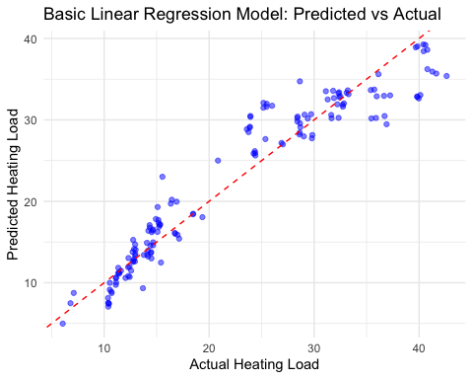

p1_cv

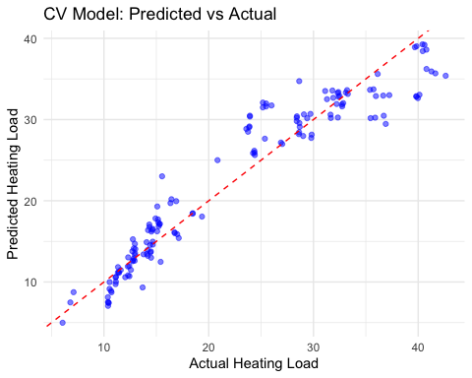

p2_loocv

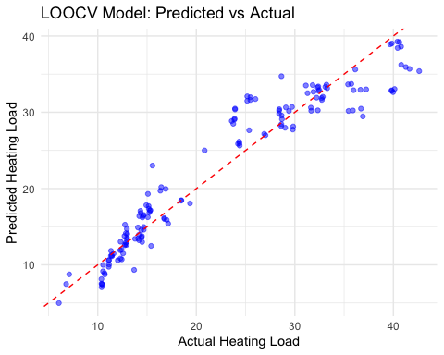

p3_backward

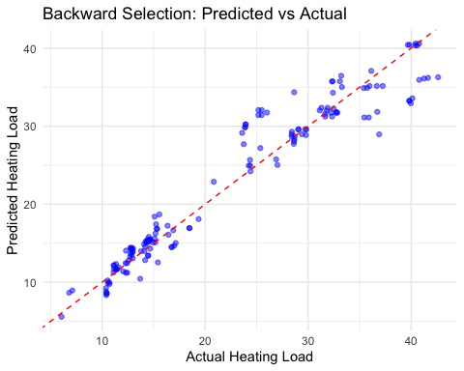

p4_forward

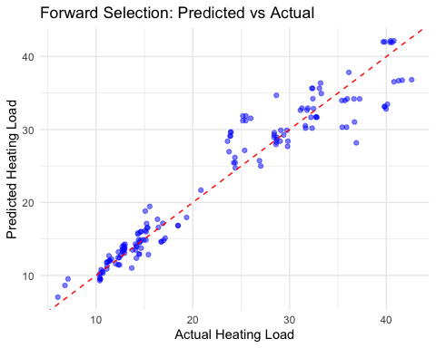

p5_backward_int

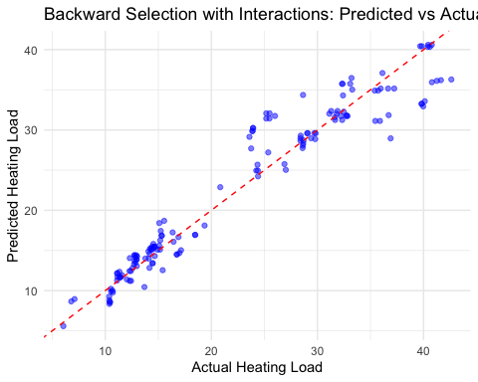

p6_forward_int

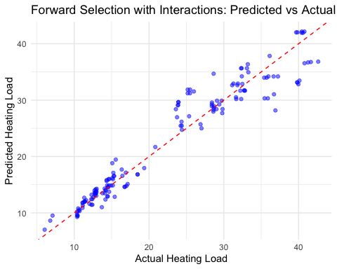

p7_lasso

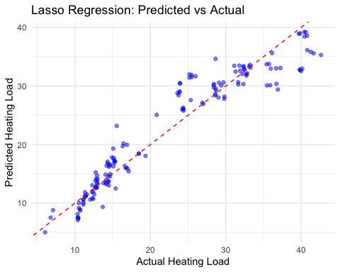

p8_ridge

