# Sahakar Maharshi Bhausaheb Santuji Thorat College Sangamner

Remark

Demonstrator’s Signature

Date:-

/

/20

DEPARTMENT OF COMPUTER SCIENCE

Sub : Mathematics

# Name:- Gorde Yash Somanath. Roll.No:-______Date:-_____________ Title of the expt:-linear programming problems _Page.no:-_____Class:-____________

__________________________________________________________________________________________

# Q1.Attempt any Two of the following

1. Write a Python program to plot 2D graph of the function f(x)=x3 in [-1,1]

->

import matplotlib.pyplot as plt import numpy as np

def f(x): return x**3

x=np.linspace(-1,1,100) y=f(x)

plt.plot(x,y)

plt.title("2D Graph") plt.xlabel("x")

plt.ylabel("f(x)") plt.show()

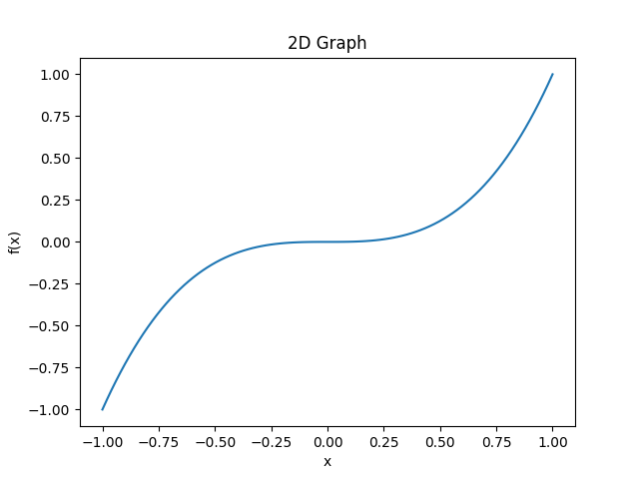

1. Write a Python program to plot 3D graph of the function f(x)=e-x2 in [-5,5] with green dashed points line with upward pointing triangle

->

import matplotlib.pyplot as plt

from mpl_toolkits.mplot3d import Axes3D import numpy as np

def f(x):

return np.exp(x**2) x=np.linspace(-5,5,100) y=f(x)

fig=plt.figure()

ax=fig.add_subplot(111,projection='3d') ax.plot(x,y,zs=0,zdir='z',color='green',linestyle='dashed',marker='^') ax.set_xlim(-5,5)

ax.set_ylim(0,np.exp(25))

ax.set_zlim(0,np.exp(25))

ax.set_xlabel('x') ax.set_ylabel('y') ax.set_zlabel('z') ax.set_title("3D Plot") plt.show()

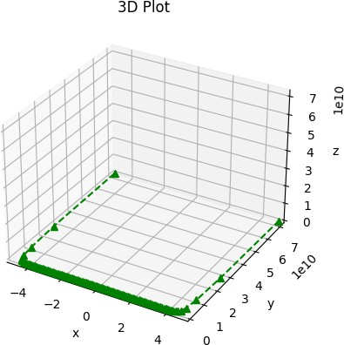

1. Using Python, Represent the following information using bar graph

|  |  |  |  |  |  |
| --- | --- | --- | --- | --- | --- |
| Item | Clothing | Food | rent | Petrol | Misc. |
| Expenditure in Rs | 600 | 4000 | 2000 | 1500 | 700 |

->

import matplotlib.pyplot as plt left=[1,2,3,4,5] height=[600,4000,2000,1500,700]

tick_label=['Clothing','Food','Rent','Petrol','Misc'] plt.bar(left,height,tick_label=tick_label, width=0.8,color=['green'])

plt.xlabel('Item') plt.ylabel('Expanditure') plt.title("")

plt.show()

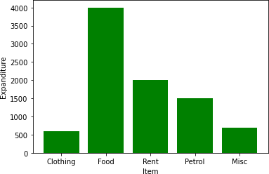

Q2) Attempt any TWO Of the Following

1. Write a python program to reflect the line segment joining the points A[5,3] and B[1,4] through the line Y=X+1

->

def reflect(point,line): x,y=point

a,b,c=line

x_reflected=(b**2-a**2)*x-2*a*b*y-2*a*c y_reflected=-2*a*b*x+(a**2-b**2)*y-2*b*c denominator=a**2+b**2

x_reflected /= denominator

y_reflected /=denominator return (x_reflected,y_reflected)

a,b,c=1,-1,-1 A=(5,3)

B=(1,4)

A_reflacted=reflect(A,(a,b,c)) B_reflacted=reflect(B,(a,b,c))

print("Reflectd point A :",A_reflacted) print("Reflected point B :",B_reflacted)

* 1. Write a python program to draw a polygon with vertices (0,0),(2,0),(2,3) and(1,6) and rotate it by 180⸰

->

import numpy as np

import matplotlib.pyplot as plt vertices=np.array([[0,0],[2,0],[2,3],[1,6]]) fig,ax=plt.subplots() ax.fill(vertices[:,0],vertices[:,1],'blue') theta=np.pi

rotation_matrix=np.array([[np.cos(theta),-np.sin(theta)],[np.sin(theta),np.cos( theta)]]) rotated_vertices=np.matmul(rotation_matrix,np.transpose(vertices)) ax.fill(rotated_vertices[0],rotated_vertices[1],'red')

plt.show()

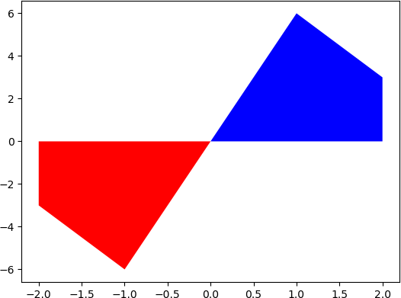

* 1. Write a python program to find the area and perimeter of the Δ ABC ,Where A[0,0],B[5,0],C[3,3]

->

import math A=[0,0]

B=[5,0]

C=[3,3]

AB=math.sqrt((B[0]-A[0])**2 + (B[1]-A[1])**2)

BC=math.sqrt((C[0]-B[0])**2 +(C[1]-B[1])**2)

CA=math.sqrt((A[0]-C[0])**2 +(A[1]-C[1])**2)

perimeter=AB+BC+CA s=perimeter /2

area=math.sqrt(s*(s-AB)*(s-BC)*(s-CA))

print("Area =",area) print("Perimeter =",perimeter)

Q3) Attempt the Following

* + 1. Attempt any one of the following
       1. Write a Python program to solve the following LPP : Max Z =150X+75Y

Subject to 4**x+6y** ≤ 24

5x+3y≤15

X ≥ 0, y ≥ 0

->

from scipy.optimize import linprog

obj=[150,75] lhs_eq=[[4,6],[5,3]] rhs_eq=[24,15]

bnd=[(0,float("inf")),(0,float("inf"))] opt=linprog(c=obj,A_eq=lhs_eq,b_eq=rhs_eq,bounds=bnd,method="highs")

print("Optimal Solution :\n",opt.x) print("Objective function value :\n",opt.fun)

* + - 1. Write a python program to display the following LPP by using pulp module and simplex method .Find its optimal solution if exist

Min Z=x + y

Subject to x≥6

y≥6

x + y≤11 x≥0,y≥0

**->**

from scipy.optimize import linprog obj=[1,1]

lhs_eq=[[1,0],[0,1],[1,1]]

rhs_eq=[6,6,11] bnd=[(0,float("inf")),(0,float("inf"))]

opt=linprog(c=obj,A_eq=lhs_eq,b_eq=rhs_eq,bounds=bnd,method="highs")

print("Optimal Solution :\n",opt.x) print("Objective function value :\n",opt.fun)

* + 1. Attempt any ONE of the following
       1. Apply python program in each of the following transformation on the point p[3,-1]

1. reflection through the X-axis
2. Scalling in x-cordinate by factor 2
3. Scalling in Y-cordinate by factor 1.5
4. reflection through the line y=x

->

p = [3, -1]

p_reflected = [p[0], -p[1]]

print("Point p after reflection through X-axis: ", p_reflected)

p_scaled = [2*p[0], p[1]]

print("Point p after scaling in x-coordinate by factor 2: ", p_scaled)

p_scaled = [p[0], 1.5*p[1]]

print("Point p after scaling in Y-coordinate by factor 1.5: ", p_scaled)

p_reflected = [p[1], p[0]]

print("Point p after reflection through the line y=x: ", p_reflected)

output :

Point p after reflection through X-axis: [3, 1]

Point p after scaling in x-coordinate by factor 2: [6, -1] Point p after scaling in Y-coordinate by factor 1.5: [3, -1.5] Point p after reflection through the line y=x: [-1, 3]

* + - 1. find the combined transformation of the line segment between the point A[5,-2] & B[4,3] by using Python program for the following sequence of transformation
         1. Rotation about origin through an angle π
         2. Scaling in X-cordinate by 2 units
         3. reflection through the line y=-x
         4. Shering in X direction by 4 units

->

import numpy as np

import matplotlib.pyplot as plt

# Define the two points as numpy arrays

A = np.array([5, -2])

B = np.array([4, 3])

# Define the transformation matrices R = np.array([[-1, 0],

[0, -1]])

Sx = np.array([[2, 0],

[0, 1]])

Ref = np.array([[-1/2, 1],

[1/2, 1]])

Shx = np.array([[1, 4],

[0, 1]])

# Apply the transformations to the two points

A = Shx @ Ref @ Sx @ R @ A

B = Shx @ Ref @ Sx @ R @ B

# Plot the original and transformed line segments plt.plot([5, 4], [-2, 3], 'b-', label='Original')

plt.plot([A[0], B[0]], [A[1], B[1]], 'r-', label='Transformed')

plt.legend() plt.show()