**Sahakar Maharshi Bhausaheb Santuji Thorat College Sangamner**

**Remark**

**Demonstrator’s Signature**

**Date:-**

**/**

**/20**

**DEPARTMENT OF COMPUTER SCIENCE**

**Sub : Mathematics**

**Name:-_Gorde Yash Somnath Roll.No:-_21_ _Date:- Title of the expt:- Slip no 11 Page.no:- Class:- BCS**

**Q1 . Attempt any TWO of the following**

**A ) Write a python program to plot 3D axes with labels as X-axis ,Y-axis and Z-axis and also pack following point with given Coordination in the same graph :(70,-25,15) as a diamond in black color**

**-**→

import matplotlib.pyplot as plt

from mpl_toolkits.mplot3d import Axes3D fig = plt.figure()

ax = fig.add_subplot(111, projection='3d')

ax.set_xlabel('X-axis') ax.set_ylabel('Y-axis') ax.set_zlabel('Z-axis') x, y, z = (70,-25,15)

ax.scatter(x, y, z, marker='D', color='black') plt.show()

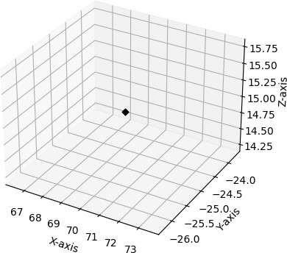

**B ) Plot the graph of y=e-x2 in [-5,5] with red dashed-points line with Upward Pointing triangle**

**-**→

import numpy as np

import matplotlib.pyplot as plt def f(x):

return np.exp(-x**2)

x = np.linspace(-5, 5, 100) y = f(x)

fig, ax = plt.subplots() ax.set_xlim([-5, 5])

ax.set_ylim([0, 1])

ax.plot(x, y, 'r-->', markersize=5) ax.set_xlabel('x') ax.set_ylabel('y')

plt.show()

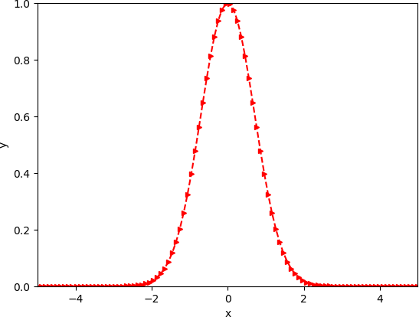

**C ) Draw a bar graph in GREEN colour to reprenset the data below :**

|  |  |  |  |  |  |
| --- | --- | --- | --- | --- | --- |
| **Subject** | **Maths** | **Science** | **English** | **Marathi** | **Hindi** |
| **Percentage of passing** | **68** | **90** | **70** | **85** | **91** |

**-**→

import matplotlib.pyplot as plt

subjects = ['Maths', 'Science', 'English', 'Marathi', 'Hindi'] percentages = [68, 90, 70, 85, 91]

fig, ax = plt.subplots() ax.set_ylim([0, 100])

ax.bar(subjects, percentages, color='green') ax.set_xlabel('Subject') ax.set_ylabel('Percentage of passing') plt.show()

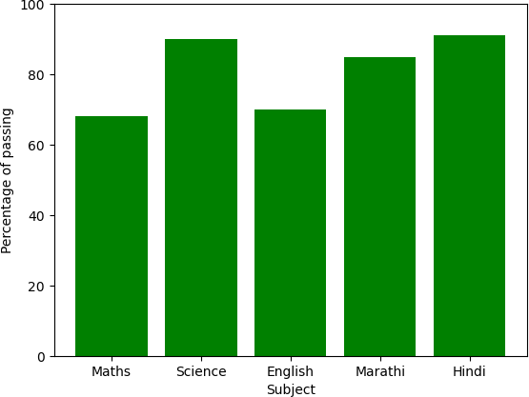

**Q2 ) Attempt any TWO of the following**

**I ) Write a python program to reflect the ∆ABC through the line Y=3 where A(1,0),B(2,-1),C(-1,3)**

**-**→

import numpy as np

import matplotlib.pyplot as plt

A = np.array([1, 0])

B = np.array([2, -1])

C = np.array([-1, 3])

triangle = np.array([A, B, C, A]) line = np.array([[-5, 3], [5, 3]])

translation_matrix = np.array([[1, 0, 0], [0, 1, -3], [0, 0, 1]])

reflection_matrix = np.array([[1, 0, 0], [0, -1, 0], [0, 0, 1]])

reflected_triangle = np.dot(reflection_matrix, np.concatenate((triangle.T, np.ones((1, 4))), axis=0)).T[:, :2]

inverse_translation_matrix = np.array([[1, 0, 0], [0, 1, 3], [0, 0, 1]])

reflected_triangle = np.dot(inverse_translation_matrix, np.concatenate((reflected_triangle.T, np.ones((1, 4))), axis=0)).T[:, :2]

fig, ax = plt.subplots()

ax.plot(triangle[:, 0], triangle[:, 1], label='ABC')

ax.plot(reflected_triangle[:, 0], reflected_triangle[:, 1], label='A\'B\'C\'')

ax.plot(line[:, 0], line[:, 1], 'k--', label='Y = 3')

ax.set_xlim([-5, 5])

ax.set_ylim([-5, 5]) ax.set_aspect('equal') ax.legend() plt.show()

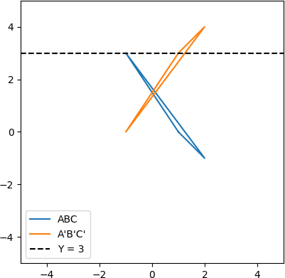

1. **) Write a python program to rotate the ∆ABC by 90⸰ where A(1,2),B(2,-2),C(-1,2)**

**-**→

import numpy as np

import matplotlib.pyplot as plt

A = np.array([1, 2])

B = np.array([2, -2])

C = np.array([-1, 2])

triangle = np.array([A, B, C, A])

angle = np.radians(90)

rotation_matrix = np.array([[np.cos(angle), -np.sin(angle)], [np.sin(angle), np.cos(angle)]])

rotated_triangle = np.dot(rotation_matrix, triangle.T).T

fig, ax = plt.subplots()

ax.plot(triangle[:, 0], triangle[:, 1], label='ABC')

ax.plot(rotated_triangle[:, 0], rotated_triangle[:, 1], label='A\'B\'C\'')

ax.set_xlim([-5, 5])

ax.set_ylim([-5, 5]) ax.set_aspect('equal') ax.legend() plt.show()

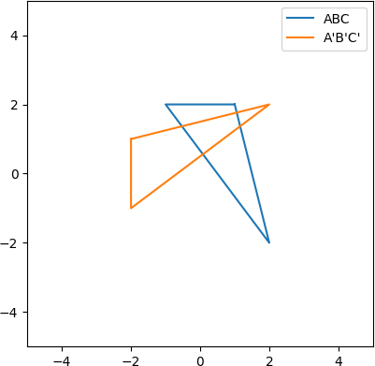

1. **) Write a python program to draw a polygon with 6 sides and radius 1 centered at (1,2) and find its area and perimeter**

**-**→

import matplotlib.pyplot as plt import numpy as np

x_center = 1

y_center = 2

n_sides = 6

radius = 1

angles = np.linspace(0, 2 * np.pi, n_sides, endpoint=True) x = x_center + radius * np.cos(angles)

y = y_center + radius * np.sin(angles) plt.plot(x, y)

plt.axis('equal') plt.show()

side_length = 2 * radius * np.sin(np.pi/n_sides) perimeter = n_sides * side_length

area = (n_sides * radius**2 * np.sin(2 * np.pi / n_sides))/2 print("Perimeter:", perimeter)

print("Area:", area) output :

Perimeter: 5.999999999999999

Area: 2.598076211353316

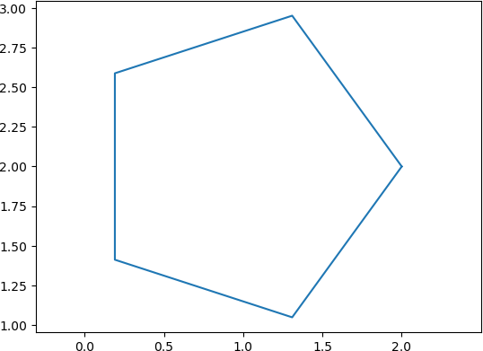

**Q3 ) Attempt any ONE of the following**

1. **) Attempt any ONE of the following**

**A ) Solve LPP by using Python : Min Z=x+y**

**Subject to x≥6**

**y≥6 x+y≥11 x,y≥0**

**-**→

from scipy.optimize import linprog c = [1, 1]

A = [[-1, 0], [0, -1], [-1, -1]]

b = [-6, -6, -11]

x_bounds = (0, None) y_bounds = (0, None)

res = linprog(c, A_ub=A, b_ub=b, bounds=[x_bounds, y_bounds])

print('Optimal value:', res.fun) print('x:', res.x[0])

print('y:', res.x[1])

output :

Optimal value: 12.0

x: 6.0

y: 6.0

**B) Write a python program to solve the following LPP and to find the optimal solution if exists**

**MAX Z=3x+5y +4z**

**Subject to 2x+3y≤8**

**2y+5z≤10**

**3x+2y+4z≤15 X,y,z≥0**

**-**→

import pulp

prob = pulp.LpProblem("LP problem", pulp.LpMaximize) x = pulp.LpVariable('x', lowBound=0, cat='Continuous')

y = pulp.LpVariable('y', lowBound=0, cat='Continuous')

z = pulp.LpVariable('z', lowBound=0, cat='Continuous') prob += 3*x + 5*y + 4*z

prob += 2*x + 3*y <= 8 prob += 2*y + 5*z <= 10

prob += 3*x + 2*y + 4*z <= 15 status = prob.solve()

print("Status:", pulp.LpStatus[status]) print("Optimal Solution:")

print("x =", pulp.value(x))

print("y =", pulp.value(y))

print("z =", pulp.value(z))

print("Optimal Value: Z =", pulp.value(prob.objective))

1. **) Attempt Any one of the following**
   1. **Write a python program to apply the following transformation on the point (-2,4) :**
      1. **Reflection through X-axis**
      2. **Scaling in X-coordinate by factor 6**
      3. **Scaling in x-direction by 4 units**
      4. **Rotate about origin through an angle 30⸰**

**-**→

import math point = [-2, 4]

reflected_point = [point[0], -1*point[1]]

print("I) Reflection through X-axis:", reflected_point)

scaled_point = [6*point[0], point[1]]

print("II) Scaling in X-coordinate by factor 6:", scaled_point)

shifted_point = [point[0] + 4, point[1]]

print("III) Scaling in x-direction by 4 units:", shifted_point)

angle = math.radians(30)

rotated_point = [point[0]*math.cos(angle) - point[1]*math.sin(angle), point[0]*math.sin(angle) + point[1]*math.cos(angle)]

print("IV) Rotate about origin through an angle 30⸰:", rotated_point)

Output :

1. Reflection through X-axis: [-2, -4]
2. Scaling in X-coordinate by factor 6: [-12, 4]
3. Scaling in x-direction by 4 units: [2, 4]
4. Rotate about origin through an angle 30⸰: [-3.732050807568877, 2.464101615137755]

**II )Write a python program to find the combined transformation between the points for the following sequence of transformation**

**A ) Rotation about origin through an angle** 𝝅

𝟐

**B ) uniform scaling by 3.5 units**

**C ) Scaling in X & Y direction by 3 & 5 units respectively**

**D ) shering in X direction by 6 units**

**-**→

import math

import numpy as np point = np.array([2, 5]) theta = math.pi/2

rotation_matrix = np.array([[math.cos(theta), -1*math.sin(theta)], [math.sin(theta), math.cos(theta)]])

point = rotation_matrix.dot(point)

print("After A) Rotation about origin through an angle π/2: ", point)

scaling_factor = 3.5

scaling_matrix = np.array([[scaling_factor, 0],

[0, scaling_factor]]) point = scaling_matrix.dot(point)

print("After B) Uniform scaling by 3.5 units: ", point)

scaling_factors = np.array([3, 5]) scaling_matrix = np.diag(scaling_factors) point = scaling_matrix.dot(point)

print("After C) Scaling in X & Y direction by 3 & 5 units respectively: ", point)

shearing_factor = 6

shearing_matrix = np.array([[1, shearing_factor],

[0, 1]])

point = shearing_matrix.dot(point)

print("After D) Shering in X direction by 6 units: ", point)

output :

After A) Rotation about origin through an angle π/2: [-5. 2.] After B) Uniform scaling by 3.5 units: [-17.5 7. ]

After C) Scaling in X & Y direction by 3 & 5 units respectively: [-52.5 35. ] After D) Shering in X direction by 6 units: [157.5 35. ]