**Sahakar Maharshi Bhausaheb Santuji Thorat College Sangamner**

**Remark Demonstrator’s Signature**

**Date:- / /20**

**DEPARTMENT OF COMPUTER SCIENCE**

**Sub : Mathematics**

**Name:-_Gorde Yash Somnath Roll.No:-_21 Date:- Title of the expt:- Slip no 15 Page.no:- Class:- BCS**

**Q1 ) Attempt any ONE of the following**

**A ) Write a python program to find the area of tringle ABC ,where A[0,0],B[5,0],C[3,3]**

**-**→

import numpy as np

A = np.array([0, 0])

B = np.array([5, 0])

C = np.array([3, 3])

area = 0.5 * np.abs(np.cross(B - A, C - A)) print("The area of triangle ABC is:", area)

output :

The area of triangle ABC is: 7.5

**B ) Write the python program to plot the graph of the function using def () F(x)={ x2 +4 if -10≤x<5 ,3x+9 if 5≤x<10}**

**-**→

import matplotlib.pyplot as plt import numpy as np

def F(x):

if -10 <= x < 5:

return x**2 + 4 elif 5 <= x < 10:

return 3*x + 9

x = np.arange(-10, 10, 0.1) y = [F(i) for i in x]

plt.plot(x, y)

plt.xlabel('x')

plt.ylabel('F(x)') plt.title('Graph of F(x)')

plt.show()

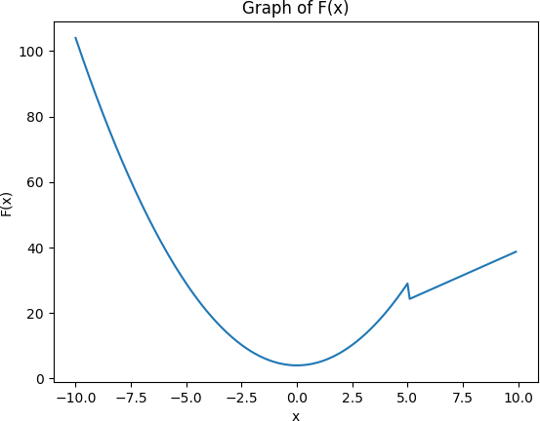

**C ) Write the python program to plot the graphs of sin x,cos x,ex ,x2 in[0,5] in one figure with 2x2 subplots**

**-**→

import numpy as np

import matplotlib.pyplot as plt x = np.arange(0, 5, 0.1)

fig, axs = plt.subplots(2, 2)

axs[0, 0].plot(x, np.sin(x))

axs[0, 0].set_title('sin x')

axs[0, 1].plot(x, np.cos(x))

axs[0, 1].set_title('cos x')

axs[1, 0].plot(x, np.exp(x))

axs[1, 0].set_title('e^x')

axs[1, 1].plot(x, x**2)

axs[1, 1].set_title('x^2')

for ax in axs.flat: ax.set(xlabel='x', ylabel='y')

fig.suptitle('Graphs of sin x, cos x, e^x, x^2') fig.tight_layout()

plt.show()

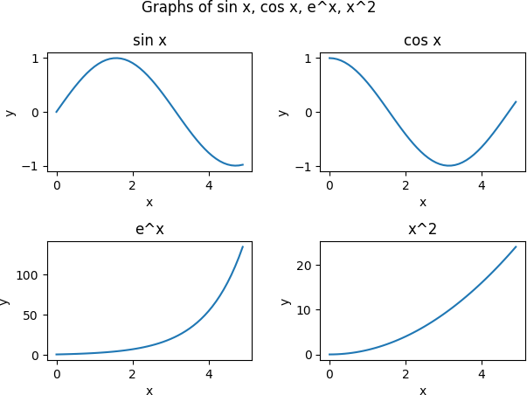

**Q 2 ) Attempt any TWO of the following**

**A ) Write the python program to rotate the triangle ABC by 180 degree, where a A[1,2],B[2,-2] & C[-1,2]**

**-**→

import matplotlib.pyplot as plt import numpy as np

A = np.array([1, 2])

B = np.array([2, -2])

C = np.array([-1, 2]) theta = np.pi

R = np.array([[np.cos(theta), -np.sin(theta)], [np.sin(theta), np.cos(theta)]])

A_rotated = R.dot(A) B_rotated = R.dot(B) C_rotated = R.dot(C)

fig, ax = plt.subplots(1, 2, figsize=(10, 5))

ax[0].set_title("Original Triangle") ax[0].plot([A[0], B[0]], [A[1], B[1]], 'b')

ax[0].plot([B[0], C[0]], [B[1], C[1]], 'b')

ax[0].plot([C[0], A[0]], [C[1], A[1]], 'b')

ax[1].set_title("Rotated Triangle")

ax[1].plot([A_rotated[0], B_rotated[0]], [A_rotated[1], B_rotated[1]], 'r')

ax[1].plot([B_rotated[0], C_rotated[0]], [B_rotated[1], C_rotated[1]], 'r')

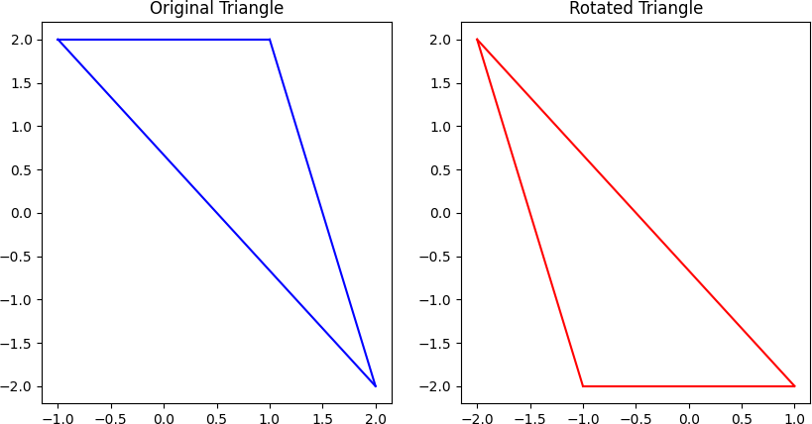ax[1].plot([C_rotated[0], A_rotated[0]], [C_rotated[1], A_rotated[1]], 'r') plt.show()

**B ) Write the python program to plot the graph of function f(x)=ex in the interval [-10,10]**

**-**→

import numpy as np

import matplotlib.pyplot as plt def f(x):

return np.exp(x)

x = np.linspace(-10, 10, 1000) y = f(x)

plt.plot(x, y)

plt.xlabel('x')

plt.ylabel('f(x)') plt.title('Graph of f(x) = e^x') plt.show()

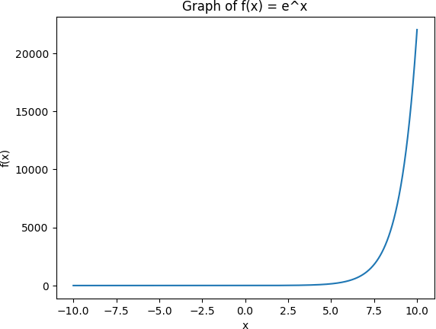

**C ) Write a python program to plot the 3D graph whose parametric equation in (cos(2x),sin(2x),x) for 10≤x≤20 (in red color), With title to the graph**

**-**→

import matplotlib.pyplot as plt

from mpl_toolkits.mplot3d import Axes3D import numpy as np

def f(x):

return np.cos(2*x), np.sin(2*x), x

x = np.linspace(10, 20, 1000) y1, y2, y3 = f(x)

fig = plt.figure()

ax = fig.add_subplot(111, projection='3d') ax.plot(y1, y2, y3, color='red')

ax.set_xlabel('X Axis') ax.set_ylabel('Y Axis') ax.set_zlabel('Z Axis')

plt.title('Graph of (cos(2x), sin(2x), x)') plt.show()

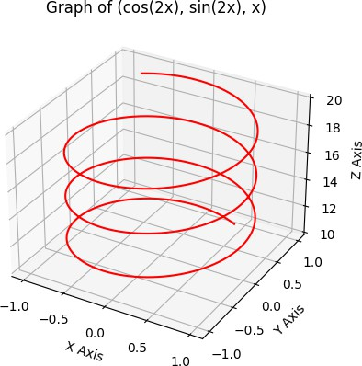

**Q3 ) Attempt the following**

**A ) Attempt any ONE of the following**

**I ) Write a python program to solve the following LPP :**

**Min Z=3.5x+2y Subject to x+y≥5**

**x≥4 y≤2 x,y≥0**

**-**→

from scipy.optimize import linprog c = [3.5, 2]

A = [[1, 1],

[-1, 0],

[0, 1]]

b = [5, -4, 2]

x_bounds = (0, None) y_bounds = (0, None)

result = linprog(c, A_ub=A, b_ub=b, bounds=[x_bounds, y_bounds])

print("Optimal value:", round(result.fun, 2)) print("Optimal point:", tuple(round(x, 2) for x in result.x))

output :

Optimal value: 14.0

Optimal point: (4.0, 0.0)

1. **Write a python program to solve the following LPP : Min Z=x+y**

**Subject to x≥6**

**y≥6 x+y≤11 x,y≥0**

**-**→

from scipy.optimize import linprog obj = [1, 1]

lhs = [[-1, 0], [0, -1], [1, 1]]

rhs = [-6, -6, 11]

bounds = [(0, None), (0, None)]

result = linprog(c=obj, A_ub=lhs, b_ub=rhs, bounds=bounds, method='simplex')

print("Status:", result.message) print("Optimal Solution:", result.fun) print("Optimal Decision Variables:", result.x)

output :

Optimal Solution: 12.0

Optimal Decision Variables: [6. 6.]

**B ) Attempt any ONE of the following**

**I ) Write a python program to find the combined transformation of the line segment between the points A[5,3] and B[1,4] for the following sequence of transformation**

* 1. **First rotation about origin through an angle π/2**
  2. **Followed by scaling in X-coordinate by 5 units**
  3. **Followed by reflection through the line y=x**

**-**→

import numpy as np

A = np.array([5, 3])

B = np.array([1, 4])

R = np.array([[0, -1], [1, 0]]) # Rotation matrix

S = np.array([[5, 0], [0, 1]]) # Scaling matrix

F = np.array([[0, 1], [1, 0]]) # Reflection matrix

def apply_transform(matrix, point): return np.dot(matrix, point)

AB = B - A # Vector representing the line segment AB AB_rot = apply_transform(R, AB) # Rotate the vector

AB_rot_scale = apply_transform(S, AB_rot) # Scale the vector AB_rot_scale_reflect = apply_transform(F, AB_rot_scale) # Reflect the vector

B_prime = A + AB_rot_scale_reflect

print(f"The coordinates of the new point B' are: {B_prime}")

output :

The coordinates of the new point B' are: [ 1 -2]

**II ) write a python program to apply each of the following transformation on the point P[- 2,4]**

**A )Reflection through the line y=x+1**

**B ) Scaling in Y-coordinate by factor 1.5**

**C ) Shering in X direction by 2 units**

**D ) Rotation about origin by an angle 45 degree**

**-**→

Import numpy as np P = np.array([-2, 4])

F = np.array([[-1/2**0.5, 1/2**0.5], [1/2**0.5, 1/2**0.5]]) P_reflect = np.dot(F, P)

print("Point P after reflection through the line y=x+1:", P_reflect)

S = np.array([[1, 0], [0, 1.5]])

P_scale = np.dot(S, P)

print("Point P after scaling in Y-coordinate by factor 1.5:", P_scale)

SH = np.array([[1, 2], [0, 1]])

P_shear = np.dot(SH, P)

print("Point P after shearing in X direction by 2 units:", P_shear)

theta = np.radians(45)

R = np.array([[np.cos(theta), -np.sin(theta)], [np.sin(theta), np.cos(theta)]]) P_rotate = np.dot(R, P)

print("Point P after rotation about origin by 45 degrees:", P_rotate)

Output :

Point P after reflection through the line y=x+1: [4.24264069 1.41421356] Point P after scaling in Y-coordinate by factor 1.5: [-2. 6.]

Point P after shearing in X direction by 2 units: [6 4]

Point P after rotation about origin by 45 degrees: [-4.24264069 1.41421356]