**Sahakar Maharshi Bhausaheb Santuji Thorat College Sangamner**

**Remark Demonstrator’s Signature**

**Date:- / /20**

**DEPARTMENT OF COMPUTER SCIENCE**

**Sub : Mathematics**

**Name:-_Gorde Yash Somnath Roll.No:-_21 Date:- Title of the expt:- Slip no 17 Page.no:- Class:- BCS**

# Q1 ) Attempt any TWO of the following

**A ) Write a python program to plot the 3D graph of the function z=x2+y2 in -6<x,y<6 using surface plot**

**-**→

import matplotlib.pyplot as plt

from mpl_toolkits.mplot3d import Axes3D import numpy as np

fig = plt.figure()

ax = fig.add_subplot(111, projection='3d') x = np.linspace(-6, 6, 100)

y = np.linspace(-6, 6, 100) X, Y = np.meshgrid(x, y)

Z = X**2 + Y**2

ax.plot_surface(X, Y, Z, cmap='cool') ax.set_xlabel('X')

ax.set_ylabel('Y') ax.set_zlabel('Z')

ax.set_title('3D Surface Plot of z=x^2+y^2') plt.show()

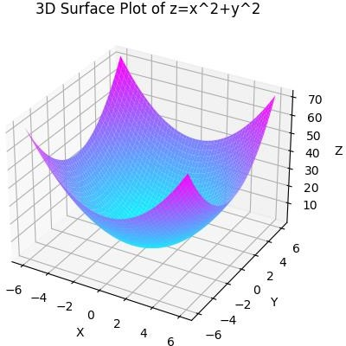

**B ) Write a python program to plot 3D countours for the function f(x,y)=log(x2y2) when -5≤x,y≤5 with greens color map**

**-**→

import numpy as np

import matplotlib.pyplot as plt

from mpl_toolkits.mplot3d import Axes3D def f(x, y):

return np.log(x**2 * y**2)

x = np.linspace(-5, 5, 100)

y = np.linspace(-5, 5, 100) X, Y = np.meshgrid(x, y) Z = f(X, Y)

fig = plt.figure()

ax = fig.add_subplot(111, projection='3d')

ax.contourf(X, Y, Z, cmap='Greens') ax.set_xlabel('X')

ax.set_ylabel('Y') ax.set_zlabel('Z')

ax.set_title('3D Countours for f(x,y)=log(x^2y^2)') plt.show()

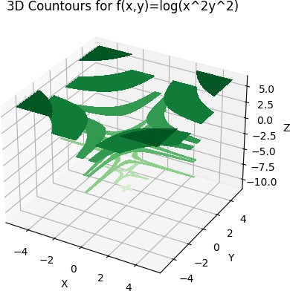

**C ) Write a python program to reflect the line segment joining the points A[-5,2] and B[1,3] through the line y=x**

**-**→

A = [-5, 2]

B = [1, 3]

def y_equals_x(x): return x

def reflect_point(point): x, y = point

return [y, x]

A_reflected = reflect_point(A) B_reflected = reflect_point(B)

print("A_reflected:", A_reflected) print("B_reflected:", B_reflected)

import matplotlib.pyplot as plt

plt.plot([A[0], B[0]], [A[1], B[1]], label="Original")

plt.plot([A_reflected[0], B_reflected[0]], [A_reflected[1], B_reflected[1]], label="Reflected")

plt.plot([-10, 10], [-10, 10], linestyle="dashed", label="y=x") plt.legend()

plt.show()

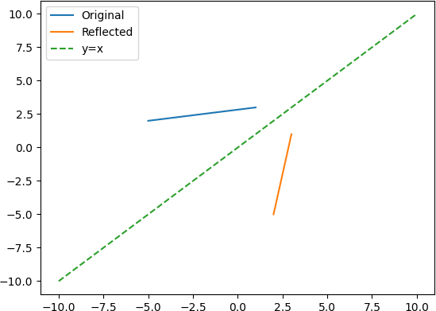

**Q 2 ) Attempt any TWO of the following**

**A ) Write a python program to rotate the line segment by 180 degrees having end points (1,0) and (2,-1)**

**-**→

A = [1, 0]

B = [2, -1]

def rotate_point(point): x, y = point

return [-x, -y]

A_rotated = rotate_point(A) B_rotated = rotate_point(B)

print("A_rotated:", A_rotated) print("B_rotated:", B_rotated)

import matplotlib.pyplot as plt

plt.plot([A[0], B[0]], [A[1], B[1]], label="Original")

plt.plot([A_rotated[0], B_rotated[0]], [A_rotated[1], B_rotated[1]], label="Rotated") plt.legend()

plt.show()

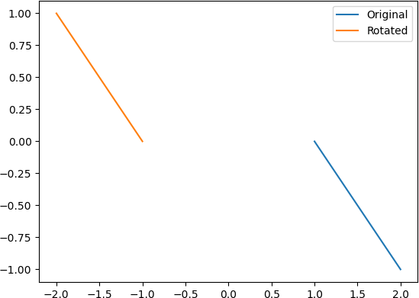

# B )Write a python program to plot triangle with vertices [3,3],[5,6],[5,2] and its rotation about the origin by angle –π radians

**-**→

import numpy as np

import matplotlib.pyplot as plt

vertices = np.array([[3, 3], [5, 6], [5, 2]]) theta = -np.pi

rotation_matrix = np.array([[np.cos(theta), -np.sin(theta)],

[np.sin(theta), np.cos(theta)]]) rotated_vertices = np.dot(vertices, rotation_matrix)

plt.plot(vertices[:, 0], vertices[:, 1], label="Original")

plt.plot(rotated_vertices[:, 0], rotated_vertices[:, 1], label="Rotated") plt.legend()

plt.show()

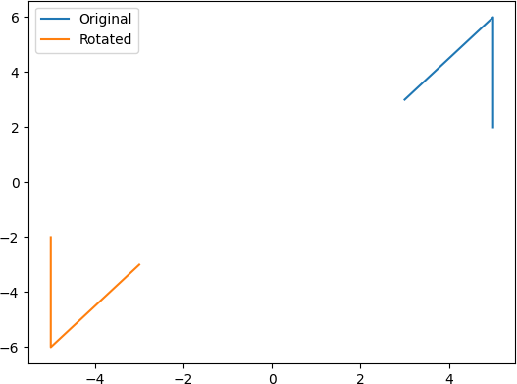

# C ) Write a python program to drawn a polygon with vertices (0,0),(1,0),(2,2),(1,4) and find its area and perimeter

**-**→

import math

import matplotlib.pyplot as plt vertices = [(0, 0), (1, 0), (2, 2), (1, 4)]

x, y = zip(*vertices) plt.plot(x, y, '-o') plt.show()

perimeter = 0

for i in range(len(vertices)): j = (i + 1) % len(vertices)

dx = vertices[j][0] - vertices[i][0] dy = vertices[j][1] - vertices[i][1]

perimeter += math.sqrt(dx**2 + dy**2)

area = 0.5 * abs(sum(x[i]*y[j] - y[i]*x[j] for i, j in zip(range(-1, len(x)-1), range(len(y))))) print("Perimeter:", perimeter)

print("Area:", area) output :

Perimeter: 9.595241580617241

Area: 4.0

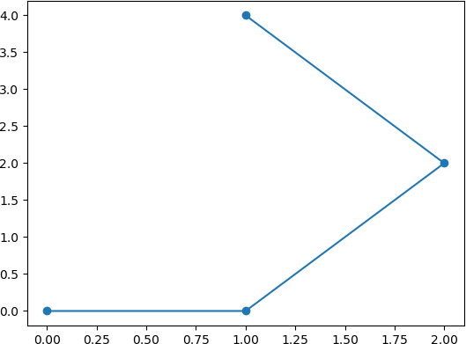

**Q3 ) Attempt the following**

**A ) Attempt any one of the following**

**I ) Write a Python program to solve the following LPP : Max Z=4x+y+3z+5w**

**Subject to 4x+6y-5y-4w≥-20**

**-8x-3y+3z2w≤20 X,y≥0**

-→

from scipy.optimize import linprog obj = [-4, -1, -3, -5]

lhs_eq = [[4, 6, -5, -4], [-8, -3, 3, 2]]

rhs_eq = [20, -20]

bnd = [(0, None), (0, None), (0, None), (0, None)]

opt = linprog(c=obj, A_eq=lhs_eq, b_eq=rhs_eq, bounds=bnd, method="simplex")

print("Optimal solution:", opt.x) print("Optimal objective value:", opt.fun)

output :

Optimal solution: [1.66666667 2.22222222 0. 0. ] Optimal objective value: -8.88888888888889

**II ) Write a python program to solve the following LPP : Max Z=x+y**

**Subject to x≤6**

**y≤6 x+y≤11 x,y≥0**

**-**→

from scipy.optimize import linprog obj = [-1, -1]

lhs_eq = [[1, 0], [0, 1], [1, 1]]

rhs_eq = [6, 6, 11]

bnd = [(0, None), (0, None)]

opt = linprog(c=obj, A_eq=lhs_eq, b_eq=rhs_eq, bounds=bnd, method="simplex")

print("Optimal solution:", opt.x) print("Optimal objective value:", -opt.fun)

output :

Optimal solution: [0. 0.] Optimal objective value: -0.0

**B )Attempt any ONE of the following**

**I )Apply each of the following transformation on the point P[3,-1]**

1. **Reflection through x-axis**
2. **Scaling in Y-coordinate by factor 1.5**
3. **Shering in both X and Y direction by -2 and 4 units respectively**
4. **Rotation about origin by anagle 30 degree**

**-**→

import math P = [3, -1]

Px = P[0] Py = -P[1]

print("Reflection through x-axis:", [Px, Py])

Px = P[0]

Py = 1.5 * P[1]

print("Scaling in Y-coordinate by factor 1.5:", [Px, Py])

Px = P[0] - 2 * P[1] Py = P[1] + 4 * P[0]

print("Shearing in both X and Y direction by -2 and 4 units respectively:", [Px, Py])

theta = math.radians(30)

Px = P[0] * math.cos(theta) - P[1] * math.sin(theta) Py = P[0] * math.sin(theta) + P[1] * math.cos(theta)

print("Rotation about origin by anagle 30 degree:", [Px, Py])

output :

Reflection through x-axis: [3, 1]

Scaling in Y-coordinate by factor 1.5: [3, -1.5]

Shearing in both X and Y direction by -2 and 4 units respectively: [5, 11]

Rotation about origin by anagle 30 degree: [3.098076211353316, 0.6339745962155611]

# II ) Write a python program to draw polygon with vertices [3,3],[4,6],[5,4],[4,2] and [2,2] and its transformation in x and y direction by factor -2 and 1 respectively

**-**→

import matplotlib.pyplot as plt

polygon_vertices = [[3,3], [4,6], [5,4], [4,2], [2,2]] x, y = zip(*polygon_vertices)

plt.plot(x, y, marker='o', color='blue') plt.title('Original Polygon') plt.show()

x_factor = -2

y_factor = 1

transformed_vertices = []

for vertex in polygon_vertices:

transformed_vertex = [vertex[0] * x_factor, vertex[1] * y_factor] transformed_vertices.append(transformed_vertex)

x, y = zip(*transformed_vertices) plt.plot(x, y, marker='o', color='green') plt.title('Transformed Polygon') plt.show()

