**Sahakar Maharshi Bhausaheb Santuji Thorat College Sangamner**

**Remark Demonstrator’s Signature**

**Date:- / /20**

**DEPARTMENT OF COMPUTER SCIENCE**

**Sub : Mathematics**

**Name:-_Gorde Yash Somnath Roll.No:-_21 Date:- Title of the expt:- Slip no 18 Page.no:- Class:- BCS**

**Q1 ) Attempt any TWO of the following**

**A ) Write a python program to draw polygon with vertices [3,3],[4,6],[2,5],[2,2] and its trasnslation in X and Y direction using the factors 3,5 respectively**

**-**→

import matplotlib.pyplot as plt import numpy as np

vertices = np.array([[3, 3], [4, 6], [2, 5], [2, 2]])

tx = 3

ty = 5

fig, axs = plt.subplots(1, 2)

axs[0].plot(vertices[:, 0], vertices[:, 1]) axs[0].set_title('Original Polygon')

translation_matrix = np.array([[1, 0, tx], [0, 1, ty], [0, 0, 1]])

translated_vertices = np.dot(translation_matrix, np.hstack((vertices, np.ones((len(vertices), 1)))).T).T[:, :-1]

axs[1].plot(translated_vertices[:, 0], translated_vertices[:, 1]) axs[1].set_title('Translated Polygon')

plt.show()

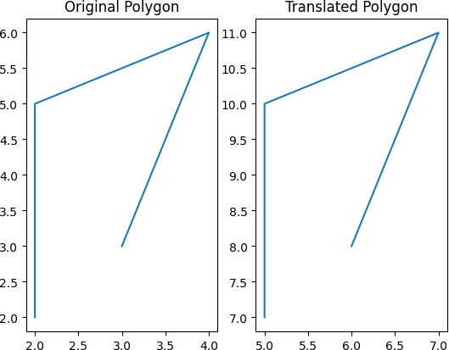

**B ) Write a python program to plot the graph 2x2-4x+5 in [-10,10] in magneta colored dashed pattern**

**-**→

import matplotlib.pyplot as plt import numpy as np

def f(x):

return 2*x**2 - 4*x + 5

x = np.linspace(-10, 10, 1000) y = f(x)

plt.plot(x, y, color='magenta', linestyle='--') plt.xlabel('x')

plt.ylabel('y')

plt.title('Graph of 2x^2 - 4x + 5') plt.show()

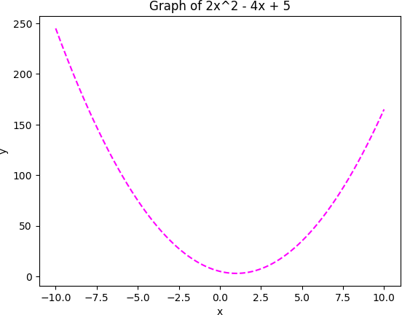

**C ) Write a python program to generate 3D plot of the function z=x2+y2 in -5<x,y<5**

**-**→

import matplotlib.pyplot as plt from mpl_toolkits import mplot3d import numpy as np

def f(x, y):

return x**2 + y**2

x = np.linspace(-5, 5, 100)

y = np.linspace(-5, 5, 100) X, Y = np.meshgrid(x, y) Z = f(X, Y)

fig = plt.figure()

ax = fig.add_subplot(111, projection='3d') ax.plot_surface(X, Y, Z)

ax.set_xlabel('x') ax.set_ylabel('y') ax.set_zlabel('z')

ax.set_title('3D Plot of z = x^2 + y^2') plt.show()

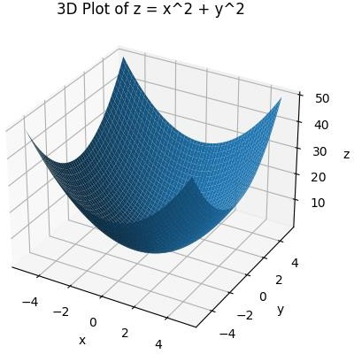

**Q2 ) Attempt any TWO of the following**

**A ) Write a python program to generate vector x in the interval [-22,22] using numpy package with 80 subintervals**

**-**→

import numpy as np n = 80

x = np.linspace(-22, 22, n+1) print(x)

outuput :

[-22. -21.45 -20.9 -20.35 -19.8 -19.25 -18.7 -18.15 -17.6 -17.05

-16.5 -15.95 -15.4 -14.85 -14.3 -13.75 -13.2 -12.65 -12.1 -11.55

-11. -10.45 -9.9 -9.35 -8.8 -8.25 -7.7 -7.15 -6.6 -6.05

-5.5 -4.95 -4.4 -3.85 -3.3 -2.75 -2.2 -1.65 -1.1 -0.55

0. 0.55 1.1 1.65 2.2 2.75 3.3 3.85 4.4 4.95

5.5 6.05 6.6 7.15 7.7 8.25 8.8 9.35 9.9 10.45

11. 11.55 12.1 12.65 13.2 13.75 14.3 14.85 15.4 15.95

16.5 17.05 17.6 18.15 18.7 19.25 19.8 20.35 20.9 21.45

22. ]

**B ) Write a python program to rotate the triangle ABC by 90 degree where A[1,2],B[2,-2] and C[-1,2]**

**-**→

import numpy as np

A = np.array([1, 2])

B = np.array([2, -2])

C = np.array([-1, 2]) theta = np.pi/2

rot_mat = np.array([[np.cos(theta), -np.sin(theta)], [np.sin(theta), np.cos(theta)]])

A_rot = np.dot(rot_mat, A) B_rot = np.dot(rot_mat, B) C_rot = np.dot(rot_mat, C)

print("Rotated triangle:") print("A':", A_rot)

print("B':", B_rot)

print("C':", C_rot)

output :

Rotated triangle:

A': [-2. 1.]

B': [2. 2.]

C': [-2. -1.]

**C ) Write a python program to plot the rectangle with vertices at [2,1],[2,4],[5,4],[5,1] and its uniform expansion by factor 4**

**-**→

import matplotlib.pyplot as plt import numpy as np

rectangle = np.array([[2, 1], [2, 4], [5, 4], [5, 1]])

scale_factor = 4

scale_mat = np.array([[scale_factor, 0],

[0, scale_factor]])

rectangle_scaled = np.dot(scale_mat, rectangle.T).T

fig, ax = plt.subplots()

ax.plot(rectangle[:, 0], rectangle[:, 1], label='Original')

ax.plot(rectangle_scaled[:, 0], rectangle_scaled[:, 1], label='Scaled') ax.legend()

plt.show()

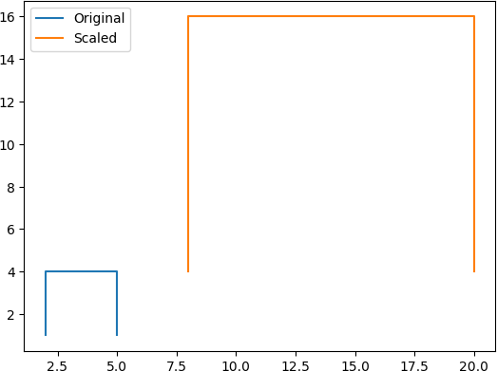

**Q3 ) Attempt the following**

**A ) Attempt any ONE of the following**

1. **) Write a python program to solve the following LPP : Min Z=x+y**

**Subjcet to x≥6**

**y≥6 x+y≤11**

**x,y≥0**

**-**→

from scipy.optimize import linprog c = [1, 1]

A = [[-1, 0], [0, -1], [1, 1]]

b = [-6, -6, 11]

x_bounds = (0, None) y_bounds = (0, None)

res = linprog(c=c, A_ub=A, b_ub=b, bounds=[x_bounds, y_bounds])

if res.success:

# Print the results

print('Optimal value:', res.fun) print('x:', res.x[0])

print('y:', res.x[1]) else:

print('No solution found.')

output :

No solution found.

1. **) Write a python program to solve the following LPP Max Z=2x+3y**

**Subject to 5x-y≥0**

**X+y≥6 X,y≥0**

**-**→

from scipy.optimize import linprog c = [-2, -3]

A = [[5, -1], [-1, 1]]

b = [0, 6]

x_bounds = (0, None) y_bounds = (0, None)

res = linprog(c=c, A_ub=A, b_ub=b, bounds=[x_bounds, y_bounds])

print('Optimal value:', -res.fun) print('x:', res.x[0])

print('y:', res.x[1])

output :

Optimal value: 25.5

x: 1.5

y: 7.5

**B) Attempt any ONE of the following**

**I ) Write a python program to find the combined transformation of the line segment between the points A[3,2] and B[2,-3] for the following sequence of transformation**

**A ) Eirst rotation about origin through an angle π/6**

**B ) Followed by scalin in y coordination by 4 units respectively**

**C ) Followed by reflection through the origin**

**-**→

import numpy as np

A = np.array([3, 2])

B = np.array([2, -3])

theta = np.pi/6

R = np.array([[np.cos(theta), -np.sin(theta)], [np.sin(theta), np.cos(theta)]])

S = np.array([[1, 0], [0, 4]])

F = np.array([[-1, 0], [0, -1]]) T = F @ S @ R

A_transformed = T @ A B_transformed = T @ B

print(f"A': {A_transformed}") print(f"B': {B_transformed}")

output :

A': [ -1.59807621 -12.92820323]

B': [-3.23205081 6.39230485]

**II ) Apply each of the following transformation on the point P[3,-1]**

**A ) Reflection through Y-axis**

**B ) Scaling in X and Y direction by ½ and 3 units respectively**

**C ) Sheriang in both X and Y direction by -2 and 4 units respectively**

**D ) Rotation about origin by an angle 60 degrees**

**-**→

import numpy as np P = np.array([3, -1])

F = np.array([[-1, 0], [0, 1]])

P_transformed = F @ P

print("After Reflection through Y-axis: ", P_transformed)

S = np.array([[0.5, 0], [0, 3]])

P_transformed = S @ P

print("After Scaling in X and Y direction by ½ and 3 units respectively: ", P_transformed)

H = np.array([[1, -2], [4, 1]])

P_transformed = H @ P

print("After Shearing in both X and Y direction by -2 and 4 units respectively: ", P_transformed)

theta = np.pi/3 # 60 degrees in radians

R = np.array([[np.cos(theta), -np.sin(theta)], [np.sin(theta), np.cos(theta)]])

P_transformed = R @ P

print("After Rotation about origin by an angle 60 degrees: ", P_transformed)

output :

After Reflection through Y-axis: [-3 -1]

After Scaling in X and Y direction by ½ and 3 units respectively: [ 1.5 -3. ] After Shearing in both X and Y direction by -2 and 4 units respectively: [ 5 11] After Rotation about origin by an angle 60 degrees: [2.3660254 2.09807621]