**Sahakar Maharshi Bhausaheb Santuji Thorat**

Remark

**Demonstrator’s**

**Signature**

**Date:-**

**/**

**/20**

**College Sangamner DEPARTMENT OF COMPUTER SCIENCE**

**Sub : Mathematics**

**Name:- Gorde Yash Somnath Roll.No:- 21 Date:- Title of the expt:- Page.no:- Class:- BCS**

**Q1) Attempt any Two Of the following**

**a) Write a python program to plot 2D graph of the function f(x)=log10 (x) in the interval [0,10]**

-> import matplotlib.pyplot as plt import numpy as np

def f(x):

return np.log10(x)

x = np.linspace(0.1, 10, 100) y = f(x)

plt.plot(x, y)

plt.xlabel('x')

plt.ylabel('log10(x)')

plt.title('2D graph of f(x) = log10(x)') plt.show()

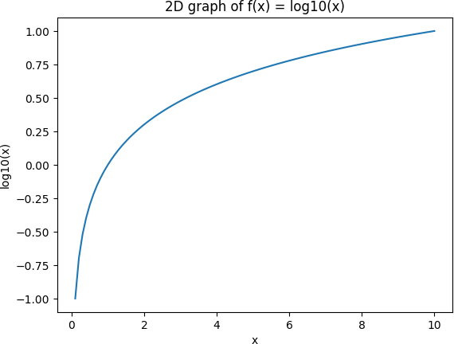

1. **Using python ,generate 3D surface plot for the function f(x)=sin(x2 +y2) in the interval [0,10]**

->

import numpy as np

import matplotlib.pyplot as plt

from mpl_toolkits.mplot3d import Axes3D def f(x, y):

return np.sin(x**2 + y**2) x = np.linspace(0, 10, 100)

y = np.linspace(0, 10, 100) X, Y = np.meshgrid(x, y) Z = f(X, Y)

fig = plt.figure()

ax = fig.add_subplot(111, projection='3d') ax.plot_surface(X, Y, Z)

ax.set_xlabel('x') ax.set_ylabel('y') ax.set_zlabel('f(x, y)') plt.show()

output :

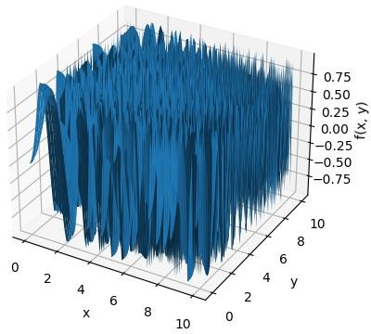

C **) Using Python draw a bar graph in Green color to represent the data below**

|  |  |  |  |  |  |
| --- | --- | --- | --- | --- | --- |
| **Subject** | **Maths** | **Science** | **English** | **Marathi** | **Hindi** |
| **Persentage of passing** | **68** | **90** | **70** | **85** | **91** |

->

import matplotlib.pyplot as plt

subjects = ['Maths', 'Science', 'English', 'Marathi', 'Hindi'] percentage = [68, 90, 70, 85, 91]

plt.bar(subjects, percentage, color='green') plt.title('Percentage of Passing') plt.xlabel('Subject') plt.ylabel('Percentage')

plt.show()

output :

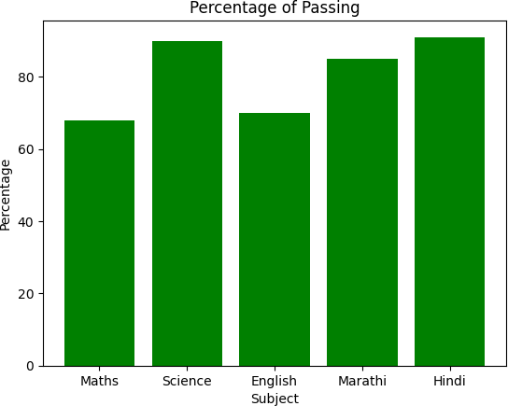

**Q2) Attempt any Two of the following**

* 1. **Using sympy declare the points A(0,2) ,B(5,2),C(3,0) check whether these points are colliner .Declare the line passing through the point A and B , find the distance of this from point C.**

->

from sympy import Point, Line

A = Point(0, 2)

B = Point(5, 2)

C = Point(3, 0)

if A.is_collinear(B, C):

print("The points A, B, and C are collinear") else:

print("The points A, B, and C are not collinear")

AB = Line(A, B)

distance = AB.distance(C)

print("The distance of the line passing through A and B from C is:", distance)

output-:

The points A, B, and C are not collinear

The distance of the line passing through A and B from C is: 2

* 1. **Using python drawn a regular polygon with 6 sides and radius 1 centerd at (1,2) and find its area**

->

import matplotlib.pyplot as plt

import math center = (1, 2)

num_sides = 6

radius = 1

vertices = []

for i in range(num_sides):

x = center[0] + radius * math.cos(2*math.pi*i/num_sides) y = center[1] + radius * math.sin(2*math.pi*i/num_sides) vertices.append((x, y))

vertices.append(vertices[0])

x_coords, y_coords = zip(*vertices) plt.plot(x_coords, y_coords)

plt.xlim(center[0] - radius - 1, center[0] + radius + 1) plt.ylim(center[1] - radius - 1, center[1] + radius + 1) plt.xlabel('x')

plt.ylabel('y') plt.show()

output :

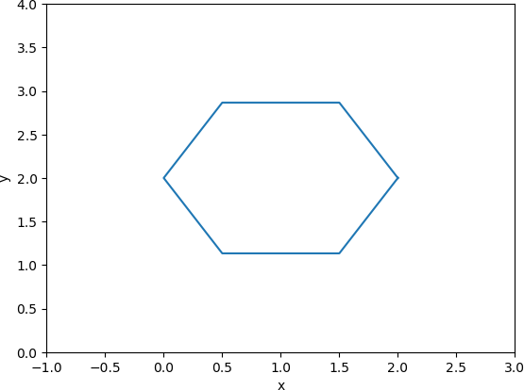

* 1. **Write a Python program to find the area and perimeter of the ∆ ABC , where A[0,0],B[6,0],C[4,4]**

->

import math

A = [0, 0]

B = [6, 0]

C = [4, 4]

AB = math.sqrt((B[0]-A[0])**2 + (B[1]-A[1])**2)

BC = math.sqrt((C[0]-B[0])**2 + (C[1]-B[1])**2)

CA = math.sqrt((A[0]-C[0])**2 + (A[1]-C[1])**2)

perimeter = AB + BC + CA

print("The perimeter of the triangle is:", perimeter) s = perimeter / 2

area = math.sqrt(s*(s-AB)*(s-BC)*(s-CA)) print("The area of the triangle is:", area)

output :

The perimeter of the triangle is: 16.12899020449196 The area of the triangle is: 11.999999999999998

**Q3) Attempt any ONE of the following**

**A )Write a python program to solve the following LPP: Max Z=5x+3y**

**Subject to x+y≤7**

**2x+5y≤1 x≥0,y≥0**

->

from scipy.optimize import linprog c = [-5, -3]

A = [[1, 1], [2, 5]]

b = [7, 1]

x_bounds = (0, None) y_bounds = (0, None)

res = linprog(c, A_ub=A, b_ub=b, bounds=[x_bounds, y_bounds], method='simplex') print("Optimal solution:")

print("x =", res.x[0])

print("y =", res.x[1]) print("Optimal value of Z:") print("Z =", -res.fun)

output:

Optimal solution: x = 0.5

y = 0.0

Optimal value of Z: Z = 2.5

1. **Write a python program to display the following LPP by using pulp module and simplex method.Find its optional solution if exist**

**max Z=3x+2y+5z**

**subject to x+2y+z≤430 3x+2z≤460 x+4y≤120**

**x,y,z≥0**

->

from pulp import *

prob = LpProblem("LPP", LpMaximize)

x = LpVariable("x", lowBound=0, cat='Continuous')

y = LpVariable("y", lowBound=0, cat='Continuous')

z = LpVariable("z", lowBound=0, cat='Continuous') prob += 3*x + 2*y + 5*z

prob += x + 2*y + z <= 430

prob += 3*x + 2*z <= 460 prob += x + 4*y <= 120

status = prob.solve() if status == 1:

print("Optimal solution:")

print("x =", value(x))

print("y =", value(y))

print("z =", value(z)) print("Optimal value of Z:") print("Z =", value(prob.objective))

else:

print("The problem is infeasible.")

* 1. **Attempt any one of the following**
     1. **Apply python program in each of the following transformation of the point P[4,-2]**
        1. **Reflection through Y-axis**
        2. **Scaling in X-cordinate by factor 3**
        3. **Scaling in Y-cordinate by factor 2.5**
        4. **Reflection through the line y=-x**

->

# Define the point P P = (4, -2)

# Reflect P through Y-axis P_reflected = (-P[0], P[1]) # Print the result

print("Reflection through Y-axis:") print("P' =", P_reflected)

# Define the point P P = (4, -2)

# Scale P in X-coordinate by factor 3 P_scaled = (3*P[0], P[1])

# Print the result

print("Scaling in X-coordinate by factor 3:") print("P' =", P_scaled)

# Define the point P

P = (4, -2)

# Scale P in Y-coordinate by factor 2.5 P_scaled = (P[0], 2.5*P[1])

# Print the result

print("Scaling in Y-coordinate by factor 2.5:") print("P' =", P_scaled)

# Define the point P P = (4, -2)

# Reflect P through the line y=-x P_reflected = (-P[1], -P[0]) print("Reflection through the line y=-x:") print("P' =", P_reflected)

output :

Reflection through Y-axis:

P' = (-4, -2)

Scaling in X-coordinate by factor 3:

P' = (12, -2)

Scaling in Y-coordinate by factor 2.5:

P' = (4, -5.0)

Reflection through the line y=-x:

P' = (2, -4)

* + 1. **Find the combined transformation of the line segment between the points A[4,-1] & B[3,0] by using the python**

**program for the following sequence of transformation Rotation about origin through an angle π**

1. **Shering in Y direction by 4.5 units**
2. **Scaling in X-cordinate by 3 units**
3. **Reflection through the line y=x**

->

import math

# Define the points A and B

A = (4, -1)

B = (3, 0)

# i) Rotate about origin through an angle pi def rotate(point, angle):

x = point[0]*math.cos(angle) - point[1]*math.sin(angle) y = point[0]*math.sin(angle) + point[1]*math.cos(angle) return (x, y)

A = rotate(A, math.pi)

B = rotate(B, math.pi)

# ii) Shear in Y direction by 4.5 units

def shear(point, factor):

x = point[0] + factor*point[1] y = point[1]

return (x, y)

A = shear(A, 4.5)

B = shear(B, 4.5)

# iii) Scale in X-coordinate by factor 3 def scale(point, factor):

x = factor*point[0] y = point[1]

return (x, y)

A = scale(A, 3)

B = scale(B, 3)

# iv) Reflect through the line y=x def reflect(point):

x = point[1] y = point[0] return (x, y)

A = reflect(A)

B = reflect(B)

# Print the final transformed line segment print("The final transformed line segment:") print("A' =", A)

print("B' =", B)

output :

The final transformed line segment:

A' = (1.0000000000000004, 1.5000000000000053)

B' = (3.6739403974420594e-16, -8.999999999999995)