**Sahakar Maharshi Bhausaheb Santuji Thorat College Sangamner**

**Remark Demonstrator’s Signature**

**Date:- / /20**

**DEPARTMENT OF COMPUTER SCIENCE**

**Sub : Mathematics**

**Name:-_Gorde Yash Somnath Roll.No:-_21 Date:- Title of the expt:- Slip no 20 Page.no:- Class:- BCS**

**Q1. Attempt any TWO of the following**

**A ) Write a python program to plot 2D graph of the function f(x)=sin x and g(x)=cos x in [- 2π,2π]**

**-**→

import numpy as np

import matplotlib.pyplot as plt def f(x):

return np.sin(x) def g(x):

return np.cos(x)

x = np.linspace(-2*np.pi, 2*np.pi, 1000) plt.plot(x, f(x), label='sin(x)')

plt.plot(x, g(x), label='cos(x)') plt.legend()

plt.title('Graphs of sin(x) and cos(x)') plt.show()

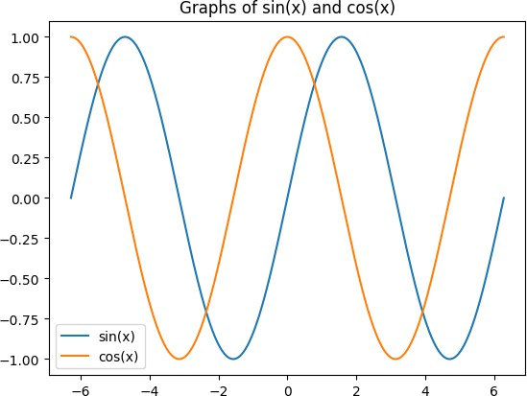

**B ) Write a python program to plot the 2D graph of the function f(x)=ex sin x in [- 5π,5π] with blue points line with upward poininting triangle**

**-**→

import numpy as np

import matplotlib.pyplot as plt def f(x):

return np.exp(x) * np.sin(x)

x = np.linspace(-5*np.pi, 5*np.pi, 1000) y = f(x)

plt.plot(x, y, 'b^-') plt.title('Graph of e^x sin(x)') plt.show()

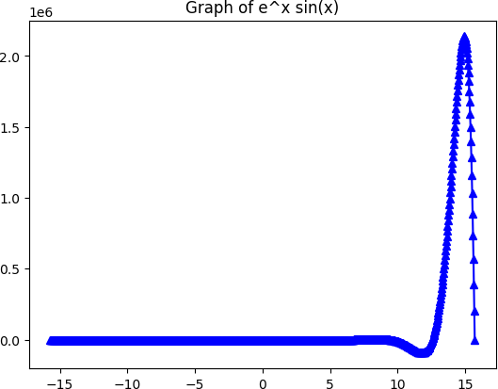

**C )Write a python program to plot the 3D graph of the function f(x)=sin(x2+y2) -6<x,y<6**

**-**→

import numpy as np

import matplotlib.pyplot as plt from mpl_toolkits import mplot3d def f(x, y):

return np.sin(x**2+y**2)

x = np.linspace(-6, 6, 100)

y = np.linspace(-6, 6, 100) X, Y = np.meshgrid(x, y) Z = f(X, Y)

fig = plt.figure()

ax = plt.axes(projection='3d') ax.plot_surface(X, Y, Z, cmap='viridis') ax.set_title('Graph of sin(x^2+y^2)') plt.show()

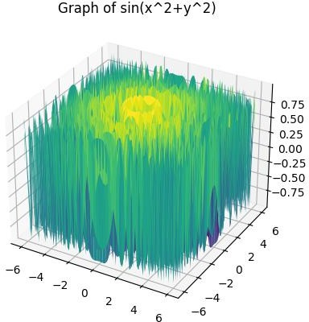

**Q2 ) Attempt any TWO of the following**

**A ) Write a python program to reflect the line segment joining the points A[- 5,2],B[3,-4] through the line y=2x-1**

**-**→

import numpy as np

import matplotlib.pyplot as plt def given_line(x):

return 2*x - 1

A = np.array([-5, 2])

B = np.array([3, -4])

m = 2

c = -1

x = np.linspace(-10, 10, 100)

plt.plot(x, given_line(x), 'b-', label='Given Line') plt.plot([A[0], B[0]], [A[1], B[1]], 'r-', label='Line Segment')

v = np.array([B[0]-A[0], B[1]-A[1]])

w = np.array([m, -1])

projection = (np.dot(v, w) / np.dot(w, w)) * w reflection = 2*projection - v

C = B + reflection

plt.plot([B[0], C[0]], [B[1], C[1]], 'g-', label='Reflected Line Segment') plt.legend()

plt.xlim(-10, 10)

plt.ylim(-10, 10)

plt.xlabel('X-axis') plt.ylabel('Y-axis')

plt.title('Reflection of Line Segment') plt.show()

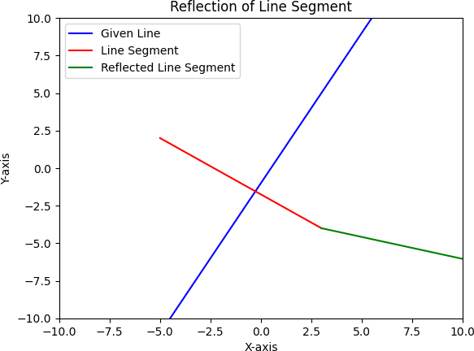

**B ) Write a python program to find the area and perimeter of a polygon with vertices (0,0),(-2,0),(5,5),(1,-3)**

**-**→

from shapely.geometry import Polygon

vertices = [(0, 0), (-2, 0), (5, 5), (1, -3)]

polygon = Polygon(vertices) area = polygon.area perimeter = polygon.length print(f"Area: {area:.2f}")

print(f"Perimeter: {perimeter:.2f}")

output :

Area: 15.00

Perimeter: 22.71

**C )Write a python program to plot the 3D graph of the function f(x,y)=sin x +cos y**

**,x,y E[-2π,2π] using wireframe plot**

**-**→

import numpy as np

import matplotlib.pyplot as plt

from mpl_toolkits.mplot3d import axes3d def f(x, y):

return np.sin(x) + np.cos(y)

x = np.linspace(-2*np.pi, 2*np.pi, 100) y = np.linspace(-2*np.pi, 2*np.pi, 100) X, Y = np.meshgrid(x, y)

Z = f(X, Y)

fig = plt.figure()

ax = fig.add_subplot(111, projection='3d') ax.plot_wireframe(X, Y, Z) ax.set_xlabel('X')

ax.set_ylabel('Y') ax.set_zlabel('Z')

ax.set_title('Wireframe Plot of f(x,y) = sin(x) + cos(y)') plt.show()

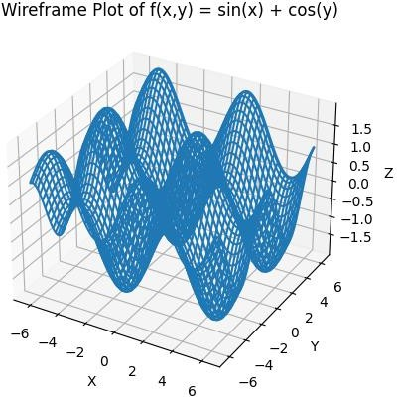

**Q3 ) Attempt the following**

**A ) Attempt any ONE of the following**

**I ) Write a python program to solve the following LPP : Max Z=x+y**

**Subject to x-y≥1**

**X+y≥2 X,y≥0**

**-**→

import numpy as np

from scipy.optimize import linprog c = np.array([1, 1])

A = np.array([[-1, 1], [1, 1]])

b = np.array([1, 2])

bounds = [(0, None), (0, None)]

res = linprog(-c, A_ub=A, b_ub=b, bounds=bounds)

print(f"Optimal value of Z: {-res.fun:.2f}") print(f"x: {res.x[0]:.2f}")

print(f"y: {res.x[1]:.2f}")

output :

Optimal value of Z: 2.00 x: 2.00

y: 0.00

**II ) Write a python program to solve the following LPP : Min Z=3.5x +2y**

**Subject to x-y≥5**

**x≥4**

**y≤2 x,y≥0**

**-**→

import numpy as np

from scipy.optimize import linprog c = np.array([3.5, 2])

A = np.array([[-1, 1], [1, 0], [0, -1]])

b = np.array([5, 4, -2])

bounds = [(4, None), (None, 2)]

res = linprog(c, A_ub=A, b_ub=b, bounds=bounds)

print(f"Optimal value of Z: {res.fun:.2f}") print(f"x: {res.x[0]:.2f}")

print(f"y: {res.x[1]:.2f}")

output :

Optimal value of Z: 18.00 x: 4.00

y: 2.00

**B ) Attempt any ONE of the following**

**I ) Apply the following transformation on the point P[3,-2]**

**A ) Scaling in Y direction by 4 units**

**B ) Reflection through Y axis**

**C ) Rotation about origin by an angle 45⸰**

**D )Reflection through the line y=x**

-→

import numpy as np P = np.array([3, -2])

A = np.array([[1, 0], [0, 4]])

P_A = A.dot(P)

print("After scaling in Y direction by 4 units:", P_A)

B = np.array([[-1, 0], [0, 1]])

P_B = B.dot(P)

print("After reflection through Y axis:", P_B)

theta = np.deg2rad(45)

C = np.array([[np.cos(theta), -np.sin(theta)], [np.sin(theta), np.cos(theta)]]) P_C = C.dot(P)

print("After rotation about origin by 45 degrees:", P_C)

D = np.array([[0, 1], [1, 0]])

P_D = D.dot(P)

print("After reflection through the line y=x:", P_D)

output :

After scaling in Y direction by 4 units: [ 3 -8] After reflection through Y axis: [-3 -2]

After rotation about origin by 45 degrees: [3.53553391 0.70710678] After reflection through the line y=x: [-2 3]

**II ) Apply the following transformation on the point P[3,-2]**

**A ) Shering in x direction by -2 units**

**B ) Scaling in x and y direction by -3 and 2 units respectively**

**C ) reflection through x axis**

**D ) Reflection through the line y=-x**

**-**→

import numpy as np P = np.array([3, -2])

A = np.array([[1, -2], [0, 1]])

P_A = A.dot(P)

print("After shering in x direction by -2 units:", P_A)

B = np.array([[-3, 0], [0, 2]])

P_B = B.dot(P)

print("After scaling in x and y direction by -3 and 2 units respectively:", P_B)

C = np.array([[1, 0], [0, -1]])

P_C = C.dot(P)

print("After reflection through x axis:", P_C)

D = np.array([[0, -1], [-1, 0]])

P_D = D.dot(P)

print("After reflection through the line y=-x:", P_D)

output :

After shering in x direction by -2 units: [ 7 -2]

After scaling in x and y direction by -3 and 2 units respectively: [-9 -4] After reflection through x axis: [3 2]

After reflection through the line y=-x: [ 2 -3]