**Sahakar Maharshi Bhausaheb Santuji Thorat College Sangamner**

**Remark**

**Demonstrator’s Signature**

**Date:-**

**/**

**/20**

**DEPARTMENT OF COMPUTER SCIENCE**

**Sub : Mathematics**

**Name:-_Gorde Yash Somnath Roll.No:-_21 Date:- Title of the expt:- Slip no 6 Page.no:- Class:- BCS**

**Q1 Attempt any TWO of the following**

**A ) Draw the horizontal bar graph for the following data in Maroon color**

|  |  |  |  |  |  |
| --- | --- | --- | --- | --- | --- |
| **City** | **Pune** | **Mumbai** | **Nasik** | **Nagpur** | **Thane** |
| **Air Quality Idex** | **168** | **190** | **170** | **178** | **195** |

→

import matplotlib.pyplot as plt

cities = ['Pune', 'Mumbai', 'Nasik', 'Nagpur', 'Thane'] air_quality = [168, 190, 170, 178, 195] plt.barh(cities, air_quality, color='maroon') plt.title('Air Quality Index for Cities in Maharashtra') plt.xlabel('Air Quality Index')

plt.ylabel('City') plt.show()

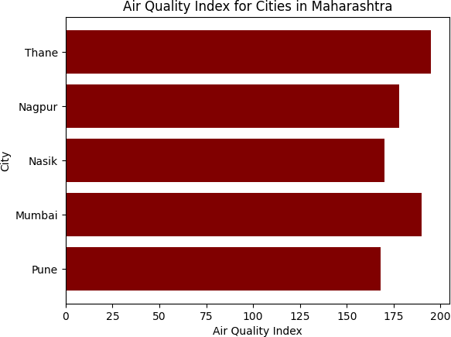

**B ) Using Python program ,Generate 3D surface plot for the function f(x)=sin(x2+y2) in the interval [0,10]**

→

import numpy as np

import matplotlib.pyplot as plt

from mpl_toolkits.mplot3d import Axes3D def f(x, y):

return np.sin(x**2 + y**2)

x = np.linspace(0, 10, 50)

y = np.linspace(0, 10, 50) X, Y = np.meshgrid(x, y) Z = f(X, Y)

fig = plt.figure()

ax = fig.add_subplot(111, projection='3d') ax.plot_surface(X, Y, Z, cmap='coolwarm') ax.set_title('f(x) = sin(x^2+y^2)') ax.set_xlabel('X')

ax.set_ylabel('Y') ax.set_zlabel('Z') plt.show()

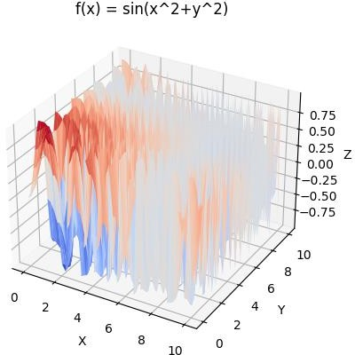

**C ) Using python ,plot the graph of function f(x)=sin(x)-ex+3x2-log10(X) on the interval [0,2π]**

→

import numpy as np

import matplotlib.pyplot as plt def f(x):

return np.sin(x) - np.exp(x) + 3*x**2 - np.log10(x)

x = np.linspace(0, 2*np.pi, 200) y = f(x)

plt.plot(x, y) plt.title('Graph of f(x)') plt.xlabel('x')

plt.ylabel('y') plt.show()

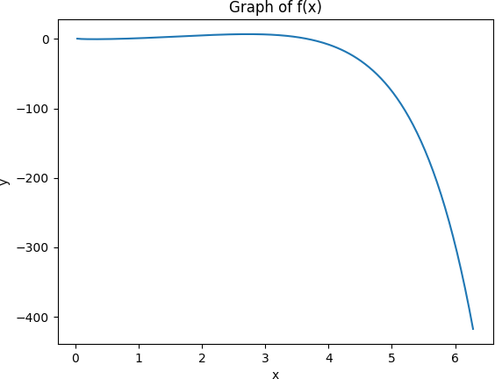

**Q2 ) Attempt any TWO of the following**

**A ) Using Python rotate the line segment by 180⸰ having end points (1,0) and (2,- 1)**

**-**→

import numpy as np

import matplotlib.pyplot as plt x = [1, 2]

y = [0, -1]

theta = np.pi

R = np.array([[np.cos(theta), -np.sin(theta)], [np.sin(theta), np.cos(theta)]])

points = np.vstack((x, y)) rotated_points = R @ points x_new = rotated_points[0] y_new = rotated_points[1]

plt.plot(x, y, label='Original') plt.plot(x_new, y_new, label='Rotated') plt.xlabel('X')

plt.ylabel('Y') plt.legend() plt.show()

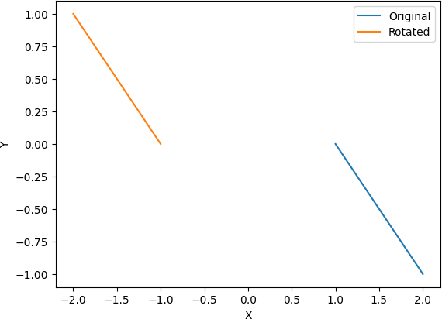

**B ) Write a python program , to draw a polygon with vertices (0,0),(2,0),(2,3) and (1,6) and rotate it by using 180⸰**

**-**→

import numpy as np

import matplotlib.pyplot as plt x = [0, 2, 2, 1]

y = [0, 0, 3, 6]

theta = np.pi

R = np.array([[np.cos(theta), -np.sin(theta)], [np.sin(theta), np.cos(theta)]]) points = np.vstack((x, y))

rotated_points = R @ points x_new = rotated_points[0] y_new = rotated_points[1]

fig, axs = plt.subplots(1, 2, figsize=(8, 4)) axs[0].plot(x, y, 'b', label='Original') axs[1].plot(x_new, y_new, 'r', label='Rotated')

for ax in axs: ax.set_xlabel('X') ax.set_ylabel('Y') ax.legend()

plt.show()

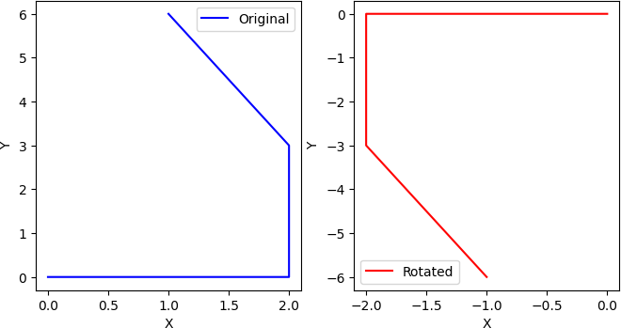

**C ) Using python program generate tringle with vertices (0,0),(4,0),(2,4) check whether the triangle is isosceles triangle**

**-**→

import math

import matplotlib.pyplot as plt

A = (0, 0)

B = (4, 0)

C = (2, 4)

a = math.sqrt((B[0]-C[0])**2 + (B[1]-C[1])**2)

b = math.sqrt((A[0]-C[0])**2 + (A[1]-C[1])**2)

c = math.sqrt((A[0]-B[0])**2 + (A[1]-B[1])**2)

fig, ax = plt.subplots()

ax.plot([A[0], B[0]], [A[1], B[1]], 'b-', label='AB')

ax.plot([B[0], C[0]], [B[1], C[1]], 'r-', label='BC')

ax.plot([C[0], A[0]], [C[1], A[1]], 'g-', label='CA')

if a == b or b == c or a == c:

ax.text(1.5, 1, 'Isosceles', fontsize=12, color='r') else:

ax.text(1.5, 1, 'Non-Isosceles', fontsize=12, color='r')

ax.set_xlim([-1, 5])

ax.set_ylim([-1, 5]) ax.set_xlabel('X') ax.set_ylabel('Y') ax.legend() plt.show()

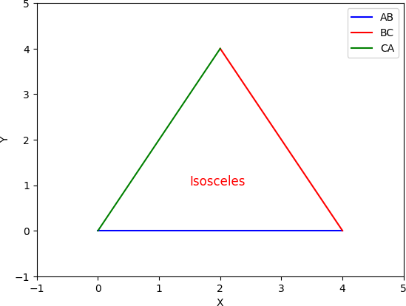

**Q3 ) Attempt the following**

**A ) Attempt any one of the following**

**I ) write a python program to solve the following LPP : Max Z=x+y**

**Subject to 2x-2y≥1**

**X+y≥2 X,y≥0**

**-**→

from pulp import *

lp_prob = LpProblem("LP problem", LpMaximize)

x = LpVariable('x', lowBound=0, cat='Continuous') y = LpVariable('y', lowBound=0, cat='Continuous')

lp_prob += x + y

lp_prob += 2*x - 2*y >= 1 lp_prob += x + y >= 2

status = lp_prob.solve() print("x = ", value(x))

print("y = ", value(y))

print("Optimal objective value = ", value(lp_prob.objective))

**II ) Write a python program to display the following LPP by using Pulp module and simplex method.Find the optimal solution if exist**

**Min Z=x+y Subject to x≥6**

**y≥6 x+y≤11 x,y≥0**

**-**→

from pulp import *

lp_prob = LpProblem("LP problem", LpMinimize) x = LpVariable('x', lowBound=0, cat='Continuous') y = LpVariable('y', lowBound=0, cat='Continuous')

lp_prob += x + y lp_prob += x >= 6 lp_prob += y >= 6 lp_prob += x + y <= 11

status = lp_prob.solve() print("Status:", LpStatus[status]) if LpStatus[status] == "Optimal":

print("Optimal solution found:") print("x = ", value(x))

print("y = ", value(y))

print("Optimal objective value = ", value(lp_prob.objective)) else:

print("No optimal solution found.")

**B ) Attempt any one of the following**

**I ) Apply Python program in each of the following transformation on the point P[4,-2]**

**A ) Reflection through Y-axis**

**B ) Scaling in X-coordinate By factor 7**

**C ) Shering in Y direction by 3 units**

**D ) Reflection through the line y=-x**

**-**→

P = [4, -2]

P_reflected = [-P[0], P[1]]

print("Reflection through Y-axis of P{} is P{}.".format(P, P_reflected))

P = [4, -2]

P_scaled = [7*P[0], P[1]]

print("Scaling in X-coordinate by factor 7 of P{} is P{}.".format(P, P_scaled))

P = [4, -2]

P_sheared = [P[0], P[1] + 3*P[0]]

print("Shearing in Y direction by 3 units of P{} is P{}.".format(P, P_sheared))

P = [4, -2]

P_reflected = [-P[1], -P[0]]

print("Reflection through the line y=-x of P{} is P{}.".format(P, P_reflected))

output :

Reflection through Y-axis of P[4, -2] is P[-4, -2].

Scaling in X-coordinate by factor 7 of P[4, -2] is P[28, -2]. Shearing in Y direction by 3 units of P[4, -2] is P[4, 10].

Reflection through the line y=-x of P[4, -2] is P[2, -4].

**II ) Find the combined transformation by using Python program for the following sequence of transformation**

**A ) Rotation about origin through an angle 60⸰**

**B ) Scaling in X-coordinate by 7 units**

**C ) Uniform scaling by 4 units**

**D ) Reflection through the line y=x**

**-**→

import numpy as np

A = np.array([[np.cos(np.radians(60)), -np.sin(np.radians(60)), 0],

[np.sin(np.radians(60)), np.cos(np.radians(60)), 0],

[0, 0, 1]])

B = np.array([[7, 0, 0],

[0, 1, 0],

[0, 0, 1]])

C = np.array([[4, 0, 0],

[0, 4, 0],

[0, 0, 1]])

D = np.array([[0, 1, 0],

[1, 0, 0],

[0, 0, 1]])

T = D @ C @ B @ A

p = np.array([[1], [2], [1]]) p_transformed = T @ p print(p_transformed)

output :

[[ 7.46410162]

[-34.49742261]

[ 1. ]]