**Sahakar Maharshi Bhausaheb Santuji Thorat College Sangamner**

**Remark**

**Demonstrator’s Signature**

**Date:-**

**/**

**/20**

**DEPARTMENT OF COMPUTER SCIENCE**

**Sub : Mathematics**

**Name:-_Gorde Yash Somnath Roll.No:-_21 Date:- Title of the expt:- Slip no 7 Page.no:- Class:- BCS**

# Q1 ) Attempt any TWO of the following

**A ) Plot the graph of f(x)=x4 in [0,5] with red dashed line with circle marked**

**-**→

import numpy as np

import matplotlib.pyplot as plt def f(x):

return x**4

x_values = np.linspace(0, 5, num=1000) y_values = f(x_values)

plt.plot(x_values, y_values, 'r--', marker='o') plt.title('Graph of f(x) = x^4')

plt.xlabel('x')

plt.ylabel('y') plt.show()

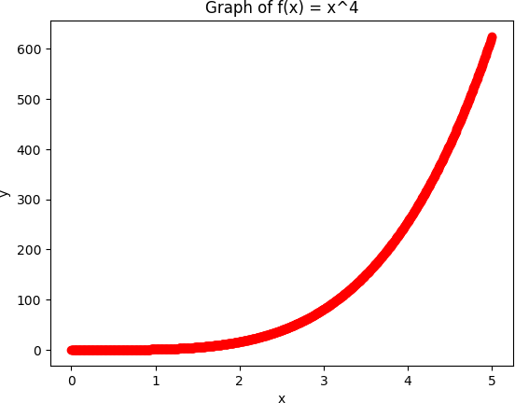

# B ) Using Python program generate 3D surface plot for the function f(x)=sin(x2+y2) in the interval [0,10]

**-**→

import numpy as np

import matplotlib.pyplot as plt

from mpl_toolkits.mplot3d import Axes3D def f(x, y):

return np.sin(x**2 + y**2)

x_values = np.linspace(0, 10, 100)

y_values = np.linspace(0, 10, 100)

x_mesh, y_mesh = np.meshgrid(x_values, y_values) z_values = f(x_mesh, y_mesh)

fig = plt.figure()

ax = fig.add_subplot(111, projection='3d') ax.plot_surface(x_mesh, y_mesh, z_values, cmap='viridis') ax.set_xlabel('x')

ax.set_ylabel('y') ax.set_zlabel('z')

ax.set_title('Surface plot of f(x,y) = sin(x^2+y^2)') plt.show()

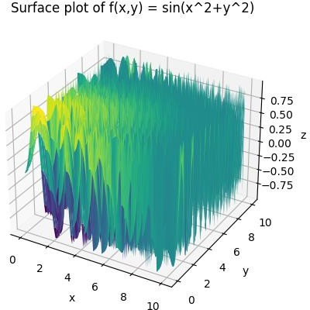

# C ) Write a python program to draw rectangle with vertices [1,0],[2,1],[1,2] and [0,1] its rotation about the origin by 𝝅 radians

𝟐

**-**→

import numpy as np

import matplotlib.pyplot as plt

vertices = np.array([[1, 0], [2, 1], [1, 2], [0, 1], [1, 0]]) theta = np.pi/2

rotation_matrix = np.array([[np.cos(theta), -np.sin(theta)],

[np.sin(theta), np.cos(theta)]]) rotated_vertices = vertices @ rotation_matrix

fig, ax = plt.subplots()

ax.plot(vertices[:,0], vertices[:,1], 'k--', label='Original') ax.plot(rotated_vertices[:,0], rotated_vertices[:,1], 'r-', label='Rotated') ax.legend()

ax.set_xlim(-2, 2)

ax.set_ylim(-2, 2) ax.grid() ax.set_xlabel('x') ax.set_ylabel('y')

ax.set_title('Rectangle and its rotation by π/2 radians') plt.show()

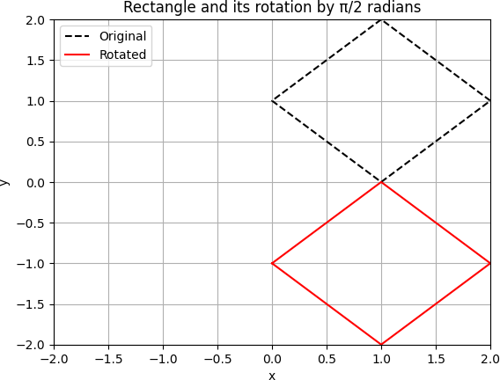

# Q 2) Attempt any TWO of the following

1. **Write a python program to reflect the line segment joining the points A[5,3] & B[1,4] through the line y=x+1**

**-**→

import numpy as np

import matplotlib.pyplot as plt

A = np.array([5, 3])

B = np.array([1, 4]) def reflection_line(x):

return x - 1

m = 1

b = 1

A_image = np.array([(1-m**2)*A[0] + 2*m*A[1] - 2*m*b, (1-m**2)*A[1] + 2*m*A[0] - 2*b])

B_image = np.array([(1-m**2)*B[0] + 2*m*B[1] - 2*m*b, (1-m**2)*B[1] + 2*m*B[0] - 2*b])

fig, ax = plt.subplots()

ax.plot([A[0], B[0]], [A[1], B[1]], 'b-', label='Original')

ax.plot([A_image[0], B_image[0]], [A_image[1], B_image[1]], 'r-', label='Reflection') ax.legend()

ax.grid() ax.set_xlabel('x') ax.set_ylabel('y')

ax.set_title('Reflection of line segment through y=x+1') plt.show()

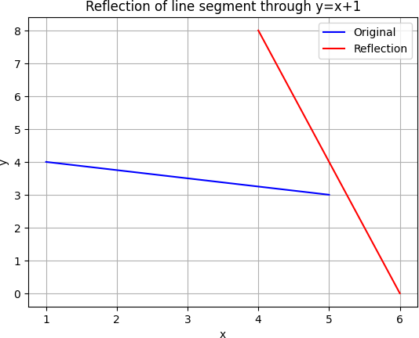

1. **Using python declare the points P(5,2),Q(5,-2),R(5,0) check whether these points are collinear.Declare the ray passing through the points P and Q find the length of this ray between P and Q. Also find slope of this ray**

**-**→

import math

# Define the coordinates of the points P, Q, and R

P = (5, 2)

Q = (5, -2)

R = (5, 0)

# Check if the points P, Q, and R are collinear

if (Q[1]-P[1])*(R[0]-Q[0]) == (R[1]-Q[1])*(Q[0]-P[0]):

print("The points P, Q, and R are collinear.") else:

print("The points P, Q, and R are not collinear.")

# Define the ray passing through P and Q ray_direction = (Q[0]-P[0], Q[1]-P[1])

# Find the length of the ray between P and Q

ray_length = math.sqrt(ray_direction[0]**2 + ray_direction[1]**2)

# Find the slope of the ray if ray_direction[0] != 0:

slope = ray_direction[1] / ray_direction[0] else:

slope = float('inf')

# Print the length and slope of the ray

print("The length of the ray between P and Q is", ray_length) print("The slope of the ray is", slope)

Output :

The points P, Q, and R are collinear.

The length of the ray between P and Q is 4.0 The slope of the ray is inf

**C ) write a python program in 3D to rotate the point (1,0,0) through X plane in anticlock wise direction(rotation through Z axis) by angle of 90⸰**

**-**→

import numpy as np point = np.array([1, 0, 0]) theta = np.radians(90)

rotation_matrix = np.array([[np.cos(theta), -np.sin(theta), 0], [np.sin(theta), np.cos(theta), 0],

[0, 0, 1]])

new_point = np.dot(rotation_matrix, point)

print("The original point was:", point) print("The rotated point is:", new_point)

output:

The original point was: [1 0 0]

The rotated point is: [6.123234e-17 1.000000e+00 0.000000e+00]

**Q 3 ) Attempt the following**

**A ) Attempt any ONE of the following**

**I ) Write a python program to solve the following LPP : Min Z=3.5x+2y**

**Subject to x+y≥5**

**x≥4 y≤2 x,y≥0**

-→

from pulp import *

prob = LpProblem("LP Problem", LpMinimize) x = LpVariable("x", lowBound=0)

y = LpVariable("y", lowBound=0) prob += 3.5*x + 2*y

prob += x + y >= 5 prob += x >= 4 prob += y <= 2 prob.solve()

print("Status: ", LpStatus[prob.status]) print("Optimal values:")

for v in prob.variables(): print(v.name, "=", v.varValue)

print("Optimal objective value: ", value(prob.objective))

1. **Write a python program to display the following LPP by using pulp module and simplex method.Find its optimal solution if exist**

**Max Z=x+2y+z Subject to x+2y+2z≤1**

**3x+2y+z≥8 X,y,x≥0**

-→

from pulp import *

prob = LpProblem("LP Problem", LpMaximize) x = LpVariable("x", lowBound=0)

y = LpVariable("y", lowBound=0)

z = LpVariable("z", lowBound=0)

prob += x + 2*y + z

prob += x + 2*y + 2*z <= 1 prob += 3*x + 2*y + z >= 8 prob.solve()

print("Status: ", LpStatus[prob.status]) print("Optimal values:")

for v in prob.variables(): print(v.name, "=", v.varValue)

print("Optimal objective value: ", value(prob.objective))

B ) Attempt any ONE of the following

**I ) Apply Python program in each of the following transformation on the point P[4,-2]**

**A ) Reflection through the Y-axis**

* 1. **Scaling in X-coordinate by factor 3**
  2. **Rotation about origin through an angle π**
  3. **Shearing in both X and Y direction by -2 and 4 units respectively**

**-**→

import numpy as np P = np.array([4, -2])

P_reflect_y = np.array([-4, 2])

print("Reflection through Y-axis:", P_reflect_y)

P_scale_x = np.array([12, -2])

print("Scaling in X-coordinate by factor 3:", P_scale_x)

theta = np.pi

rot_matrix = np.array([[np.cos(theta), -np.sin(theta)], [np.sin(theta), np.cos(theta)]])

P_rotate = rot_matrix.dot(P)

print("Rotation about origin through an angle π:", P_rotate)

shear_matrix = np.array([[1, -2], [4, 1]]) P_shear = shear_matrix.dot(P)

print("Shearing in both X and Y direction by -2 and 4 units respectively:", P_shear)

Output :

Reflection through Y-axis: [-4 2]

Scaling in X-coordinate by factor 3: [12 -2] Rotation about origin through an angle π: [-4. 2.]

Shearing in both X and Y direction by -2 and 4 units respectivel y: [ 8 14]

**II ) Find the combined transformation of the line segment between the points A[4,-1] & B[3,2] by using python program for the following sequence of transformation**

1. **Rotation about origin through an angle** 𝝅

𝟒

1. **Shering in Y direction by 4 units**
2. **Scaling in X-coordinate by 5 units**
3. **reflection through Y-axis**

**-**→

import numpy as np

A = np.array([4, -1])

B = np.array([3, 2]) theta = np.pi/4

rot_matrix = np.array([[np.cos(theta), -np.sin(theta)], [np.sin(theta), np.cos(theta)]])

A_rot = rot_matrix.dot(A) B_rot = rot_matrix.dot(B)

shear_matrix = np.array([[1, 0], [4, 1]]) A_shear = shear_matrix.dot(A_rot) B_shear = shear_matrix.dot(B_rot)

scale_matrix = np.array([[5, 0], [0, 1]]) A_scale = scale_matrix.dot(A_shear) B_scale = scale_matrix.dot(B_shear)

A_reflect_y = np.array([-A_scale[0], A_scale[1]]) B_reflect_y = np.array([-B_scale[0], B_scale[1]])

print("Transformed point A:", A_reflect_y) print("Transformed point B:", B_reflect_y)

output :

Transformed point A: [-17.67766953 16.26345597]

Transformed point B: [-3.53553391 6.36396103]