**Sahakar Maharshi Bhausaheb Santuji Thorat College Sangamner**

Remark

**Demonstrator’s**

**Signature**

**Date:-**

**/**

**/20**

**DEPARTMENT OF COMPUTER SCIENCE**

**Sub : Mathematics**

**Name:- Gorde Yash Somnath Roll.No:-_21 Date:- Title of the expt:- Slip no 8 Page.no:- Class:- BCS**

**Q1 Attempt any TWO of the following**

1. **Plot the graph of sin x , cos x ,ex and x2 in [0,5] in one figure with (2x2) subplots.**

→

import numpy as np

import matplotlib.pyplot as plt x = np.linspace(0, 5, 100)

fig, axs = plt.subplots(2, 2) axs[0, 0].plot(x, np.sin(x))

axs[0, 0].set_title('sin(x)')

axs[0, 1].plot(x, np.cos(x))

axs[0, 1].set_title('cos(x)')

axs[1, 0].plot(x, np.exp(x))

axs[1, 0].set_title('exp(x)') axs[1, 1].plot(x, x**2)

axs[1, 1].set_title('x^2')

fig.suptitle('Plots of sin(x), cos(x), exp(x) and x^2') plt.show()

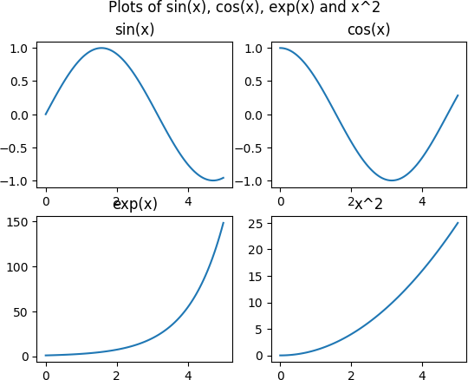

# Using python plot the graph of function f(x)=cos(x) in the interval [0,2π]

**-**→

import numpy as np

import matplotlib.pyplot as plt x = np.linspace(0, 2*np.pi, 100) y = np.cos(x)

plt.plot(x, y)

plt.xlabel('x')

plt.ylabel('f(x)')

plt.title('Graph of f(x) = cos(x) in the interval [0, 2π]') plt.show()

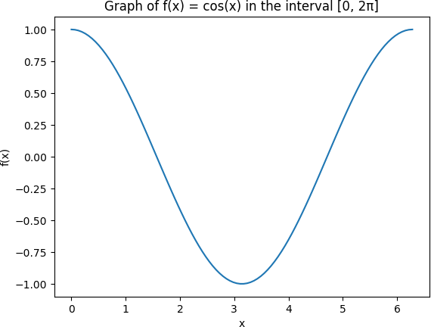

1. **Write a python program to generate 3D plot of the function z=sin x+ cos y in -10**

**<x,y<10**

**-**→

import numpy as np

import matplotlib.pyplot as plt

from mpl_toolkits.mplot3d import Axes3D fig = plt.figure()

ax = fig.add_subplot(111, projection='3d')

x = np.linspace(-10, 10, 100)

y = np.linspace(-10, 10, 100) X, Y = np.meshgrid(x, y)

Z = np.sin(X) + np.cos(Y)

ax.plot_surface(X, Y, Z) ax.set_xlabel('x') ax.set_ylabel('y') ax.set_zlabel('z')

plt.title('3D Plot of z = sin(x) + cos(y) in -10 < x,y < 10') plt.show()

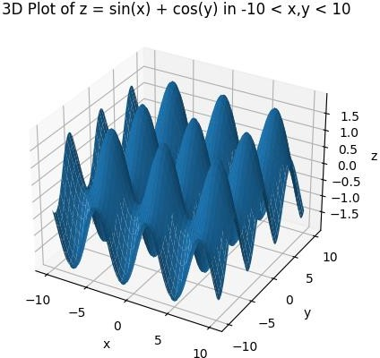

# Q2 ) Attempt any TWO of the following

**a) Write a python program in 3D to rotate the point (1,0,0) through XZ plane in anticlockwise direction(Rotation through Y axis by an angle of 90⸰**

**-**→

import numpy as np

import matplotlib.pyplot as plt

from mpl_toolkits.mplot3d import Axes3D fig = plt.figure()

ax = fig.add_subplot(111, projection='3d') ax.set_xlim([-1, 1])

ax.set_ylim([-1, 1])

ax.set_zlim([-1, 1])

p = np.array([1, 0, 0, 1]) theta = np.pi/2

R = np.array([[np.cos(theta), 0, np.sin(theta), 0],

[0, 1, 0, 0],

[-np.sin(theta), 0, np.cos(theta), 0],

[0, 0, 0, 1]])

q = R @ p

ax.scatter(p[0], p[1], p[2], color='red')

ax.scatter(q[0], q[1], q[2], color='blue')

ax.plot([p[0], q[0]], [p[1], q[1]], [p[2], q[2]], color='black') ax.set_xlabel('X')

ax.set_ylabel('Y') ax.set_zlabel('Z')

plt.title('Rotation of (1,0,0) through XZ plane by 90 degrees') plt.show()

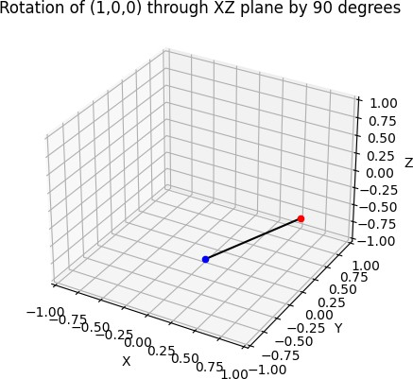

# Using python generate tringle with vertices (0,0),(4,0),(1,4) check whether the tringle is Scalene triangle

**-**→

import math

import matplotlib.pyplot as plt

A = [0, 0]

B = [4, 0]

C = [1, 4]

a = math.sqrt((B[0]-C[0])**2 + (B[1]-C[1])**2)

b = math.sqrt((C[0]-A[0])**2 + (C[1]-A[1])**2)

c = math.sqrt((A[0]-B[0])**2 + (A[1]-B[1])**2)

if a != b and b != c and c != a:

print("The triangle is a Scalene triangle.") color = 'green'

else:

print("The triangle is not a Scalene triangle.") color = 'red'

fig, ax = plt.subplots()

ax.plot([A[0], B[0]], [A[1], B[1]], color='black')

ax.plot([B[0], C[0]], [B[1], C[1]], color='black')

ax.plot([C[0], A[0]], [C[1], A[1]], color='black')

ax.scatter([A[0], B[0], C[0]], [A[1], B[1], C[1]], color=color) ax.set_xlim([-1, 5])

ax.set_ylim([-1, 5]) ax.set_xlabel('X') ax.set_ylabel('Y')

plt.show()

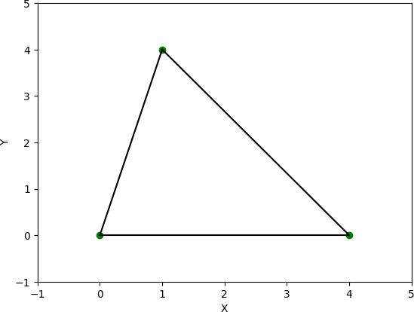

# Write a python program to find the area and perimeter of the ∆ABC , where A[0,0],B[6,0],C[4,4]

**-**→

import math

A = [0, 0]

B = [6, 0]

C = [4, 4]

a = math.sqrt((B[0]-C[0])**2 + (B[1]-C[1])**2)

b = math.sqrt((C[0]-A[0])**2 + (C[1]-A[1])**2)

c = math.sqrt((A[0]-B[0])**2 + (A[1]-B[1])**2) perimeter = a + b + c

s = perimeter / 2

area = math.sqrt(s * (s - a) * (s - b) * (s - c)) print("The area of the triangle is:", area) print("The perimeter of the triangle is:", perimeter)

output

The area of the triangle is: 11.999999999999996 The perimeter of the triangle is: 16.12899020449196

**Q3) Attempt the following**

**A )Attempt any ONE of the following**

**I ) Write a python program to solve the following LPP : MAX Z=150x+75y**

**Subject to 4x+6y≤24**

**5x+3y≤15 X,y≥0**

**-**→

from scipy.optimize import linprog obj = [-150, -75]

lhs = [[4, 6], [5, 3]]

rhs = [24, 15]

bounds = [(0, None), (0, None)]

res = linprog(c=obj, A_ub=lhs, b_ub=rhs, bounds=bounds, method='simplex') print("The maximum value of Z is:", -res.fun)

print("The values of x and y that maximize Z are:", res.x)

output :

The maximum value of Z is: 450.0

The values of x and y that maximize Z are: [3. 0.]

**II) Write a python program to display the following LPP by using pulp module and simplex method . Find its optimal solution if exist**

**Max Z=3x+5y+4z Subject to 2x+3y≤8**

**2y+5z≤10**

**3x+2y+4z≤15 X,y,z≥0**

**-**→

import pulp

prob = pulp.LpProblem('LPP', pulp.LpMaximize)

x = pulp.LpVariable('x', lowBound=0)

y = pulp.LpVariable('y', lowBound=0)

z = pulp.LpVariable('z', lowBound=0)

prob += 3*x + 5*y + 4*z prob += 2*x + 3*y <= 8 prob += 2*y + 5*z <= 10

prob += 3*x + 2*y + 4*z <= 15 prob.solve()

print('Optimal Solution:')

print('Z =', pulp.value(prob.objective)) print('x =', pulp.value(x))

print('y =', pulp.value(y))

print('z =', pulp.value(z))

**B ) Attempt any ONE of the following**

**I ) Apply Python program in each of the following transformation on the point P[4,-2]**

**A ) Refection trough Y-axis**

**B ) Scaling in X-coordinate by factor 5**

**C ) Rotation about origin through an angle** 𝝅

𝟐

**D ) Shering in X direction by** 𝟕 **units**

𝟐

**-**→

import numpy as np

# reflection through Y-axis p = np.array([4, -2])

R = np.array([[-1, 0],

[0, 1]])

q = R @ p print(q)

# scaling in X-coordinate by factor 5

p = np.array([4, -2])

S = np.array([[5, 0],

[0, 1]])

q = S @ p print(q)

# rotation about origin through an angle π/2 p = np.array([4, -2])

theta = np.pi/2

R = np.array([[np.cos(theta), -np.sin(theta)],

[np.sin(theta), np.cos(theta)]]) q = R @ p

print(q)

# shearing in X direction by 7/2 units p = np.array([4, -2])

a = 7/2

S = np.array([[1, a],

[0, 1]])

q = S @ p print(q)

output :

[-4 -2]

[20 -2]

[2. 4.]

[-3. -2.]

1. **Find the combined transformation of the line segment between the point A[7,-2] & B[6,2] by using python program for the following sequence of transformation**

**A ) Rotation about origin through an angle** 𝝅

𝟑

**B ) Scaling in X-cordinate by 7 units**

* 1. **Uniform scaling by -4 units**
  2. **reflection through the line X-axis**

**-**→

import numpy as np

import matplotlib.pyplot as plt A = np.array([7,-2])

B = np.array([6,2]) theta = np.pi/3

Sx = 7

Sy = -4

R = np.array([[np.cos(theta), -np.sin(theta)], [np.sin(theta), np.cos(theta)]])

S = np.array([[Sx, 0], [0, Sy]])

T = np.array([[1, 0], [0, -1]])

A = T @ S @ R @ A

B = T @ S @ R @ B

plt.plot([A[0], B[0]], [A[1], B[1]], color='blue') plt.xlim(-30, 30)

plt.ylim(-30, 30) plt.xlabel('X-axis') plt.ylabel('Y-axis')

plt.title('Transformed Line Segment') plt.show()

