Open Source Repo Metrics Handoff Doc

# 

# 

Nicole Avila and Shweta Kumar

# 

# Current Status

The current status of this project is based on the progress made during the 2023 Summer CiF Fellowship. The aim of this project is to pull open source github data for different organizations within CMS and provide a metrics visualization tool to aid PMs and Code Developers in quickly assessing project health.

This project is inspired by the Twitter Open Source Repo Metrics Project which can be found [here](https://twitter.github.io/metrics/).

## Front End

### Web Development

Currently the webpage contains a navbar and a weekly and month metrics page. Mock svgs have been uploaded to the webpage to demonstrate where the The next steps would be to implement the combobox with autocomplete feature such that the visualizations for a specific repository in a given organization will appear onto the screen. Refer to the design document to see how to approach making the combobox with autocomplete.

### Data Visualizations

Currently, the data visualizations are generated within the /gen_graphs.py file and the data used to generate the graphs are stored in the /_dataVis folder. The visualizations are then inputted into the _graphs/DSACMS folder where each repo specific graph is stored in an individual folder and the general overview graph is listed externally.

Additional graph visualizations should be stored in each specific repo and org folder to allow for easy and organized access into the data visualizations. Currently, the data visualizations are done using the Pygals Python Library and the Binary Treemap graph. With the time restrictions, only Binary Treemaps were done to provide a general, visual overview, but more specific visualizations would be helpful to present the data in different ways. Visualizations should update weekly and monthly for the project -auto updating is not currently done.

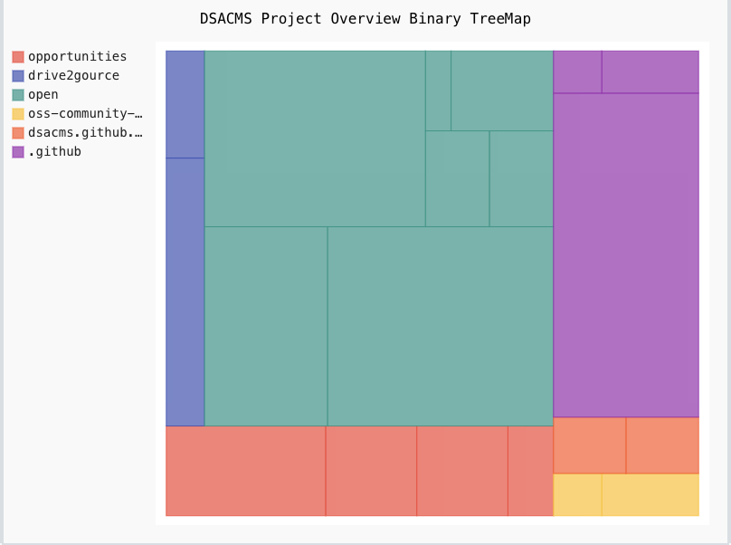

Figure 1: Data Visualization Overview for DSACMS

## Back End

## Additional

# Project Goals

## Visions

The vision for this project is to provide a metric based overview of open source organizations in CMS. This project is based off of the [Twitter metrics project](https://twitter.github.io/metrics/). For more information on where this project can be taken, it is best to discuss with DSAC OS lead Remy DeCausemaker or research and mock up potential design ideas with developing this project and present them to Remy. The freedom on how to present the information and what sort of metrics to present is open to interpretation.

# Important Resources

* **Metrics Github:** <https://github.com/DSACMS/metrics>
* **Design Document:** [metrics design docume](https://docs.google.com/document/d/1uz2CnqGl2-Cxn12Ib6VDAf9mK2Q4B40sAo3RZ51Jlx0/edit?usp=sharing)
* **Figma Design Front-End:** [figma design](https://www.figma.com/file/shQNqJlD7zEBRl4tlL5juU/Open-Source-Repo-Metrics?type=design&node-id=2%3A2601&mode=design&t=dlZ2AZxBo0yzrG1i-1)
  + - * **Weekly Sprints:** 
        + **CHAOSS Slack:** [**Chaoss**](https://chaoss.community/kb-getting-started/)
        + **CMSgov slack: (Ask Remy to join)**

